A
Lab Records of
Programming Fundamentals of C
Computer Science and Engineering- Sem 1

RUNGTA INTERNATIONAL SKILLS UNIVERSITY
SESSION: 2025-26

Submitted to- Submitted by-
Prof. Aashish Shivhare Shivam Raj
(11375)

RUNGTA INTERNATIONAL SKILLS UNIVERSITY,CG
SCHOOL OF COMPUTER SCIENCE AND TECHNOLOGY

INDEX
S.NO | NAME OF PRACTICAL | SUBMISSION DATE | REMARKS
1. | Setup VS Code +  GCC, write first C program, explain  structure, print  name/age using printf statement
2. | Draw flowcharts for sum & largest of two numbers, Implement  the program in C, Show VS Code shortcuts any 5
3. | Declare variables of int, float, char,  double; scanf/printf with format  specifiers, Swap numbers
4. | Odd/Even check using if-else, Max of  three numbers (nested  if), Ternary operator,  Switch-case calculator

Practical-1
Aim- GCC compiler, install vs code, steps for installation and writing first program Code:
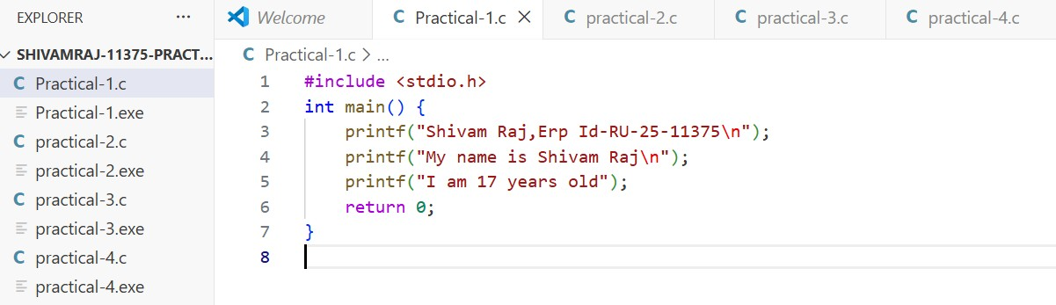
Output:
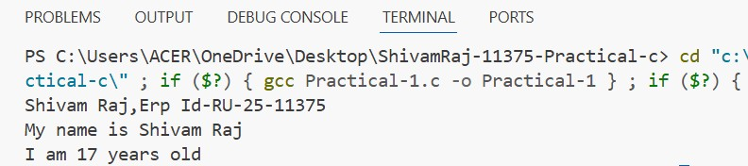

.

Practical-2
Aim-Draw flowcharts for sum & largest of two numbers, Implement the program in C, Show VS Code shortcuts any 5
=>Flowchart for showing largest two numbers



Start

Enter Two Number: A,
B

Is A

>

B?

Display “First
number is greater
”

Display “Second
number is greater”

Stop

Code:
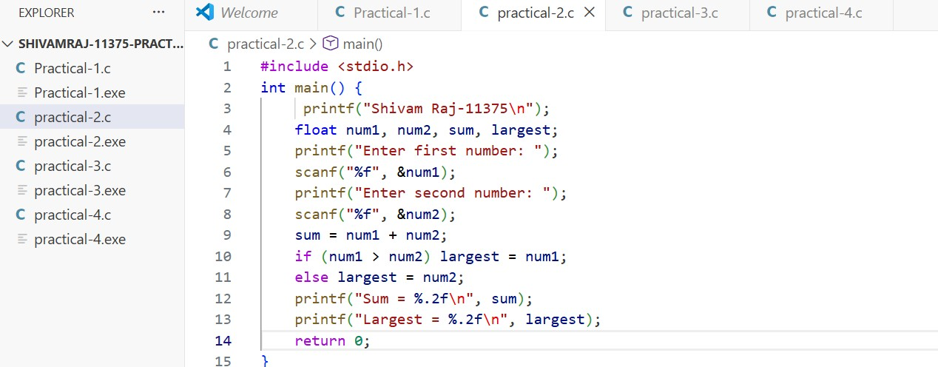
Output:
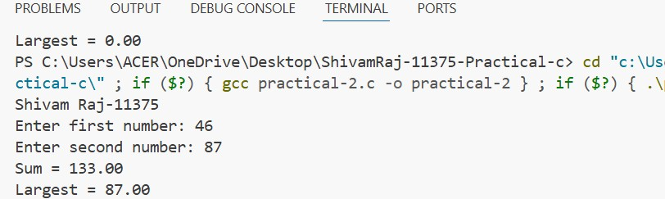
VS Code shortcuts:
1. Run Code- Ctrl+ Alt+ N 2. Open Terminal - Ctrl + backtick 3. Save file - Ctrl + S 4. Copy Line Down - Alt + Shift + down arrow 5. Comment - Ctrl + /

.

Practical-3
Aim-Declare variables of int, float, char, double; scanf/printf with format specifiers, Swap numbers

Code:
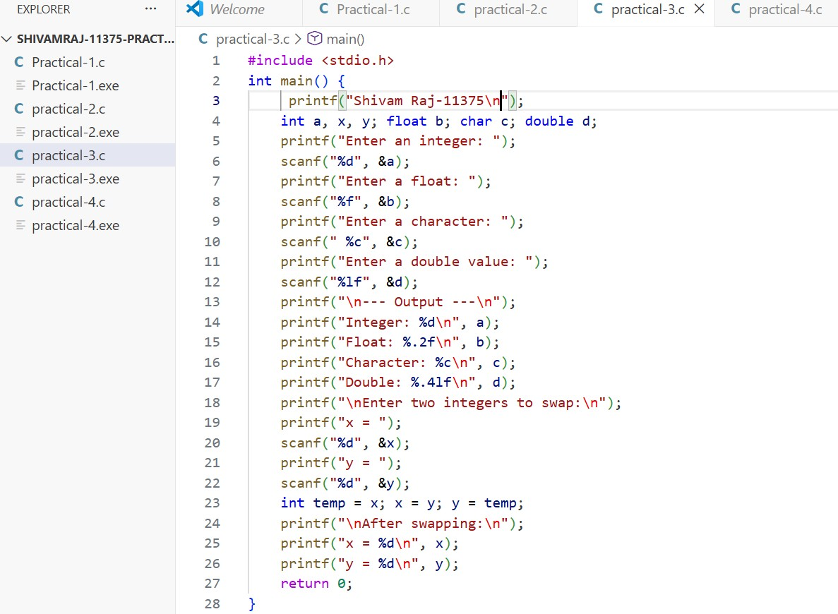

.
Output:
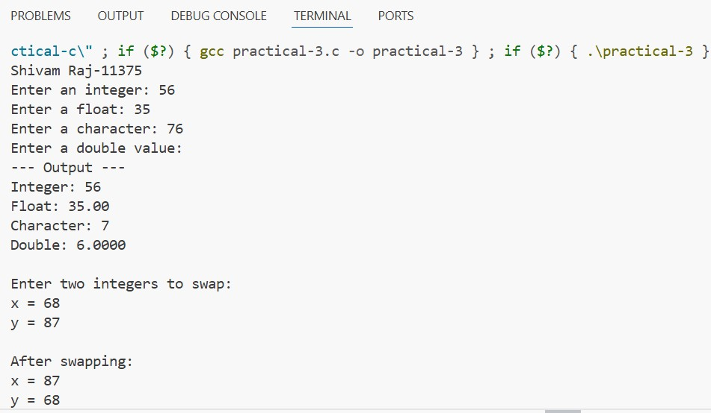

.

Practical-4
Aim- Odd/Even check using if-else, Max of three numbers (nested if), Ternary operator, Switch-case calculator Code:
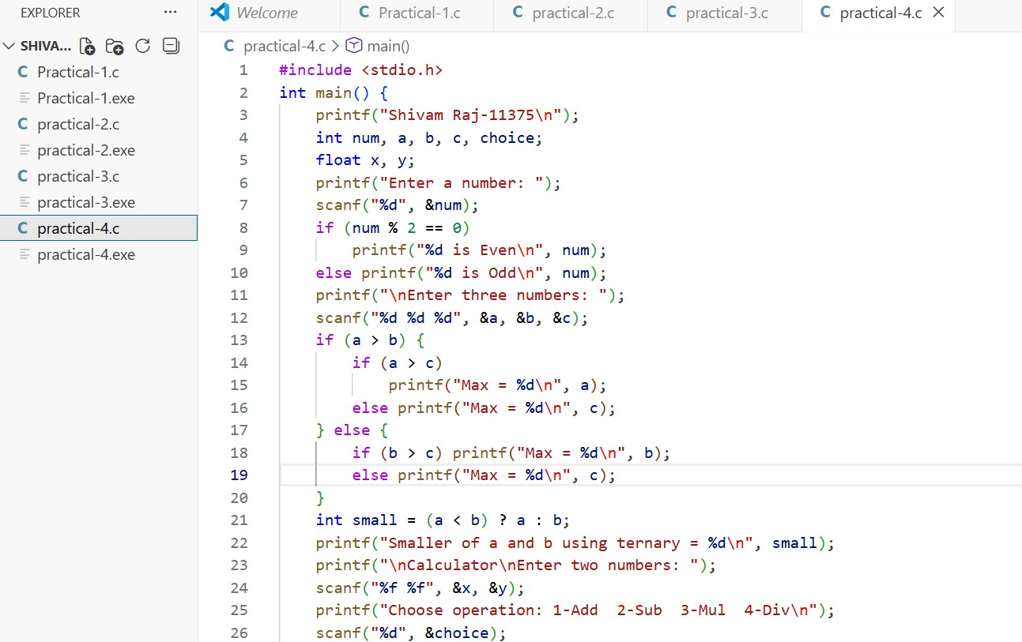

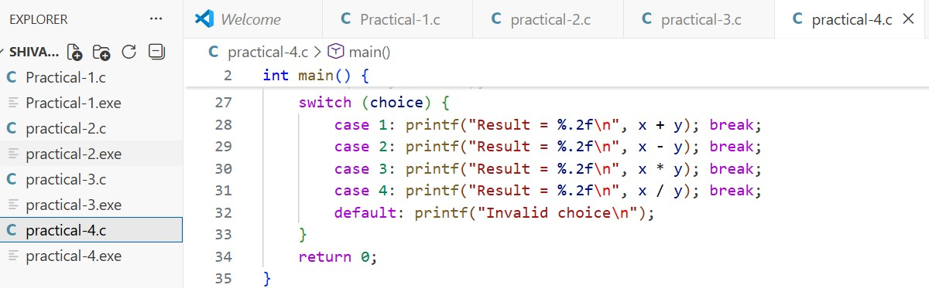

Output:
