## C:\Users\Raja\Desktop\NIMO\Narasaraopeta\Documents\Doc 2.png

## International Conference on Mobile Cloud Computing, Communication and Engineering

## 17th -18th April 2018

## C:\Users\Raja\Desktop\NIMO\Narasaraopeta\130501030503_qs.jpg(ICMCCCE-18)

**Organized By**

**Research Forum**

Narasaraopet Engineering College, Yellamanda (Post),

Guntur (Dist.), Andhra Pradesh

Web: www. icmccce.com, Email: [icmccce18@gmail.com](mailto:icmccce18@gmail.com)

All the selected papers presented in the conference will be published in - Scopus indexed journal

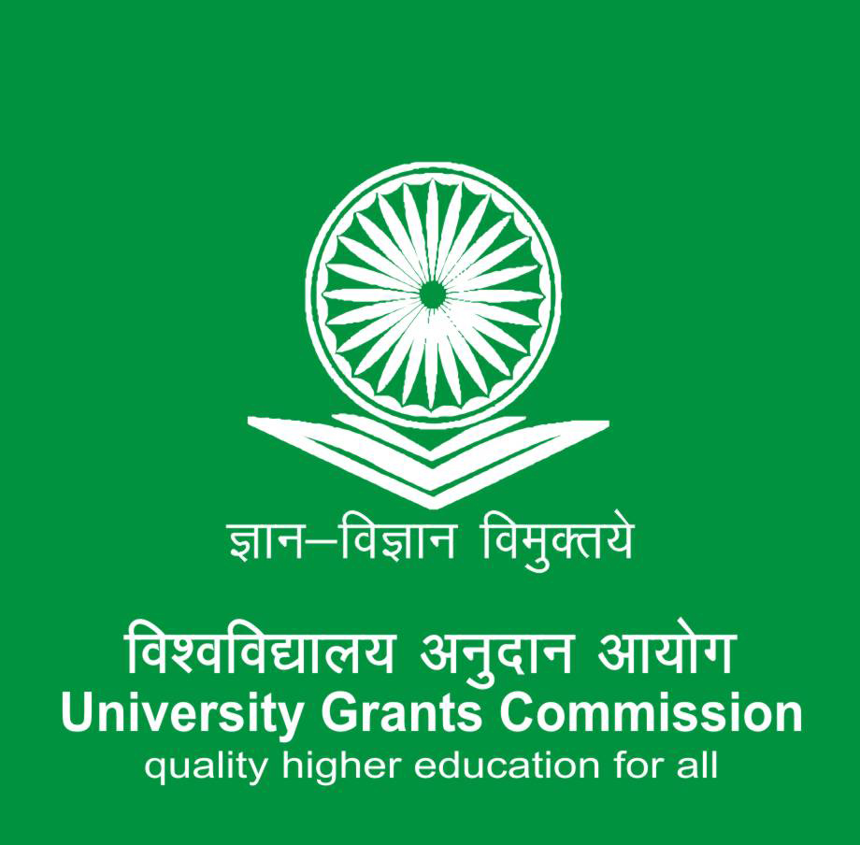

**ABOUT NECCT**

**NEC COLLEGE OF TECHNOLOGY**,

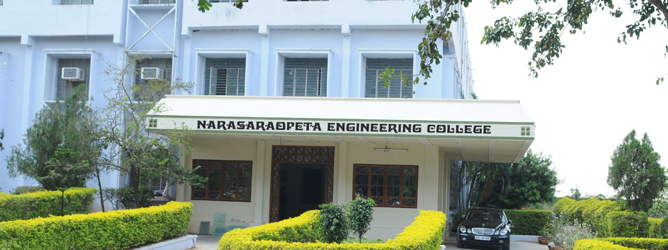 Narasaraopeta Engineering College was established in the year 1998 by Gayatri Educational Development Society, Narasaraopet, under the leadership of Sri M.V.Koteswara Rao, who has a vision of developing this college as an autonomous institution of higher learning & knowledge in the heart of Palnadu region. The college is approved by AICTE, permanently affiliated to JNTUK Kakinada, accredited ‘A’ Grade by NAAC, Accredited twice by NBA and ISO 9001: 2008 certified. NEC is accorded ‘AUTONOMOUS’ status by UGC and JNTUK in the year 2016. The college has launched Incubation Centre where the students can implement their ideas into start-ups. Six startups have already been launched and six more are incubating. NEC is the first Engineering College in A.P. to sign MOU with Foreign Universities like Oracle and Scholars University (USA). The college offers six M.Tech programmes, two PG courses of MCA, MBA and five courses at B.Tech level in the branches EEE, CSE, ECE, ME and CIVIL. The college is having 314 qualified and experienced faculty out of which 32 are Ph.D holders. The faculty has published 478 technical papers in referred International/National journals and conferences. Departments of ECE, CSE and Mechanical Engg have been recognized as research centres by JNTUK. The college has well equipped laboratories including 1000 computers with a bandwidth of 100 MBPS internet. The college is an Edvantage platinum partner of Microsoft and established a Microsoft Innovation Centre in the college through which more than 200 Mobile Apps, 50 Cloud Apps and 100 Windows Apps are uploaded every year. Narasaraopet is on the railway line of Guntur to Guntakal and is on the state highway. It is 240 km from Hyderabad and 50km from Guntur, A.P

**ABOUT LABTECH INNOVATIONS™**

Labtech Innovations™, Chennai is one of the India’s foremost and a fast growing professional association for research development and promotion in the field of Engineering, Technology & Science operating under Dexority Innovations Pvt. Ltd. Labtech Innovations™ is a paramount body which is on the track of bringing a rapid technical revolution and sustainable development in the field of Engineering, Technology & Science by facilitating knowledge flow from Institution to institution & Industry to Institution & vice versa.

The ace organization is supported by its International Advisory Board (IAB) which European to boost our organization. LABTECH is collaborated with leading technical institutes including Universities and research centers to promote the exchange of technical proceeding and research magazine.

**ABOUT THE CONFERENCE**

We are glad to announce the “International Conference on Mobile Cloud Computing, Communication and Engineering (ICMCCCE), Andhra Pradesh during 22nd and 23rd June 2018 in association with Labtech Innovations. All the submitted research articles will be peer-reviewed by the program and technical committees of the conference. ICMCCCE-18 will provide an excellent international forum for sharing knowledge and results in Emerging Technological Innovations in Sciences, Engineering, Technology and Management. The aim of the Conference is to provide a platform to the researchers and practitioners from both academia as well as industry to meet & share the cutting-edge developments in the field of engineering technology.

**SCOPE OF THE CONFERENCE**

* All the accepted papers will be published in the conference proceedings.
* All the accepted paper will be published in relevant Scopus indexed International Journals.
* Awards will be given for the best research paper as well as best paper presentation.
* Delegates with research activities and innovative ideas which may be beneficiary for humanities will be funded through Labtech Innovations™ Research Funding Scheme.

**CALL FOR PAPERS**

The full text paper should be in MS Word one column format (Font -Times New roman, size -12, Line spacing- 1.5)

**Original Contributions are solicited on topics covered under broad areas such as (but not limited to):**

* Big data analytics, Cloud Computing, Data Mining
* Parallel, Distributed Computing and Ubiquitous Computing
* ICT and IOT
* Advanced algorithms and complexity
* Mobile, Wireless and Sensor Networks
* Artificial Intelligence, Neural Networks and machine learning
* Network Security
* Software Engineering
* Bio-Informatics
* Human computer interaction
* Programming languages and environment
* Computer graphics and visualization
* Analog and digital signal processing
* Image processing & Speech processing
* Cognitive radio networks
* Wireless-mobile communication and technologies
* Embedded & wireless systems
* 4G-5G Cellular communications
* Computer and Intelligent communications
* Advance VLSI systems
* Nano Technology in Electronics
* 3-D Integrated circuits
* Advanced battery and fuel cell development for electric vehicles
* Advanced cooling systems
* Automated guided vehicle system
* Electronic fuel injection
* Biomass fuelled power plant
* Carbon Nano tubes
* Digital manufacturing
* Eco friendly surface treatments
* Fly ash utilization
* Nano Robotic technology
* Nano fluids thermal applications
* Thermo Acoustic Refrigeration
* Use of industrial waste
* Structural analysis and design
* Social and environmental research
* Life-Cycle analysis
* Micro climate
* Human factors in technology development and use
* Green building materials
* Geographic information techniques
* Environment and technology
* Disaster prevention and mitigation
* Challengers to finance management in next generation
* Human resource information system
* Smart marketing
* Quality control and management
* Financial reporting
* E-governance
* Value chain analysis
* Forex markets
* Managing global workforce
* Corporate governance
* Retail marketing challenges Big data analysis
* Condensed Matter
* Optical Materials
* Non-linear optics
* Computational Physics
* Nanomaterial and its applications
* Environmental Chemistry
* Medicinal Chemistry
* Electrochemistry
* Catalysis and its applications
* Phytochemistry
* Technical writing
* Fuzzy Theory
* Graph Theory
* Operation research and statistics
* Numerical methods
* Cryptography
* Neural Networks
* Game theory
* Stochastic process
* Cryptography and Applied Mathematics
* Computer Architecture and VLSI
* Control and Systems Engineering
* Digital and Embedded Systems
* Reconfigurable Systems and Architectures
* Power-Efficient and Reconfigurable Architectures
* Robotics and Intelligent Control
* Digital Photogrammetry, Remote Sensing, GIS and GPS
* E-Governance, E-Commerce, E-Business
* Educational Computing
* Wireless Communication
* Antenna Design
* Wearable Devices
* Internet of Things
* Image Processing
* Wireless Sensor Networks

|  |  |  |  |
| --- | --- | --- | --- |
| **IMPORTANT DATES** | March 30th,2018 | |  |
| Paper submission : |  |
| Acceptance & Notification : | M April 10th, 2018 | |  |
| Registration and camera ready : May 7th, 2018 | |  |
| **REGISTRATION FEES** | |  |
| Researcher / Student/ Academic faculty | INR 8000/- | |  |
| Industrial Participants | INR 9000/- | |  |
| Foreign Delegates | US $300 | |  |
| Foreign Students | US $250 | |  |

Payment can be made only online (For details visit the website: www.icmccce.com)

**CHIEF PATRON Chakravarthi Mittapalli**, Managing Director,

NEC Group of Institutions

**PATRON**

**M. V. Koteswara Rao**, Chairman, NEC Group of Institutions

**Mr. M. Ramesh Babu,** Secretary, Narasaraopeta Engineering College

**Dr. D. Suneel,** Principal, Narasaraopeta Engineering College

**GENERAL CHAIR**

**Dr. Dash S S**, SRM University, Chennai.  
**Dr . P. V Rao**, Professor, Dept. of ECE, VBIT, Hyderabad.

**Dr. P. V Naganjaneyulu**, Principal, MVRCE, Vijayawada, A.P.

**ORGANISING COMMITTEE**

**Dr. Prakash Kodali,** Assoc. Prof, Dept. of ECE, Narasaraopeta Engineering College

**Dr. Ajay Kumar Maddirala,** Assoc. Prof, Dept. of ECE, Narasaraopeta Engineering College

**Dr. P. Lakshmanan**, Professor & Dean (TPC), Dept. of EEE, Narasaraopeta Engineering College

**Dr. B. Jhansi Vazram,** Professor, Dept. of CSE, Narasaraopeta Engineering College

**Dr. K. Lakshminadh**, Assoc. Professor, Dept. of CSE, Narasaraopeta Engineering College

**Dr. S. Siva Nageswara Rao**, Assoc. Professor, Dept. of CSE, Narasaraopeta Engineering College

**Dr. D. Jagadeesh,** Professor & Head, Dept. of ME, Narasaraopeta Engineering College

**Dr. K. P. Lakshmi,** HOD-BS&H, Dean-Student Affairs, Narasaraopeta Engineering College

**CONVENORS**  
**Dr. V. Venkata Rao**, HOD, Dept of ECE, Narasaraopeta Engineering College

**Dr. S. N. Thirumala Rao,** HOD, Dept of CSE, Narasaraopeta Engineering College

**Mr. B.Anil Kumar,** Dept. of ECE, VBIT, Hyderabad Publication Chairs  
**Prof. Akash Kumar Bhoi**, SMIT, India.  
**Prof. Samarjeet Borah**, CSE, SMIT

**NATIONAL ADVISORY COMMITTEE:**   
**Dr. Debashish Jena**, NITK, India Dr. N.P. Padhy, IIT Roorkee  
**Dr. S. Biswas,** CSE Department, IIT Guwahati

**Dr. N. R. Mohapatra**, EE Department, IIT Gandhinagar

**Dr. Vasudevan M,** AGM, HCL Technology,Chennai.

**Dr. G. Rama Murthy**, Assoc.Professor, Dept of SPCRC, IIIT, Hyderabad

**Dr. S. Srinivasa Rao,** Professor, Dept of E&I, Madras Institute of Technology, Anna University

**Dr. N. C. Shiva Prakash**, Professor, Dept of IAP, IISc, Bangalore

**Dr.Amruthansu**, Dept of Electronics,IIT BHU,Varanasi

**Dr. V. Valli Kumari**, Professor, Dept of CSE, AUCE, Visakhapatnam

**Dr. P. Prem Chand**, Professor, Dept of CSE, Osmania University, Hyderabad

**Dr.P.Trinatha Rao,Dept**. of ECE,GITAM University,Hyderabad

**Dr. Roy Paily,** EEE Department, IIT Guwahati

**Dr. Sashikala Mishra**, IIIT-Pune.

**Dr. Sukumar Nandi**, CSE Department, IIT Guwahati

**Dr. S.Kishore kumar**, Dept of Electronics,IIT BHU,Varanasi

**Dr. Ashok Kumar Pradhan**, IIT Kharagpur  
**Dr. Bhim Singh**, IIT Delhi  
**Dr. Ganapati Panda**, IIT Bhuvaneshwar

**Dr. T. R. Lenka**, ECE Department, NIT Silchar  
**Dr. N.P. Padhy**, IIT Roorkee  
**Dr. Sukadev Meher**, ECE Department, NIT Rourkela  
**Dr. Kamala Kanta Mahapatra**, ECE Department, NIT Rourkela  
**Dr. Ayas Kanta Swain**, ECE Department, NIT Rourkela  
**Dr. Sarat Kumar Patra**, ECE Department, NIT Rourkela  
**Dr. Karuppanan P**, ECE Department, NIT Allahabad  
**Dr. Ranjay Hazra**, EIE Department, NIT Silchar  
**Dr. Debashish Jena**, NITK, India.

**INTERNATIONAL ADVISORY COMMITTEE:**  
**Dr. Ahmed Faheem Zobaa**, BU, UK  
**Dr. Akhtar Kalam**, VU, Australia  
**Dr. Alfredo Vaccaro**, US, Italy  
**Dr. David YU**, UWM, US  
**Dr. Dmitri Vinnikov**, TUT, Estonia  
**Dr. Gorazd Štumberger**, UM, Slovenia  
**Dr. Hussain Shareef**, UKM, Malaysia  
**Dr. Joseph Olorunfemi Ojo**, TTU, USA  
**Dr. Junita mohamad-Saleh**, US, Malaysia  
**Dr. Mohamed A. Zohdy**, OU, MI  
**Dr. Murad Al-Shibli,** Head, EMET, Abu Dhabi  
**Dr. Nesimi Ertugrul**, UA, Australia  
**Dr. Omar Abdel-Baqi,** UWM, USA  
**Dr. Avinash Konkani**, AHFP, University of Virginia Health System, USA.  
**Dr. Atilla Elci**, Chairman, EEE, Aksaray University, Turkey

ADDRESS FOR COMMUNICATION

**Mr.J. Arun Venkatesh// Prof S K Thakur**

**Narasaraopet Engineering College**

Kotappakonda Road, Yellamanda (Post), Guntur (Dist.), Andhra Pradesh.

Web: www.icpiesmpae.com, E-mail: icpiesmpae@gmail.com

Mobile no: +91 -, +91 -9884518242

Phone: 08647 – 239903