ASSIGNMENT 4

Stephen Smitshoek

2022-04-18

# Markdown Basics

## Favorite Foods

1. Pizza
2. Cous Cous
3. Nachos

## Images

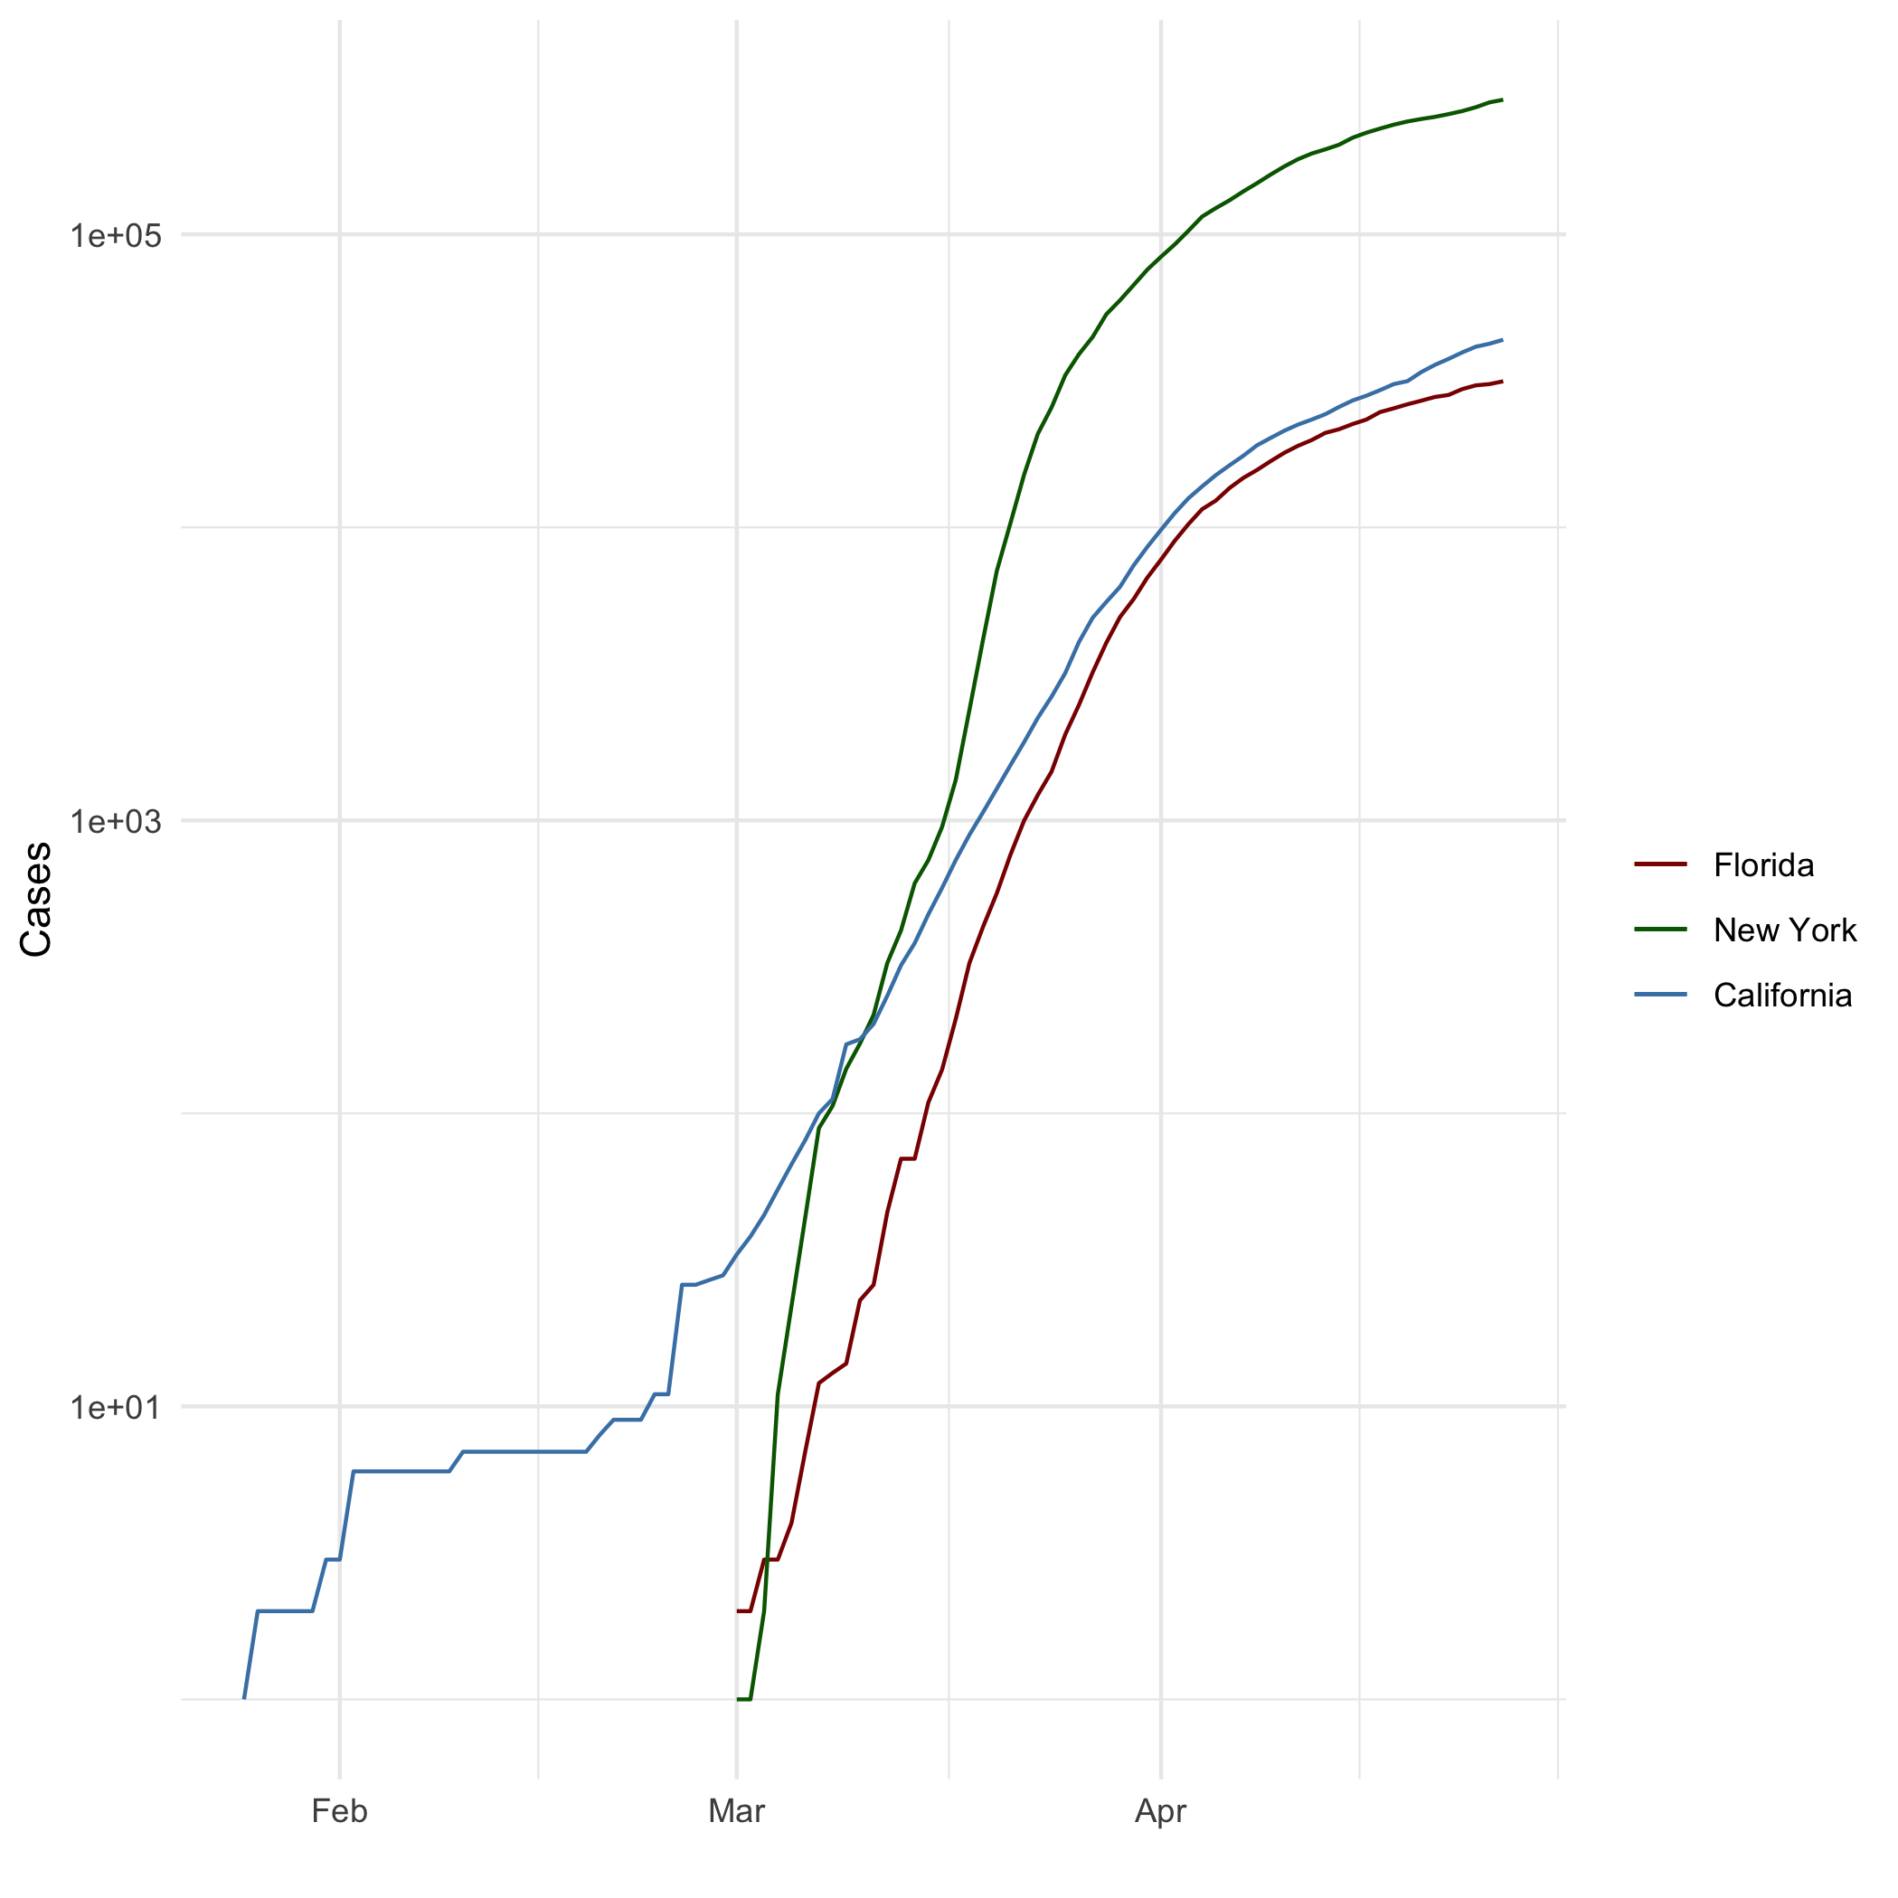

All Cases (Log Plot)

## Add a Quote

Tis but a flesh wound

## Add an Equation

$$PV=nRT$$

## Add a Footnote

[1]

## Add Citations

* Lander, Jared (2021). *R for Everyone*. Addison-Wesley.
* Field, Andy (2012). *Discovering Statistics Using R*. SAGE Publications Inc.

# Inline Code

## NY Times COVID-19 Data

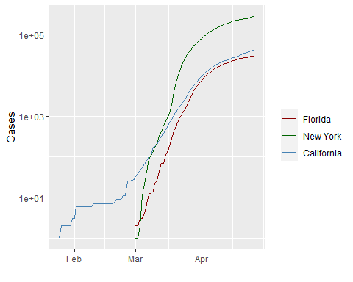

## R4DS Height vs Earnings

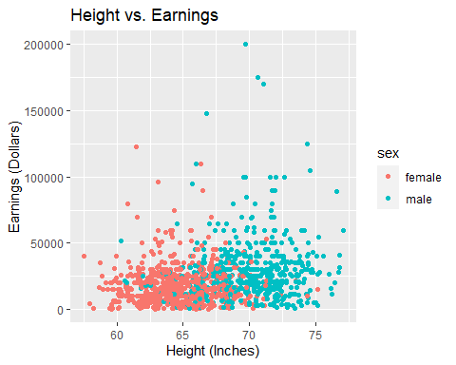

# Tables

## Knitr Table with Kable

One Ring to Rule Them All

| name | race | in_fellowship | ring_bearer | age |
| --- | --- | --- | --- | --- |
| Aragon | Men | TRUE | FALSE | 88 |
| Bilbo | Hobbit | FALSE | TRUE | 129 |
| Frodo | Hobbit | TRUE | TRUE | 51 |
| Galadriel | Elf | FALSE | FALSE | 7000 |
| Sam | Hobbit | TRUE | TRUE | 36 |
| Gandalf | Maia | TRUE | TRUE | 2019 |
| Legolas | Elf | TRUE | FALSE | 2931 |
| Sauron | Maia | FALSE | TRUE | 7052 |
| Gollum | Hobbit | FALSE | TRUE | 589 |

## Pandoc Table

## Warning: package 'pander' was built under R version 4.1.3

##   
##   
## +-----------+--------+---------------+-------------+------+  
## | name | race | in_fellowship | ring_bearer | age |  
## +===========+========+===============+=============+======+  
## | Aragon | Men | TRUE | FALSE | 88 |  
## +-----------+--------+---------------+-------------+------+  
## | Bilbo | Hobbit | FALSE | TRUE | 129 |  
## +-----------+--------+---------------+-------------+------+  
## | Frodo | Hobbit | TRUE | TRUE | 51 |  
## +-----------+--------+---------------+-------------+------+  
## | Galadriel | Elf | FALSE | FALSE | 7000 |  
## +-----------+--------+---------------+-------------+------+  
## | Sam | Hobbit | TRUE | TRUE | 36 |  
## +-----------+--------+---------------+-------------+------+  
## | Gandalf | Maia | TRUE | TRUE | 2019 |  
## +-----------+--------+---------------+-------------+------+  
## | Legolas | Elf | TRUE | FALSE | 2931 |  
## +-----------+--------+---------------+-------------+------+  
## | Sauron | Maia | FALSE | TRUE | 7052 |  
## +-----------+--------+---------------+-------------+------+  
## | Gollum | Hobbit | FALSE | TRUE | 589 |  
## +-----------+--------+---------------+-------------+------+

# References

1. This is a footnote