4-1 :

1. S->SA 消除左递归后：(e代表空串）
2. >S’ S’->AS’|e
3. S->SB 消除左递归后:

S->S`` S``->BS``|B

3.A->AB 消除左递归后:

A->A` A`->BA`|e

合并后：  
 S->S` S`->AS`|e S->S`` S``->BS``|B A->A`

A`->BA`|e S->A A->B A->(S) A->()

1. >[S] B->[]

4-3:

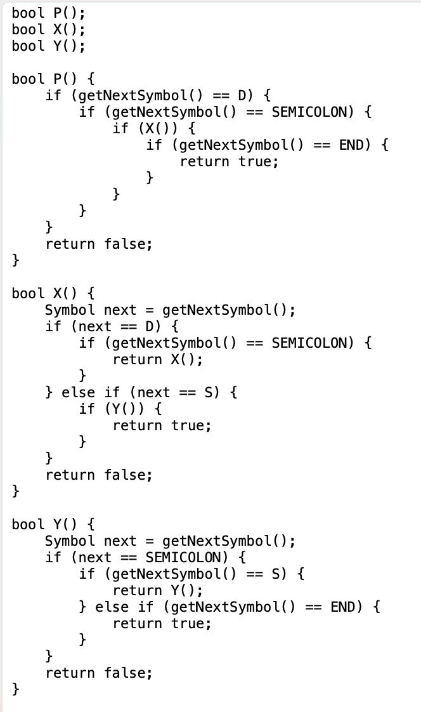

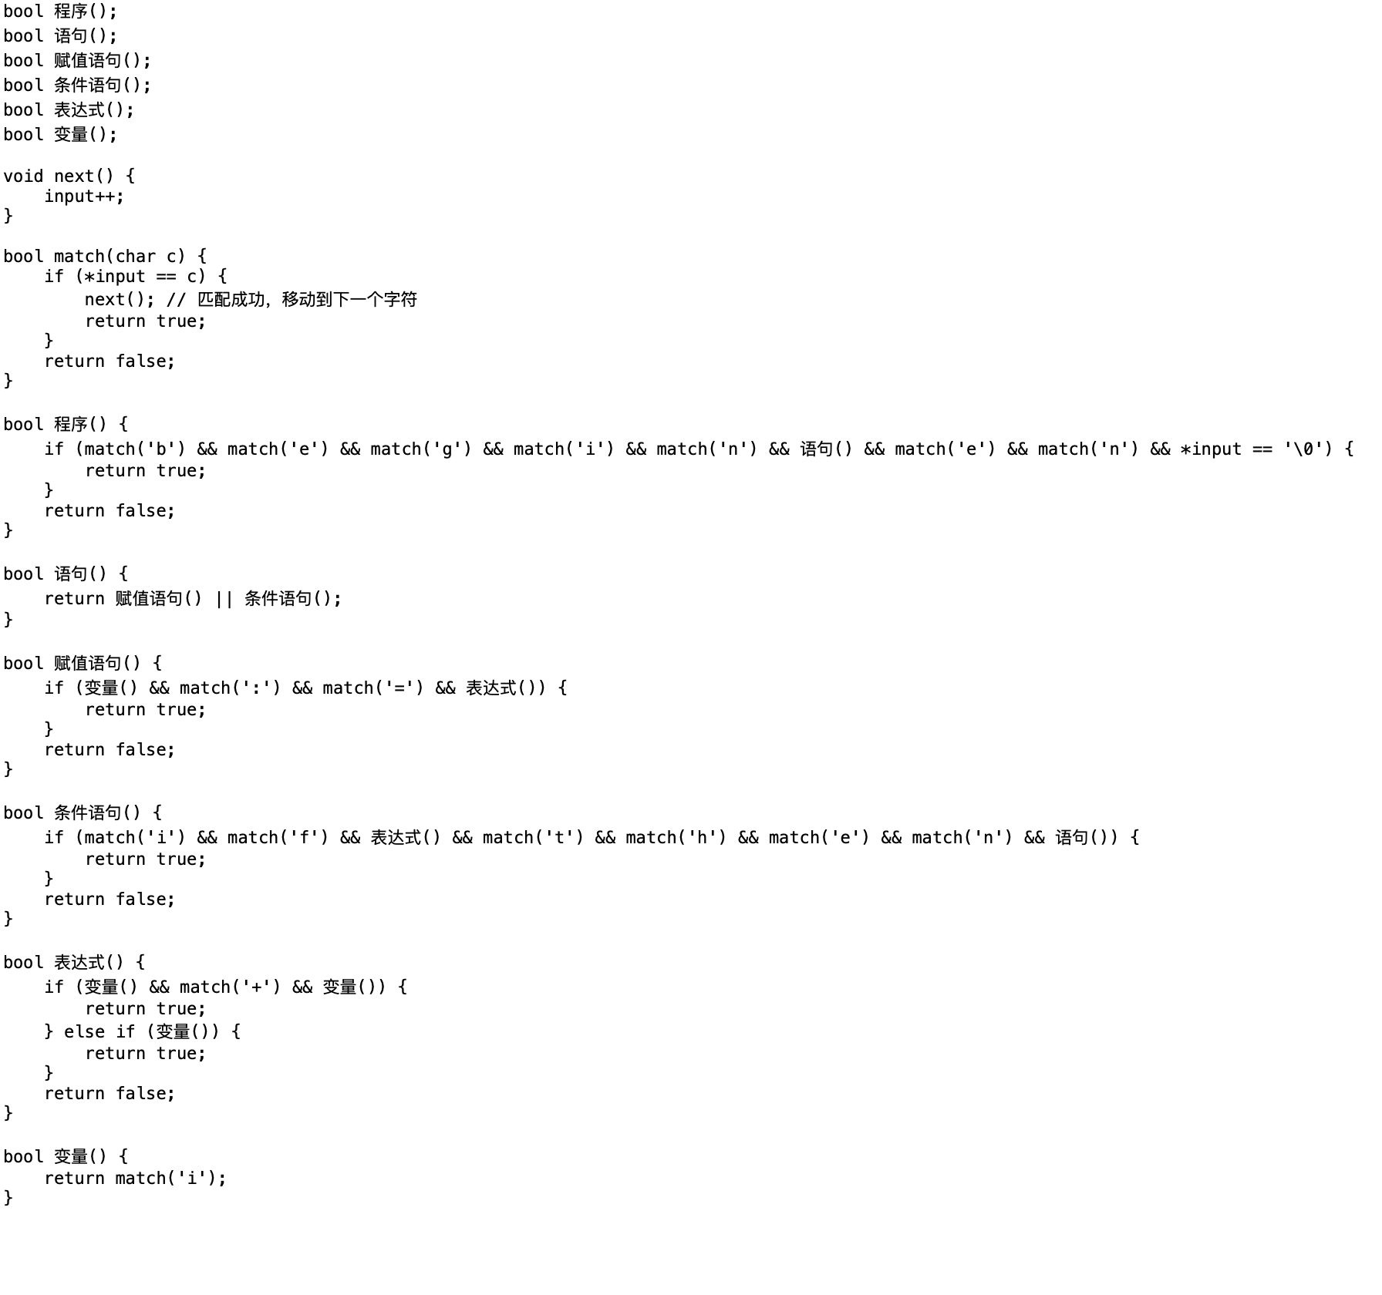

4-4:

FISRT(S) = {a,b,e} FIRST(A)={a,e} FIRST(B) = {b,e}

FOLLOW(S)={#} FOLLOW(A)={b,#} FOLLOW(B)={#}

4-8:

更改的文法如下：  
S->AbS'|bS'

S'->bS'|e

A->aA'

A'->aA'|e

first和follow集：

FISRT(S)={a,b,e}

FISRT(S`)={b,e}

FISRT(A)={a}

FISRT(A`)={a,e}

FOLLOW(S)={b,#}

FOLLOW(S`)={b,#}

FOLLOW(A)={b,#}

FOLLOW(A`)={b,#}

LL(1)表格如下所示：

|  |  |  |  |  |
| --- | --- | --- | --- | --- |
|  | a | b | e | # |
| S | S->AbS` | S->bS` | S->bS` | - |
| S` | - | S`->bS` | S`->e | S`->e |
| A | A->aA` | - | - | - |
| A` | - | A`->aA` | A`->e | A`->e |

4-9:

FIRST(S)={b}

FIRST(A)={a,b}

FIRST(B)={a,b}

FOLLOW(S)={#,a,c}

FOLLOW(A)={c}

FOLLOW(B)={#,a,c}

修改文法如下：

S->bBS`

S`->aBS`|e S -> bB A->S A->a B->Ac

4-13:

列表如下：

|  |  |  |  |  |
| --- | --- | --- | --- | --- |
|  | S | A | / | A |
| S |  |  | = > | > |
| A | = | < |  | = |
| / |  |  | < | > |
| a |  |  | > | > |

A与/之间同时有两种关系，为‘=’和‘>’故此不是简单优先文法

4-20:

文法如下：

S->E

E->E-T|T

T->T*F|F

F->-P|P  
P->(E)|i

FIRSTVT和LASTVT：

|  |  |  |
| --- | --- | --- |
|  | FIRSTVT | LASTVT |
| S | {-,*,(,i} | {-,*,),i} |
| E | {-,*,(,i} | {-,*,),i} |
| T | {-,*,(,i} | {-,*,),i} |
| F | {-(,i} | {-,),i} |
| P | {(,i} | {),i} |

算符优先文法：

|  |  |  |  |  |  |  |
| --- | --- | --- | --- | --- | --- | --- |
|  | - | * | （ | ） | i | # |
| - | \ | > | > | < | > | \ |
| * | < | > | > | < | > | \ |
| ( | < | < | = | < | = | \ |
| ) | \ | > | \ | \ | > | \ |
| i | < | < | \ | \ | \ | \ |
| # | < | < | \ | \ | \ | = |

观察上述矩阵，可以发现符号之间的优先关系并不总是唯一确定的。在某些情况下存在无法比较的情况（\），这意味着无法确定这些符号之间的优先级关系。那么就不是合格的算符优先文法

更改后的文法如下：  
S->E

1. >E-X | X

X-> TX` | T

X` -> - TX`|e

T->FT`|F

T`->*FT`|e

1. >-P|P
2. >(E)|i

4-31:

文法如下：  
E->E+T | T  
T->T*F|F

F->P↑ F | P

P->(E)|i

FIRSTVT和LASTVT如下：

|  |  |  |
| --- | --- | --- |
|  | FIRSTVT | LASTVT |
| E | {+,*,↑,(,i} | {+,*,↑,),i} |
| T | {*,↑,(,i} | {*,↑,),i} |
| F | {↑,(,i} | {↑,),i} |
| P | {(,i} | {),i} |

优先矩阵：

|  |  |  |  |  |  |  |  |
| --- | --- | --- | --- | --- | --- | --- | --- |
|  | + | * | ↑ | ( | ) | i | # |
| + | \ | < | < | < | > | < | < |
| * | \ | \ | < | < | > | < | < |
| ↑ | \ | \ | \ | < | > | < | < |
| ( | < | < | < | < | = | < | \ |
| ) | \ | \ | \ | \ | \ | \ | \ |
| i | \ | \ | \ | < | > | \ | \ |
| # | < | < | < | < | \ | < | \ |

矩阵线性化后结果为：

稳定状态闭包为：

|  |  |  |  |  |  |  |  |
| --- | --- | --- | --- | --- | --- | --- | --- |
|  | + | * | ↑ | （ | ） | i | # |
| + | \ | < | < | < | > | < | < |
| * | \ | \ | < | < | > | < | < |
| ↑ | \ | \ | \ | < | > | < | < |
| ( | < | < | < | < | = | < | \ |
| ) | \ | \ | \ | \ | \ | \ | \ |
| i | \ | \ | \ | < | > | \ | \ |
| # | < | < | < | < | \ | < | \ |

可得线性序列为：（ ， ↑，+，*，），i，#

4—33:给出优先矩阵如下：

|  |  |  |  |  |
| --- | --- | --- | --- | --- |
|  | [ | ] | a | # |
| [ | > | = | \ | \ |
| ] | > | \ | \ | > |
| a | > | > | < | \ |
| # | < | < | < | \ |

使用bell方法求优先函数如下所示：

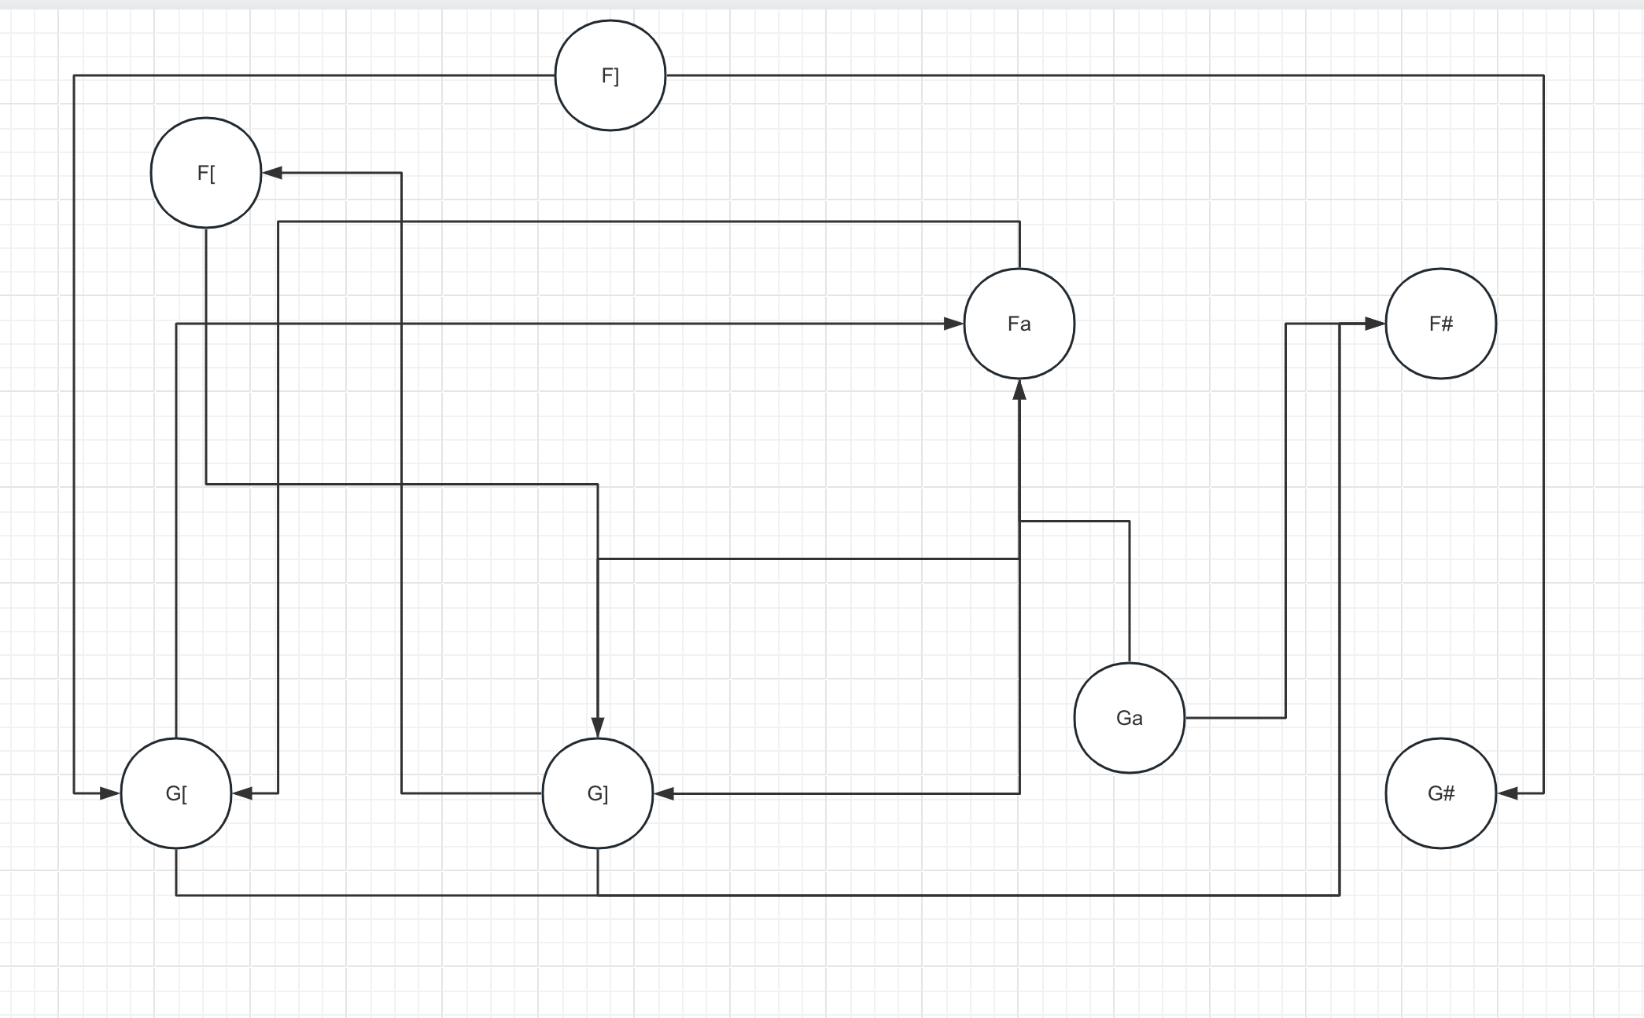

可列表格如下所示：

|  |  |  |  |  |
| --- | --- | --- | --- | --- |
|  | [ | ] | a | # |
| f | 5 | 7 | 5 | 1 |
| g | 5 | 5 | 6 | 1 |

文法不是算符优先文法，不可线性化

4-35:

识别活前缀DFA如下所示：  
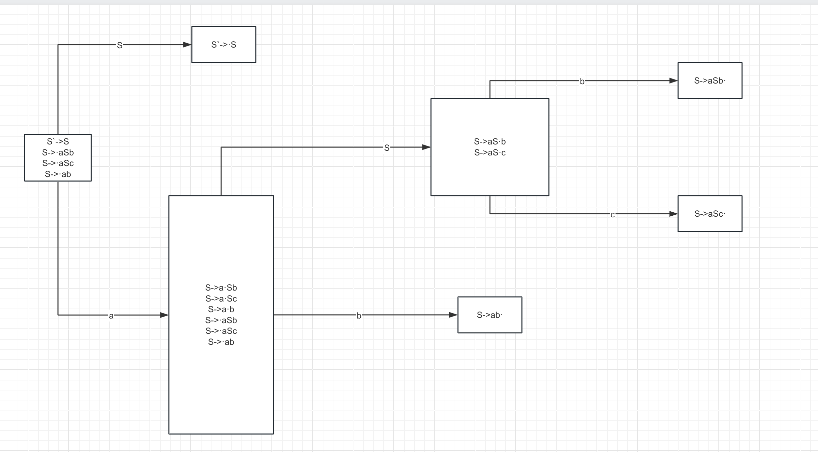

4-36:

1. 是LR（0）文法，SLR（1）分析表如下所示：

|  |  |  |  |  |  |
| --- | --- | --- | --- | --- | --- |
|  | ACTION | | | | GOTO |
|  | a | b | c | # | S |
| 0 | S2 | \ | \ | \ | 1 |
| 1 | \ | \ | \ | ACC | \ |
| 2 | S2 | S4 | \ | \ | 3 |
| 3 | \ | S5 | S6 | \ | \ |
| 4 | \ | R3 | R3 | R3 | \ |
| 5 | \ | R1 | R1 | R1 | \ |
| 6 | \ | R2 | R2 | R2 | \ |

4-**38:**识别活前缀DFA如下所示：

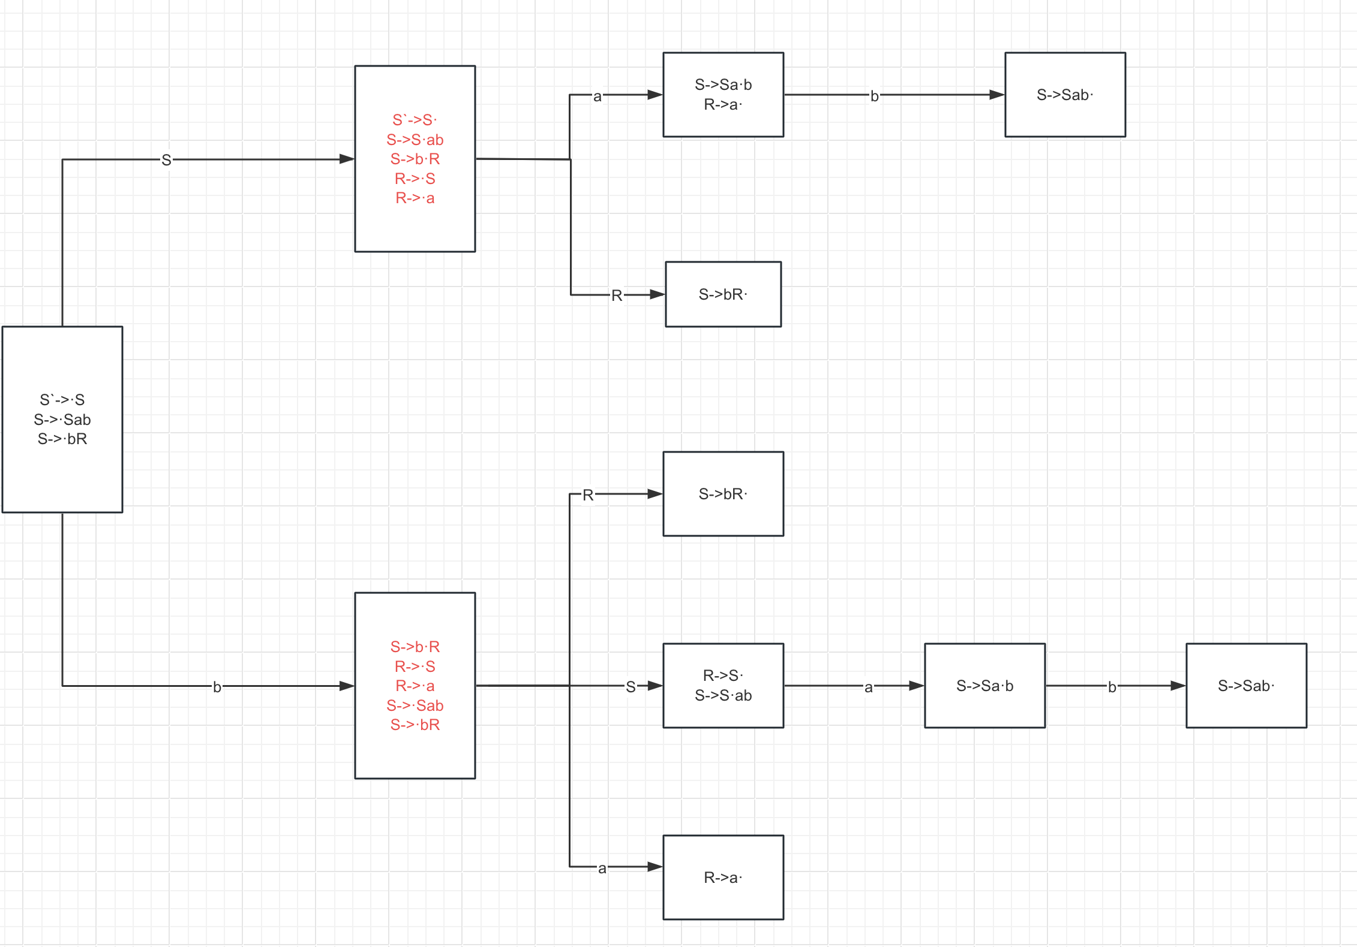

如上图所示，同时有移进和规约项目，SLR（1）规则不能解决冲突，故此不是SLR（1）文法