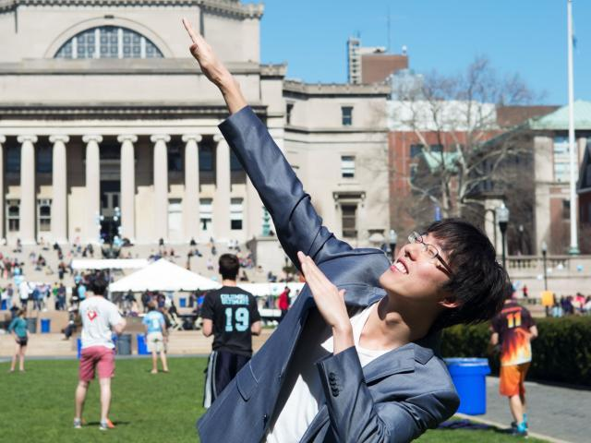

Jackson Lu (陆冠南)

Ph.D. Candidate

Organizational Behavior, Columbia Business School

Doctoral Fellow, Center on Japanese Economy and Business

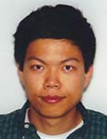

Ji Liu (刘骥)

M.A. Candidate 2015

Department of International & Intercultural Studies Teachers College

[jl4103@tc.columbia.edu](mailto:jl4103@tc.columbia.edu)

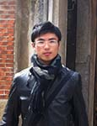

Handong Ma (马汉东)

M.A. Candidate 2015

Department of Biomedical Informatics

 Graduate School of Arts and Sciences

[handongma.work@gmail.com](mailto:handongma.work@gmail.com)



Ran An (安然)

M.A. Candidate 2015

Department of Arts and Humanities

Teachers College

anran0201@gmail.com



Zhixian Yu (俞至諴)

Master Candidate, 2015

International Education Development

Teachers College

[Zy2183@tc.columbia.edu](mailto:Zy2183@tc.columbia.edu)



Li Jing (李靖)

EMPA 2015

School of International and Public Affairs, Columbia University

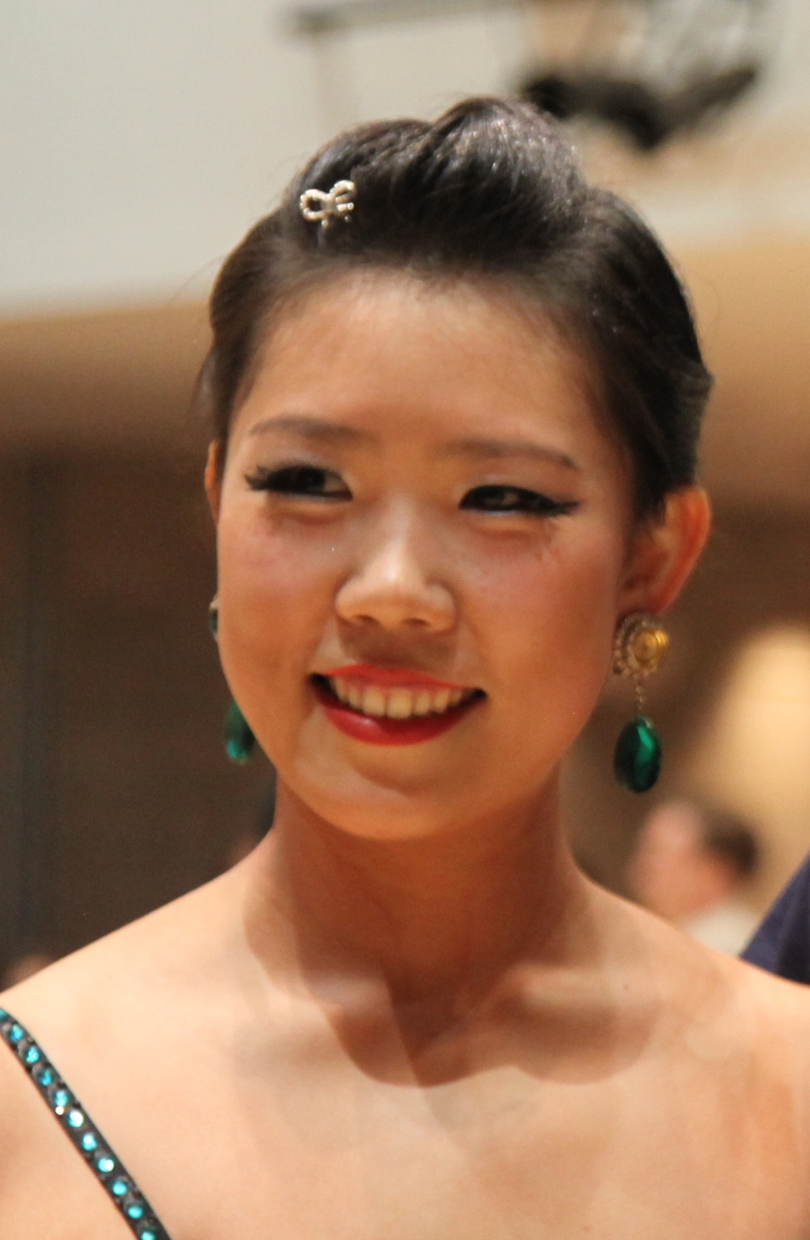

Fei Bo （薄菲）

Master 2015

Public Administration

School of International and Public Affairs