HOUSEPRICEAI: MACHINE-LEARNING-BASED CALIFORNIA HOUSE PRICE PREDICTION AND ANALYTICS DASHBOARD
A PROJECT REPORT
Submitted by
SK TOUFIQUE (24BCD10154)
in partial fulfillment for the award of the degree of
BACHELOR OF COMPUTER APPLICATIONS (HONS.)
IN
DATA SCIENCE

Chandigarh University
NOVEMBER 2026

BONAFIDE CERTIFICATE
Certified that this project report “HOUSEPRICEAI: MACHINE-LEARNING-BASED CALIFORNIA HOUSE PRICE PREDICTION AND ANALYTICS DASHBOARD” is the bonafide work of “SK TOUFIQUE (UID: 24BCD10155, Section: 24BCD3B)” who carried out the project work under my supervision.

<<Signature of the HoD>>  SIGNATURE | <<Signature of the Supervisor>>  SIGNATURE
<<Name of the Head of the Department>>  HEAD OF THE DEPARTMENT  <<Department>> | <<Name of the Supervisor>>  SUPERVISOR  <<Academic Designation>>  <<Department>>
Submitted for the project viva-voce examination held on ______________________
INTERNAL EXAMINER | EXTERNAL EXAMINER

TABLE OF CONTENTS
List of Figures 4
List of Tables 5
List of Standards 6
ABSTRACT 7
GRAPHICAL ABSTRACT 8
ABBREVIATIONS 9
SYMBOLS 10
CHAPTER 1. INTRODUCTION 11
1.1. Identification of Client / Need / Relevant Contemporary issue 11
1.2. Identification of Problem 11
1.3. Identification of Tasks 12
1.4. Timeline 12
1.5. Organization of the Report 13
CHAPTER 2. LITERATURE REVIEW / BACKGROUND STUDY 14
2.1. Timeline of the reported problem 14
2.2. Existing solutions 14
2.3. Bibliometric analysis 15
2.4. Review Summary 15
2.5. Problem Definition 16
2.6. Goals/Objectives 16
CHAPTER 3. DESIGN FLOW / PROCESS 17
3.1. Evaluation & Selection of Specifications/Features 17
3.2. Design Constraints 17
3.3. Analysis of Features and finalization subject to constraints 18
3.4. Design Flow 18
3.5. Design selection 19
3.6. Implementation plan/methodology 20
CHAPTER 4. RESULTS ANALYSIS AND VALIDATION 22
4.1. Implementation of solution 22
CHAPTER 5. CONCLUSION AND FUTURE WORK 28
5.1. Conclusion 28
5.2. Future work 28
REFERENCES 30
APPENDIX 32
1. Plagiarism Report 32
2. Design Checklist 32
USER MANUAL 33

List of Figures
Figure 1.1: Gantt chart of the project timeline 13
Figure 3.1: Layered architecture of the HousePriceAI system (Design B) 19
Figure 3.2: Flowchart of the training methodology 20
Figure 4.1: Distribution of the median house value 23
Figure 4.2: Pearson correlation matrix of features and target 23
Figure 4.3: Geographic distribution of block groups coloured by median value 23
Figure 4.4: MAE and RMSE of the three models 24
Figure 4.5: Comparison of standardised coefficients 25
Figure 4.6: Actual versus predicted values on the test set (Ridge) 26
Figure 4.7: Distribution of residuals (Ridge) 26

List of Tables
Table 2.1: Timeline of key developments in house-price modelling 5
Table 2.2: Comparison of existing approaches 5
Table 3.1: Features identified for the solution 5
Table 3.2: Comparison of the alternative designs 5
Table 4.1: Modern tools used in the project 5
Table 4.2: Descriptive statistics of the dataset 5
Table 4.3: Evaluation metrics on the test set 5
Table 4.4: Standardised model coefficients 5
Table 4.5: Functional test plan 5

List of Standards
Standards followed in this project
Standard | Publishing Agency | About the standard | Page no.
PEP 8 | Python Software Foundation | Style guide for Python code covering naming, layout and readability; followed in train_models.py and app.py. | 17
ISO/IEC 25010:2011 | ISO / IEC | Software product quality model (functional suitability, usability, reliability, maintainability, portability) used to set design criteria. | 19
ISO/IEC/IEEE 29148:2018 | ISO / IEC / IEEE | Requirements engineering process; used to structure the objectives and system features. | 17

ABSTRACT
Housing is one of the largest financial commitments for households, and accurate estimates of property value support buyers, sellers, lenders, planners and policy makers. Manual valuation is slow, subjective and difficult to scale, while purely statistical reports are rarely accessible to non-technical users. This project, titled HousePriceAI, applies supervised machine learning to the California Housing dataset, which describes 20,640 census block groups through eight numeric attributes: median income, house age, average rooms, average bedrooms, population, average occupancy, latitude and longitude. The target variable is the median house value of each block group, expressed in units of $100,000.
Three regression algorithms — Linear Regression, Ridge Regression (L2 regularisation, alpha = 1.0) and Lasso Regression (L1 regularisation, alpha = 0.01) — were trained on 80% of the data after standardising the features with a StandardScaler fitted only on the training split. The remaining 20% (4,128 block groups) was used to evaluate the models using Mean Absolute Error (MAE), Root Mean Squared Error (RMSE) and the coefficient of determination (R²). The three models performed very similarly: R² values lie between 0.5759 and 0.5817, with Lasso Regression achieving the lowest RMSE (0.7403) and the highest R² (0.5817). Median income was by far the strongest predictor, followed by the geographic coordinates.
The trained models and the scaler are serialised with Joblib and consumed by an interactive Streamlit dashboard. The dashboard provides an overview page, a price-prediction form that returns estimates from all three models, a model-performance page with actual-versus-predicted and residual plots, a geographic map, a data explorer with a correlation matrix, and a session-level prediction history that can be exported as CSV. The project demonstrates an end-to-end workflow — data understanding, preprocessing, model training, evaluation, persistence and deployment of a user interface — and discusses the limitations of linear models on this dataset, such as the censoring of the target at $500,000 and the neglect of non-linear and spatial interactions.
Keywords: house price prediction, California Housing, linear regression, ridge regression, lasso regression, scikit-learn, Streamlit, data science.

GRAPHICAL ABSTRACT
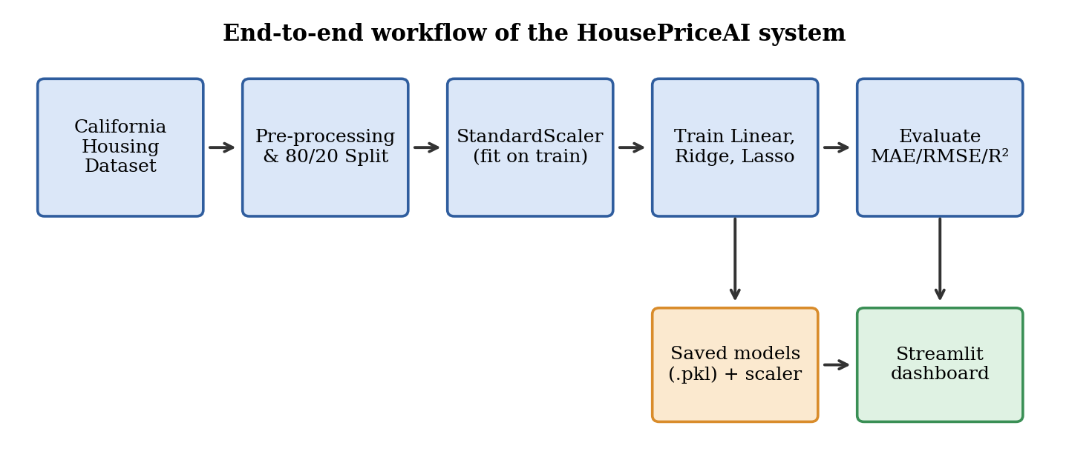
Graphical abstract: workflow from dataset to prediction dashboard
The graphical abstract summarises the pipeline implemented in this project. The California Housing data are pre-processed and split into training and test subsets; features are standardised; three regression models are trained and evaluated; the best-performing artefacts are persisted and finally exposed to the user through an interactive Streamlit dashboard.

ABBREVIATIONS
Table: List of abbreviations used in this report
Abbreviation | Expansion
ML | Machine Learning
MAE | Mean Absolute Error
MSE | Mean Squared Error
RMSE | Root Mean Squared Error
R² | Coefficient of Determination
OLS | Ordinary Least Squares
L1 / L2 | Lasso / Ridge penalty norms
EDA | Exploratory Data Analysis
UI | User Interface
CSV | Comma-Separated Values
PKL | Pickle (serialised Python object file)
API | Application Programming Interface
MedInc | Median Income of the block group
MedHouseVal | Median House Value of the block group
CU | Chandigarh University

SYMBOLS
Table: List of symbols used in this report
Symbol | Meaning
x | Feature vector of one block group (8 elements)
y | Actual median house value (target)
ŷ | Predicted median house value
n | Number of samples in the evaluation set
β | Regression coefficient vector
β₀ | Intercept term
α (alpha) | Regularisation strength of Ridge / Lasso
μ, σ | Feature mean and standard deviation used for standardisation
‖β‖₁, ‖β‖₂ | L1 and L2 norms of the coefficient vector
ȳ | Mean of the actual target values

CHAPTER 1.

INTRODUCTION

1.1. Identification of Client / Need / Relevant Contemporary issue
Housing affordability and fair property valuation are among the most widely discussed economic issues in the world today. California is a particularly important case: according to the 2020 United States Census it is the most populous state in the country with roughly 39.5 million residents, and its housing market is repeatedly described by agencies such as the U.S. Census Bureau and the California Legislative Analyst's Office as one of the most expensive in the United States. Decisions about where to buy, how to price a property, how to underwrite a loan or where to invest in new housing all depend on reliable estimates of property value.
The dataset used in this project illustrates the scale of the issue. Across 20,640 census block groups, the mean median house value is about $206,860, yet values range from about $15,000 to the dataset ceiling of $500,000, and 992 block groups (about 4.8%) are recorded at that ceiling. Such a wide spread shows that value depends strongly on neighbourhood characteristics, and that a simple rule of thumb cannot capture it.
The potential clients for a solution of this kind are real-estate analysts, mortgage and insurance firms, municipal planners, students of data science and prospective home buyers who want a quick, data-driven reference value. The need is justified by three observations:
- Manual appraisals are time-consuming, costly and subjective; an automated baseline estimate can support, but not replace, a professional appraisal.
- Property-value information is usually published as large statistical tables that are hard for non-experts to interpret; an interactive dashboard makes the same information accessible.
- Machine learning is now a standard analytical tool, and a transparent, reproducible example on a well-known public dataset is valuable for learning and for benchmarking more advanced approaches.
Because the project is built on a publicly documented dataset (derived from the 1990 U.S. Census and distributed with scikit-learn), the underlying problem is documented in the academic literature, as discussed in Chapter 2.

1.2. Identification of Problem
The broad problem addressed in this work is that stakeholders lack an accessible, quantitative way to understand how neighbourhood-level characteristics such as income, housing age, occupancy and location relate to the typical value of homes in an area, and to obtain a consistent estimate of that value for a new or hypothetical area.
In particular, three difficulties can be identified: (i) the relationship between the many attributes of a neighbourhood and its housing value is not obvious by inspection; (ii) different statistical techniques give different estimates, and users have no simple means of comparing them; and (iii) the results of technical analyses are rarely delivered in a form that a non-specialist can explore and reuse.

1.3. Identification of Tasks
To resolve the problem the work was divided into the following tasks, which also determine the structure of this report:
- Task 1 — Requirement and domain study: understand the dataset, its attributes and target variable, and review existing approaches to house-price estimation.
- Task 2 — Data understanding and preparation: inspect the data for missing values and outliers, study distributions and correlations, and split the data into training and test sets.
- Task 3 — Model development: standardise the features and train Linear, Ridge and Lasso regression models; persist the models and scaler.
- Task 4 — Evaluation: measure MAE, RMSE and R² on unseen data and analyse residuals and coefficients.
- Task 5 — Application development: design and implement a multi-page Streamlit dashboard that loads the saved artefacts, accepts user input and presents analytics.
- Task 6 — Testing, documentation and presentation: validate the end-to-end behaviour, write the user manual and prepare this report.

1.4. Timeline
The project was planned over ten weeks. The activities, their duration and their overlap are shown as a Gantt chart in Figure 1.1. Model development and dashboard development were deliberately overlapped so that the interface could be tested against real model artefacts as early as possible.
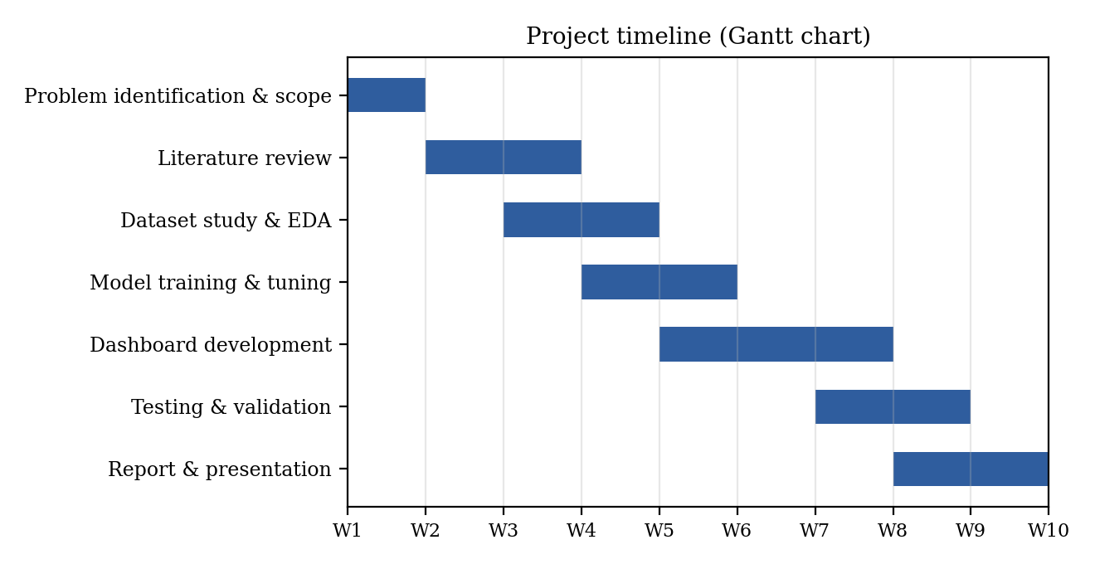
Figure 1.1: Gantt chart of the project timeline

1.5. Organization of the Report
- Chapter 1 — Introduction: presents the need, the problem, the tasks, the timeline and this outline.
- Chapter 2 — Literature Review / Background Study: traces the history of the problem, summarises existing solutions, compares them and defines the problem and objectives.
- Chapter 3 — Design Flow / Process: evaluates features and constraints, compares two alternative designs, selects one and describes the implementation methodology.
- Chapter 4 — Results Analysis and Validation: describes the implementation, the tools used, the exploratory analysis, the model results and their interpretation.
- Chapter 5 — Conclusion and Future Work: summarises the outcome, deviations from expectation and the way ahead.
- References, Appendix and User Manual: list the sources used, supporting checklists and step-by-step instructions for running the project.

CHAPTER 2.

LITERATURE REVIEW / BACKGROUND STUDY

2.1. Timeline of the reported problem
The problem of explaining and predicting property values has been studied for more than five decades. The main milestones relevant to this project are summarised in Table 2.1.
Table 2.1: Timeline of key developments in house-price modelling
Year | Development | Significance
1970 | Hoerl & Kennard introduce ridge regression | Stabilises regression when predictors are correlated
1974 | Rosen proposes the hedonic pricing framework | Value of a house is explained by the value of its attributes
1978 | Harrison & Rubinfeld publish the Boston housing study | Popularises regression on neighbourhood attributes
1996 | Tibshirani introduces the lasso | Adds automatic feature selection through an L1 penalty
1997 | Pace & Barry release the California housing data | Provides a benchmark with spatial information
2001 | Random forests and gradient boosting are proposed | Non-linear ensembles become strong baselines
2011 | Scikit-learn and the Ames housing dataset appear | Open tooling makes reproducible studies easy

The California Housing data used here were derived from the 1990 U.S. Census by Pace and Barry (1997) in their work on sparse spatial autoregressions, and are now distributed as a standard dataset in scikit-learn. They have been used in countless tutorials, textbooks and research papers as a benchmark for regression methods, which provides a rich body of documentation against which the present results can be compared.

2.2. Existing solutions
Earlier solutions to the house-price estimation problem can be grouped into the following families.
- Hedonic regression: ordinary least squares models in which price is regressed on structural and neighbourhood attributes (Rosen, 1974; Harrison & Rubinfeld, 1978). They are simple and interpretable.
- Regularised linear models: Ridge (Hoerl & Kennard, 1970) and Lasso (Tibshirani, 1996) add penalties that control variance and, for the lasso, perform feature selection.
- Spatial econometric models: spatial autoregressions (Pace & Barry, 1997) explicitly model the dependence between nearby locations.
- Tree ensembles: random forests (Breiman, 2001) and gradient boosting (Friedman, 2001) capture non-linearities and interactions automatically and often give the best accuracy on tabular data.
- Neural networks: multilayer perceptrons and, more recently, models that combine images or text with tabular data; these require more data, tuning and computing resources.
- Commercial automated valuation models: proprietary systems used by portals and lenders; they combine many data sources but are not open to inspection.

2.3. Bibliometric analysis
Table 2.2 compares the families of solutions on the basis of their key features, effectiveness and drawbacks, drawing on the cited literature and on the widely reported behaviour of these methods on the California Housing benchmark.
Table 2.2: Comparison of existing approaches
Approach | Key features | Effectiveness | Drawbacks
Hedonic OLS | Linear, closed-form, interpretable coefficients | Good baseline; explains a moderate share of variance | Assumes linearity; sensitive to correlated features
Ridge | L2 penalty shrinks coefficients | Similar accuracy to OLS; more stable | Does not remove features; limited by linearity
Lasso | L1 penalty can zero out coefficients | Comparable accuracy; simpler model | May discard correlated but useful features
Spatial autoregression | Models neighbour dependence | Strong when location effects dominate | Needs spatial weights; heavier computation
Random forest / boosting | Non-linear, handles interactions | Typically the highest accuracy | Less interpretable; larger models; tuning required
Neural networks | Flexible function approximators | Strong with large, multi-modal data | Data-hungry; opaque; costly to train

2.4. Review Summary
The review shows that linear models remain the most transparent way to relate house value to its determinants, and that regularisation provides a principled way to control model complexity. Non-linear ensembles can achieve higher accuracy but at the cost of interpretability. For an educational and demonstration project whose aim is to compare algorithms transparently and deliver them through an interface, a comparison of Linear, Ridge and Lasso regression is therefore well justified: the models are fast to train, easy to explain, and expose how each feature influences the prediction. The review also highlights a gap — many published examples stop at a printed score and do not provide a reusable, interactive application — which this project addresses.

2.5. Problem Definition
The problem addressed is to develop a reproducible machine-learning pipeline that predicts the median house value of a California census block group from eight neighbourhood attributes, compares three regression algorithms using standard error metrics, and exposes the trained models through an interactive web dashboard.
What is to be done: train and evaluate Linear, Ridge and Lasso regression models; persist them; build a dashboard for prediction, comparison and exploration.
How it is to be done: using Python, scikit-learn for modelling, Joblib for persistence, and Streamlit with Plotly for the interface.
What is not to be done: the system is not a professional appraisal tool; it does not predict the price of an individual property, does not use data after 1990, and does not attempt to implement non-linear or spatial models in this phase.

2.6. Goals/Objectives
The following specific, measurable objectives were set for the project:
- To perform exploratory analysis of the California Housing dataset and identify the features most strongly associated with house value.
- To train Linear, Ridge and Lasso regression models using an 80/20 train–test split with a fixed random seed (42) for reproducibility.
- To evaluate each model on unseen data using MAE, RMSE and R², and to identify the best-performing model.
- To save the fitted scaler and models to disk so that the application applies exactly the same preprocessing as during training.
- To develop a Streamlit dashboard with at least six pages that supports prediction, performance comparison, geographic exploration and data inspection.
- To validate the dashboard by checking input ranges, model loading errors and the consistency of predictions with the offline evaluation.

CHAPTER 3.

DESIGN FLOW / PROCESS

3.1. Evaluation & Selection of Specifications/Features
The literature and the nature of the dataset suggest the list of specifications in Table 3.1. They are divided into data features (inputs to the model) and system features (capabilities of the application).
Table 3.1: Features identified for the solution
No. | Feature | Type | Description
1 | Median income (MedInc) | Data | Median household income of the block group in $10,000s; strongest predictor
2 | House age (HouseAge) | Data | Median age of houses in years
3 | Average rooms (AveRooms) | Data | Average number of rooms per household
4 | Average bedrooms (AveBedrms) | Data | Average number of bedrooms per household
5 | Population | Data | Number of residents in the block group
6 | Average occupancy (AveOccup) | Data | Average household size
7 | Latitude / Longitude | Data | Location of the block group
8 | Feature scaling | System | Standardisation using a saved scaler
9 | Multiple models | System | Linear, Ridge and Lasso regression for comparison
10 | Prediction form | System | Validated numeric input and instant estimates
11 | Performance analytics | System | MAE, RMSE, R², actual-vs-predicted and residual plots
12 | Geographic and data exploration | System | Map, histograms, correlation matrix, statistics
13 | Prediction history and export | System | Session history downloadable as CSV

3.2. Design Constraints

3.2.1. Standards
The design follows the following standards and conventions: PEP 8 for Python code style; ISO/IEC 25010:2011 for software quality characteristics (functional suitability, usability, reliability, maintainability and portability); and ISO/IEC/IEEE 29148:2018 for the structuring of requirements. These are listed in the List of Standards at the beginning of this report.

3.2.2. Other constraints
- Regulations and ethics: the dataset is public and aggregated at block-group level; no personal data are processed. The application displays a warning that estimates are not appraisals, avoiding misuse in financial or legal decisions.
- Economic and cost: only free, open-source software (Python, scikit-learn, Streamlit, Plotly) is used and the application runs on an ordinary laptop, so no licence or hardware cost is incurred.
- Environmental and health: training takes seconds on a CPU, so energy consumption is negligible; the interface uses a readable colour scheme and large controls.
- Safety and security: all inputs are bounded numeric fields, so malformed input cannot reach the model; models are loaded only from a local folder.
- Social and political: the data reflect 1990 conditions and aggregated areas; predictions must not be used to make decisions about individuals or communities.
- Manufacturability / maintainability: code is split into a training script and an application script, so models can be retrained without modifying the interface.
- Technical: the target is capped at $500,000 and the features are heavy-tailed, which limits the accuracy of linear models; Mapbox tokens are not available, so a Plotly geographic projection is used instead of tile maps.

3.3. Analysis of Features and finalization subject to constraints
In the light of the constraints, the feature list was revised as follows. The feature scaling step was made mandatory and the scaler is saved with the models, because a mismatch between training and serving preprocessing is a common source of silent errors. Complex features such as neural networks, spatial autoregression and ensemble models were removed from the scope of this phase because of time and interpretability constraints and are listed as future work. Input bounds were added to the prediction form (for example latitude 32–42, longitude −125 to −114) to keep inputs inside the range seen during training. A disclaimer was added to every prediction page, and the geographic page was changed from tile maps to a built-in projection to avoid external dependencies. A session-based history with CSV export was retained because it is inexpensive and valuable for validation.

3.4. Design Flow
Two alternative designs were considered for the system.

Design A — Notebook-based analysis
In this design the entire workflow is carried out in a Jupyter notebook: data loading, training, evaluation and plotting. Models are retrained each time the notebook is executed, and results are shown as static tables and charts. Stakeholders who wish to obtain a prediction must edit code cells.

Design B — Modular training script with Streamlit dashboard
In this design the workflow is separated into two parts. An offline script (train_models.py) loads the data, splits it, fits the scaler and the three models, evaluates them and saves the artefacts with Joblib. A separate Streamlit application (app.py) loads the saved artefacts, applies the same scaler to user input, and presents seven pages of analytics. The architecture of Design B is shown in Figure 3.1.
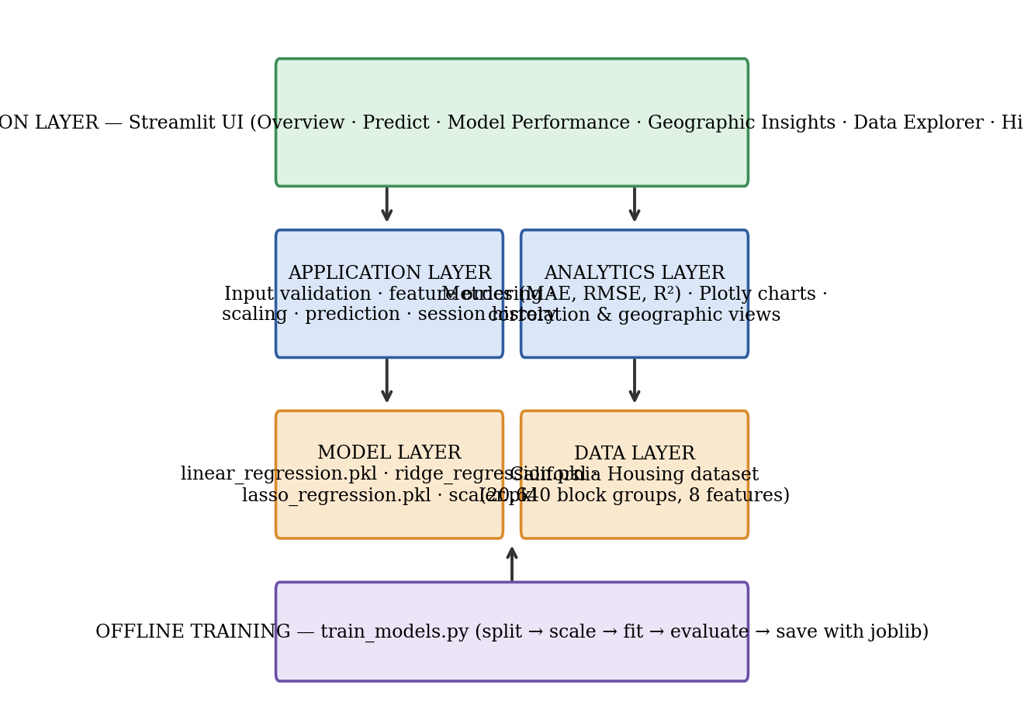
Figure 3.1: Layered architecture of the HousePriceAI system (Design B)

3.5. Design selection
The two designs were compared against criteria derived from the objectives (Table 3.2). Each criterion was rated from 1 (poor) to 5 (excellent).
Table 3.2: Comparison of the alternative designs
Criterion | Design A: Notebook | Design B: Script + Dashboard
Usability for non-programmers | 1 | 5
Reproducibility of preprocessing | 3 | 5
Speed of prediction at run time | 2 | 5
Ease of comparing models visually | 3 | 5
Maintainability / modularity | 2 | 4
Development effort | 5 | 3
Total (out of 30) | 16 | 27

Design B scores clearly higher. Although it requires more development effort, it separates training from serving, guarantees that the same scaler is used at prediction time, loads in seconds because models are not retrained, and presents the results in a form that non-programmers can use. Design B was therefore selected.

3.6. Implementation plan/methodology
The methodology of the selected design is shown as a flowchart in Figure 3.2 and is described step by step below.
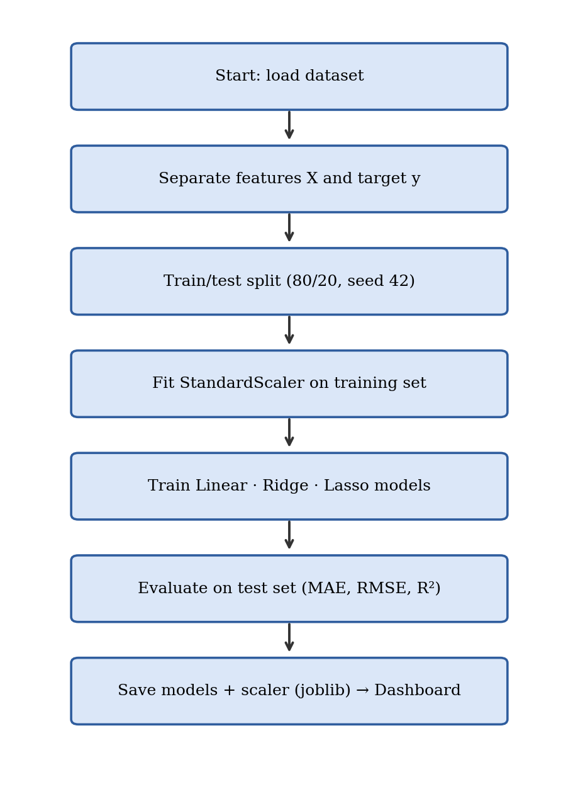
Figure 3.2: Flowchart of the training methodology
- Step 1 — Load data: fetch_california_housing(as_frame=True) returns a DataFrame with the eight features and the target MedHouseVal.
- Step 2 — Separate features and target: X contains all columns except MedHouseVal; y contains MedHouseVal.
- Step 3 — Split: train_test_split with test_size = 0.2 and random_state = 42 yields 16,512 training and 4,128 test samples.
- Step 4 — Scale: StandardScaler is fitted on the training features only and applied to the test features, which prevents information leakage; the scaler is saved to models/scaler.pkl.
- Step 5 — Train: LinearRegression(), Ridge(alpha=1.0) and Lasso(alpha=0.01, max_iter=10000) are fitted on the scaled training data.
- Step 6 — Evaluate: predictions on the scaled test data are compared with the true values using MAE, RMSE (the square root of MSE) and R².
- Step 7 — Persist: each model is saved with joblib.dump under a file name derived from its name, for example ridge_regression.pkl.
- Step 8 — Serve: app.py loads the models with caching, applies the scaler to user input in the training feature order, multiplies predictions by 100,000 to obtain dollars and renders the results.

Mathematical background
Linear regression estimates the coefficient vector β by minimising the sum of squared errors, ŷ = β₀ + β₁x₁ + … + β₈x₈. Ridge regression adds an L2 penalty, minimising Σ(y − ŷ)² + α‖β‖₂², which shrinks coefficients towards zero but never exactly to zero. Lasso regression adds an L1 penalty, α‖β‖₁, which can set some coefficients exactly to zero and thus performs feature selection. The evaluation metrics are MAE = (1/n)Σ|y − ŷ|, RMSE = √((1/n)Σ(y − ŷ)²) and R² = 1 − Σ(y − ŷ)² / Σ(y − ȳ)².

CHAPTER 4.

RESULTS ANALYSIS AND VALIDATION

4.1. Implementation of solution

4.1.1. Tools and technologies
Table 4.1: Modern tools used in the project
Purpose | Tool
Programming language | Python 3
Data handling | Pandas, NumPy
Modelling and metrics | Scikit-learn (LinearRegression, Ridge, Lasso, StandardScaler, metrics)
Model persistence | Joblib
Interactive visualisation | Plotly Express and Plotly Graph Objects
Web application | Streamlit
Static figures for the report | Matplotlib
Environment | Windows machine with a local Python environment
Report preparation | Microsoft Word compatible document

4.1.2. Dataset description and exploratory analysis
The dataset contains 20,640 rows and nine columns (eight features and the target). Table 4.2 gives descriptive statistics. Several features are strongly right-skewed: for example the maximum average number of rooms per household is about 142 and the maximum average occupancy is more than 1243, indicating block groups with unusual compositions such as hotels or institutions. The target is capped at 5.0 (that is, $500,000).
Table 4.2: Descriptive statistics of the dataset
Variable | Mean | Std. dev. | Min | Median | Max
MedInc | 3.871 | 1.900 | 0.500 | 3.535 | 15.000
HouseAge | 28.640 | 12.586 | 1.000 | 29.000 | 52.000
AveRooms | 5.429 | 2.474 | 0.846 | 5.229 | 141.9
AveBedrms | 1.097 | 0.474 | 0.333 | 1.049 | 34.067
Population | 1425.5 | 1132.5 | 3.000 | 1166.0 | 35682.0
AveOccup | 3.071 | 10.386 | 0.692 | 2.818 | 1243.3
Latitude | 35.632 | 2.136 | 32.540 | 34.260 | 41.950
Longitude | -119.6 | 2.003 | -124.3 | -118.5 | -114.3
MedHouseVal | 2.069 | 1.154 | 0.150 | 1.797 | 5.000

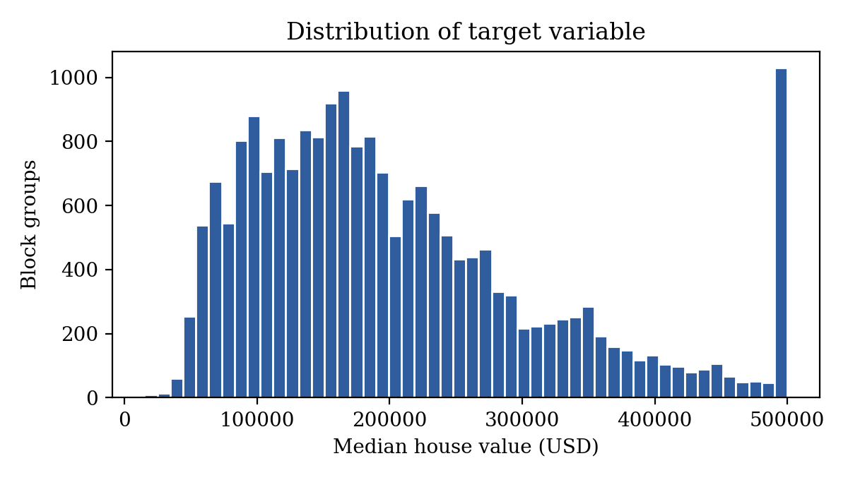
Figure 4.1: Distribution of the median house value
Figure 4.1 shows that the target distribution is right-skewed with a visible spike at $500,000, where 992 block groups are censored. A linear model cannot represent this ceiling, which partly explains the residual structure discussed later. The dataset has no missing values in its original scikit-learn form, which the dashboard's Data Explorer page confirms.
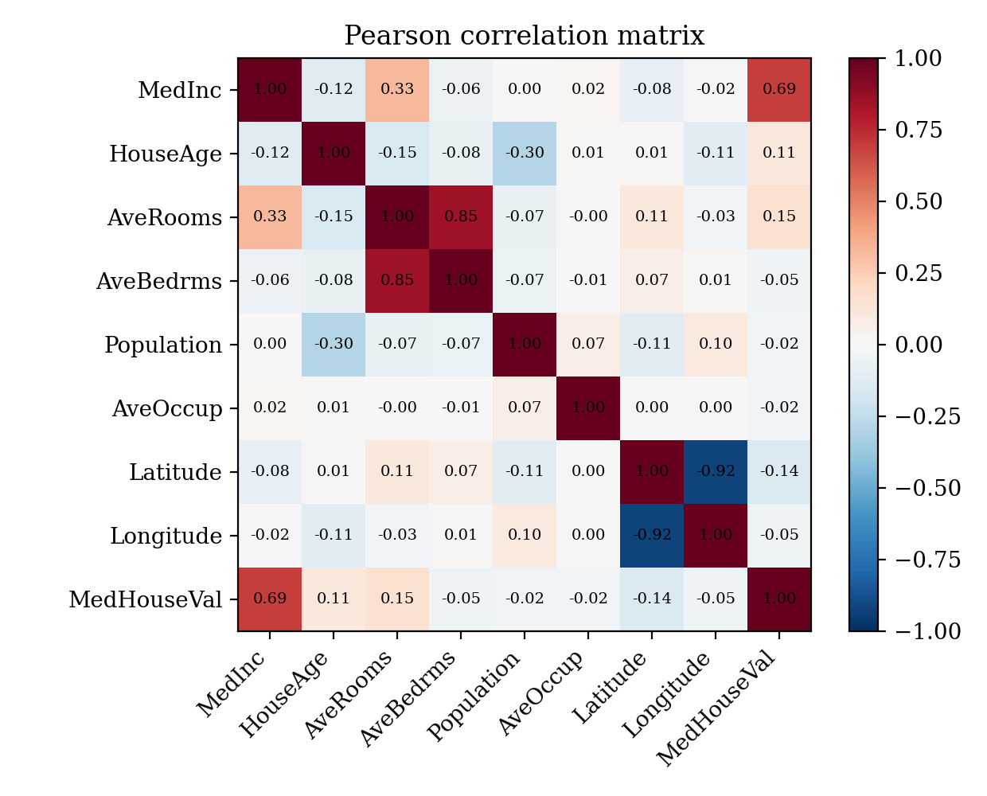
Figure 4.2: Pearson correlation matrix of features and target
The correlation analysis in Figure 4.2 shows that median income has by far the strongest linear relationship with house value (r = 0.69). Average rooms (0.15), house age (0.11) and latitude (-0.14) show weaker relationships, while population (-0.02) and average occupancy (-0.02) are almost uncorrelated with value on their own. The geographic distribution of values is shown in Figure 4.3: the highest values are concentrated along the coast, in particular around the San Francisco Bay Area and Southern California.
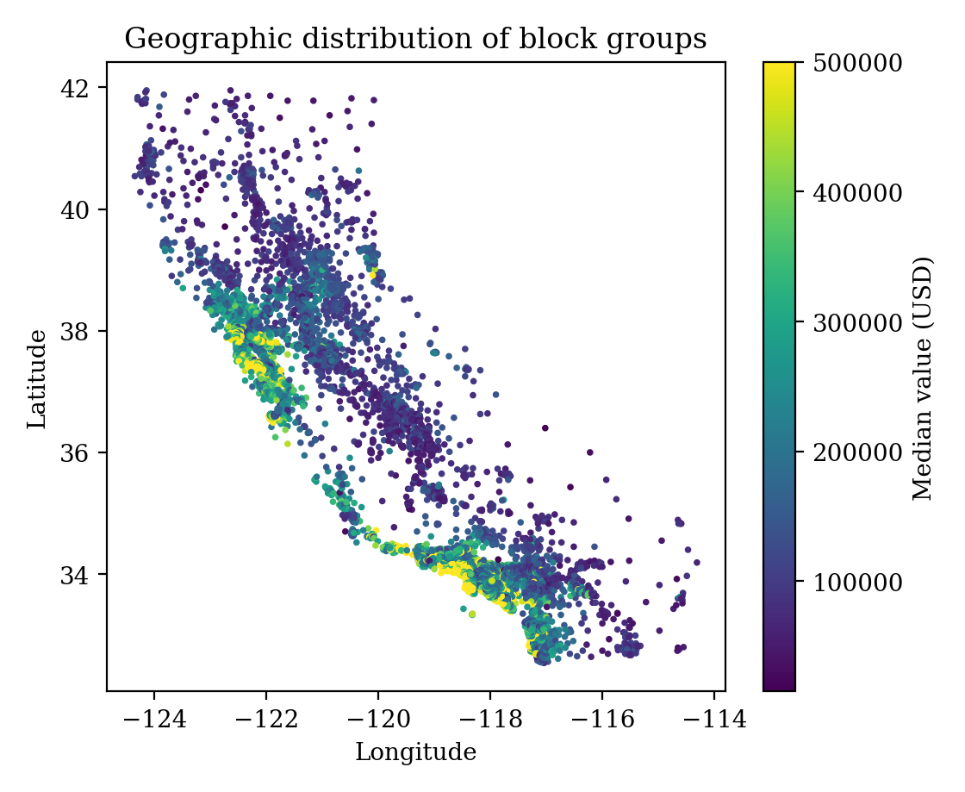
Figure 4.3: Geographic distribution of block groups coloured by median value

4.1.3. Model training and evaluation results
The three models were evaluated on the 4,128 unseen test block groups. The results are given in Table 4.3 and plotted in Figure 4.4. MAE and RMSE are expressed in the target scale (units of $100,000), so an MAE of 0.5335 corresponds to an average absolute error of about $53,355.
Table 4.3: Evaluation metrics on the test set
Model | MAE | RMSE | R² Score
Linear Regression | 0.5336 | 0.7455 | 0.5759
Ridge Regression | 0.5335 | 0.7455 | 0.5759
Lasso Regression | 0.5354 | 0.7403 | 0.5817

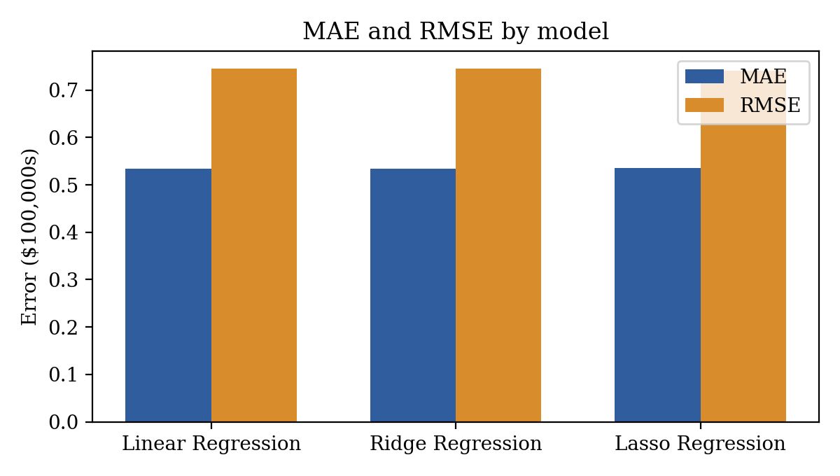
Figure 4.4: MAE and RMSE of the three models
All three models achieve almost the same accuracy. Linear and Ridge regression are practically identical (R² 0.5759 and 0.5759), which is expected because there are many more samples than features and the regularisation strength (alpha = 1.0) is small relative to the scaled data. Lasso regression with alpha = 0.01 obtained the lowest RMSE (0.7403) and the highest R² (0.5817), although its MAE (0.5354) is marginally higher. The differences between the models are small, and approximately 58% of the variance of the median house value is explained by a linear combination of the eight features.

4.1.4. Interpretation of coefficients
Because the features were standardised, the coefficients are directly comparable. Table 4.4 and Figure 4.5 present them.
Table 4.4: Standardised model coefficients
Feature | Linear | Ridge | Lasso
MedInc | 0.8544 | 0.8543 | 0.8010
HouseAge | 0.1225 | 0.1226 | 0.1271
AveRooms | -0.2944 | -0.2942 | -0.1628
AveBedrms | 0.3393 | 0.3390 | 0.2062
Population | -0.0023 | -0.0023 | 0.0000
AveOccup | -0.0408 | -0.0408 | -0.0306
Latitude | -0.8969 | -0.8962 | -0.7901
Longitude | -0.8698 | -0.8691 | -0.7557

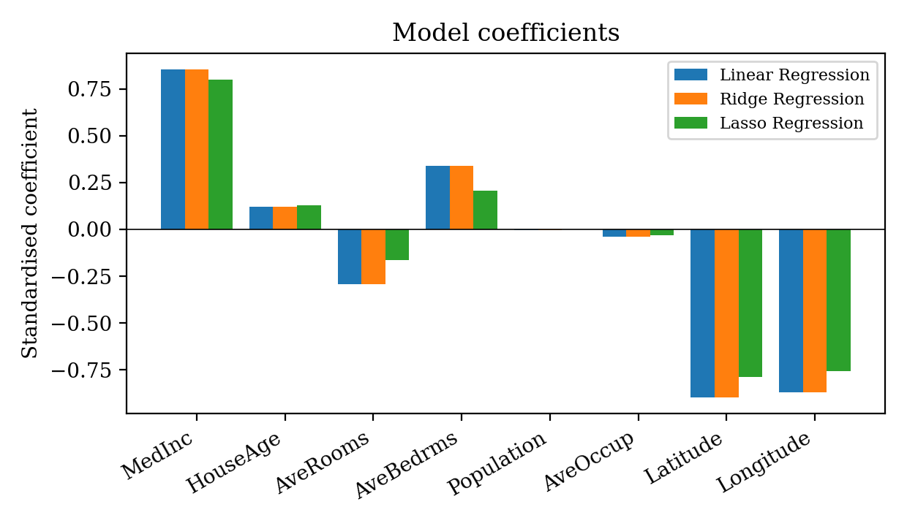
Figure 4.5: Comparison of standardised coefficients
Median income has the largest positive effect (about 0.85 in standardised units), while latitude and longitude have large negative coefficients (about -0.90 and -0.87), reflecting the fact that values fall as one moves north and east away from the expensive coastal areas. Average rooms and average bedrooms have opposite signs, a sign of multicollinearity between them. The Lasso penalty shrinks the coefficients of these correlated variables and reduces the population coefficient to essentially zero, showing that population carries almost no additional linear information once the other variables are known.

4.1.5. Residual analysis
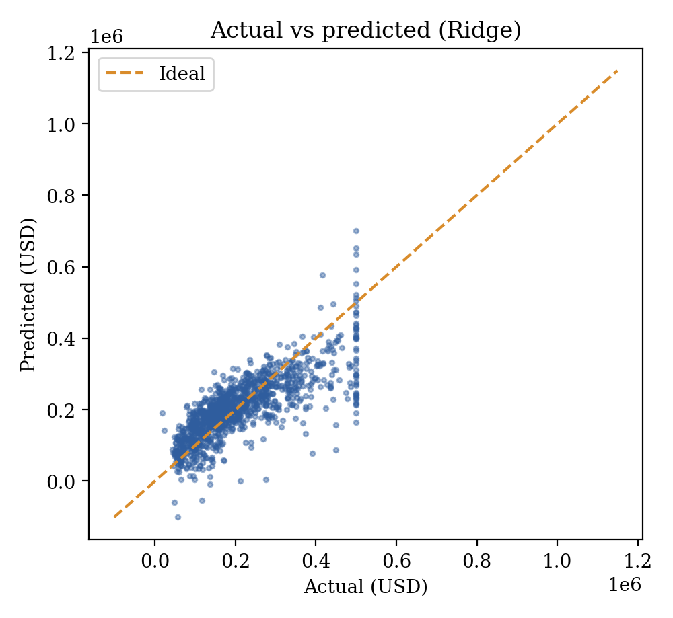
Figure 4.6: Actual versus predicted values on the test set (Ridge)
Figure 4.6 shows that predictions follow the ideal diagonal in the middle of the range but deviate for the cheapest and most expensive block groups; the horizontal band of points at the right edge corresponds to the censored $500,000 observations, for which the model predicts lower values. The residual histogram in Figure 4.7 is centred near zero with a longer right tail, confirming that the model tends to under-predict high-value areas.
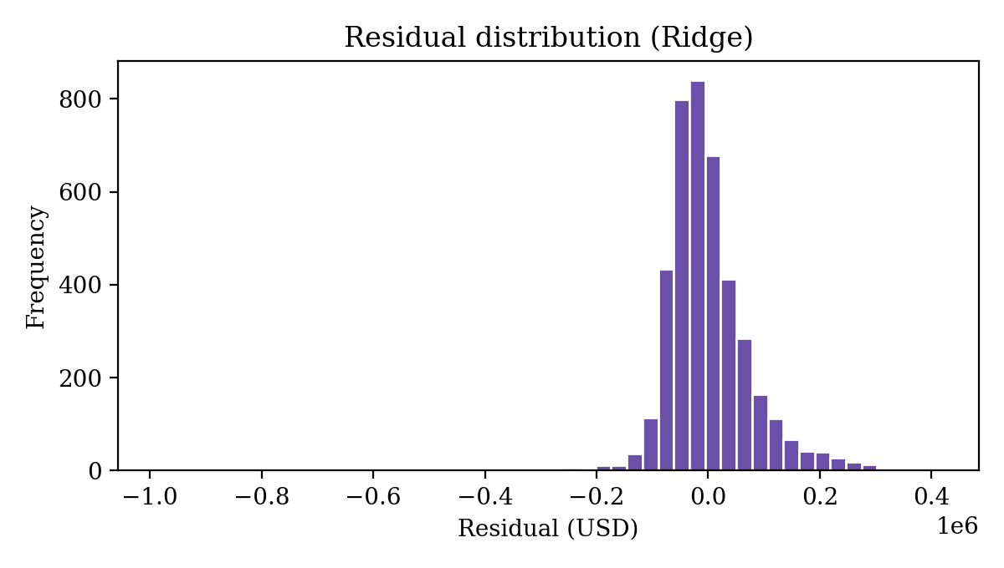
Figure 4.7: Distribution of residuals (Ridge)

4.1.6. Dashboard implementation and validation
The Streamlit application implements seven pages: Overview, Predict House Price, Model Performance, Geographic Insights, Data Explorer, Prediction History and About. The following measures were used to validate it:
- Model-loading check: if any of the model files or the scaler is missing, the application displays an error message instructing the user to run train_models.py instead of crashing.
- Feature-order check: the input DataFrame is constructed with the same column order as used in training, and the saved scaler is applied before prediction.
- Input validation: every numeric input has minimum, maximum and step values, which prevents out-of-range or non-numeric values.
- Consistency check: the Overview and Model Performance pages recompute the metrics from the saved models on the same split (random_state = 42) and show the same values as the training script.
- Session behaviour: each prediction is stored in the session state, can be cleared, and can be exported as CSV.
- Disclaimers: each prediction and the About page remind users that the output is a block-group-level estimate, not an appraisal.
Table 4.5 lists the functional test cases designed for the dashboard, with the expected result of each. The Status column is left blank so that it can be completed after the tests are run on the final build.
Table 4.5: Functional test plan
ID | Test | Expected result | Status
T1 | Start the app with all model files present | Seven pages load; “3 models loaded” shown
T2 | Start the app after deleting a .pkl file | Clear error message; app stops safely
T3 | Predict with default inputs | Three estimates and a bar chart appear
T4 | Enter a value outside the allowed range | Input control prevents or clamps the value
T5 | Make several predictions, open history | All rows listed, newest first
T6 | Download history as CSV | File house_price_prediction_history.csv is produced
T7 | Compare metrics page with training output | MAE, RMSE and R² agree

CHAPTER 5.

CONCLUSION AND FUTURE WORK

5.1. Conclusion
The project successfully delivered an end-to-end solution for house-price estimation on the California Housing dataset. Three linear regression models were trained on a reproducible split, evaluated on unseen data and delivered through an interactive Streamlit dashboard. The expected outcome was a working pipeline in which regularised models perform at least as well as ordinary least squares and the user can obtain and compare predictions; this outcome was achieved. Lasso regression gave the best RMSE (0.7403) and R² (0.5817), while Linear and Ridge regression produced nearly identical results.
The main deviation from the expectation was that regularisation did not give a clear accuracy gain over ordinary least squares. The reason is that the dataset has a large number of samples relative to the number of features and only moderate multicollinearity, so the variance reduction offered by Ridge and Lasso is small. A second deviation is that R² is only about 0.58: the relationship between location, income and value is non-linear and spatial, and the censoring of the target at $500,000 cannot be modelled by a linear function. These limitations are inherent to the choice of linear models and are not defects of the implementation.
From a learning perspective, the project demonstrated the importance of preventing data leakage by fitting the scaler on training data only, of persisting the preprocessing together with the models, and of presenting results in a form that supports exploration. The dashboard makes the work accessible to non-programmers, which was a primary objective.

5.2. Future work
Several directions are suggested for extending the solution:
- Add non-linear models such as Random Forest, Gradient Boosting, XGBoost or LightGBM and compare them with the linear baselines using cross-validation and hyper-parameter search (GridSearchCV or Optuna).
- Engineer additional features such as rooms per person, bedroom ratio, distance to the coast or to major cities, and spatial clusters obtained with k-means on latitude and longitude.
- Handle the censored target explicitly, for example by excluding capped records during training or by using censored-regression techniques.
- Use more recent data (for example current census or listing data) so that the model reflects present-day prices.
- Add model explainability using SHAP values or permutation importance, and display prediction intervals so that users can see the uncertainty.
- Deploy the dashboard on a cloud platform (for example Streamlit Community Cloud), add user authentication and store the prediction history in a database.
- Package the pipeline with automated tests and continuous integration, and monitor data drift if the system were used in production.

REFERENCES
[1] Pace, R. K., & Barry, R. (1997). Sparse spatial autoregressions. Statistics & Probability Letters, 33(3), 291–297.
[2] Pedregosa, F., Varoquaux, G., Gramfort, A., et al. (2011). Scikit-learn: Machine learning in Python. Journal of Machine Learning Research, 12, 2825–2830.
[3] Hoerl, A. E., & Kennard, R. W. (1970). Ridge regression: Biased estimation for nonorthogonal problems. Technometrics, 12(1), 55–67.
[4] Tibshirani, R. (1996). Regression shrinkage and selection via the lasso. Journal of the Royal Statistical Society: Series B, 58(1), 267–288.
[5] Rosen, S. (1974). Hedonic prices and implicit markets: Product differentiation in pure competition. Journal of Political Economy, 82(1), 34–55.
[6] Harrison, D., & Rubinfeld, D. L. (1978). Hedonic housing prices and the demand for clean air. Journal of Environmental Economics and Management, 5(1), 81–102.
[7] Breiman, L. (2001). Random forests. Machine Learning, 45(1), 5–32.
[8] Friedman, J. H. (2001). Greedy function approximation: A gradient boosting machine. The Annals of Statistics, 29(5), 1189–1232.
[9] Hastie, T., Tibshirani, R., & Friedman, J. (2009). The Elements of Statistical Learning (2nd ed.). Springer.
[10] Géron, A. (2019). Hands-On Machine Learning with Scikit-Learn, Keras and TensorFlow (2nd ed.). O’Reilly Media.
[11] McKinney, W. (2010). Data structures for statistical computing in Python. Proceedings of the 9th Python in Science Conference, 56–61.
[12] Harris, C. R., Millman, K. J., van der Walt, S. J., et al. (2020). Array programming with NumPy. Nature, 585, 357–362.
[13] Hunter, J. D. (2007). Matplotlib: A 2D graphics environment. Computing in Science & Engineering, 9(3), 90–95.
[14] Plotly Technologies Inc. (2015). Collaborative data science. Montréal, QC. https://plot.ly
[15] Streamlit Inc. Streamlit documentation. https://docs.streamlit.io
[16] Joblib Developers. Joblib: running Python functions as pipeline jobs. https://joblib.readthedocs.io
[17] De Cock, D. (2011). Ames, Iowa: Alternative to the Boston housing data as an end of semester regression project. Journal of Statistics Education, 19(3).
[18] van Rossum, G., Warsaw, B., & Coghlan, N. (2001). PEP 8 – Style Guide for Python Code. Python Software Foundation.
[19] ISO/IEC 25010:2011. Systems and software engineering — Systems and software Quality Requirements and Evaluation (SQuaRE) — System and software quality models.
[20] ISO/IEC/IEEE 29148:2018. Systems and software engineering — Life cycle processes — Requirements engineering.

APPENDIX

1. Plagiarism Report
The plagiarism report generated by the university-approved similarity-checking tool is to be attached on this page before submission. Report details: similarity index ______ %; date of check ______________; tool used ______________.

2. Design Checklist
Table: Design checklist
No. | Checklist item | Status
1 | Problem statement is clearly defined and free of solution hints | Done
2 | Objectives are specific, measurable and validated | Done
3 | At least two alternative designs were compared | Done
4 | Design selection is supported by criteria and reasons | Done
5 | Standards and design constraints were identified | Done
6 | Training and serving use the same preprocessing | Done
7 | Models evaluated on unseen test data with standard metrics | Done
8 | User inputs validated and failure cases handled | Done
9 | Ethical and social limitations are disclosed in the application | Done
10 | References cited in the report | Done

3. Project Files
Table: Files in the project folder
File / folder | Purpose
train_models.py | Loads data, splits, scales, trains Linear/Ridge/Lasso, evaluates and saves artefacts
app.py | Streamlit dashboard (Overview, Predict, Performance, Geographic, Data Explorer, History, About)
models/scaler.pkl | Fitted StandardScaler
models/linear_regression.pkl | Saved Linear Regression model
models/ridge_regression.pkl | Saved Ridge Regression model
models/lasso_regression.pkl | Saved Lasso Regression model

USER MANUAL
This manual gives the step-by-step instructions needed to run the project on a Windows computer. The illustrations in this section are schematic layouts of the pages; replace them with screenshots from your own run if required by your evaluator.

Step 1: Install Python and the required libraries
Install Python 3.9 or later from python.org (tick “Add Python to PATH”). Open Command Prompt in the project folder and run:
pip install streamlit scikit-learn pandas numpy plotly joblib

Step 2: Train the models
Make sure train_models.py and app.py are in the same folder. Run the training script once. It downloads the dataset through scikit-learn, trains the three models, prints the comparison table and creates the models folder containing four .pkl files.
python train_models.py

Step 3: Start the dashboard
Start the Streamlit server. A browser tab opens automatically at http://localhost:8501; if it does not, open that address manually.
streamlit run app.py

Step 4: Explore the Overview page
The Overview page shows the number of records, the average median value, the top-performing model and the number of predictions made in the current session, followed by a model-performance chart and the correlation of each feature with house value.
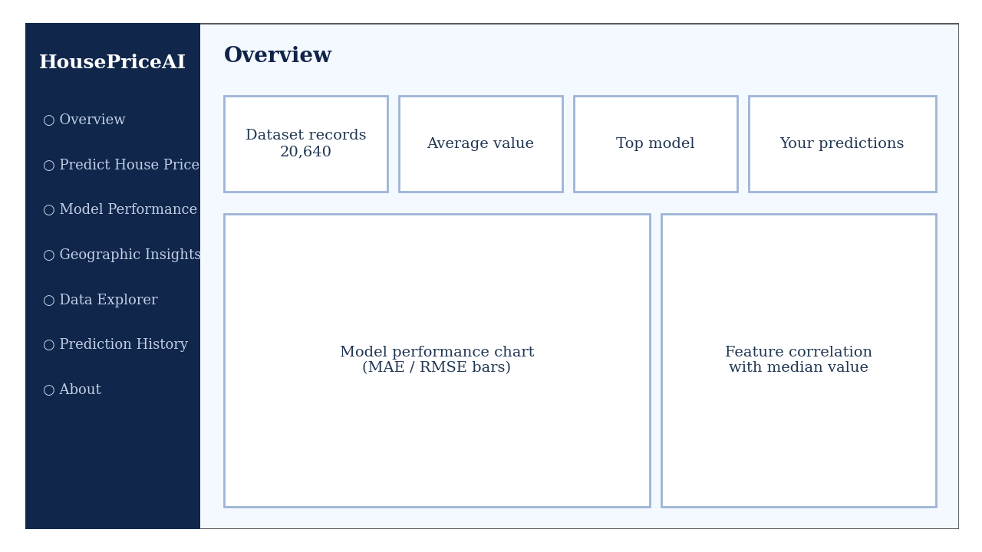
Figure: Schematic of the Overview page

Step 5: Predict a house value
Select Predict House Price in the sidebar. Enter the latitude, longitude, population, house age, average rooms, average bedrooms, average occupancy and median income (in $10,000s; for example 5.0 means about $50,000). Choose the model to be highlighted and click Generate price estimate. The page shows the highlighted estimate, the estimates of all three models and a comparison bar chart. The result is also added to the Prediction History page.
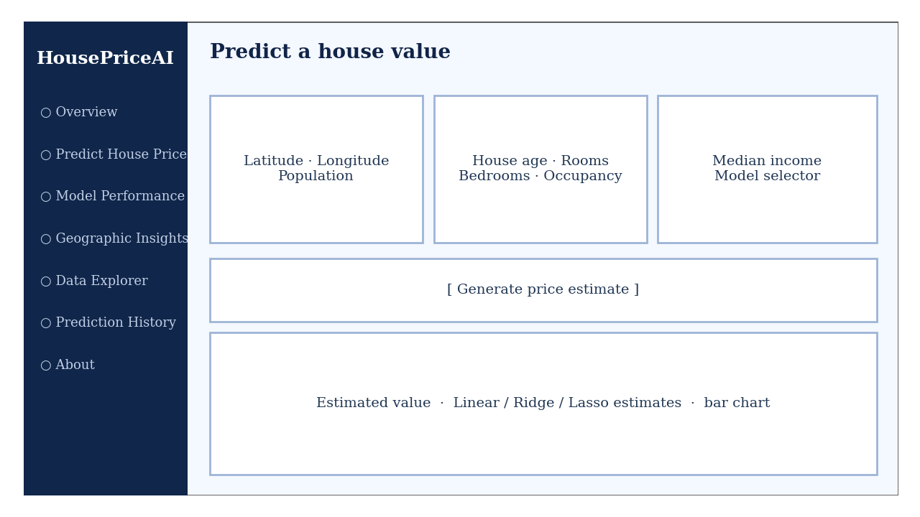
Figure: Schematic of the Predict House Price page

Step 6: Compare model performance
Model Performance shows MAE, RMSE and R² for each model, identifies the best model, and provides actual-versus-predicted and residual plots for a model selected from the drop-down list.
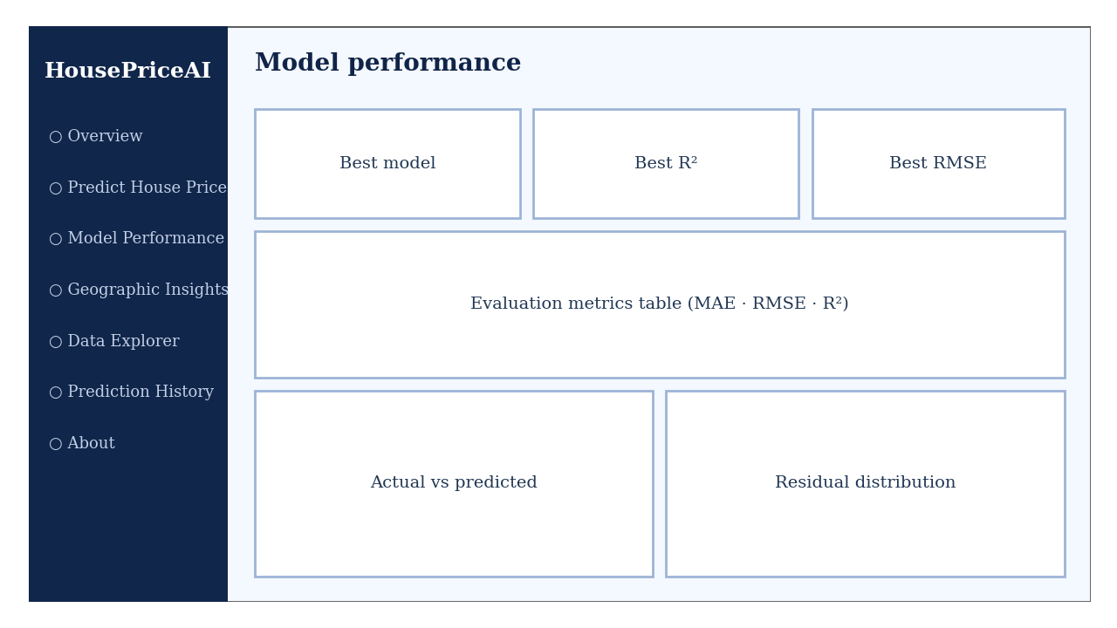
Figure: Schematic of the Model Performance page

Step 7: Other pages
- Geographic Insights: a map of up to 5,000 block groups coloured by value, plus scatter and histogram views.
- Data Explorer: dataset preview, feature histograms, correlation matrix and descriptive statistics.
- Prediction History: all predictions of the session; use Clear history to reset or download them as CSV.
- About: algorithms, features, technology stack and the disclaimer.

Troubleshooting
- “Model loading problem: Missing model file(s)” — run python train_models.py first and keep the models folder next to app.py.
- “streamlit is not recognised” — reinstall with pip install streamlit or run python -m streamlit run app.py.
- Dataset download fails — check the internet connection; scikit-learn downloads the California Housing data on the first run and caches it.
- To stop the application, press Ctrl + C in the Command Prompt window.

