* Different ways to create Objects in java
//https://www.javatpoint.com/how-to-create-object-in-java
1. Using new keyword
2. Using deserialization
3. Using clone() method
4. Using newInstance() method of the Constructor class
5. Using newInstance() method of the Class class

* Different ways to create Objects in java

* Introduction
Thank you for giving me this opportunity.
I am SWAPNIL KAMBLE from MUMBAI. I have total 2.3 years of experience into java development. I am currently working in Softura.pvt.ltd as java BACKEND developer.
I have worked on core java, advanced java, spring and hibernate frameworks, also very good experience into designing restful web services, having good experience into e commerce domain, hands-on experience into MYSQL database.
* ROLES AND RESPONSIBILITY
• Producing and consuming the restful web services.
• Requirement analyse, design, coding and testing etc.
• Bug fixing
• Analyse the program to identify the code changes as per the business requirements.
• Involved in knowledge sharing activities with team.
• Preparing the technical specification document based on existing system and new design changes.
• Manages user requirements; provides timely project updates.

* Why do you want to leave your current job?
seeking better career growth and development, learning new skills and gaining new experience, seeking better job security or stability, wanting a better work-life balance, wanting to challenge oneself and grow in one's career, aligning with a company's values, pursuing personal growth, finding a better opportunity, needing to relocate for personal reasons
* From your resume it seems you took a gap year. Would you like to tell us why that was?
* What are your salary expectations?
* What d u mean by Synchronized ?
* Is there any alternative for synchronization?
* What is alternative to synchronized in java
* How to show error message to client
* What methods used for sorting
* How to build a maven project and configuration
* Scenarios and Programs on multithreading
* What is printStackTrace
The printStackTrace() method in Java is a tool used to handle exceptions and errors. It is a method of Java's throwable class which prints the throwable along with other details like the line number and class name where the exception occurred. printStackTrace() is very useful in diagnosing exceptions.
* Write a program to print sequence of numbers using 4 threads
* What is Custom Exception? Write scenario of custom exception
* Write program for Custom Exception
* what is exception handling?write a scenario of exception handling?
* how do you handle exception
* Hierarchy of Java Exception classes
* what is io exception
*What is Unreachable Catch Block Error?
When we are using multiple catch blocks for a single try block, the order of exceptions in the catch block must be placed in such a way that first, subclass exception comes and later on superclass exception.
If we place superclass exception first and later on subclass exception, all the exceptions thrown for subclass exception will be caught by the first catch block.
In this case, the second catch block will not be used in the program and java compiler will generate unreachable catch block error.

* when do the get file not found exception
FileNotFoundException is another exception class available in the java.io package. The exception occurs when we try to access that file which is not available in the system. It is a checked exception because it occurs at run time, not compile-time, and it is thrown by one of the following constructors:
- RandomAccessFile
- FileInputStream
- FileOutputStream
* Why FileNotFoundException occurs?
There are mainly two reasons by which we get this error. The reasons for getting this exception are as follows:
When we try to access that file, that is not available in the system.
When we try to access that file which is inaccessible, for example, if a file is available for read-only operation and try to modify it, it can throw the error.

* difference between collection and collections
The Collection is an interface (extends iterable interface )whereas Collections is a utility class(extends Object class) in Java. The Set, List, and Queue are some of the subinterfaces of Collection interface, a Map interface is also part of the Collections Framework, but it doesn't inherit Collection interface. The important methods of Collection interface are add(), remove(), size(), clear() etc and Collections class contains only static methods like sort(), min(), max(), fill(), copy(), reverse() etc.

* difference between final finally finalized
The basic difference between final, finally and finalize is that the final is an access modifier, finally is the block in Exception Handling and finalize is the method of object class.
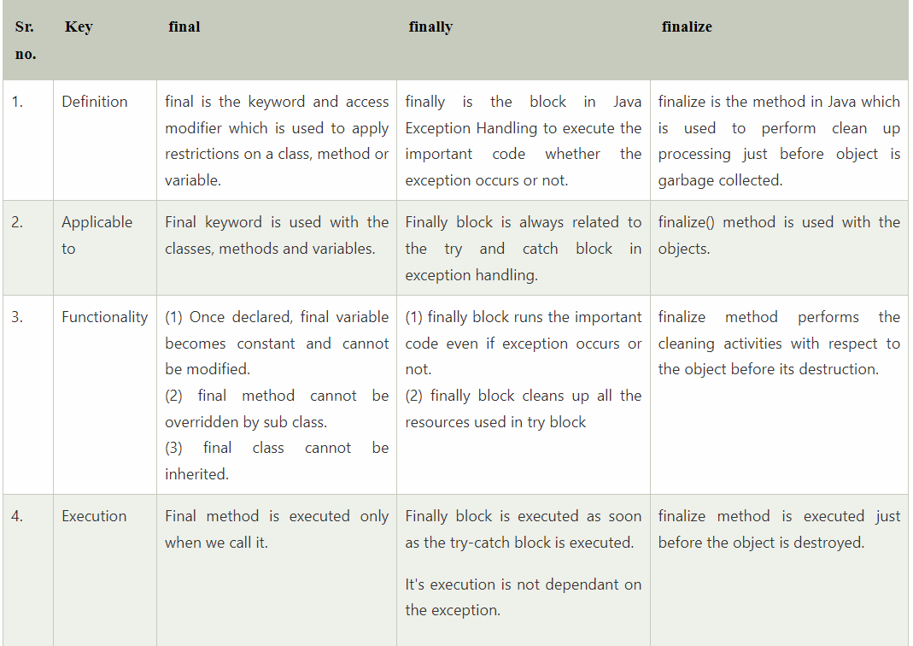
* why do need finally?
* what is alternative of finally block in java

* What is the difference between get and load method?
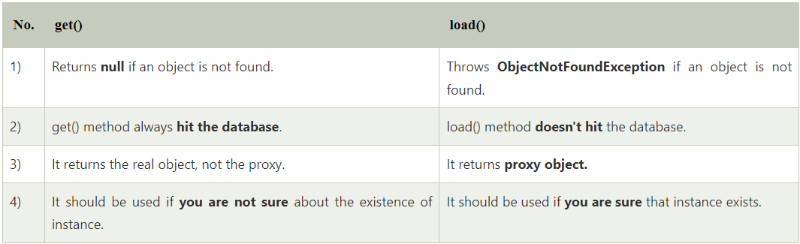

* contract between equals and hashcode method
* Internal working of hashmap
* Difference between Comparable and Comparator
Comparable and Comparator both are interfaces and can be used to sort collection elements.
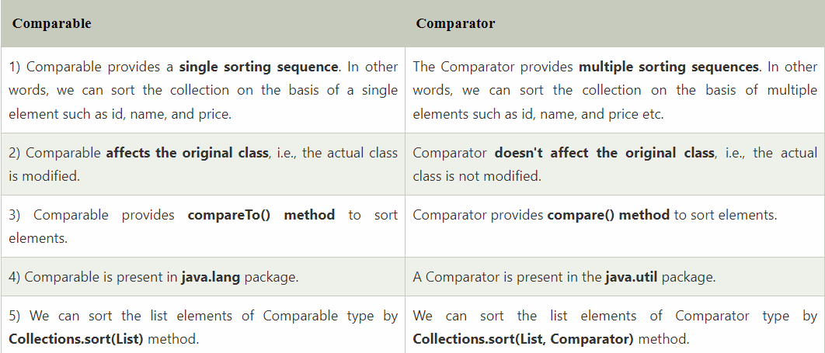

* What is serialization?
* What is de Serialization?
* Explain java8 features.

* 16)write a step of hibernate configuration
17)what is hibernat dialect?
18) what is pojo class? how to write pojo class why need pojo class
19)what is yml file
20) what is pom.xml file

22)explain hibernate architecture?
21)what is hibernate does?
22)what is hibernate annotation expalin each
23)what is flow of hibernate to create and application?
10. In Hibernate, use of cascade
- why string is immuatable?
- What is immutable class?
- can we create a immuatable class? if yes the how?
- how to serialize an object without implementing serializable interface.
------------------------------------------------------------------------------------------------
* Map is part of collection framework or not?
Map interface is also part of Java collection framework but it does not inherit the Collection interface.

* In Hibernate mapping Which one is best suitable for many type - set or list?
the choice between using a Set or a List for mapping a collection of entities in Hibernate depends on the specific requirements of the use case. If the order of the elements in the collection is important, then a List is the best choice. If the collection should not contain duplicates, then a Set is the best choice. However, the type also influences how Hibernate manages the association in the database, so the choice should also take into account the efficiency of the mapping.
* what is one to many and many to many mapping ?
One-to-many mapping refers to a relationship between two entities where one entity can have multiple instances of another entity, but the second entity can only have one instance of the first entity. For example, an employee can work in one division, but a division can have multiple employees.
Many-to-many mapping refers to a relationship between two entities where one entity can have multiple instances of another entity, and the second entity can also have multiple instances of the first entity. An example of this is the relationship between students and classes, where a student can take multiple classes, and a class can have multiple students.
* What is jhipster?
JHipster is a free and open-source development platform that generates modern web applications and microservices using Angular or React and the Spring Framework.
* many people say that set is most used than list what u say?
The choice between using a Set or a List depends on the specific use case. If you need to maintain the order of elements and allow duplicates, then a List is the better choice. If you need to ensure that there are no duplicates and order is not important, then a Set is the better choice
* is a sort method takes set or not?
Collections.sort() method can take a List as an argument, but it cannot take a Set directly.
it is possible to convert a Set to a List and then sort the List using Collections.sort(). or
there are some Set implementations that maintain the order of elements, such as TreeSet.
* can we override static method or not?
No, we cannot override static methods in Java. This is because static methods are associated with the class rather than the object, and they resolved using Static Binding during compile time. On the other hand, method overriding is based on dynamic binding at runtime, where the correct overridden method is resolved based on the object at runtime.
However, we can declare static methods with the same signature in a subclass, but it is not considered overriding as there won't be any runtime polymorphism. If a derived class defines a static method with the same signature as a static method in the base class, the method in the derived class is hidden by the method in the base class.
In summary, we cannot override static methods in Java, but we can declare static methods with the same signature in a subclass, which is not considered overriding.

* Can we Overload static method in Java
Yes, we can overload the static method in Java. In terms of method overloading, the static method is just like normal methods. To overload the static method, you need to provide another static method with the same name but a different method signature. The static overloaded method is resolved using Static Binding during compile time. The overloading method in Java is completely different than the overriding method.
* Which collection classes are thread-safe in Java?
The collection classes that are thread-safe in Java are Stack, Vector, Properties, Hashtable, ConcurrentHashMap etc.
* is hashmap is thread safe?
No, HashMap is not thread-safe.
it is possible to synchronize a HashMap using the Collections.synchronizedMap() method.
(It is important to note that Hashtable is synchronized and can be shared with many threads.)
* concurrent hashmap is thread safe or not ? & what he do for thread safety?
OR
* can a multiple thread access same object in concurrent hashmap?
ConcurrentHashMap is thread-safe, which means that multiple threads can access it simultaneously without any synchronization issues.
The ConcurrentHashMap class achieves thread-safety by dividing the map into segments, the lock is required not for the entire object but for one segment, i.e one thread requires a lock of one segment.
*what is Linked hashmap?
Java LinkedHashMap class is Hashtable and Linked list implementation of the Map interface, with predictable iteration order. It inherits HashMap class and implements the Map interface.
*Which implementation is better to use: HashMap or LinkedHashMap?
Both HashMap and LinkedHashMap classes provide comparable performance but HashMap is a natural choice if the ordering of elements is not an issue.
Adding, removing, and finding entries in a LinkedHashMap is slightly slower than in HashMap because it needs to maintain the order of doubly linked list in addition to the hashed data structure.
*what u think which gives best performance linked list and arraylist?
ArrayList | LinkedList
It is best choice if our frequent operation is retrieval. | It is the best choice if our frequent operation is insertion and deletion.
ArrayList provides random access. | LinkedList does not provide random access.
Underlying data structure for arraylist is resizable or growable array. | Underlying data structure is double linked list.
ArrayList takes less memory as it stores only object | LinkedList takes more memory, as it stores the object as well as the address of that object.

*what are pros and cons of wrapper classes.
Pros:
Wrapper classes provide a way to use primitive data types as objects, which is required in certain situations, such as when working with collections that can only store objects
Wrapper classes provide a way to convert primitive data types into objects and vice versa
Cons:
they are less efficient than primitive data types and can lead to more complex code and errors if not used properly.

*Differnce between global variable vs local variable
Global Variable | Local Variable
It is defined outside of a method but inside the class. It is called as instance variable. | The variables which are declared inside method body, constructor or block
It stored in “Heap Memory area”, each instance(object) of a class has its own copy of instance variable. | Local variables are stored in stack area.
It is initialized automatically by JVM and default value is zero. | It does not initialize automatically.  If you are trying to use local variables without initialization then we will get compile time error.
Global variables scope is anywhere in the class. | Scope of local variables is within the method, constructor and block only.
Static keyword can be applied to global variable and it will become static variable. | Static keyword is not applied to local variable

* what is default priority, min priority, max priorty of thread ?
thread's priority is an integer value in the range 1 to 10 .Default priority of a thread is 5 (NORM_PRIORITY). The value of MIN_PRIORITY is 1 and the value of MAX_PRIORITY is 10.
* can we call run method by its name in multithreading?
Yes, we can call the run() method by its name in multithreading, but it will not create a new thread.
The run() method is the entry point for a new thread.
To create a new thread in Java, we need to create an instance of the Thread class and pass an instance of a class that implements the Runnable interface to its constructor. The Runnable interface has only one method, run(), which is called when the thread starts.
* what are ways to create thread & which is the best way.
there are two ways to create a thread:
by extending the Thread class and by implementing the Runnable interface.
Extending thread class- if the class is not extending another class then we should go for thread class.
Implementing runnable interface- if our class is already extending another class then we could not use extend keyword due to multiple inheritance. So best way to go for runnable interface.
* When we implement runnable r u sure we create thread class object & then why we create thread class object
when we implement the Runnable interface, we do not create a Thread class object directly. Instead, we create a Thread object and pass the Runnable object to its constructor.
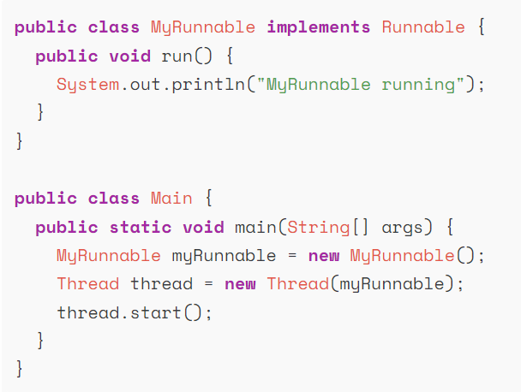
* have u work with spring security
Spring Security is a framework which provides various security features like: authentication, authorization to create secure Java Enterprise Applications.
Authentication is the process of identifying a user to provide access to a system.
In this, the user or client and server are verified.
Authorization is the process of giving permission to access the resources.
In this, it is verified that if the user is allowed through the defined policies and rules.

* how many types of cache in java
Hibernate provides two types of caching: First Level Cache and Second Level Cache and Query Cache.
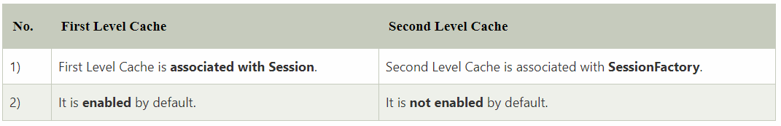
* what is query level cache and when it excute
Query cache will cache the results of the query against the object.
If we have queries which runs multiple times with the same parameters then Query caching is best to use to avoid multiple DB calls.
Query cache is disabled by default and we can enable it using configuration.
We just need to set the hibernate.cache.use_query_cache property to true to enable Query cache.

* What is JPA?
A JPA (Java Persistence API) is a specification of Java which is used to access, manage, and persist data between Java object and relational database. It is considered as a standard approach for (ORM)Object Relational Mapping.
JPA can be seen as a bridge between object-oriented domain models and relational database systems. Being a specification, JPA doesn't perform any operation by itself. Thus, it requires implementation. So, ORM tools like Hibernate, TopLink, and iBatis implements JPA specifications for data persistence.
* What Is a JPA Repository in Spring Boot?
JPA Repository is mainly used for managing the data in a Spring Boot Application.
* What is Hibernate?
Hibernate is an open-source and lightweight ORM tool that is used to store, manipulate, and retrieve data from the database.
Hibernate framework is a mediator through which java application can communicate with database.
Hibernate is an implementation of JPA. So, it follows the common standards provided by the JPA.

* Need of JPA
As we have seen so far, JPA is a specification. It provides common prototype and functionality to ORM tools. By implementing the same specification, all ORM tools (like Hibernate, TopLink, iBatis) follows the common standards. In the future, if we want to switch our application from one ORM tool to another, we can do it easily.

* JPA vs. Hibernate
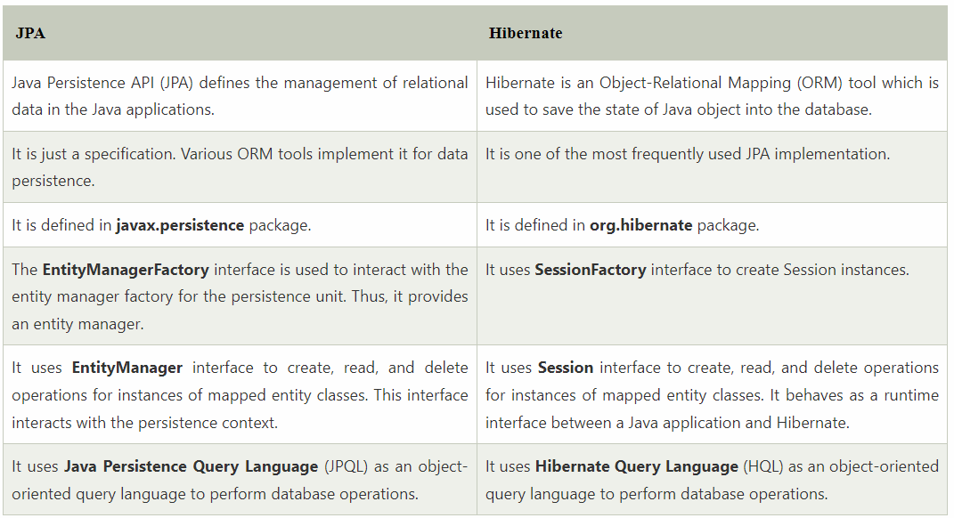

* is project developed from scratch(start)
* which technology used in project
* tell Project Desciption
*Solid principles-explain each of them.
SOLID principles are an object-oriented approach that are applied to software structure design
The word SOLID acronym for:
- Single Responsibility Principle (SRP)
- Open-Closed Principle (OCP)
- Liskov Substitution Principle (LSP)
- Interface Segregation Principle (ISP)
- Dependency Inversion Principle (DIP)

* Can we override or replace the Embedded tomcat server in Spring Boot?
Yes, we can replace the Embedded Tomcat server with any server by using the Starter dependency in the pom.xml file. Like you can use spring-boot-starter-jetty as a dependency for using a jetty server in your project.
*SpringFramework
It is a lightweight, loosely coupled and integrated framework for developing enterprise applications in java.
*SpringBoot
It is a Spring module that provides the RAD (Rapid Application Development) feature to the Spring Framework.
It is used to create a stand-alone Spring-based application that you can just run because it needs minimal Spring configuration.
*Difference between Spring Framework and Spring Boot.
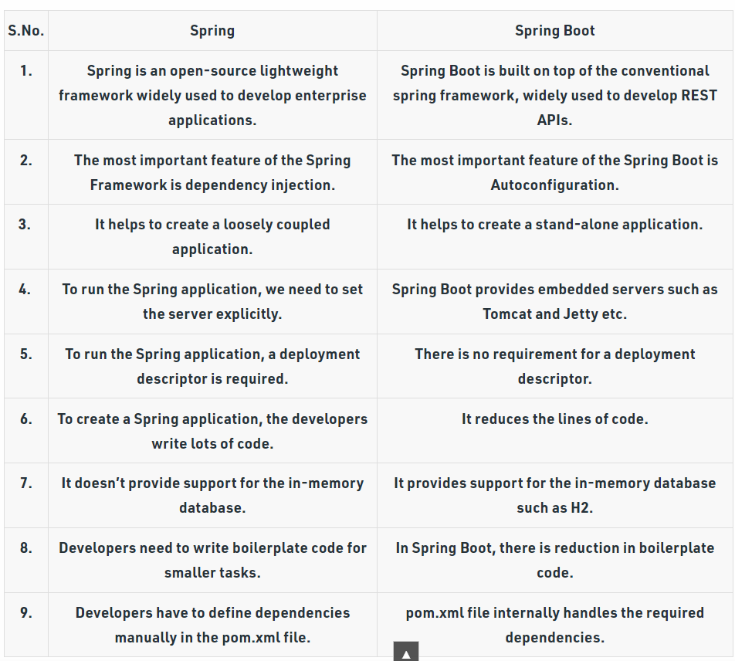
*
*What New Features Were Added in Java 8?
1) Lambda Expression
2) Functional Interfaces
3) Default methods
4) Predicates
5) Optional Class

6) Double colon operator (::)
7) Stream API
8) Date and Time API
*What is a Predicate? State the difference between a Predicate and a Function?
Predicate is a pre-defined Functional Interface. It is under java.util.function package. It accepts only a single argument
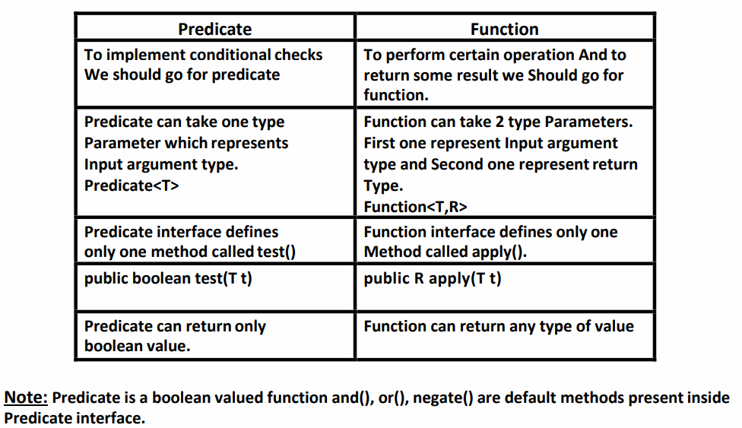
*What are the main characteristics of the Lambda Function?
Lambda Expression is just an anonymous (nameless) function. That means the function which doesn’t have the name, return type and access modifiers.
-A lambda expression can have zero or more number of parameters (arguments)
-Usually we can specify type of parameter. If the compiler expects the type based on the context then we can remove type. i.e., programmer is not required.
-If multiple parameters present then these parameters should be separated with comma (,).
-If zero number of parameters available then we have to use empty parameter [ like ()].
-If only one parameter is available and if the compiler can expect the type then we can remove the type and parenthesis also.
-Similar to method body lambda expression body also can contain multiple statements. If more than one statements present then we have to enclose inside within curly braces. If one statement present then curly braces are optional.
-Once we write lambda expression we can call that expression just like a method, for this functional interfaces are required.
*What are Functional Interfaces?
If an interface contain only one abstract method, such type of interfaces are called functional interfaces and the method is called functional method or single abstract method (SAM).
Ex:
1) Runnable → It contains only run() method
2) Comparable → It contains only compareTo() method
3) ActionListener → It contains only actionPerformed()
4) Callable → It contains only call() method
Inside functional interface in addition to single Abstract method (SAM) we write any number of default and static methods.
In Java 8, Sun Micro System introduced @Functional Interface annotation to specify that the interface is Functional Interface.
*How can you create a Functional Interface?
Although Java can identify a Functional Interface, you can define one with the annotation @FunctionalInterface
* What is a Stream API? Why do we require the Stream API?
Stream API is a new feature added in Java 8. It is a special class that is used for processing objects from a source such as Collection.
We require the Stream API because,
- It supports aggregate operations which makes the processing simple.
- It supports Functional-Style programming.
- It does faster processing. Hence, it is apt for better performance.
- It allows parallel operations.
*What is the difference between the Collection API and Stream API?
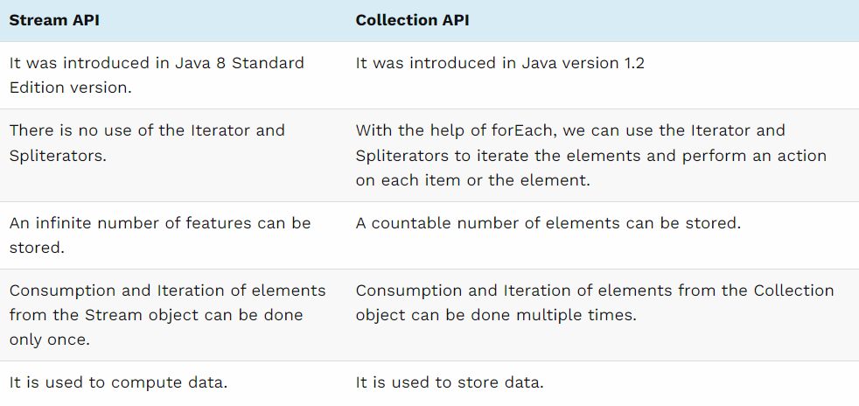
*If we have HashTable for thread safe operation, then what is the need to go for "Concurrent HashMap"
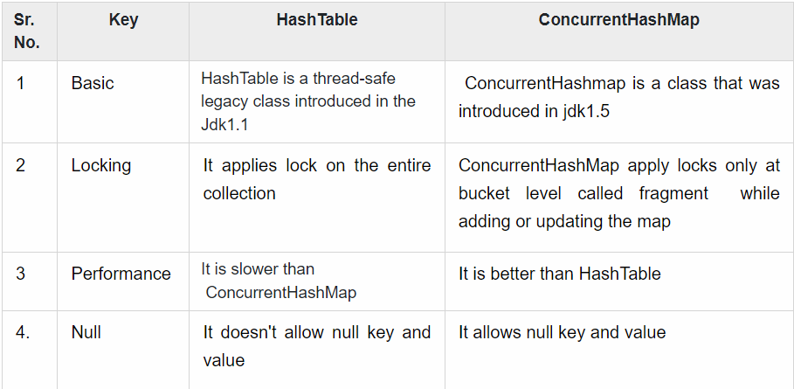
* Difference between fail fast and fail safe with example

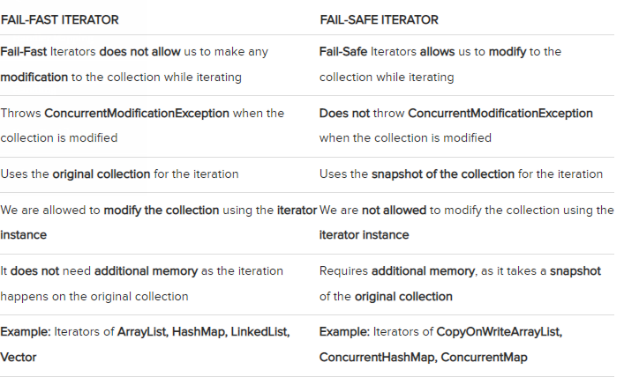

*How to handle "Concurrent Modification Exception"- write a code.
we have an ArrayList of integers and we are trying to remove an element from the list while iterating over it. This will result in a ConcurrentModificationException being thrown.
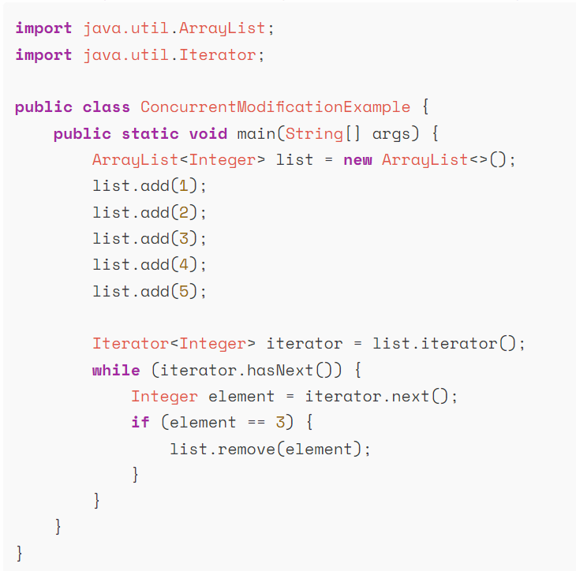
To avoid this exception, we can use an iterator to iterate over the list and remove the element using the remove() method of the iterator instead of the remove() method of the list.
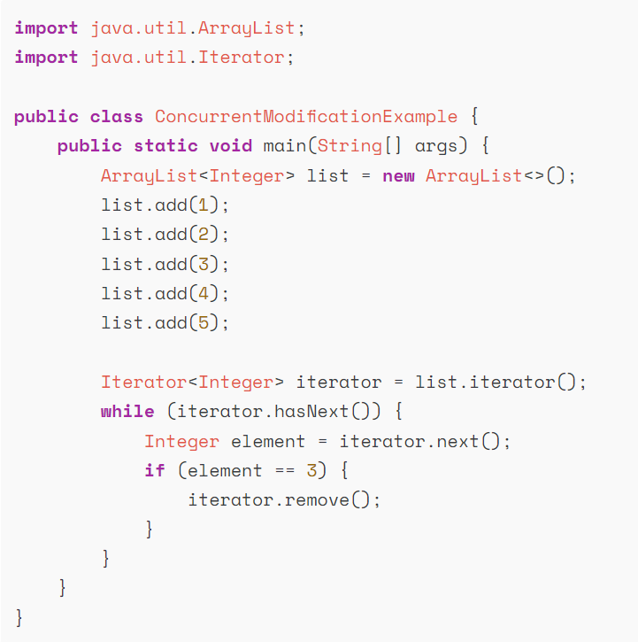

* What are the types of IOC container in spring?
There are two types of IOC containers in spring framework.
- BeanFactory
- ApplicationContext

*What is the difference between constructor injection and setter injection?
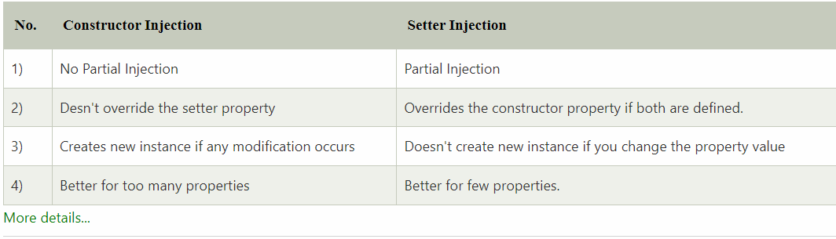

* What is the difference between BeanFactory and ApplicationContext?
ApplicationContext extends the BeanFactory interface.BeanFactory is the basic container whereas ApplicationContext is the advanced container. ApplicationContext provides more facilities than BeanFactory such as integration with spring AOP, message resource handling
*What is Spring MVC
A Spring MVC is a Java framework which is used to build web applications.
It follows the Model-View-Controller design pattern.
It implements all the basic features of a core spring framework like Inversion of Control, Dependency Injection
It is build on the top of Servlet API
* What does the ViewResolver class?
The View Resolver class resolves the view component to be invoked for the request. It defines prefix and suffix properties to resolve the view component.

* Which ViewResolver class is widely used?
The org.springframework.web.servlet.view.InternalResourceViewResolver class is widely used.

* What is the front controller class of Spring MVC?
Front Controller - In Spring Web MVC, the DispatcherServlet class works as the front controller. It is responsible to manage the flow of the Spring MVC application.
*
*
*
*
*

