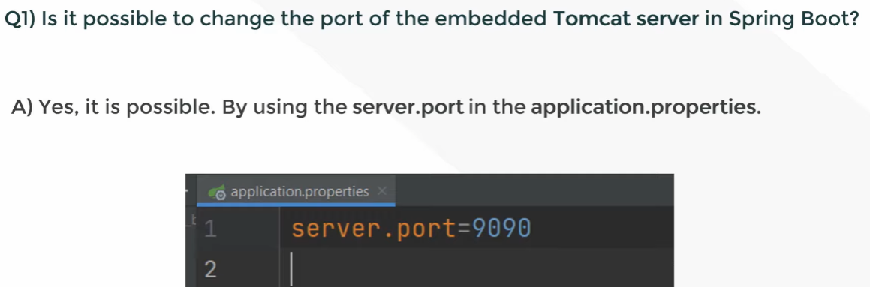
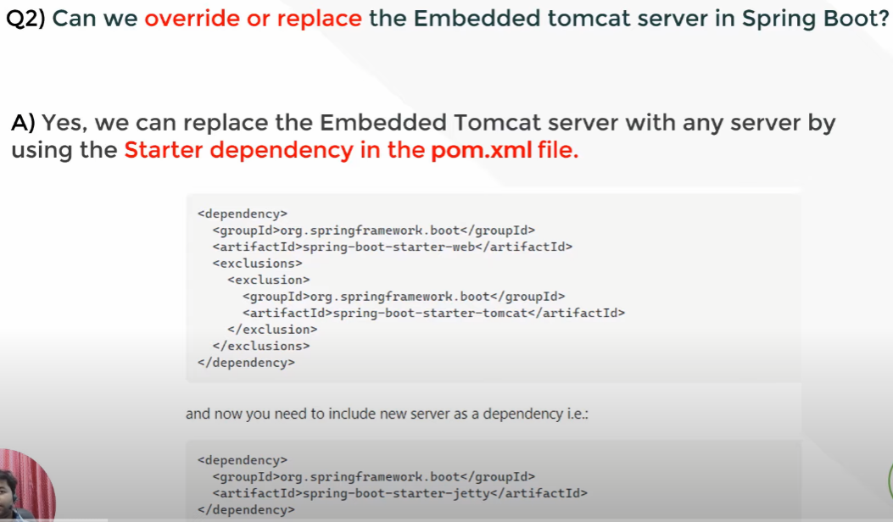

How to Exclude Tomcat server From Spring Boot Application | Embedded Servers in Spring Boot
// https://www.youtube.com/watch?v=gnCeFZksqLo
Spring Boot Profiles | Profiles in Spring Boot | application properties
// https://www.youtube.com/watch?v=j-wByL3YK2A&t=123s

What are the Spring Boot key components?
Below are the four key components of spring-boot:
Spring Boot auto-configuration.
Spring Boot CLI.
Spring Boot starter POMs.
Spring Boot Actuators.
What is the use of Profiles in spring boot?
While developing the application we deal with multiple environments such as dev, QA, Prod, and each environment requires a different configuration. For eg., we might be using an embedded H2 database for dev but for prod, we might have proprietary Oracle or DB2. Even if DBMS is the same across the environment, the URLs will be different.
To make this easy and clean, Spring has the provision of Profiles to keep the separate configuration of environments.
What is an IOC container?
IoC Container is a framework for implementing automatic dependency injection. It manages object creation and its life-time and also injects dependencies into the class.
What is dependency Injection?
The process of injecting dependent bean objects into target bean objects is called dependency injection.
Setter Injection: The IOC container will inject the dependent bean object into the target bean object by calling the setter method.
Constructor Injection: The IOC container will inject the dependent bean object into the target bean object by calling the target bean constructor.
Field Injection: The IOC container will inject the dependent bean object into the target bean object by Reflection API.
Explain the bean scopes supported by Spring
There are five scoped provided by the Spring Framework supports following five scopes:
• In singleton scope, Spring scopes the bean definition to a single instance per Spring IoC container.
• In prototype scope, a single bean definition has any number of object instances.
• In request scope, a bean is defined to an HTTP request. This scope is valid only in a web-aware Spring ApplicationContext.
• In session scope, a bean definition is scoped to an HTTP session. This scope is also valid only in a web-aware Spring ApplicationContext.
• In global-session scope, a bean definition is scoped to a global HTTP session. This is also a case used in a web-aware Spring ApplicationContext.
The default scope of a Spring Bean is Singleton.

Explain Bean lifecycle in Spring framework
