**Dialogs:** they are meant to do a step by step operation (like Wizards)…they can be applied on a specific entity..you can define different steps for creating that entitity take certain data..check conditions (depending on data queried from different entities.).Child dialogs can be linked to parent dialog…

Dialogs can be started directly from the browsing by put an URL.

A sample URL to start a dialog:

<http://crmserver/AdventureWorksCycle/cs/dialog/rundialog.aspx?DialogId=9F53D2D8-AC54-46A6-A190-F23DE6677C65&EntityName=contact&ObjectId=41D1884E-B4B6-DF11-BF5E-00155DB05986>

**Workflows** can be used to automate many of the processes in Dynamics CRM. From handling of a series of follow-up emails to a customer following a purchase to extremely customized workflow logic, Workflows can be a very powerful tool.

1. The new workflow capabilities in Dynamics CRM 2011that are made possible by the use of Windows Workflow Foundation 4(WF4). You will learn how the Web Based workflow designer can be used to design workflows and how these workflows can be exported as XAML for modification by a developer. Because XAML provides a declarative definition of each workflow it is possible to open these XAML representations of a CRM 2011 workflow using the workflow designer inside Visual Studio 2010. You will open and edit a CRM 2011 workflow in Visual Studio before updating it back into CRM 2011 and then executing that workflow. By editing the workflow directly in Visual Studio you will be able to take advantage of some of the new WF4 activities that are not supported in the web based designer.

### Microsoft Dynamics CRM for Outlook

* Need to download the outlook client for Crm.
* Workflow can be used to automatically send emails at certain events (e.g. entity creation\updation).
* This emails can be opened from sent items or in inbox (responses recd) and from the CRM menu..there is a option to track this email communication in CRM..the emails are then visisble in the “Completed Activities” tab.
* Emails betn 2 crm users can be tracked as incoming and outgoing email respectively for both users (go to Settings->Administration-> system setting.

### Scenario 2: E-mail Router

In this scenario, you configure the Microsoft Dynamics CRM Online E-mail Router to process both outgoing e-mail that users create in Microsoft Dynamics CRM Online and incoming e-mail that will be received into and tracked in Microsoft Dynamics CRM Online. Before you begin this scenario, you must install the Microsoft Dynamics CRM Online E-mail Router.

This scenario does not require a forward mailbox, it does not require users to install Microsoft Dynamics CRM Online for Outlook, and it does not require that you install the Rule Deployment Wizard. For more information, see [Microsoft Dynamics CRM 2011 E-mail Router Installing Guide for use with Microsoft Dynamics CRM Online](http://technet.microsoft.com/en-us/library/hh871393.aspx).

### Scenario 3: E-mail Router and forward mailbox

In this scenario, you configure Microsoft Dynamics CRM Online to use the E-mail Router for outgoing email and a forward mailbox for incoming email. A forward mailbox receives incoming e-mail and transfers it to Microsoft Dynamics CRM Online for individual users of Microsoft Dynamics CRM Online. The E-mail Router is used to send outgoing e-mail that users create in Microsoft Dynamics CRM Online.

Before you begin this scenario, you must install the Microsoft Dynamics CRM Online E-mail Router and the Rule Deployment Wizard. Microsoft Dynamics CRM Online for Outlook does not have to be installed. For more information, see [Microsoft Dynamics CRM 2011 E-mail Router Installing Guide for use with Microsoft Dynamics CRM Online](http://technet.microsoft.com/en-us/library/hh871393.aspx).

**Data Auditing.** There is often a need to go back through the history of changes to your data and CRM 2011 offers custom auditing settings to facilitate that. This exercise will show you the basics you need to start auditing data.

**Role Based Forms.** Using Dynamics CRM 2011 allows each user to have a different experience using role-based forms. Different users have different needs and they use different data fields to complete their tasks

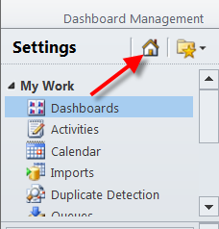

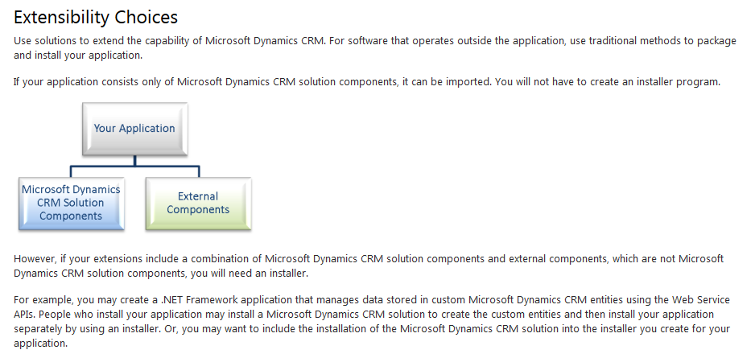

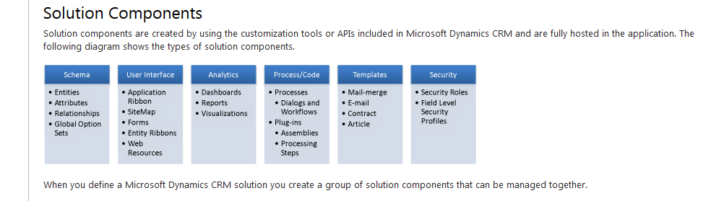

**Unmanaged and Managed Solutions**

There are two types of Microsoft Dynamics CRM solutions: *Unmanaged* and *Managed*. A managed solution is a completed solution that is intended to be distributed and installed. An unmanaged solution is one that is still under development or is not intended to be distributed. When the unmanaged solution is complete and you want to distribute it, export the unmanaged solution and select the option to package it as a managed solution.

The following diagram introduces how managed and unmanaged solutions interact with the system solution to control application behavior

<http://msdn.microsoft.com/en-us/library/gg334576.aspx>

You will find a lot of cases for both ways of doing this, I would say there are no rights or wrongs but these are my thoughts.

I would use the unmanaged solution in all cases where it's not a "product" you sell. The reason is that it is so much easier to make changes when you need them. An example is a field that you have added to an entity that you no longer want or need. To remove that usning a managed solution is quite the task, in an unmanaged solution you simply remove the field from the solution in dev and remove the field from the solution in production environment.   
It's also quite easy to create dependencies between solutions that will prevent you from removing one of them.

#### Importing Unmanaged Solutions

When you import an unmanaged solution, you can edit its components in the new organization.

* 1. .NET code in the form of a CRM plug-in.
  2. Plug-ins allows a CRM 2011 developer to execute custom code as part of an event pipeline provided by the CRM Application Framework. Plug-ins allow you to execute code when records are created, updated, deleted, assigned or have their state changed.

1. Dynamics CRM 2011uses an event driven pipeline to allow applications to integrate custom code into the processing of normal platform operations. Plug-ins are the mechanism that allows developers to create custom code that can subscribe to the published events. For example, a plug-in can subscribe to the operations on entities such as when data is inserted or updated to perform additional custom logic. In this exercise you will create a plug-in to execute in this pipeline.
2. The plug-in will be built using the new isolatable plug-ininterface supported by Dynamics CRM 2011. This interface allows plug-ins to be executed in an isolated sandbox so that their potential to adversely impact the stable operation of the CRM server is greatly reduced. You will install your plug-in into the new CRM 2011plug-inSandbox and test the execution of the custom code.

The Tracing Service is a new feature of CRM 2011 that allows plugins to trace progress. The output from the trace is then logged and made available when an exception occurs. Insert the following code after the prior step’s code.

* + 1. **public void Execute(IServiceProviderserviceProvider)**
    2. **// CRM 2011: function signature changed**
    3. **{**

**}**

### Integrating with custom made HTML Forms Using OData

Suppose u need a form in crm, which is composed of different entitities..or connecting with other third party systems at same time..one can make a custom form with html fields..import that form as web resource ..display that web resource in tab in CRM form…and use Jquery and ajax using Odata to get data from the relevant CRM entity or third party system (using there service..thing to try) ..refer to the Lab..