Application of Keyboard Character Distance in Word Correction

David Skufca^{1,2}, Dr. Sean Banerjee³

¹Department of Mathematics, Clarkson University
²Department of Computer Science, Clarkson University
³Department of Electrical and Computer Engineering, Clarkson University

skufcadj@clarkon.edu

My current research utilizes keyboard character distances to determine the viability of a character and neighboring characters for a given word. My approach is designed using the common 'QWERTY' keyboard layout, and each alphabetical key is mapped into a two-dimensional coordinate system. The first version of the coordinate system is illustrated below.

Each character key is assigned three values,: x-coordinate, y-coordinate, and b-value. The x and y coordinate represent the positional location of the key. The b-value is computed using the the equation of a straight line given a slope of one, where the b-value represents the y-intercept. Given these three values, we can compute the distance between a pair of character keys.

By using key character distances, we can determine the likelihood that the user intended to press the given key as opposed to a neighboring key. For example, the word 'thrn' is more likely to be a typographical error of 'then' as opposed to 'than', as the key 'r' and 'e' share a 1-unit distance as opposed to the keys 'r' and 'a'.
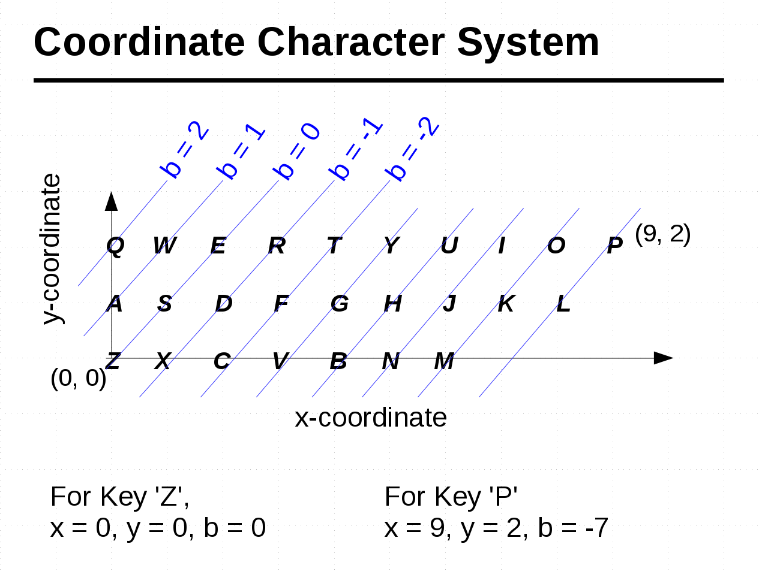

Mentor: Dr. Sean Banerjee, Department of Electrical and Computer Engineering, Clarkson University

