Table of Contents
Angular Building Blocks 2
Components 2
Modules 2
How to create/run project 3
Component Workflow 4
Create a component 4
Register component in module 5
Add an element in an HTML markup 5
Services 6
Concepts 7
String Interpolation & Property Binding & Class Binding & Style Binding 7
DOM & HTML Mapping 8
What is Bootstrap and How to use? 10
Event Binding/Event Filtering/Template Variable 11
1 Way Binding Vs 2 Way Binding 12

Angular is a framework for building client applications in HTML, CSS, and JavaScript/TypeScript.

Angular Building Blocks
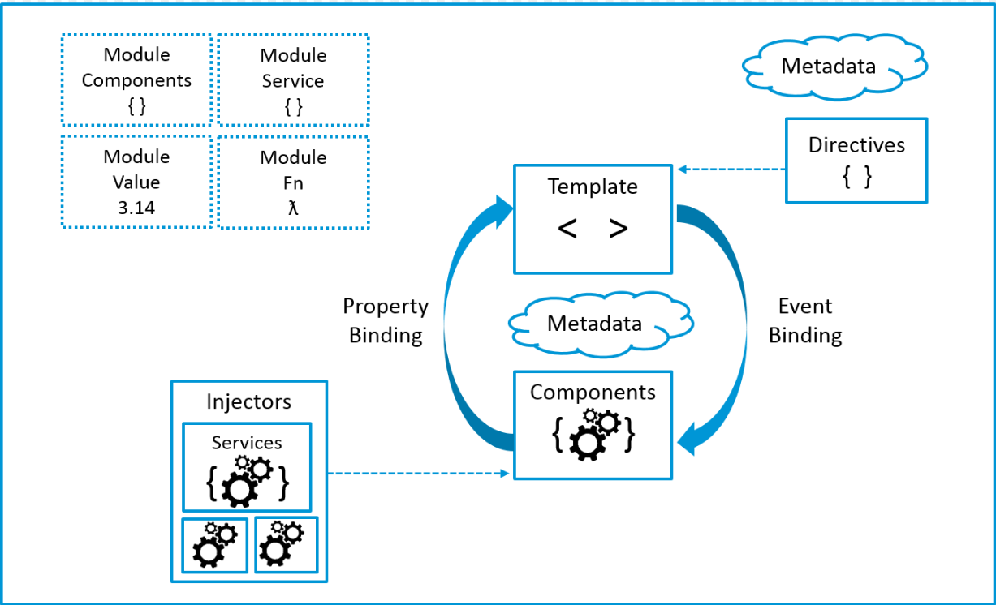

Components
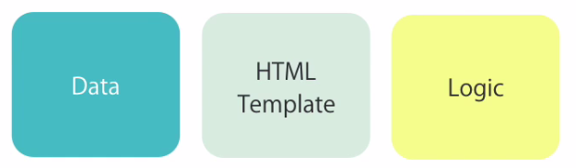
Workflow:
- Create a component.
- Register it in a module.
- Add an element in an HTML markup.

Modules
Is a container of group or related components.

How to create/run project

1) Open Command Prompt.
2) Go to corresponding directory.
Example:
cd c:\Development\learningAngular
3) Create new project.
Example:
c:\Development\learningAngular>ng new hello-world
? Would you like to add Angular routing? Yes
? Which stylesheet format would you like to use? CSS
4) Project will be created after copying all the angular dependency, load the project in any editor and check for following folder:
<project_name>/e2e <end to end test>
<project_name>/node_modules <third party library>
<project_name>/src/
Component/module: app
Note: Every project will have at least one module and component
<project_name>/src/assets <any assets for example image file etc.>
<project_name>/src/environments <configuration setting for the environment>
main.ts, index.html, polyfills.ts {browser specific features}, styles.css {global style}, test.ts, karma.conf.js, package.json {angular library and dependency version}, tsconfig.json{setting for typescript compiler}, tslint.json {typescript static tool}
5) To compile/launch application:
ng serve
6) Open firefox/chrome and type "http://localhost:4200/"
7) Angular home page should display.

Component Workflow

Create a component
- Create a typescript file for example “<component_name>.component.ts” for the component (inside src/app).
- Create a class and use export keyword before the class, to angular to see it.
- Add metadata (decorator) to make this class as a component.

IMP: Generate a component through angular cli: ng g c <component-name>

Register component in module

Add component into the “app.module.ts” under “declarations”.

Add an element in an HTML markup
Update “app.component.html” file for the html code.

Services
In real word we get the data from server (http end-point).
Refer bellow for the service creation and dependency injection:
IMP: Generate a component through angular cli: ng g s <service-name>

Concepts

String Interpolation & Property Binding & Class Binding & Style Binding

Property Binding Mapping:
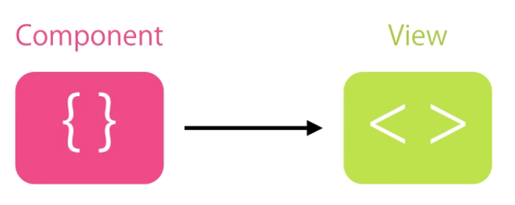

DOM & HTML Mapping
DOM: The Document Object Model (DOM) is a cross-platform and language-independent application programming interface that treats an HTML, XHTML, or XML document as a tree structure where in each node is an object representing a part of the document. The DOM model represents a document with a logical tree. Each branch of the tree ends in a node, and each node contains objects. DOM methods allow programmatic access to the tree; with them one can change the structure, style or content of a document. Nodes can have event handlers attached to them. Once an event is triggered, the event handlers get executed.
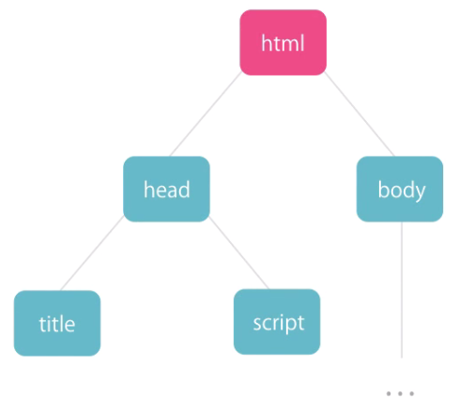
HTML: is a markup language to represent DOM to text.
When an HTML document is loaded into a web browser, it becomes a document object.
The document object is the root node of the HTML document.

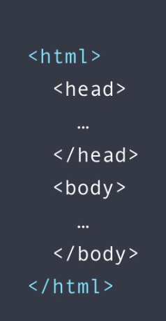

HTML has one to one binding with DOM (Document Object Model) with some exception (colspan etc).

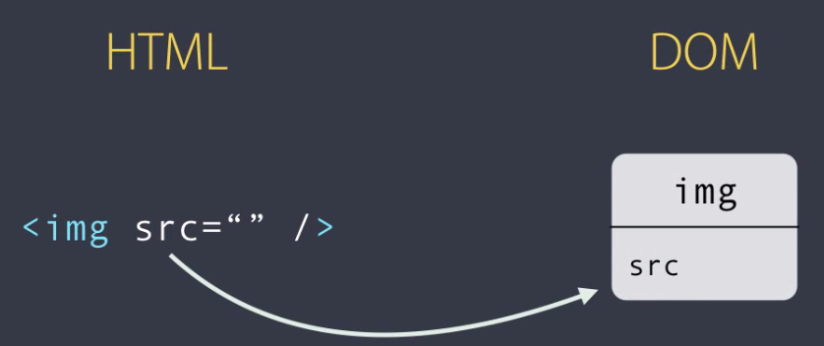

To handle such attribute into the angular,

What is Bootstrap and How to use?
Bootstrap is a free and open-source front-end framework for developing websites and web applications. It contains HTML- and CSS-based design templates for typography, forms, buttons, navigation and other interface components, as well as optional JavaScript extensions. Unlike many earlier web frameworks, it concerns itself with front-end development only. {https://getbootstrap.com}
install
npm install bootstrap –save
Add Style
Update “style.css” to add styles
Add bootstrap style

Event Binding/Event Filtering/Template Variable

1 Way Binding Vs 2 Way Binding

