10**月 91月报统计 (周期：2023/07-2023/10月)**

|  |  |  |  |  |  |
| --- | --- | --- | --- | --- | --- |
| **部门名称** | **部门负责人** | **数据来源** | **报告负责人** | **制作日期** | **提交日期** |
| **内容部** | **林冲** | **后台** | **慧娟** | **2023/11/1** | **2023/11/1** |

1. **近四个月各数据占比统计：**

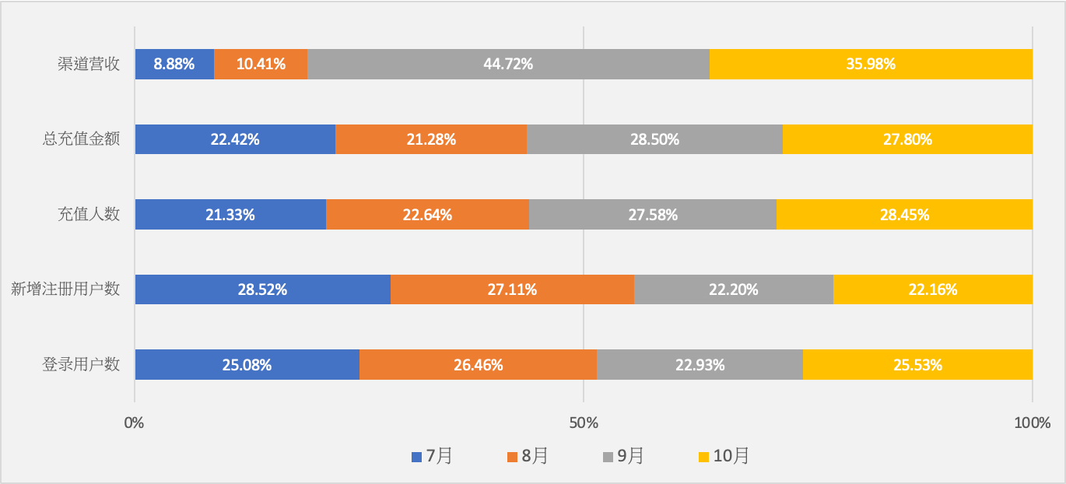

|  |  |  |  |  |  |  |  |  |  |  |
| --- | --- | --- | --- | --- | --- | --- | --- | --- | --- | --- |
| **月份** | **登录用户数** | **新增注册用户数** | **充值**  **人数** | **总充值金额** | **渠道营收** | **次日**  **留存** | **三日**  **留存** | **七日**  **留存** | **arpu** | **arppu** |
| 7月 | 33,224,494 | 11,092,264 | 53,593 | 13,375,150 | 766,165 | 11.58% | 6.40% | 4.15% | 0.40 | 627.89 |
| 8月 | 35,041,231 | 10,543,198 | 56,896 | 12,694,680 | 897,759 | 16.61% | 9.33% | 5.73% | 0.36 | 570.83 |
| 9月 | 30,368,535 | 8,633,438 | 69,307 | 17,003,475 | 3,856,703 | 16.98% | 9.10% | 7.14% | 0.59 | 721.90 |
| 10月 | 33,819,062 | 8,619,476 | 71,495 | 16,581,862 | 3,103,279 | 16.82% | 9.03% | 6.13% | 0.52 | 678.44 |

1. **月环比图表数据分析：**

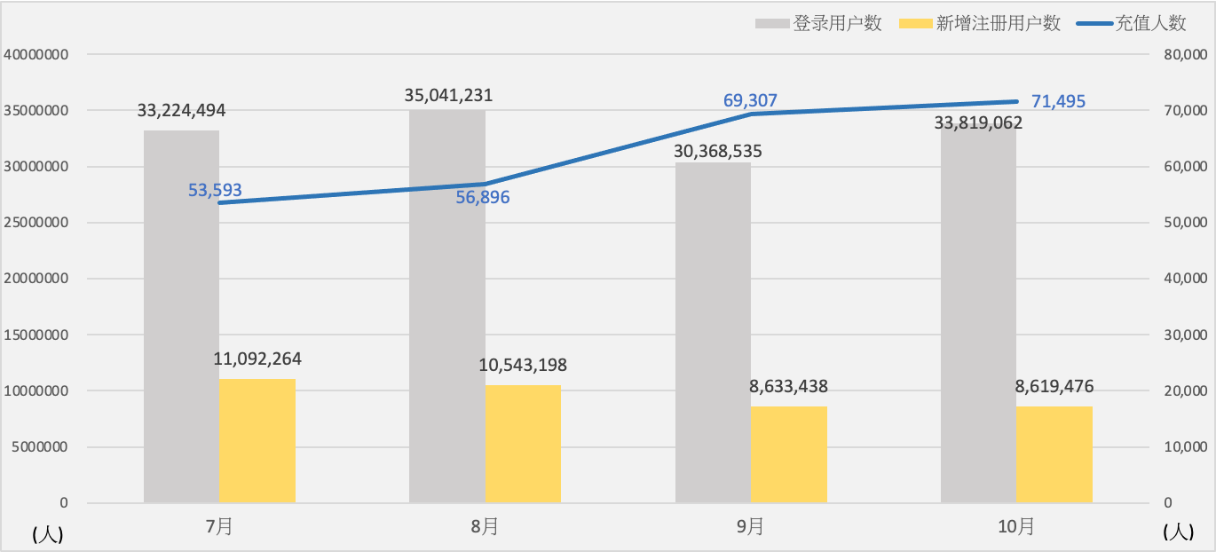

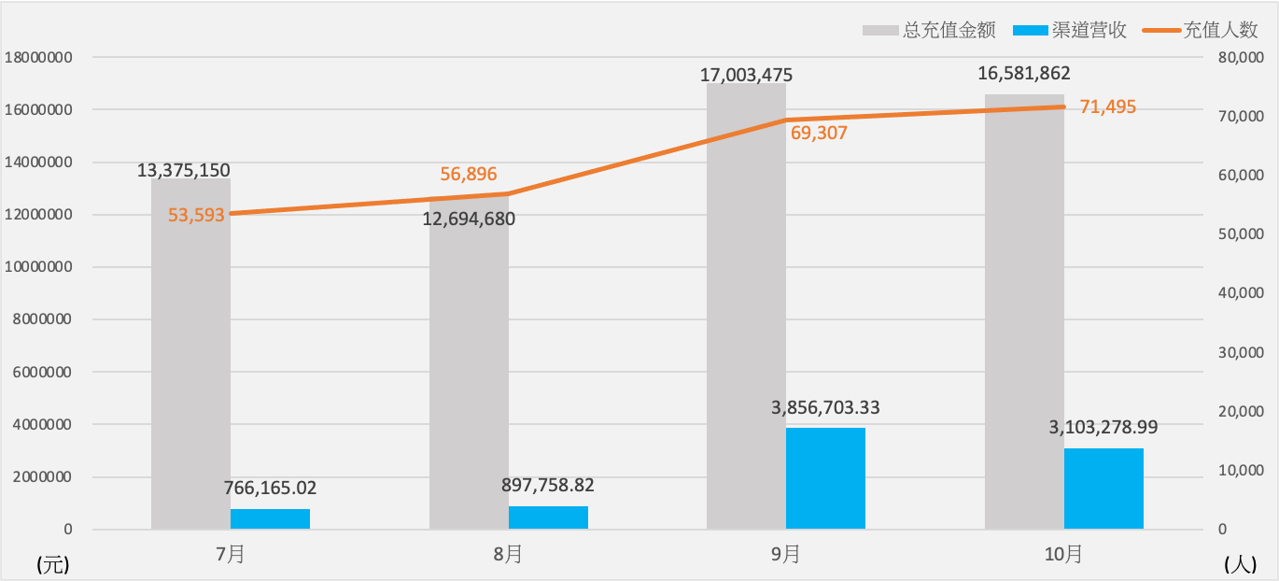

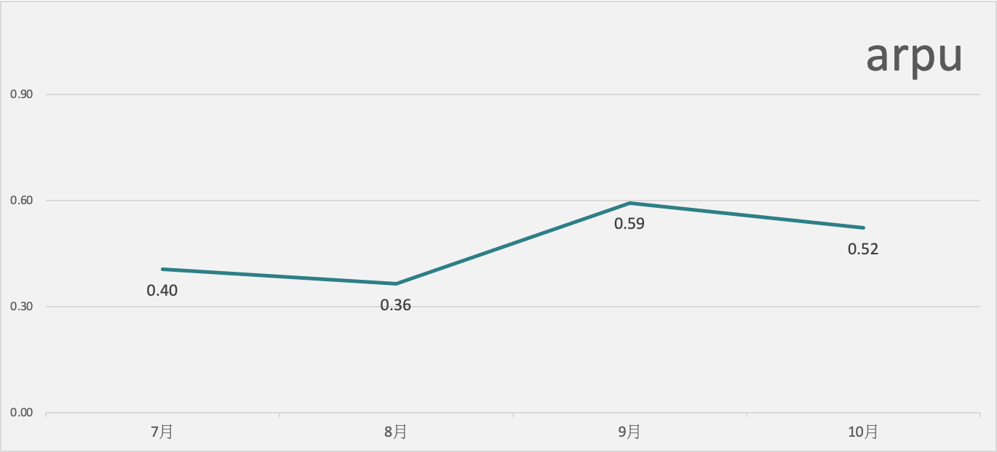

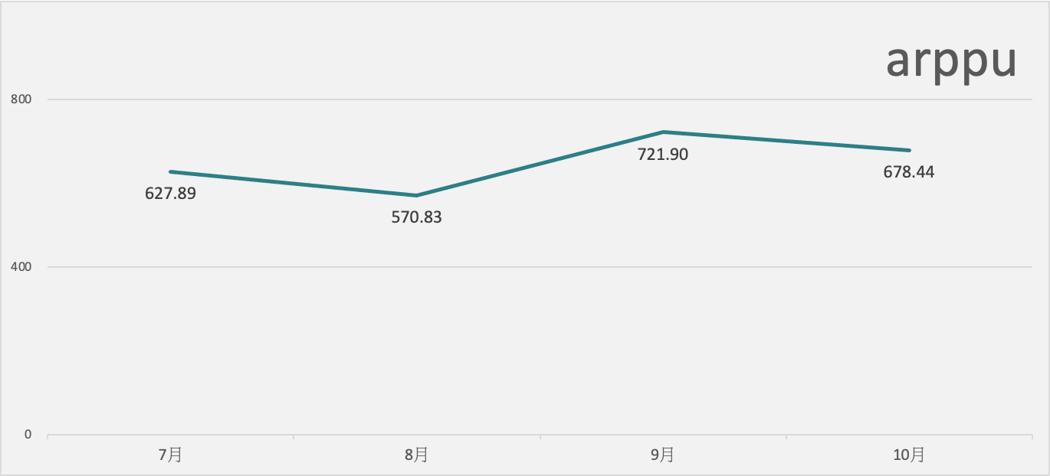

1. **四个月份走势图：**

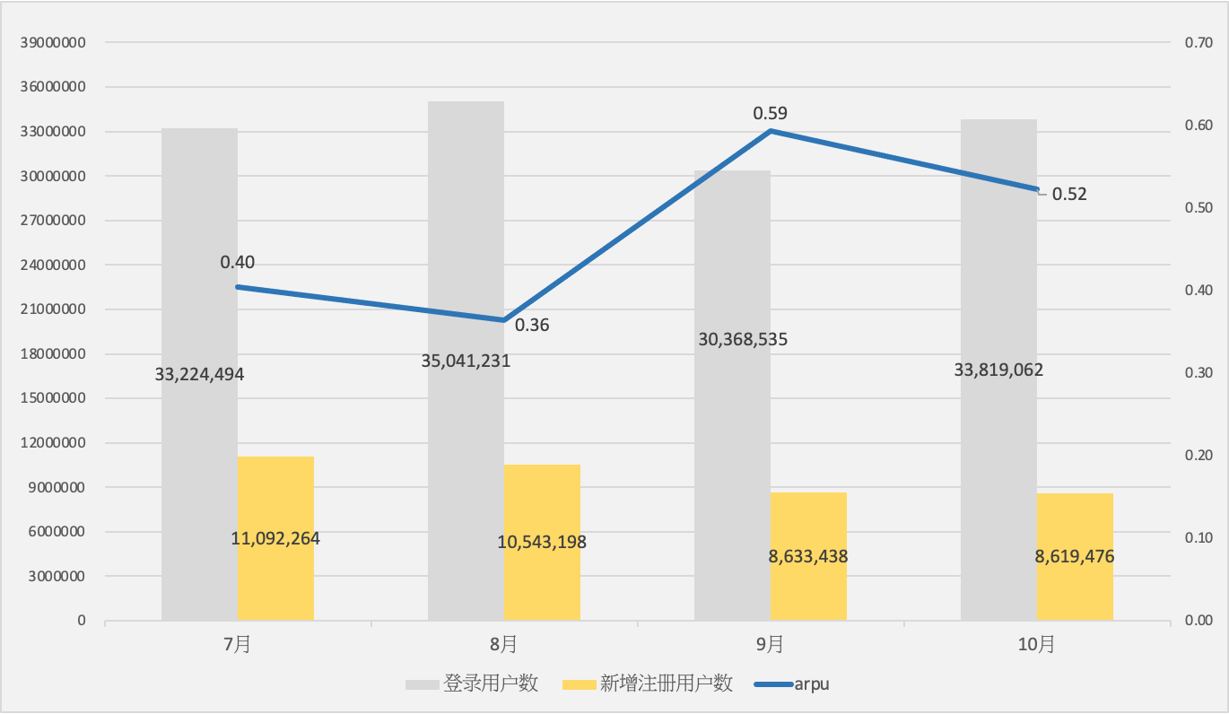

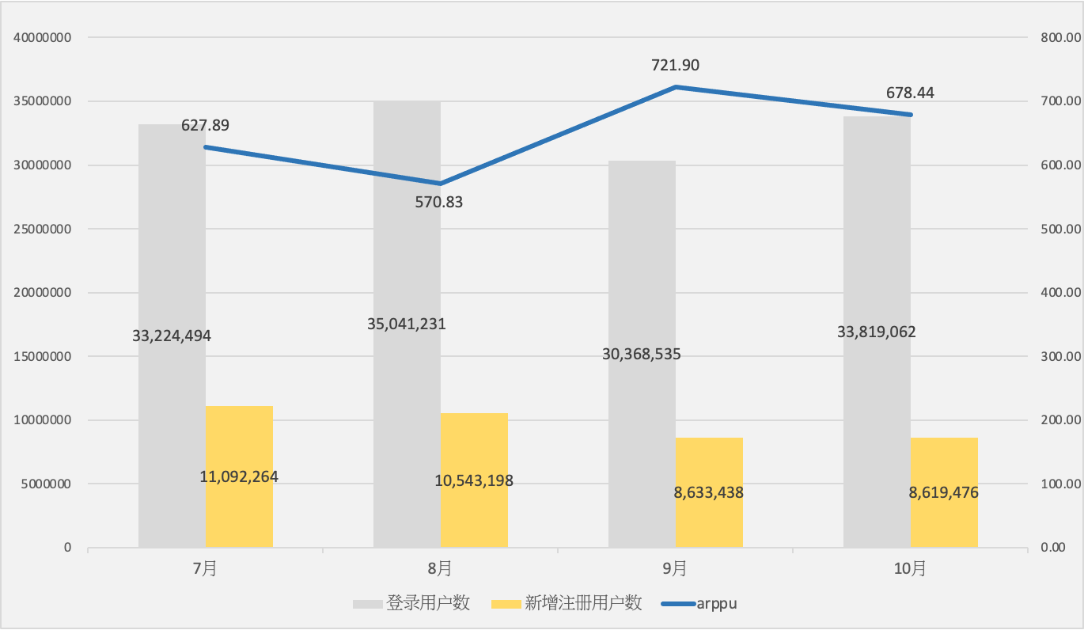

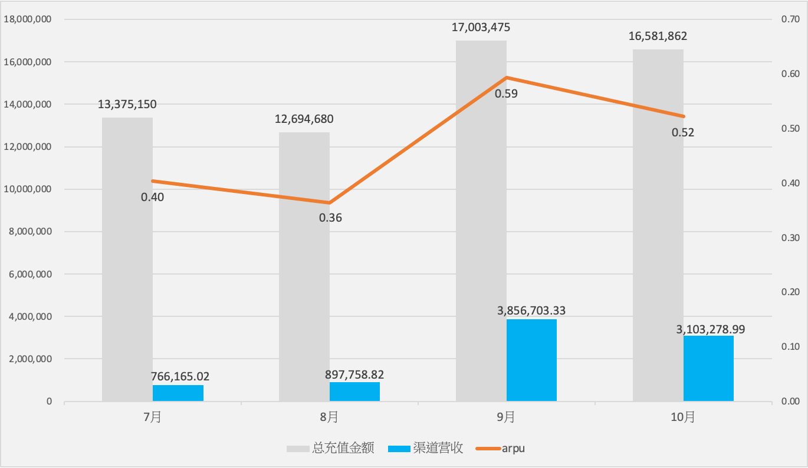

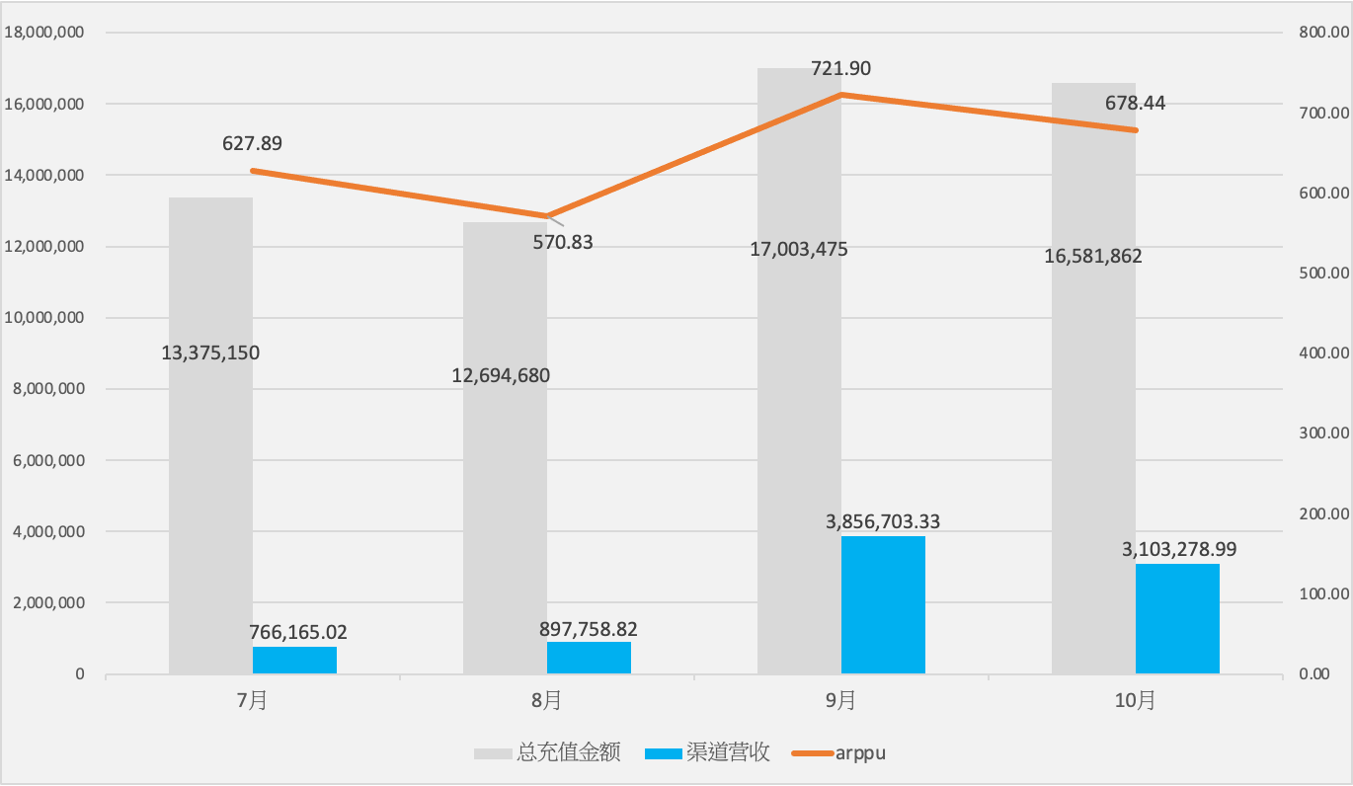

1. **近四个月份充值情况：**

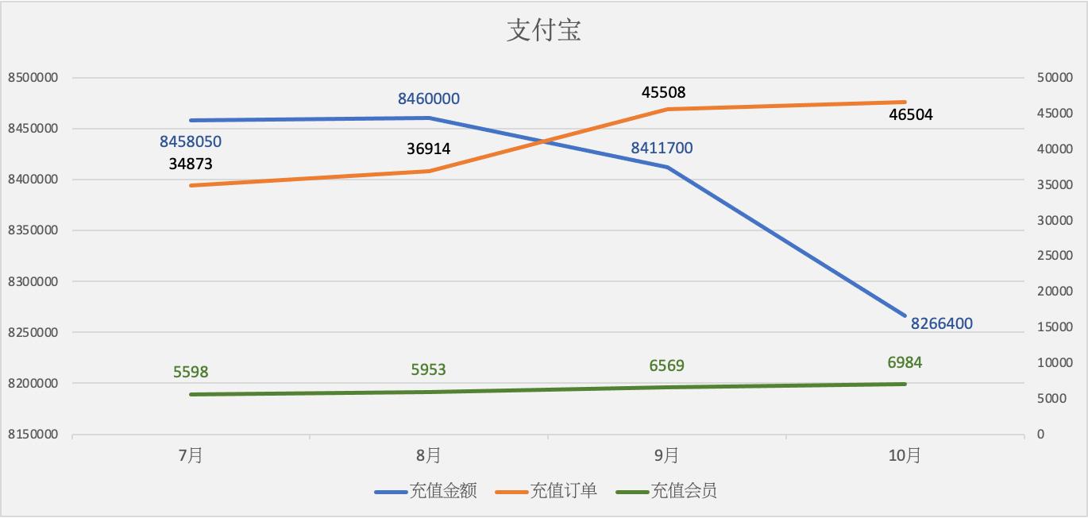

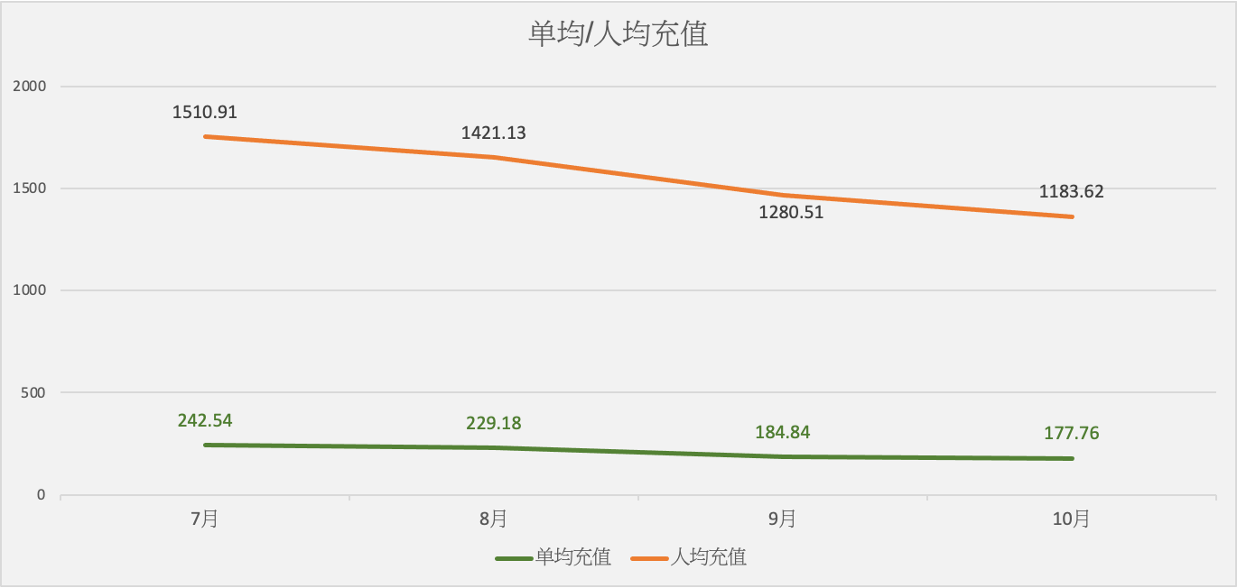

|  |  |  |  |  |  |  |  |  |  |  |
| --- | --- | --- | --- | --- | --- | --- | --- | --- | --- | --- |
| **支付宝** | **充值金额** | **充值订单** | **充值会员** | **单均充值** | **人均充值** | **金额同比** | **订单同比** | **会员同比** | **单均同比** | **人均同比** |
| 7月 | 8458050 | 34873 | 5598 | 242.54 | 1510.91 | 32.23% | 7.55% | 37.14% | 22.95% | -3.58% |
| 8月 | 8460000 | 36914 | 5953 | 229.18 | 1421.13 | 0.02% | 5.85% | 6.34% | -5.51% | -5.94% |
| 9月 | 8411700 | 45508 | 6569 | 184.84 | 1280.51 | -0.57% | 23.29% | 12.19% | -19.35% | -11.37% |
| 10月 | 8266400 | 46504 | 6984 | 177.76 | 1183.62 | -1.73% | 2.19% | 6.32% | -3.83% | -7.57% |

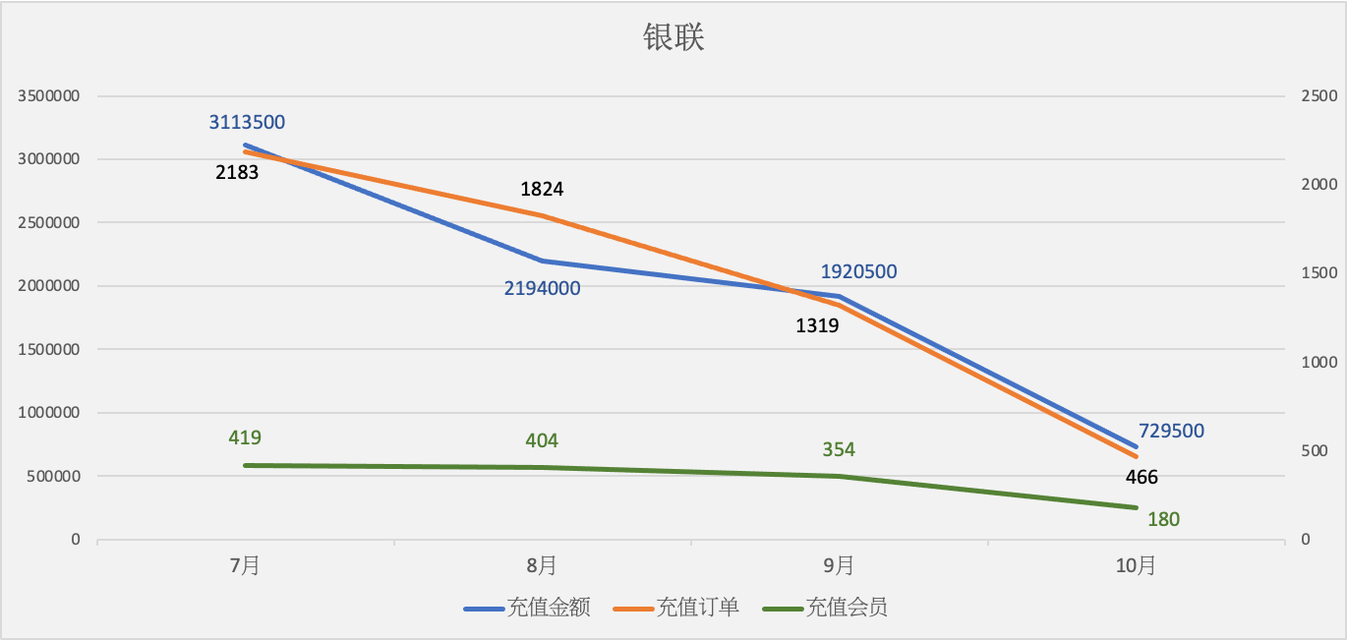

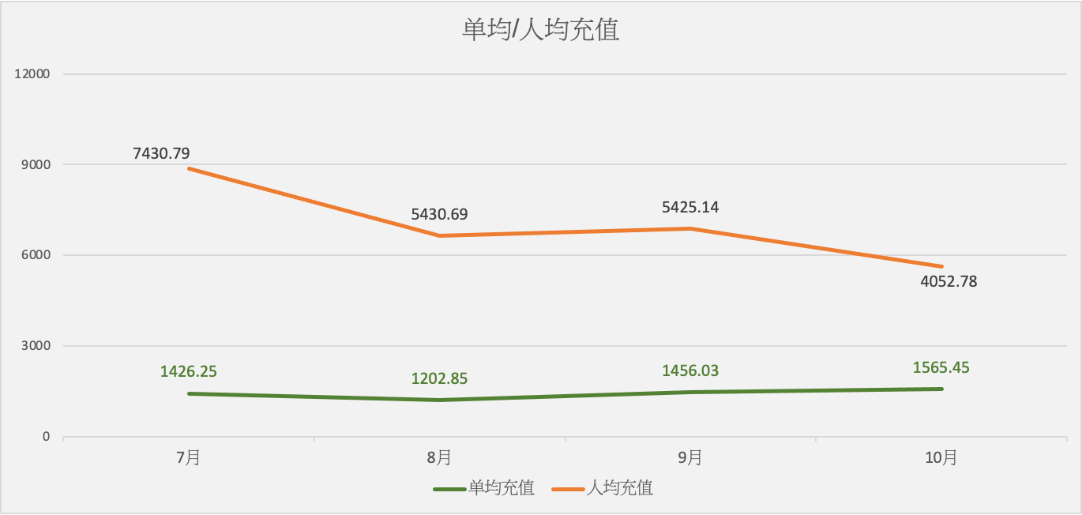

|  |  |  |  |  |  |  |  |  |  |  |
| --- | --- | --- | --- | --- | --- | --- | --- | --- | --- | --- |
| **银联** | **充值金额** | **充值订单** | **充值会员** | **单均充值** | **人均充值** | **金额同比** | **订单同比** | **会员同比** | **单均同比** | **人均同比** |
| 7月 | 3113500 | 2183 | 419 | 1426.25 | 7430.79 | -40.39% | -36.91% | -20.64% | -5.52% | -24.88% |
| 8月 | 2194000 | 1824 | 404 | 1202.85 | 5430.69 | -29.53% | -16.45% | -3.58% | -15.66% | -26.92% |
| 9月 | 1920500 | 1319 | 354 | 1456.03 | 5425.14 | -12.47% | -27.69% | -9.23% | 21.05% | -3.56% |
| 10月 | 729500 | 466 | 180 | 1565.45 | 4052.78 | -62.02% | -64.67% | -49.15% | 7.52% | -25.30% |

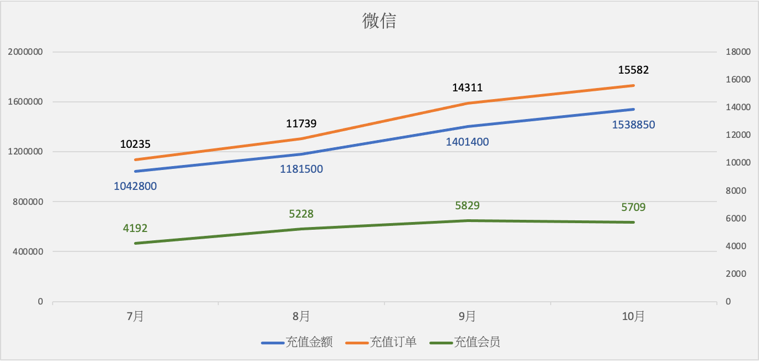

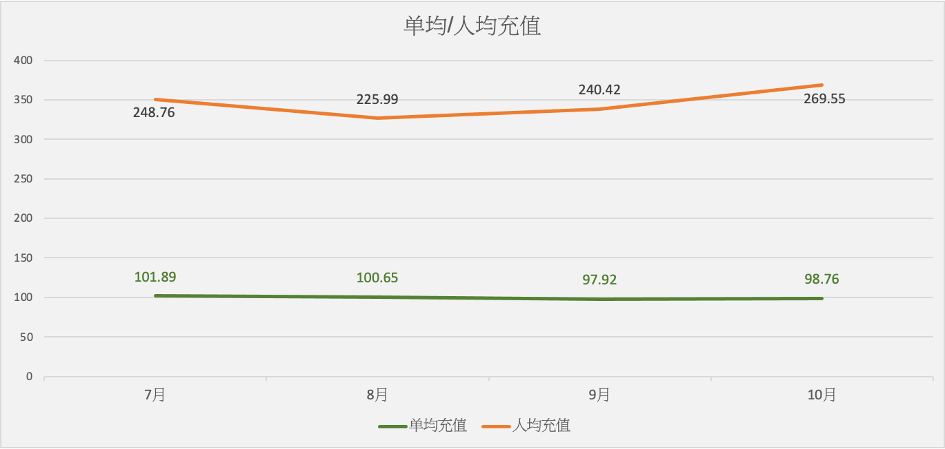

|  |  |  |  |  |  |  |  |  |  |  |
| --- | --- | --- | --- | --- | --- | --- | --- | --- | --- | --- |
| **微信** | **充值金额** | **充值订单** | **充值会员** | **单均充值** | **人均充值** | **金额同比** | **订单同比** | **会员同比** | **单均同比** | **人均同比** |
| 7月 | 1042800 | 10235 | 4192 | 101.89 | 248.76 | -12.41% | -4.64% | 36.64% | -8.14% | -35.89% |
| 8月 | 1181500 | 11739 | 5228 | 100.65 | 225.99 | 13.30% | 14.69% | 24.71% | -1.22% | -9.15% |
| 9月 | 1401400 | 14311 | 5829 | 97.92 | 240.42 | 18.61% | 21.91% | 12.49% | -2.71% | 5.45% |
| 10月 | 1538850 | 15582 | 5709 | 98.76 | 269.55 | 9.81% | 8.88% | -2.06% | 0.85% | 12.12% |

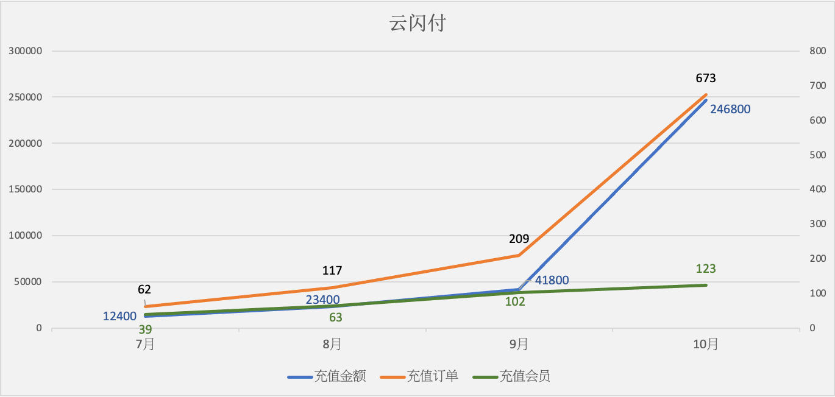

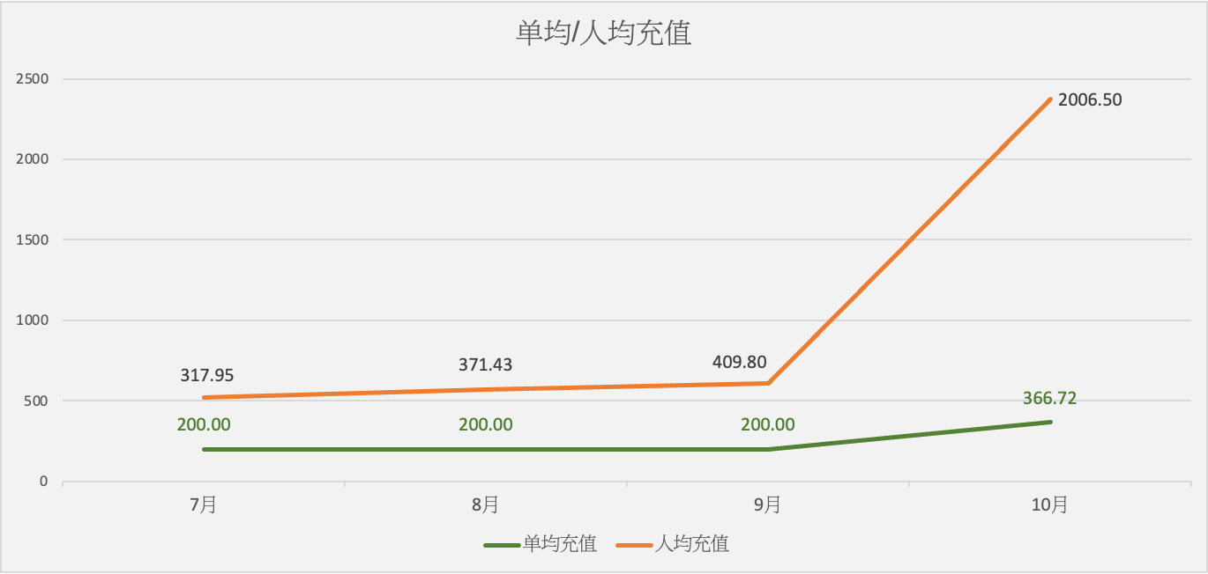

|  |  |  |  |  |  |  |  |  |  |  |
| --- | --- | --- | --- | --- | --- | --- | --- | --- | --- | --- |
| **云闪付** | **充值金额** | **充值订单** | **充值会员** | **单均充值** | **人均充值** | **金额同比** | **订单同比** | **会员同比** | **单均同比** | **人均同比** |
| 7月 | 12400 | 62 | 39 | 200.00 | 317.95 | -89.71% | -88.28% | -65.18% | -12.20% | -70.45% |
| 8月 | 23400 | 117 | 63 | 200.00 | 371.43 | 88.71% | 88.71% | 61.54% | 0.00% | 16.82% |
| 9月 | 41800 | 209 | 102 | 200.00 | 409.80 | 78.63% | 78.63% | 64.52% | 0.00% | 8.58% |
| 10月 | 246800 | 673 | 123 | 366.72 | 2006.50 | 490.43% | 222.01% | 20.59% | 83.36% | 389.63% |

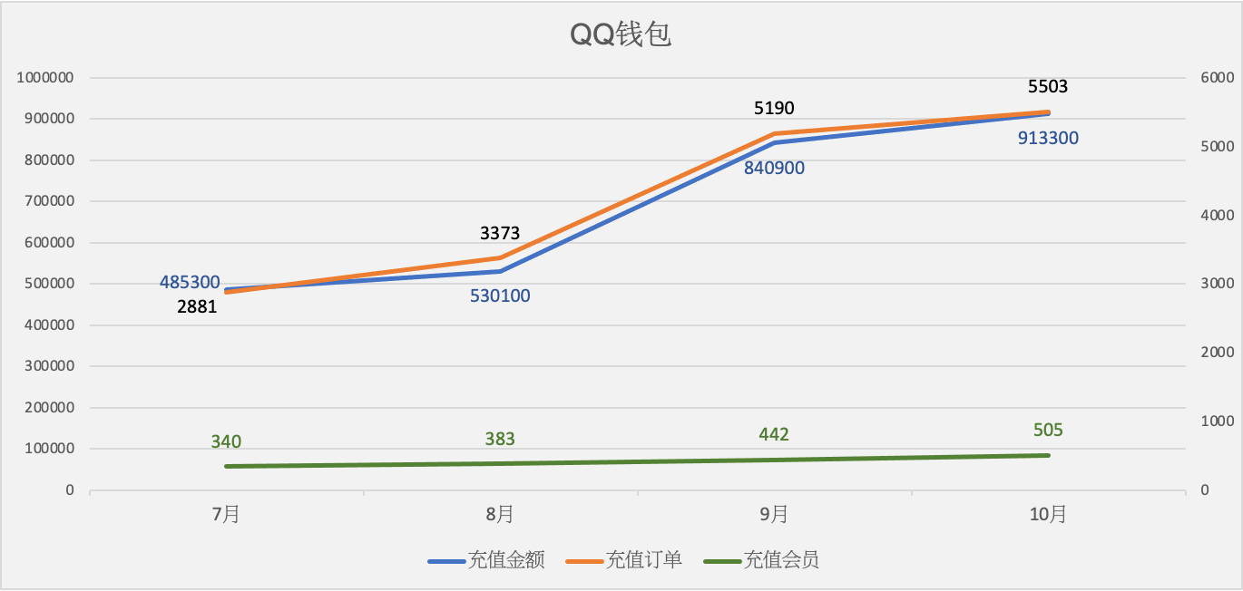

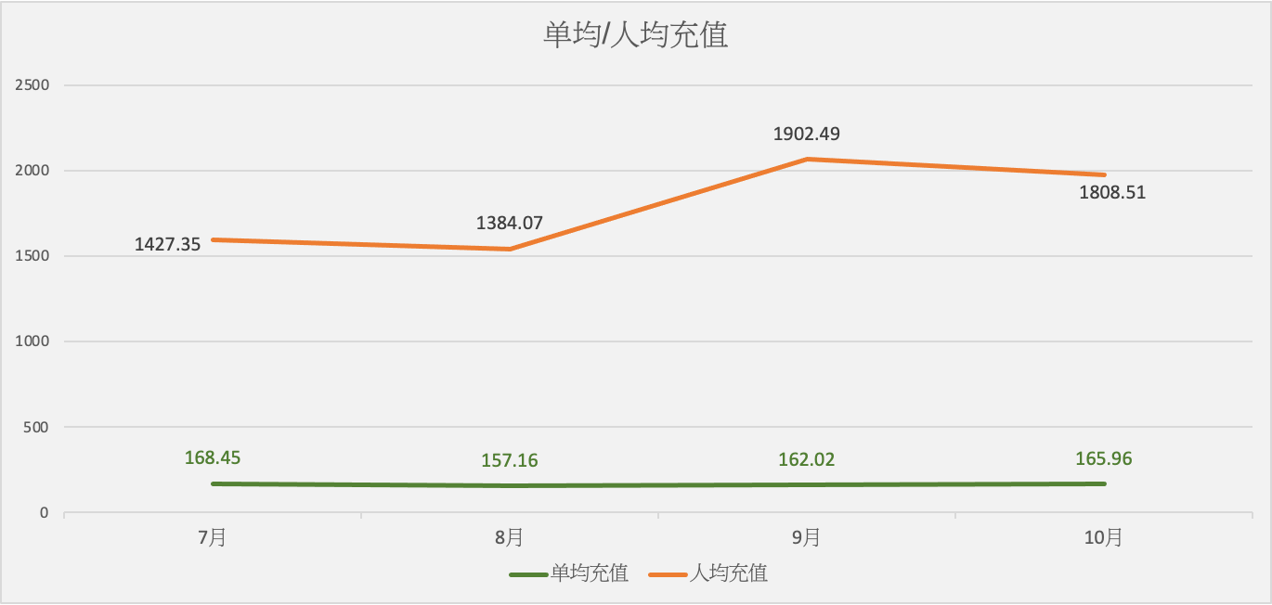

|  |  |  |  |  |  |  |  |  |  |  |
| --- | --- | --- | --- | --- | --- | --- | --- | --- | --- | --- |
| **QQ钱包** | **充值金额** | **充值订单** | **充值会员** | **单均充值** | **人均充值** | **金额同比** | **订单同比** | **会员同比** | **单均同比** | **人均同比** |
| 7月 | 485300 | 2881 | 340 | 168.45 | 1427.35 | -4.13% | -4.09% | 10.03% | -0.04% | -12.87% |
| 8月 | 530100 | 3373 | 383 | 157.16 | 1384.07 | 9.23% | 17.08% | 12.65% | -6.70% | -3.03% |
| 9月 | 840900 | 5190 | 442 | 162.02 | 1902.49 | 58.63% | 53.87% | 17.87% | 3.09% | 34.58% |
| 10月 | 913300 | 5503 | 505 | 165.96 | 1808.51 | 8.61% | 6.03% | 14.25% | 2.43% | -4.94% |

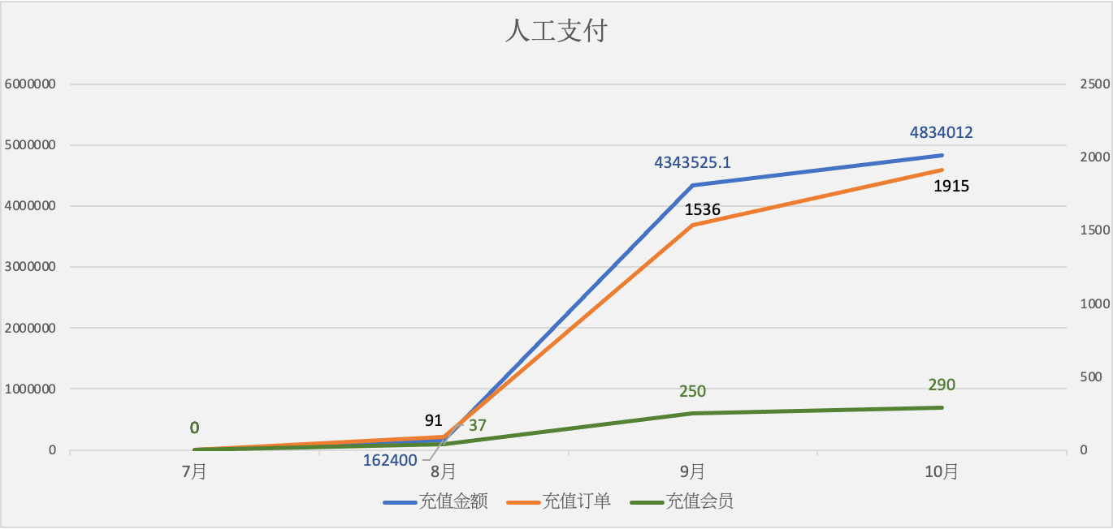

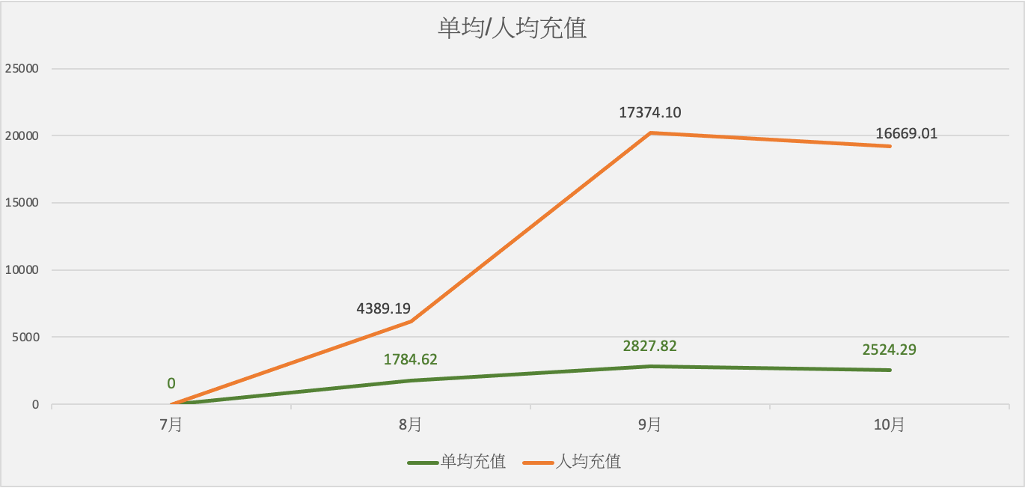

|  |  |  |  |  |  |  |  |  |  |  |
| --- | --- | --- | --- | --- | --- | --- | --- | --- | --- | --- |
| **人工支付** | **充值金额** | **充值订单** | **充值会员** | **单均充值** | **人均充值** | **金额同比** | **订单同比** | **会员同比** | **单均同比** | **人均同比** |
| 7月 | - | - | - | - | - | - | - | - | - | - |
| 8月 | 162400 | 91 | 37 | 1784.62 | 4389.19 | - | - | - | - | - |
| 9月 | 4343525.1 | 1536 | 250 | 2827.82 | 17374.10 | 2574.58% | 1587.91% | 410.20% | 58.46% | 424.22% |
| 10月 | 4834012 | 1915 | 290 | 2524.29 | 16669.01 | 11.29% | 24.67% | 16.00% | -10.73% | -4.06% |

1. **9月-10月环比分析**

|  |
| --- |
| 备 注  1.↑↓为描述整体数据增长值  2.异常描述：0.00％-30.00％标注为上升（下降），30.01％-90.00％标注为大幅上升（下降），90.01％以上标注为极大幅上升（下降） |
| (1) 登录用户数30368535上升11.36%至33819062(↑3450527人)  (2) 新增注册用户8633438下降0.16%至8619476(↓13962人)  (3) 渠道营收3856703.33下降19.54%至3103278.99(↓753424.34元)  (4) 充值人数69307上升3.16%至71495(↑2188人)  (5) 总充值金额17003475.1下降2.48%至16581862(↓421613元) |
| (1) 次日留存16.98%下降0.92%至16.82%(↓0.16%)  (2) 三日留存9.10%下降0.75%至9.03%(↓0.07%)  (3) 七日留存7.14%下降14.18%至6.13%(↓1.01%)  (4) arpu 0.59下降11.98%至0.52(↓0.07元)  (5) arppu 721.90下降6.02%至678.44(↓43.46元) |