**2023/11/5 91免费版日报统计**

|  |  |  |  |  |  |
| --- | --- | --- | --- | --- | --- |
| **部门名称** | **部门负责人** | **数据来源** | **报告负责人** | **制作日期** | **提交日期** |
| **数据部** | **林冲** | **后台** | **慧娟** | **2023/11/6** | **2023/11/6** |

1. **数据用户、金额加总走势图：**

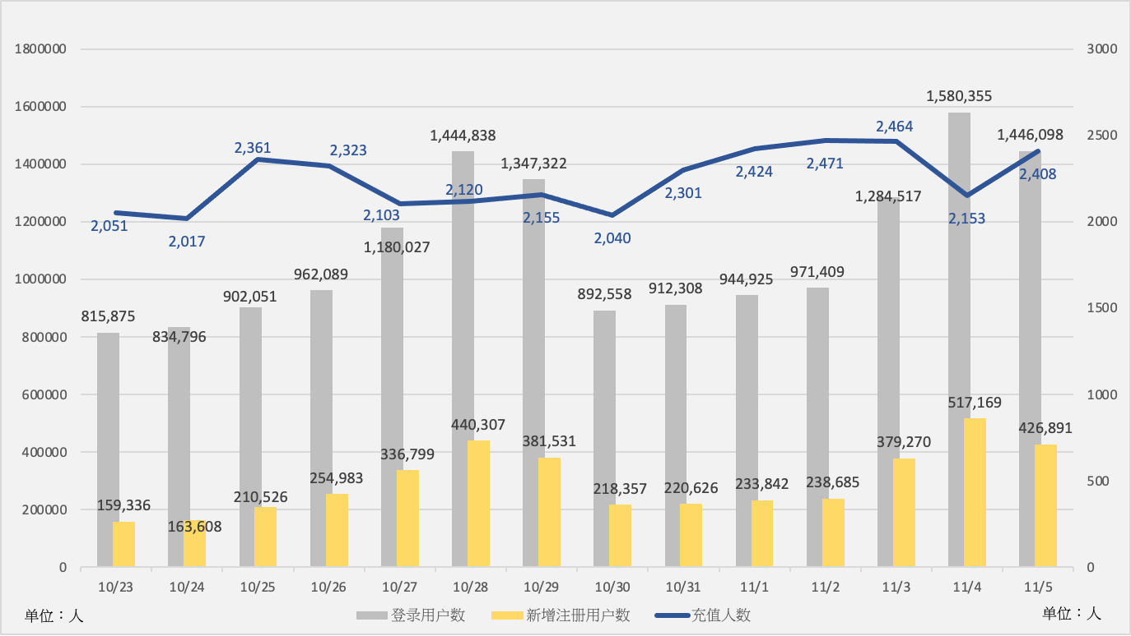

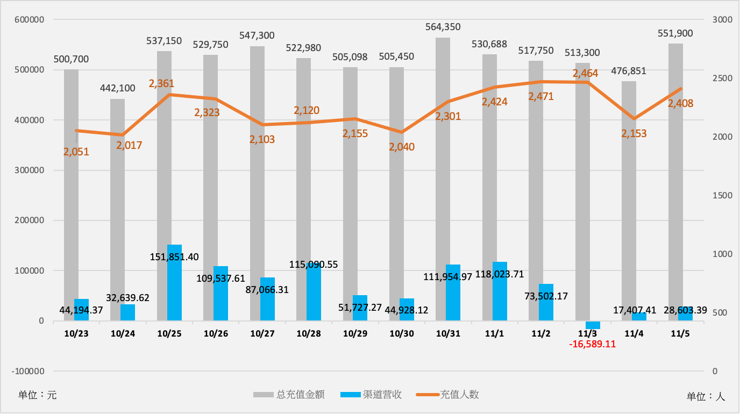

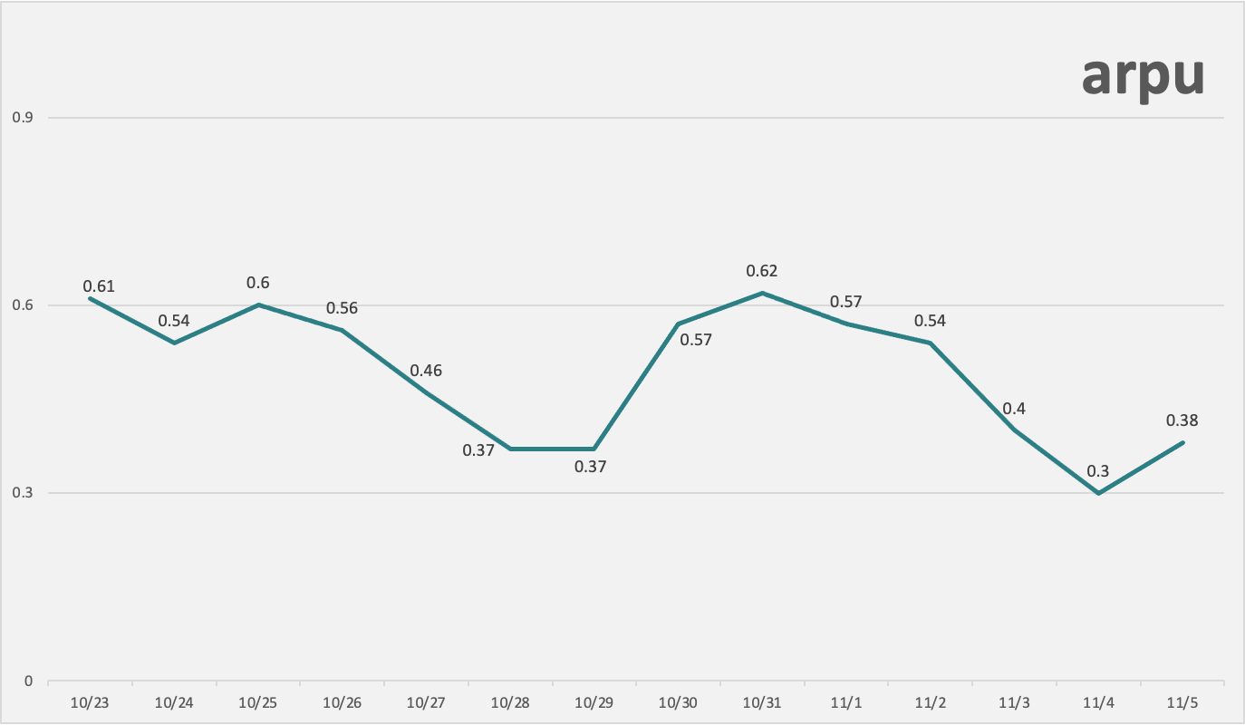

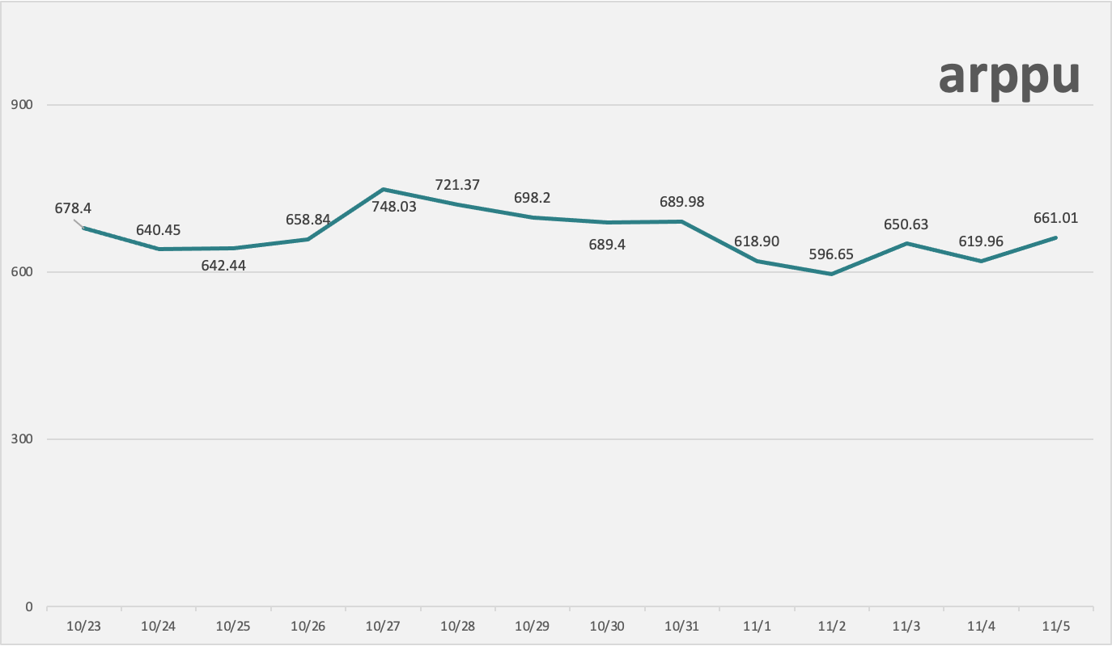

**（二）近七日走势图：**

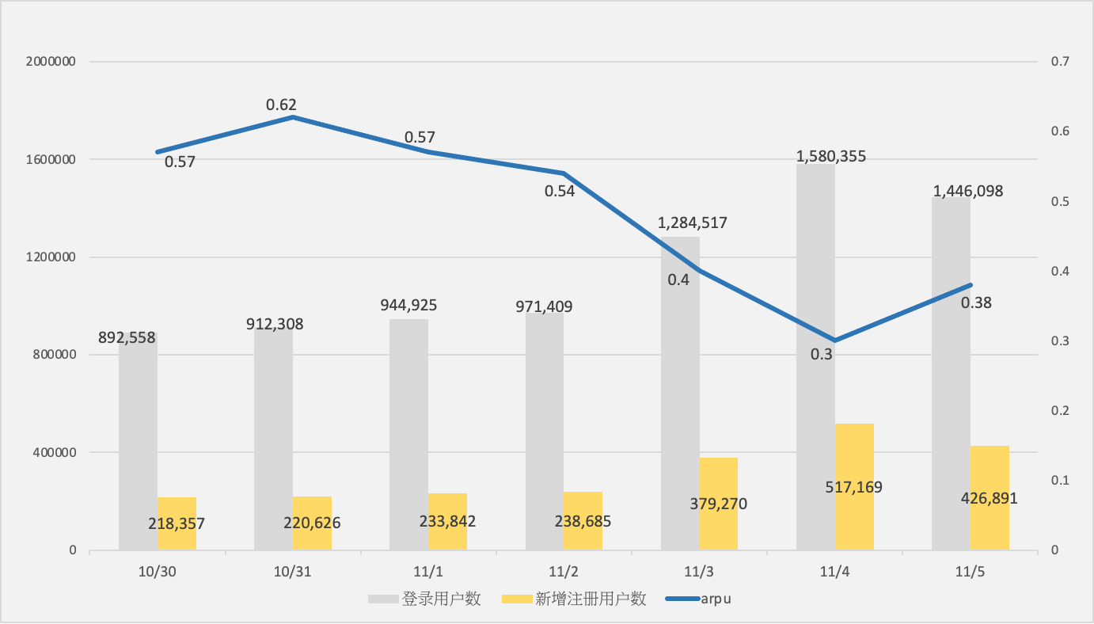

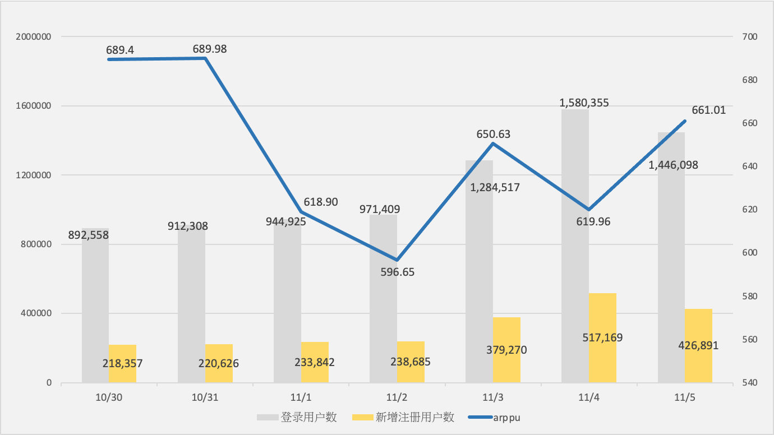

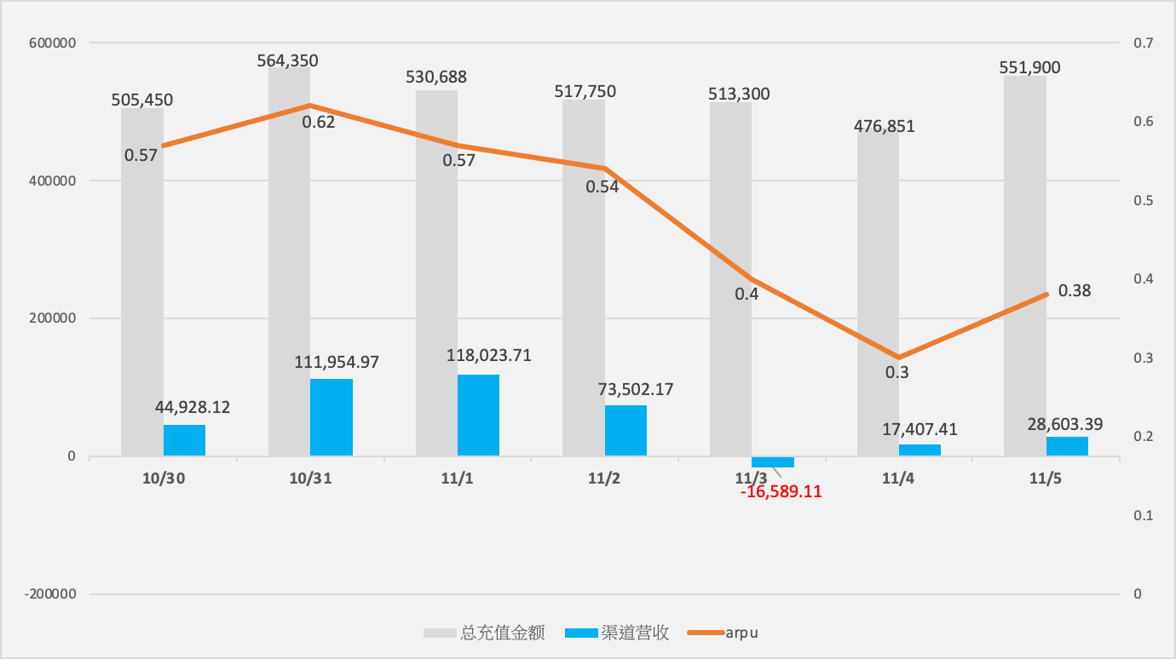

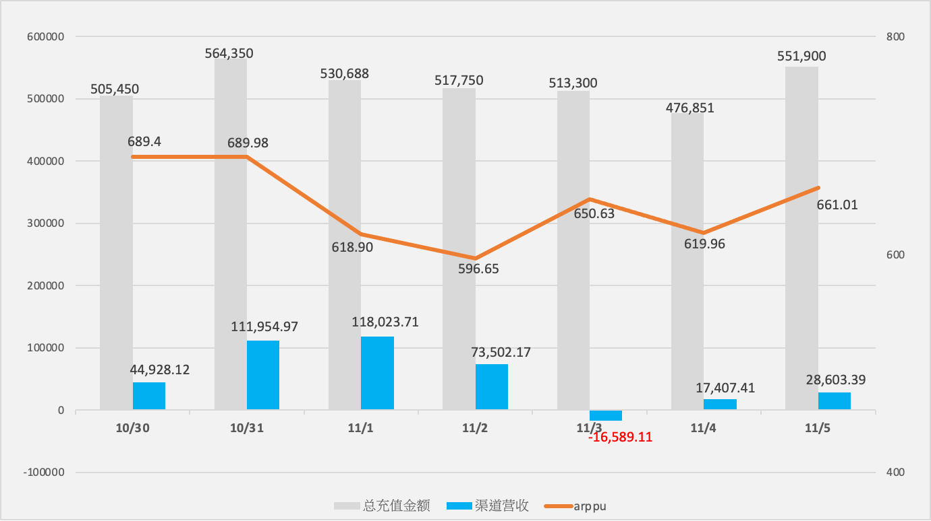

**（三）近七日充值情况：**

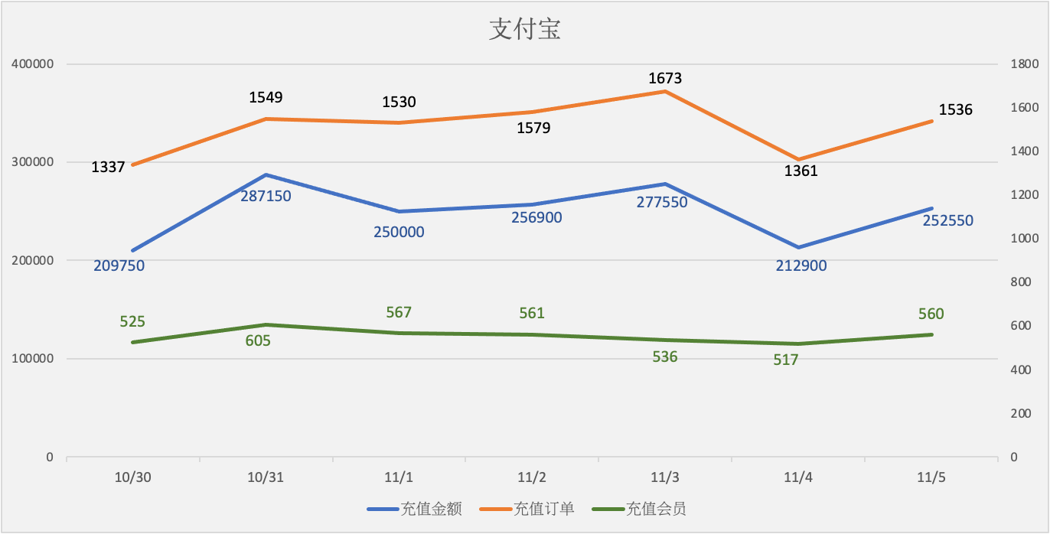

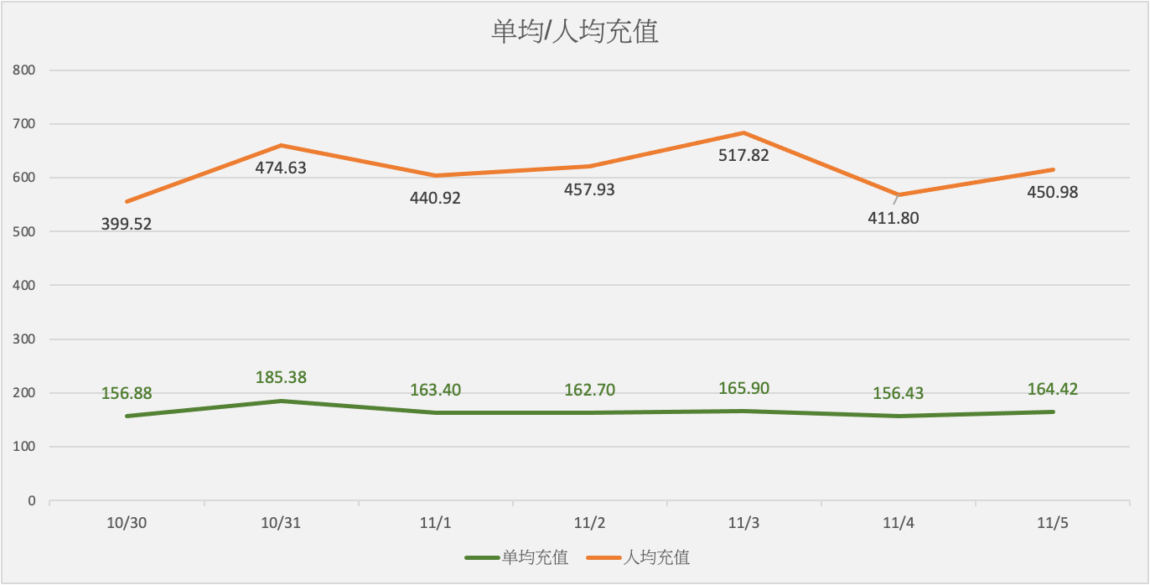

|  |  |  |  |  |  |  |  |  |  |  |
| --- | --- | --- | --- | --- | --- | --- | --- | --- | --- | --- |
| **支付宝** | **充值金额** | **充值订单** | **充值会员** | **单均充值** | **人均充值** | **金额同比** | **订单同比** | **会员同比** | **单均同比** | **人均同比** |
| 10/30 | 209750 | 1337 | 525 | 156.88 | 399.52 | -5.56% | -3.54% | 3.35% | -2.10% | -8.62% |
| 10/31 | 287150 | 1549 | 605 | 185.38 | 474.63 | 36.90% | 15.86% | 15.24% | 18.16% | 18.80% |
| 11/1 | 250000 | 1530 | 567 | 163.40 | 440.92 | -12.94% | -1.23% | -6.28% | -11.86% | -7.10% |
| 11/2 | 256900 | 1579 | 561 | 162.70 | 457.93 | 2.76% | 3.20% | -1.06% | -0.43% | 3.86% |
| 11/3 | 277550 | 1673 | 536 | 165.90 | 517.82 | 8.04% | 5.95% | -4.46% | 1.97% | 13.08% |
| 11/4 | 212900 | 1361 | 517 | 156.43 | 411.80 | -23.29% | -18.65% | -3.54% | -5.71% | -20.47% |
| 11/5 | 252550 | 1536 | 560 | 164.42 | 450.98 | 18.62% | 12.86% | 8.32% | 5.11% | 9.52% |

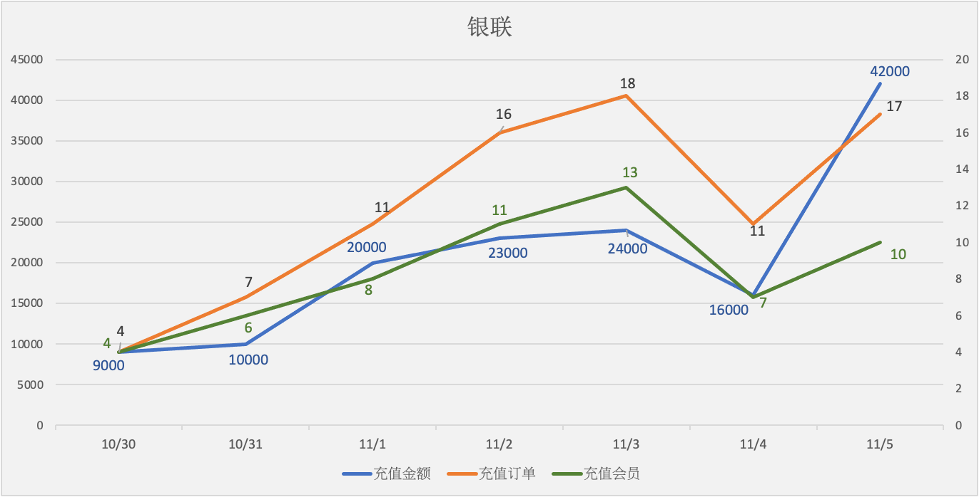

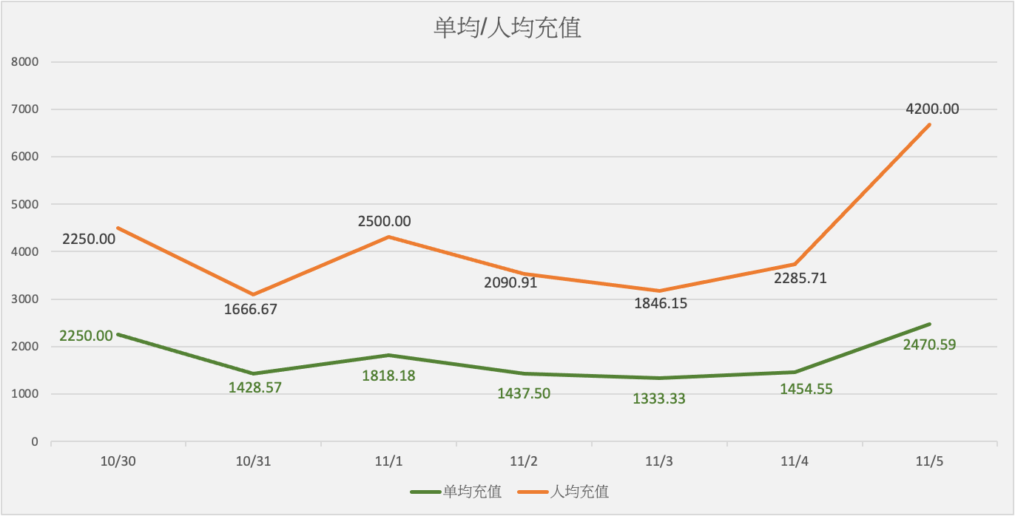

|  |  |  |  |  |  |  |  |  |  |  |
| --- | --- | --- | --- | --- | --- | --- | --- | --- | --- | --- |
| **银联** | **充值金额** | **充值订单** | **充值会员** | **单均充值** | **人均充值** | **金额同比** | **订单同比** | **会员同比** | **单均同比** | **人均同比** |
| 10/30 | 9000 | 4 | 4 | 2250.00 | 2250.00 | 12.50% | -50.00% | -42.86% | 125.00% | 96.88% |
| 10/31 | 10000 | 7 | 6 | 1428.57 | 1666.67 | 11.11% | 75.00% | 50.00% | -36.51% | -25.93% |
| 11/1 | 20000 | 11 | 8 | 1818.18 | 2500.00 | 100.00% | 57.14% | 33.33% | 27.27% | 50.00% |
| 11/2 | 23000 | 16 | 11 | 1437.50 | 2090.91 | 15.00% | 45.45% | 37.50% | -20.94% | -16.36% |
| 11/3 | 24000 | 18 | 13 | 1333.33 | 1846.15 | 4.35% | 12.50% | 18.18% | -7.25% | -11.71% |
| 11/4 | 16000 | 11 | 7 | 1454.55 | 2285.71 | -33.33% | -38.89% | -46.15% | 9.09% | 23.81% |
| 11/5 | 42000 | 17 | 10 | 2470.59 | 4200.00 | 162.50% | 54.55% | 42.86% | 69.85% | 83.75% |

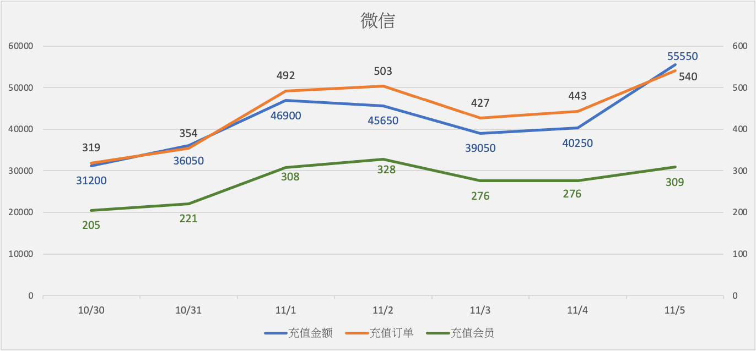

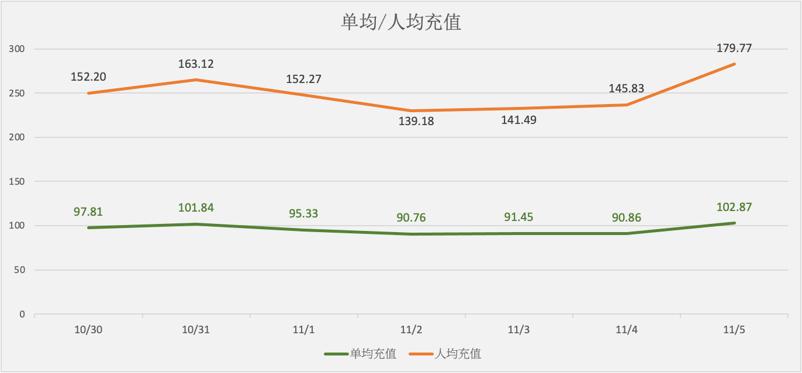

|  |  |  |  |  |  |  |  |  |  |  |
| --- | --- | --- | --- | --- | --- | --- | --- | --- | --- | --- |
| **微信** | **充值金额** | **充值订单** | **充值会员** | **单均充值** | **人均充值** | **金额同比** | **订单同比** | **会员同比** | **单均同比** | **人均同比** |
| 10/30 | 31200 | 319 | 205 | 97.81 | 152.20 | 13.04% | 4.93% | -1.91% | 7.73% | 15.25% |
| 10/31 | 36050 | 354 | 221 | 101.84 | 163.12 | 15.54% | 10.97% | 7.80% | 4.12% | 7.18% |
| 11/1 | 46900 | 492 | 308 | 95.33 | 152.27 | 30.10% | 38.98% | 39.37% | -6.39% | -6.65% |
| 11/2 | 45650 | 503 | 328 | 90.76 | 139.18 | -2.67% | 2.24% | 6.49% | -4.79% | -8.60% |
| 11/3 | 39050 | 427 | 276 | 91.45 | 141.49 | -14.46% | -15.11% | -15.85% | 0.77% | 1.66% |
| 11/4 | 40250 | 443 | 276 | 90.86 | 145.83 | 3.07% | 3.75% | 0.00% | -0.65% | 3.07% |
| 11/5 | 55550 | 540 | 309 | 102.87 | 179.77 | 38.01% | 21.90% | 11.96% | 13.22% | 23.27% |

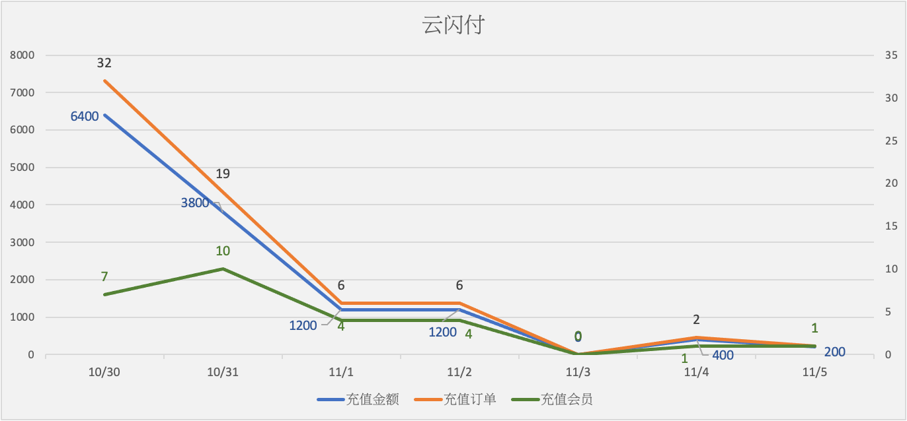

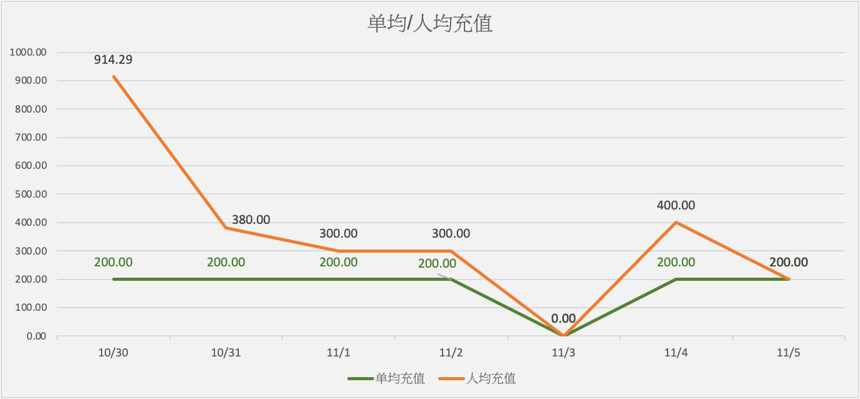

|  |  |  |  |  |  |  |  |  |  |  |
| --- | --- | --- | --- | --- | --- | --- | --- | --- | --- | --- |
| **云闪付** | **充值金额** | **充值订单** | **充值会员** | **单均充值** | **人均充值** | **金额同比** | **订单同比** | **会员同比** | **单均同比** | **人均同比** |
| 10/30 | 6400 | 32 | 7 | 200.00 | 914.29 | 68.42% | 68.42% | 16.67% | 0.00% | 44.36% |
| 10/31 | 3800 | 19 | 10 | 200.00 | 380.00 | -40.63% | -40.63% | 42.86% | 0.00% | -58.44% |
| 11/1 | 1200 | 6 | 4 | 200.00 | 300.00 | -68.42% | -68.42% | -60.00% | 0.00% | -21.05% |
| 11/2 | 1200 | 6 | 4 | 200.00 | 300.00 | 0.00% | 0.00% | 0.00% | 0.00% | 0.00% |
| 11/3 | 0 | 0 | 0 | 0.00 | 0.00 | -100.00% | -100.00% | -100.00% | -100.00% | -100.00% |
| 11/4 | 400 | 2 | 1 | 200.00 | 400.00 | 40000.00% | 200.00% | 100.00% | 20000.00% | 40000.00% |
| 11/5 | 200 | 1 | 1 | 200.00 | 200.00 | -50.00% | -50.00% | 0.00% | 0.00% | -50.00% |

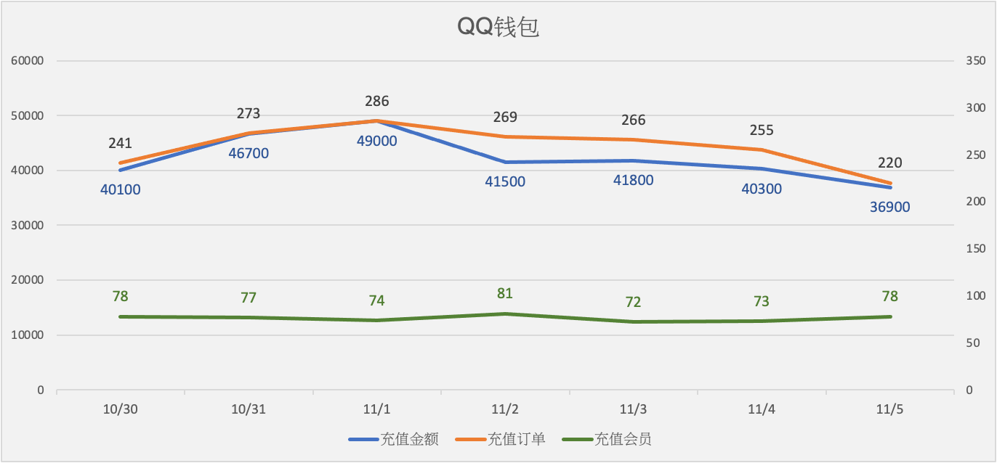

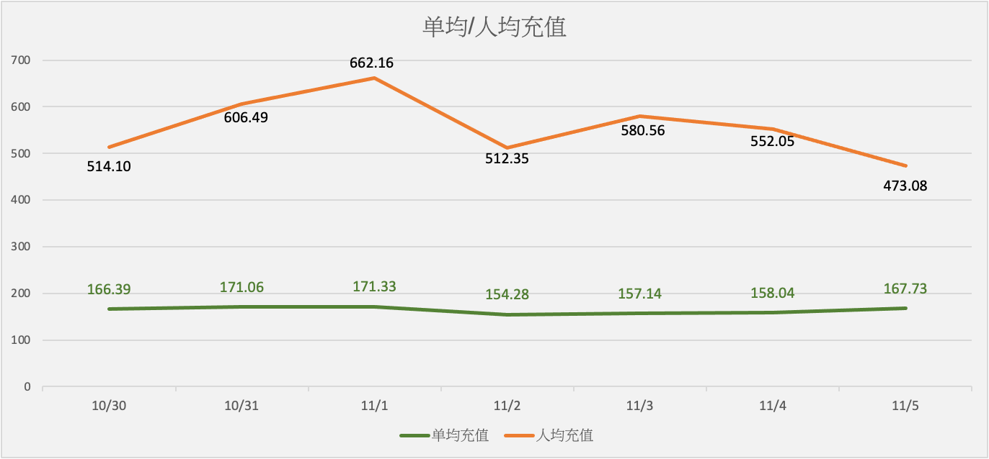

|  |  |  |  |  |  |  |  |  |  |  |
| --- | --- | --- | --- | --- | --- | --- | --- | --- | --- | --- |
| **QQ钱包** | **充值金额** | **充值订单** | **充值会员** | **单均充值** | **人均充值** | **金额同比** | **订单同比** | **会员同比** | **单均同比** | **人均同比** |
| 10/30 | 40100 | 241 | 78 | 166.39 | 514.10 | -29.15% | -29.12% | 5.41% | -0.05% | -32.79% |
| 10/31 | 46700 | 273 | 77 | 171.06 | 606.49 | 16.46% | 13.28% | -1.28% | 2.81% | 17.97% |
| 11/1 | 49000 | 286 | 74 | 171.33 | 662.16 | 4.93% | 4.76% | -3.90% | 0.16% | 9.18% |
| 11/2 | 41500 | 269 | 81 | 154.28 | 512.35 | -15.31% | -5.94% | 9.46% | -9.95% | -22.63% |
| 11/3 | 41800 | 266 | 72 | 157.14 | 580.56 | 0.72% | -1.12% | -11.11% | 1.86% | 13.31% |
| 11/4 | 40300 | 255 | 73 | 158.04 | 552.05 | -3.59% | -4.14% | 1.39% | 0.57% | -4.91% |
| 11/5 | 36900 | 220 | 78 | 167.73 | 473.08 | -8.44% | -13.73% | 6.85% | 6.13% | -14.31% |

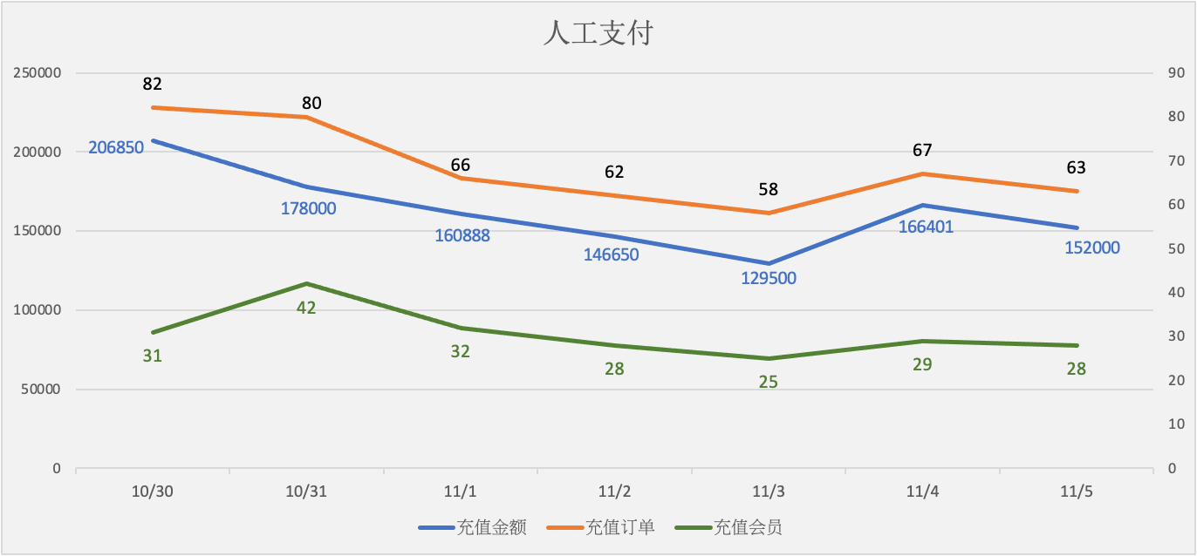

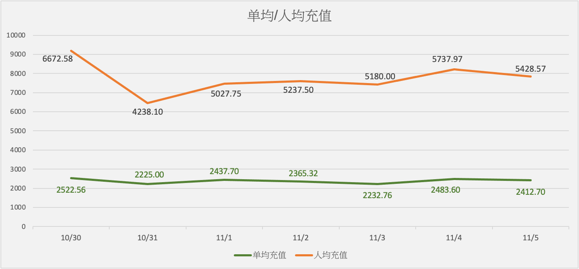

|  |  |  |  |  |  |  |  |  |  |  |
| --- | --- | --- | --- | --- | --- | --- | --- | --- | --- | --- |
| **人工支付** | **充值金额** | **充值订单** | **充值会员** | **单均充值** | **人均充值** | **金额同比** | **订单同比** | **会员同比** | **单均同比** | **人均同比** |
| 10/30 | 206850 | 82 | 31 | 2522.56 | 6672.58 | 13.47% | 12.33% | -3.13% | 1.01% | 17.13% |
| 10/31 | 178000 | 80 | 42 | 2225.00 | 4238.10 | -13.95% | -2.44% | 35.48% | -11.80% | -36.48% |
| 11/1 | 160888 | 66 | 32 | 2437.70 | 5027.75 | -9.61% | -17.50% | -23.81% | 9.56% | 18.63% |
| 11/2 | 146650 | 62 | 28 | 2365.32 | 5237.50 | -8.85% | -6.06% | -12.50% | -2.97% | 4.17% |
| 11/3 | 129500 | 58 | 25 | 2232.76 | 5180.00 | -11.69% | -6.45% | -10.71% | -5.60% | -1.10% |
| 11/4 | 166401 | 67 | 29 | 2483.60 | 5737.97 | 28.49% | 15.52% | 16.00% | 11.23% | 10.77% |
| 11/5 | 152000 | 63 | 28 | 2412.70 | 5428.57 | -8.65% | -5.97% | -3.45% | -2.85% | -5.39% |

**（四）文字数据分析：**

|  |
| --- |
| 备 注  1.↑↓为描述整体数据增长值  2.异常描述：0.00％-30.00％标注为上升（下降），30.01％-90.00％标注为大幅上升（下降），90.01％以上标注为极大幅上升（下降） |
| 1. 登录用户数下降8.50%（↓134257人）至1446098人；   较近七天（10/30 - 11/05）的平均约1147453上升26.03%（↑298645人)   1. 新增注册用户数下降17.46%（↓90278人）至426891人；   较近七天（10/30 - 11/05）的平均约319263大幅上升33.71%（↑107628人)   1. 充值人数上升11.84%（↑255人）至2408人；较近七天（10/30 - 11/05）的平均约2323上升3.66%（↑85人) 2. 总充值金额上升15.74%（↑75049元）至551900元；   较近七天（10/30 - 11/05)的平均约522898上升5.55%（↑29002.00元）   1. 渠道营收大幅上升64.32%（↑11195.98元）至28603.39元；   较近七天（10/30 - 11/05）的平均约53975.81大幅下降47.01%（↓25372.42元) |
| 1. 次日留存下降22.33%（↓4.99%）至17.36%；较近七天（10/30 - 11/05）的平均约17.69%下降1.85%（↓0.33%) 2. 三日留存下降6.01%（↓0.69%）至10.80%；较近七天（10/30 - 11/05）的平均约10.09%上升7.04%（↑0.71%) 3. 七日留存下降21.38%（↓2.67%）至9.82%；较近七天（10/30 - 11/05）的平均约9.81%上升0.10%（↑0.01%) 4. arpu上升26.67%（↑0.08元）至0.38元；较近七天（10/30 - 11/05）的平均约0.48 下降21.30%（↓0.10元) 5. arppu上升6.62%（↑41.05元）至661.01元；   较近七天（10/30 - 11/05）的平均约646.65 上升2.22%（↑14.36元) |