Skúli Arnarsson skulia15
Darri Valgarðsson darriv15

(1) (15%) Problem X (Weighted graphs) in the final exam 2015. DONE

(2) (10%) Suppose the weight of every edge in a weighted graph is decreased by one. Explain (in 20 words or less) why the MST computed by Kruskal does not change.
It finds an edge with the least possible weight, decreasing the weight of every edge doesn‘t change the relative weigth.

(3) (15%) Problem V (Sorting algorithms) in the final exam 2015. DONE

(4) (15%) Problem IX (Ternary Search Tries) in the final exam 2015. DONE

(5) (15%) Construct a set S of strings in lowercase (R = 26) for which the R-way trie uses space (in words) less than the total number of characters in strings in S. (The number of characters in the set {abc, bcd,aabd} is 10.)
We construct a set consisting of strings containing the character a, the first string contains a single a, the rest one more a than the string before. That way each string is a prefix of the one before, and the space used is minimized. The size of the trie is (R+1) = N, where R is 26 and N is the number of Nodes used in the trie, which because of the set we use, will equal the size of the last string. n, the number of characters in the string equals (N*(N+1))/2 We now have an equation to find the size of our set, (R+1)*N < n which equals 27N < (N*(N+1))/2 which equals 53 < N. So our set S has the longest string of length 54 and the number of nodes as 54, number of characters in strings in S are 1485, and the space the trie uses is equal to 1458.

(6) (20%) (Problem 5.5.8) Give the result of encoding the string ab, abab, ababab, abababab, . . . (strings consisting of N repetitions of ab) with run-length, Huffman and LZW encoding. What is the compression ratio as a function of N?
ASCII value for A: 0100 0001 B: 0100 0010
Run-length encoding:
ab: 0100 0001 0100 0010
Run length encoding for ab: 0001 0001 0101 0001 0001 0001 0100 0001 0001 = 36
ab + N*ab: same encoding as for ab repeated N times
36 N / 16 N = 2.25 compression ratio – constant compression ratio
Huffman encoding:
Frequency of a = N
Frequency of b = N
Construct a ST for key-value pairs for ab:

a | 0
b | 1

Trie representation for characters a b:
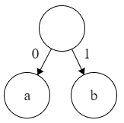
Compressed bitstring for ab: 01.
ab + N*ab: same encoding as for ab repeated N times.
2 N / 16 N = 0.125 => 1/8 compression ratio – constant compression ratio.

LZW: Give the result of encoding the string a, aa, aaa, aaaa, . . . (strings consisting of N repetitions of a: 1 n = 1
a a: 1 1 n = 2
a aa: 1 2 n = 3
a aa a: 1 2 1 n = 4
a aa aa: 1 2 2 n = 5
a aa aaa: 1 2 3 n = 6
a aa aaa a: 1 2 3 1 n = 7, the last number increments by 1 for the next 3 additions of a.
a aa aaa aaaa a 1 2 3 4 1 n = 11 the last number increments by 1 for the next 4 additions of a.
a aa aaa aaaa aaaaa 1 2 3 4 5 1 n = 16 the last number increments by 1 for the next 5 additions of a.
And so on.. That is for each new segment of a‘s the number of codewords that can represent the string increases by one.
The compression ratio for a, aa, aaa .... is then (floor(squareroot(2N) + 1/2)) / N.

(7) (10%) (Problem 5.5.18) Let Fk be the k-th Fibonacci number. Consider N symbols, where the k-th symbol has frequency Fk. Note that F1 + F2 + . . . FN = FN+2 − 1. Describe the Huffman code. (Hint: The longest codeword has length N − 1).
For k of any size, F_{k} will never be less than the sum of the numbers below it, excluding the one directly below it. This means that that all nodes F_{x} for x<k must be merged into a trie before they can merged with F_{k}. This will result in a trie looking somewhat like this:
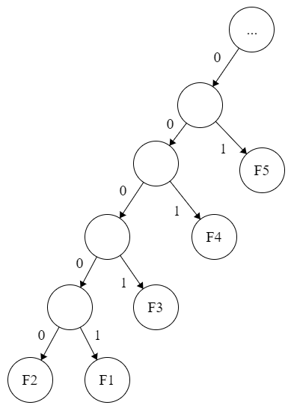
The code will then be:
F_{k} | 1
F_{k-1} | 01
F_{k-2} | 001
... | ...
F_{k-x} | x mörg 0 svo 1

V. (8%) Röðunarreiknirit/ Sorting algorithms
Í töflunni að neðan er dálkurinn lengst til vinstri inntak af strengjum og dálkurinn lengst til hægri strengirnir raðaðir. Hver af fjórum af hinum dálkunum er staðan í miðri keyrslu á einu af röðunarreikniritunum fjórum (númer 2-5) listuðum að neðan. Parið saman dálkana og reikniritin, og notið hverja tölu einu sinni. Tveir dálkar eiga því ekki við neitt af þessum reikniritum.
/ The leftmost column in the table below is the original input of strings to be sorted, and the rightmost column consists of the strings in sorted order. Four of the other columns are the contents at some intermediate step during one of the sorting algorithms (number 2-5) listed below. Match each algorithm by writing its number under the corresponding column. Use each number exactly once. Two columns therefore do not apply to any of these algorithms.

KISS ENYA ABBA ENYA ENYA ACDC ABBA ABBA
ENYA ABBA ACDC INXS INXS ABBA ACDC ACDC
0. Upphaflegt inntak / Original input
1. Raðað / Sorted
2. LSD radix sort
3. MSD radix sort
4. 3-way string quicksort (no shuffle)
5. Mergesort (neðansækið/bottom-up)

INXS AQUA BECK KISS DIDO AQUA AQUA AQUA
STYX ACDC BLUR STYX CARS BUSH BECK BECK
SOAD SOAD BUSH ACDC ACDC BLUR BLUR BLUR
ACDC CAKE CAKE FUEL FUEL BECK ENYA BUSH
KORN MUSE CARS KORN BUSH CAKE KORN CAKE
FUEL HOLE DIDO SOAD ABBA CARS FUEL CARS
BUSH SADE ENYA ABBA AQUA DIDO BUSH DIDO
ABBA BUSH FUEL BUSH CAKE ENYA KISS ENYA
WHAM RUSH HOLE CAKE BLUR FUEL WHAM FUEL
CAKE BECK INXS WHAM JAYZ HOLE CAKE HOLE
BLUR FUEL JAYZ BECK BECK INXS SOAD INXS
MUSE TSOL KISS BLUR HOLE JAYZ MUSE JAYZ
BECK WHAM KORN MOBY KORN KISS STYX KISS
MOBY KORN MOBY MUSE KISS KORN MOBY KORN
HOLE DIDO MUSE AQUA TSOL MUSE HOLE MOBY
TSOL BLUR RUSH HOLE MOBY MOBY TSOL MUSE
JAYZ KISS SADE JAYZ MUSE RUSH JAYZ RUSH
AQUA INXS SOAD TSOL SADE STYX INXS SADE
SADE CARS STYX CARS WHAM SOAD SADE SOAD
CARS STYX TSOL DIDO SOAD SADE CARS STYX
DIDO MOBY AQUA RUSH RUSH TSOL DIDO TSOL
RUSH JAYZ WHAM SADE STYX WHAM RUSH WHAM

0 2 X 5 4 3 X 1
---- ---- ---- ---- ---- ---- ---- ----

X. (8%) Vegin net / Weighted graphs
f
i
h
b
c
a
X
Y
50
80
110
100
70
Z
d
e
20
60
90
30
60

Þykku leggirnir í netinu að ofan tákna leggi sem höfðu verið valdir á einhverjum tímapunkti af MST reikniriti. / The bold-faced edges in the above weighted graph represent the edges that had been selected by some intermediate stage of an MST algorithm.

(a) Hvaða gildi gætu vægin X, Y, Z tekið, ef reiknirit Kruskals er keyrt? / Which of the following could be the weights of edges X, Y, Z, respectively, if Kruskal‘s algorithm was run?
15 25 35 45 55 65 75 85 95 105
x □ □ □ □ □ □     Stærra en 70
y        □ □ □ minna en 80
z □ □ □ □       stærra en 50

(c) Hvaða gildi gætu vægin X, Y, Z tekið, ef reiknirit Prims er keyrt, með upphafshnútinn a? / Which of the following could be the weights of edges X, Y, Z, respectively, if Prim‘s algorithm was run with initial node a?
15 25 35 45 55 65 75 85 95 105
x           getur verið hvað sem er
y        □ □ □ Y er minna en 80
z □ □ □ □       stærra en 50

XI. (8%) Ternary Search Tries

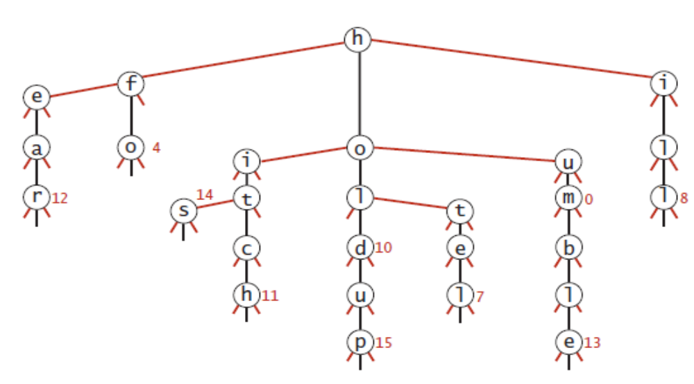
Að neðan er útkoma sem fæst úr því að setja safn af strengjum (ásamt tengdum heiltölugildum) inn í þríleitartræ (ternary search trie). / Below is the result of inserting a set of strings (and associated integer values) into a ternary search trie.

(a) Teldu upp í stafrófsröð strengina sem voru settir inn. / List in alphabetical order the set of strings that were inserted.
Svar: Ear, Fo, His, Hitch, Hold, Holdup, Hotel, Hum, Humble, Ill

(b) Bættu við strengnum hobo, með gildið 18, og strengnum hung, með gildið 21, inn í træið, og sýndu breytingarnar á træinu á myndinni að ofan.
/ Add the string hobo (with associated value 18) and the string hung (with associated value 21) and the string, and illustrate the changes to the trie in the figure above. 