

Bharati Vidyapeeth’s

Institute of Management & Information Technology

C.B.D. Belapur, Navi Mumbai 400614

Vision:

Providing high quality, innovative and value-based education in information technology to build competent professionals.
Mission
M1. Technical Skills:-To provide solid technical foundation theoretically as well as practically capable of providing quality services to industry.

M2. Development: -Department caters to the needs of students through comprehensive educational programs and promotes lifelong learning in the field of computer Applications.

M3. Ethical leadership:-Department develops ethical leadership insight in the students to succeed in industry, government and academia.

CERTIFICATE

This is to certify that the journal is the work of Mr. / Ms.

_Joisar Kajal Satishbhai_____ Roll No. 25 of MCA (Sem- 1 Div: A ) for the

academic year 2022 -2024

Subject Code: MCAL12

Subject Name: Advanced Java Lab

Subject-in-charge |  |  |  |  | Principal
Date:

External Examiner

Date:

Bharati Vidyapeeth's Institute of Managment & Information Technology

MCA Semester I AY 2022-23

MCAL12: Advanced Java Lab

INDEX

Sr No. | Date | Topic | Sign
1 |  | Java Generics
1.1 |  | Write a Java Program to demonstrate a Generic Class.
1.2 |  | Write a Java Program to demonstrate Generic Methods.
1.3 |  | Write a Java Program to demonstrate Wildcards in Java Generics.
2 |  | List Interface
2.1 |  | Write a Java program to create List containing list of items of type
 |  | String and use for- --each loop to print the items of the list.
2.2 |  | Write a Java program to create List containing list of items and use
 |  | ListIterator interface to print items present in the list. Also print the list
 |  | in reverse/ backward direction.
3 |  | Set Interface
3.1 |  | Write a Java program to create a Set containing list of items of type
 |  | String and print the items in the list using Iterator interface. Also print
 |  | the list in reverse/ backward direction.
3.2 |  | Write a Java program using Set interface containing list of items and
 |  | perform the following operations:
 |  | a. Add items in the set.
 |  | b. Insert items of one set in to other set.
 |  | c. Remove items from the set
 |  | d. Search the specified item in the set
4 |  | Map Interface
4.1 |  | Write a Java program using Map interface containing list of items
 |  | having keys and associated values and perform the following
 |  | operations:
 |  | a. Add items in the map.
 |  | b. Remove items from the map
 |  | c. Search specific key from the map
 |  | d. Get value of the specified key
 |  | e. Insert map elements of one map in to other map.
 |  | f. Print all keys and values of the map.
5 |  | Lambda Expression
5.1 |  | Write a Java program using Lambda Expression to print ”Hello
 |  | World”.
5.2 |  | Write a Java program using Lambda Expression with single
 |  | parameters.
5.3 |  | Write a Java program using Lambda Expression with multiple
 |  | parameters to add two numbers.
5.4 |  | Write a Java program using Lambda Expression to calculate the
 |  | following:
 |  | a. Convert Fahrenheit to Celcius
 |  | b. Convert Kilometers to Miles.
5.5 |  | Write a Java program using Lambda Expression with or without return

 |  |  | keyword.
 | 5.6 |  | Write a Java program using Lambda Expression to concatenate two
 |  |  | strings.
 | 6 |  | Web application development using JSP
 | 6.1 |  | Create a Telephone directory using JSP and store all the information
 |  |  | within a database, so that later could be retrieved as per the
 |  |  | requirement. Make your own assumptions.
 | 6.2 |  | Write a JSP page to display the Registration form (Make your own
 |  |  | assumptions).
 | 6.3 |  | Write a JSP program to add, delete and display the records from
 |  |  | StudentMaster (RollNo, Name, Semester, Course) table.
 | 6.4 |  | Design loan calculator using JSP which accepts Period of Time (in
 |  |  | years) and Principal Loan Amount. Display the payment amount for
 |  |  | each loan and then list the loan balance and interest paid for each
 |  |  | payment over the term of the loan for the following time period and
 |  |  | interest rate:
 |  |  | a. 1 to 7 year at 5.35%
 |  |  | b. 8 to 15 year at 5.5%
 |  |  | c. 16 to 30 year at 5.75%
 | 6.5 |  | Write a program using JSP that displays a webpage consisting
 |  |  | Application form for change of Study Center which can be filled by
 |  |  | any student who wants to change his/ her study center. Make necessary
 |  |  | assumptions.
 | 6.6 |  | Write a JSP program to add, delete and display the records from
 |  |  | StudentMaster (RollNo, Name, Semester, Course) table.
 | 6.7 |  | Write a JSP program that demonstrates the use of JSP declaration,
 |  |  | scriptlet, directives, expression, header and footer.
 | 6.8 |  | Write a JSP program that demonstrates the use of Cookies and session
 |  |  | tracking in java.
 | 6.9 |  | Write a JSP program that demonstrates the use of custom tags
 | 7 |  | Spring Framework
 | 7.1 |  | Write a program to print “Hello World” using spring framework.
 | 7.2 |  | Write a program to demonstrate dependency injection via setter
 |  |  | method.
 | 7.3 |  | Write a program to demonstrate dependency injection via Constructor.
 | 8 |  | Aspect Oriented Programming
 | 8.1 |  | Write a program to demonstrate Spring AOP – before advice.
 | 8.2 |  | Write a program to demonstrate Spring AOP – after advice.
 | 8.3 |  | Write a program to demonstrate Spring AOP – around advice.
 | 8.4 |  | Write a program to demonstrate Spring AOP – after returning advice.
 | 8.5 |  | Write a program to demonstrate Spring AOP – after throwing advice.

9 |  | Spring JDBC
9.1 |  | Write a program to insert, update and delete records from the given
 |  | table.
9.2 |  | Write a program to demonstrate PreparedStatement in Spring
 |  | JdbcTemplate.
9.3 |  | Write a program in Spring JDBC to demonstrate ResultSetExtractor
 |  | Interface.
9.4 |  | Write a program to demonstrate RowMapper interface to fetch the
 |  | records from the database.
10 |  | Spring Boot and RESTful Web Services
10.1 |  | Write a program to create a simple Spring Boot application that prints
 |  | a message.
10.2 |  | Write a program to demonstrate RESTful Web Services with spring
 |  | boot.

Assignment 1

Java Generics

- Write a Java Program to demonstrate a Generic Class.

- Write a Java Program to demonstrate Generic Methods.

- Write a Java Program to demonstrate Wildcards in Java Generics.

Problem Statement 1 : Write a Java Program to demonstrate a Generic Class.

Code :

class geg<T>

{
T obj;
geg(T obj){this.obj = obj;}
public T get() {return this.obj;}
}
class G1
{
public static void main (String[] args)
{
geg<Integer>i=new geg<Integer>8(35);
System.out.println(i.get());

geg<String> s =

new geg<String>("Hello");
System.out.println(s.get());
}

}

Output :

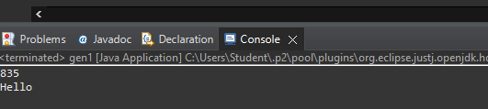


Problem Statement 2 : Write a Java Program to demonstrate Generic Methods.

Code :

public class Genericmethod

{
void display()
{
System.out.println("generic method exmaple");
}
<T> void gdisplay (T e)
{
System.out.println(e.getClass().getName() + " = " + e);
}
public static void main(String[] args)
{
Genericmethod g1=new Genericmethod();
g1.display();

g1.gdisplay(1);

g1.gdisplay("KAJAL");
g1.gdisplay(23.56);
}
}

Output :

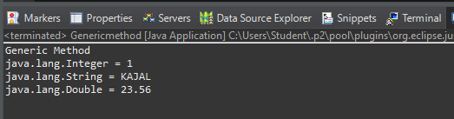

Problem Statement 3 : Write a Java Program to demonstrate Wildcards in Java Generics.

Code :

import java.util.*;

public class Wildcardex {

// Upper bounded

private static double sum(List<? extends Number> list) { double sum = 0.0;

for (Number i : list) {

sum = sum + i.doubleValue();

}

return sum;

}

// Lower Bounded

private static void show(List<? super Integer> list) { list.forEach((x) -> {

System.out.print(x + " ");

});

}

public static void main(String[] args) { System.out.println("Upper Bounded : "); List<Integer> list1 = Arrays.asList(4, 2, 7, 5, 1, 9); System.out.println("List 1 Sum : " + sum(list1)); List<Double> list2 = Arrays.asList(4.7, 2.4, 7.3, 5.4, 1.5, 9.2); System.out.println("List 2 Sum : " + sum(list2)); System.out.println("\nLower Bounded : ");

List<Integer> list3 = Arrays.asList(4, 2, 7, 5, 1, 9);

System.out.println("Only Classes With Integer Superclass will be Accepted : "); show(list3);

}

}

Output :

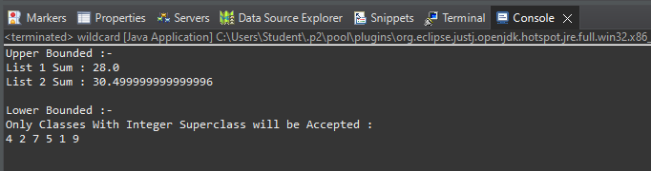

Assignment 2

List Interface

- Write a Java program to create List containing list of items of type String and use for- --each loop to print the items of the list.
- Write a Java program to create List containing list of items and use ListIterator interface to print items present in the list. Also print the list in reverse/ backward direction.

Problem Statement 1 : Write a Java program to create List containing list of items of type String and use for- --each loop to print the items of the list.

Code :

package listeg;

import java.util.*;
public class Array1 {
public static void main(String[] args) { ArrayList<String>list=new ArrayList<String>();

list.add(“SPRING");

list.add("JSP");
list.add("JAVA");
list.add("JDBC");

System.out.println(list);

System.out.println("Traversing list through for each loop"); for(String subject:list)
System.out.println(subject);

}

}

Output :

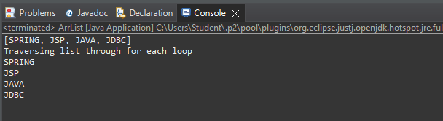

Problem Statement 2 : Write a Java program to create List containing list of items and use ListIterator interface to print items present in the list. Also print the list in reverse/ backward direction.

Code :

package listeg;

import java.util.*;
public class Reverse {

public static void main(String[] args) {

List<String> mylist = new ArrayList<String>();

mylist.add("Vinit");

mylist.add("Rahul");
mylist.add("Owesh");
mylist.add("Vinayak");
mylist.add("Akash");

System.out.println("Traversing through iterator");

System.out.println("Original List:");
Iterator itr=mylist.iterator();
while(itr.hasNext()) {
System.out.println(itr.next());

}

Collections.reverse(mylist);
System.out.println(); //space between two lines
System.out.println("Reversed List:");
Iterator itr1=mylist.iterator();
while(itr1.hasNext()) {

System.out.println(itr1.next());

}

}

}
Output :

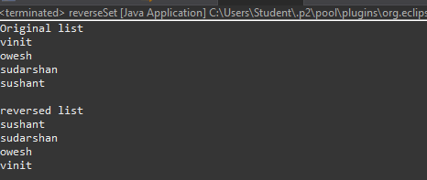

Assignment 3

Set Interface

- Write a Java program to create a Set containing list of items of type String and print the items in the list using Iterator interface. Also print the list in reverse/ backword direction.
- Write a Java program using Set interface containing list of items and perform the following operations: a. Add items in the set.
b. Insert items of one set in to other set. c. Remove items from the set

d. Search the specified item in the set

Problem Statement 1 : Write a Java program to create a Set containing list of items of type String and print the items in the list using Iterator interface. Also print the list in reverse/ backword direction.

Solution :

import java.util.*;

public class Reverse {
public static void main(String[] args) {
// Let us create a list of strings
List<String> mylist = new ArrayList<String>();
mylist.add("vinit");
mylist.add("owesh");
mylist.add("sudarshan");
mylist.add("sushant");
System.out.println("Original list ");

Iterator<String> itr=mylist.iterator();//getting the Iterator while(itr.hasNext()){//check if iterator has the elements System.out.println(itr.next()); }

Collections.reverse(mylist);
System.out.println(" ");
System.out.println("reversed list ");

Iterator<String> itr1=mylist.iterator();//getting the Iterator while(itr1.hasNext()){//check if iterator has the elements

System.out.println(itr1.next());

}
}
}

Output :



Problem Statement2 : Write a Java program using Set interface containing list of items and perform the following operations:

a. Add items in the set.

b. Insert items of one set in to other set.

c. Remove items from the set

d. Search the specified item in the set

Solution :

import java.util.*;

public class set1{
public static void main(String[] args) {
- TODO Auto-generated method stub Set<Integer> s = new LinkedHashSet<Integer>(); s.add(69);
s.add(57);
s.add(10);
s.add(18);
s.add(90);
s.add(151);
Set<Integer> s1 = new LinkedHashSet<Integer>(); s1.add(70);

s1.add(35);

s.addAll(s1);

System.out.println("Set1: " + s);
System.out.println("Set2: " + s1);
System.out.println();
System.out.println("After Adding set2 into set1: " + s);
s.remove(10);
s.remove(18);
System.out.println("Set after removing elements: " + s); System.out.println();

System.out.println("Does the Set contains: 57? "
+ s.contains(57));
System.out.println("Does the Set contains: 18? "
- s.contains(18));
}
}

Output :

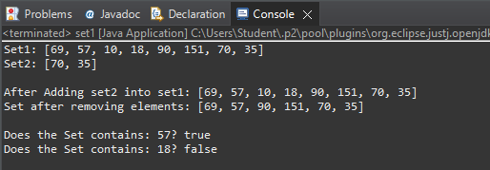

Assignment 4

Map Interface

- Write a Java program using Map interface containing list of items having keys and associated values and perform the following operations:

a. Add items in the map.

b. Remove items from the map

c. Search specific key from the map

d. Get value of the specified key

e. Insert map elements of one map in to other map.

f. Print all keys and values of the map.

Solution :

import java.util.*;

public class mapinterface {
public static void main(String[] args) {
- TODO Auto-generated method stub Map<Integer, String> map = new HashMap<>(); map.put(1 ,"Vinit");

map.put(2,"Owesh");
map.put(3,"Sudarshan");
map.put(4,"Sushant");
map.put(5,"Ashish"); System.out.println();
Map<Integer, String> map1 = new HashMap<>(); map1.put(6 ,"Shruti"); map1.put(7,"Prachi"); map1.put(8,"Shradhha"); System.out.println("Map 1");

for (Map.Entry<Integer, String> e : map.entrySet()) System.out.println(e.getKey() + " " + e.getValue()); System.out.println(); System.out.println("Map 2");

for (Map.Entry<Integer, String> e : map1.entrySet()) System.out.println(e.getKey() + " " + e.getValue()); System.out.println("Insert map into another map"); Map<Integer, String> map2 = new HashMap<>(); map2.putAll(map);
map2.putAll(map1); System.out.println(map2); System.out.println(); System.out.println("Remove items from the map"); map.remove((3));

for (Map.Entry<Integer, String> e : map.entrySet()) System.out.println(e.getKey() + " "+ e.getValue()); System.out.println();

System.out.println();

System.out.println("Search specific key from the map"); System.out.println("Is the key '2' present? " + map.containsKey(2));
System.out.println("Is the key '6' present? " +
map.containsKey(6));
System.out.println();
System.out.println("Get value of the specified key");
String val = (String)map.get(2);
System.out.println(val);
System.out.println();
}
}

Output :

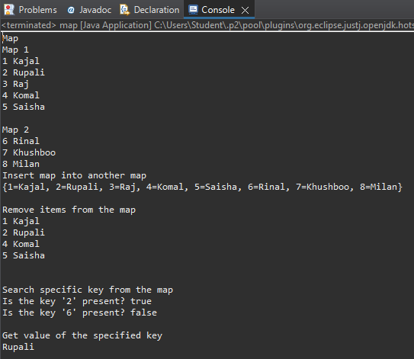

Assignment 5

Lambda Expressions

- Write a Java program using Lambda Expression to print “Hello World!”.

- Write a Java program using Lambda Expression with single parameter.

- Write a Java program using Lambda Expression with multiple parameters to add two numbers.

- Write a Java program using Lambda Expression to calculate the following:

  - Convert Fahrenheit to Celcius

  - Convert Kilometers to Miles.

- Write a Java program using Lambda Expression with or without return keyword.

- Write a Java program using Lambda Expression to concatenate two strings.

Problem Statement 1 :Write a Java program using Lambda Expression to print “Hello World!”.

Solution :

package Lambdaexpression;

interface HelloWorld1 {

String sayHello(String name);
}
public class helloworld {
public static void main(String args[]){
HelloWorld1 helloWorld = (String name) -> { return "Hello " + name; }; System.out.println(helloWorld.sayHello("World"));
}

}

Output :
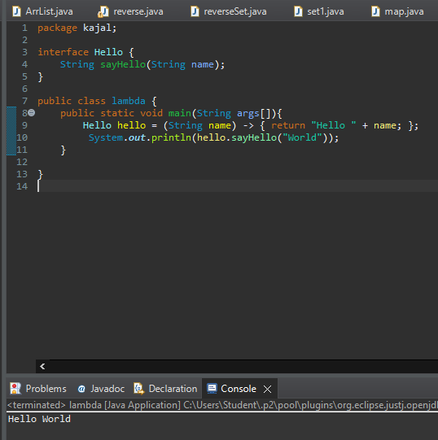

Problem Statement 2 :Write a Java program using Lambda Expression with single parameter.

Solution :

package Lambdaexpression;

interface Say{
public String say(String name);
}
public class singleparameter{
public static void main(String[] args) {
Say s1=(name)->{
return "Hello "+name;
};
System.out.println(s1.say("vinit"));
}
}

Output :
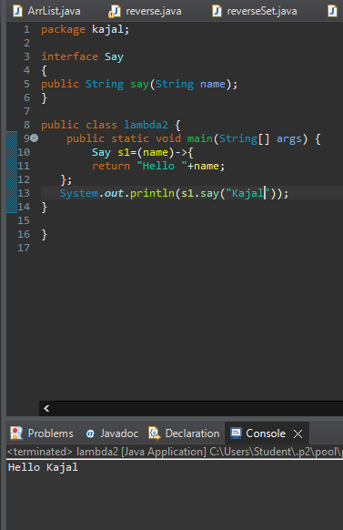

Problem Statement 3 : Write a Java program using Lambda Expression with multiple parameters to add two numbers.

Solution :

package Lambdaexpression;

interface Add{
int add(int a,int b);
}

public class multiplepara{

public static void main(String[] args) {

Add ad1=(a,b)->(a+b);

System.out.println("Sum: " +ad1.add(500,20));

Add ad2=(int a,int b)->(a+b);

System.out.println("Sum: " +ad2.add(300,200));
}

}

Output :

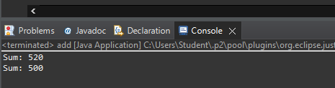

Problem Statement 4 : Write a Java program using Lambda Expression to calculate the following:

- Convert Fahrenheit to Celsius

Solution :

package Lambdaexpression;

interface temp
{
public double convert(double temp);

}

public class farherntoce1 {
public static void main(String[] args) {
temp t1=(double a)->{
return((a-32)* 5/9);
};
System.out.print("Convert fahrenheit to celsius: "+ t1.convert(86));
}

}

Output :

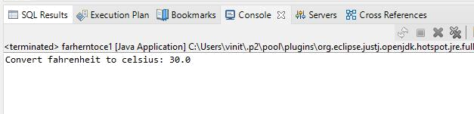
- Convert Kilometers to Miles.

Solution :

package Lambdaexpression;

interface temp1
{
public double convert(double temp);

}

public class kmtomiles {
public static void main(String[] args) {
temp t1=(double a)->{
return(a/1.6);
};
System.out.print("Convert KM to MILES: "+ t1.convert(10)+ " Miles");
}

}

Output :

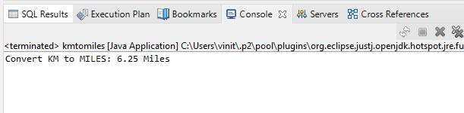
Problem Statement 5 : Write a Java program using Lambda Expression with or without return keyword.

Solution :

package Lambdaexpression;

interface Add2{
int add(int a,int b);
}

public class withwithoutkeywords {

public static void main(String[] args) {

- without return keyword Add2 ad1=(a,b)->(a+b);

System.out.println("Sum: " +ad1.add(43,23));

- with return keyword Add2 ad2=(int a,int b)->
{
return (a+b); };

System.out.println("Sum: " +ad2.add(54,320));
}
}

Output :

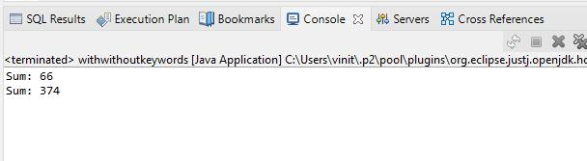
Problem Statement 6 : Write a Java program using Lambda Expression to concatenate two strings.

Solution :

package Lambdaexpression;

interface conc1 {

public String concat(String a,String b);
}
public class concatenate {

public static void main(String[] args) {

conc1 s1 = (String a,String b)->{
return (a+b);
};
System.out.println(s1.concat("Hello"," Kajal"));
}
}

Output :

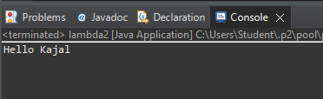

Assignments 6

Web Application Development using JSP

- Create a Telephone directory using JSP and store all the information within a database, so that later could be retrieved as per the requirement. Make your own assumptions.

- Write a JSP page to display the Registration form (Make your own assumptions)

- Write a JSP program to add, delete and display the records from StudentMaster (RollNo, Name, Semester, Course) table.

- Design loan calculator using JSP which accepts Period of Time (in years) and Principal Loan Amount. Display the payment amount for each loan and then list the loan balance and interest paid for each payment over the term of the loan for the following time period and interest rate:

a. 1 to 7 year at 5.35%

b. 8 to 15 year at 5.5%

c. 16 to 30 year at 5.75%

- Write a program using JSP that displays a webpage consisting Application form for change of Study Center which can be filled by any student who wants to change his/ her study center. Make necessary assumptions

- Write a JSP program that demonstrates the use of JSP declaration, scriptlet, directives, expression, header and footer.

- Write a JSP program that demonstrates the use of session or cookies.


Problem Statement 1. Create a Telephone directory using JSP and store all the information within a database, so that later could be retrieved as per the requirement. Make your own assumptions.

Database table (phone1) :

CREATE TABLE phone1

(

id SERIAL PRIMARY KEY,

name varchar(50),

no varchar(50)

);

Index.jsp :

<%@page import="java.sql.*" %>

<%

try

{

String driver ="org.postgresql.Driver";

String url ="jdbc:postgresql://localhost:5432/postgres";

String username ="postgres";

String password ="admin";

Connection con =null;

Class.forName(driver).newInstance();

con = DriverManager.getConnection(url,username,password); System.out.println("Opened database successfully");

if(request.getParameter("delete")!=null)

{

int id=Integer.parseInt(request.getParameter("delete"));

PreparedStatement pstmt=null; //create statement

pstmt=con.prepareStatement("delete from phone1 where id=? "); // delete query

pstmt.setInt(1,id);

pstmt.executeUpdate(); //execute query

con.close(); //close connection

}

}

catch(Exception e)

{

out.println(e);

}

%>

<html>

<head>

<title>JSP:Insert, Update, Delete </title>

</head>

<body>

<br>

<br>

<center>

<h1><a href="add.jsp">CLICK HERE TO ADD A NEW MOBILE NUMBER</a></h1>

</center>

<br>

<center>

<table border='1' cellpadding='23'>

</center>

<tr>

<th>ID</th>

<th>NAME</th>

<th>MOBILE NUMBER</th>

<th>UPDATE</th>

<th>DELETE</th>

</tr>

<%

try

{

String driver ="org.postgresql.Driver";

String url ="jdbc:postgresql://localhost:5432/postgres";

String username ="postgres";

String password ="admin";

Connection con =null;

Class.forName(driver).newInstance();

con = DriverManager.getConnection(url,username,password);

PreparedStatement pstmt=null; //create statement

pstmt=con.prepareStatement("select * from phone1"); //select query

ResultSet rs=pstmt.executeQuery(); //execute query and set in resultset object rs.

while(rs.next())

{

%>

<tr>

<td><%=rs.getInt(1)%></td>

<td><%=rs.getString(2)%></td>

<td><%=rs.getString(3)%></td>

<td><a href="update.jsp?edit=<%=rs.getInt(1)%> ">Edit</a></td> <td><a href="?delete=<%=rs.getInt(1)%> ">Delete</a></td>

</tr>

<%

}

}

catch(Exception e)

{

out.println(e);

}

%>

</table>

</body>

</html>

Add.jsp :

<%@ page import="java.sql.*" %>

<%

try

{

String driver ="org.postgresql.Driver";

String url ="jdbc:postgresql://localhost:5432/postgres";

String username ="postgres";

String password ="admin";

Connection con =null;

Class.forName(driver).newInstance();

con = DriverManager.getConnection(url,username,password); System.out.println("Opened database successfully");

if(request.getParameter("btn_add")!=null) //check button click event not null

{

String name,no;

name=request.getParameter("txt_name"); //txt_name

no=request.getParameter("txt_no"); //txt_owner

PreparedStatement pstmt=null; //create statement

pstmt=con.prepareStatement("insert into phone1(name,no)values(?,?)"); // insert query

pstmt.setString(1,name);

pstmt.setString(2,no);

pstmt.executeUpdate(); //execute query

con.close(); //close connection

out.println("Insert Successfully...! Click Home page.");// after insert record successfully message

}

}

catch(Exception e)

{

out.println(e);

}

%>

<html>

<head>

<title>JSP:Insert, Update, Delete using MySQL</title>

<!-- javascript for form validation-->

<script>

function validate()

{

var name = document.myform.txt_name;

var no = document.myform.txt_no;

if (name.value == "")

{

window.alert("please enter a name ?");

name.focus();

return false;

}

if (no.value == "")

{

window.alert("please enter a mobile number ?");

name.focus();

return false;

}

}

</script>

</head>

<body>

<form method="post" name="myform" onsubmit="return validate();"> <center>
<h1>Insert Record</h1>

</center>

<table>

<tr>

<td><b>Name: </b></td>

<td><input type="text" name="txt_name"></td>

</tr>

<tr>

<td><b>Phone number:</b></td></b>

<td><input type="text" name="txt_no"></td>

</tr>

<tr>

<td><input type="submit" name="btn_add" value="Insert"></td>

</tr>

</table>

<center>

<h1><a href="index.jsp">Home page</a></h1>

</center>

</form>

</body>

</html>

Update.jsp :

<%@ page import="java.sql.*" %>

<%

try

{

String driver ="org.postgresql.Driver";

String url ="jdbc:postgresql://localhost:5432/postgres";

String username ="postgres";

String password ="admin";

Connection con =null;

Class.forName(driver).newInstance();

con = DriverManager.getConnection(url,username,password); System.out.println("Opened database successfully");

if(request.getParameter("btn_update")!=null) //check button click event not null

{

int hide,name,no;;

String name_up,no_up;

hide=Integer.parseInt(request.getParameter("txt_hide")); //it is hidden id get for update record

name_up=request.getParameter("txt_name");

no_up=request.getParameter("txt_no"); //txt_name

PreparedStatement pstmt=null; //create statement

pstmt=con.prepareStatement("update phone1 set name=?,no=? where id=?"); // update query

pstmt.setString(1,name_up);

pstmt.setString(2,no_up);

pstmt.setInt(3,hide);

pstmt.executeUpdate(); //execute query

con.close(); //connection close

out.println("Update Successfully...! Click Back link."); //after update record successfully message }

}

catch(Exception e)

{

out.println(e);

}

%>

<html>

<head>

<title>JSP:Insert, Update, Delete using MySQL</title>

<!-- javascript for form validation-->

<script>

function validate()

{

var name = document.myform.txt_name;

var no = document.myform.txt_no;

if (rno.value == "")

{

window.alert("please enter name ?");

name.focus();

return false;

}

if (name.value == "")

{

window.alert("please enter number ?");

name.focus();

return false;

}

}

</script>

</head>

<body>

<form method="post" name="myform" onsubmit="return validate();">

<center>

<h1>Update Record</h1>

</center>

<table>

<%

try

{

String driver ="org.postgresql.Driver";

String url ="jdbc:postgresql://localhost:5432/postgres";

String username ="postgres";

String password ="admin";

Connection con =null;

Class.forName(driver).newInstance();

con = DriverManager.getConnection(url,username,password); System.out.println("Opened database successfully");

if(request.getParameter("edit")!=null)

{

int id=Integer.parseInt(request.getParameter("edit"));

String name,no;

PreparedStatement pstmt=null; // create statement

pstmt=con.prepareStatement("select * from phone1 where id=?"); // sql select query pstmt.setInt(1,id);
ResultSet rs=pstmt.executeQuery(); // execute query store in resultset object rs.

while(rs.next())

{

id=rs.getInt(1);

name=rs.getString(2);

no=rs.getString(3);

%>

<tr>

<td>Name</td>

<td><input type="text" name="txt_name" value="<%=name%>"></td>

</tr>

<tr>

<td>Mobile Number</td>

<td><input type="text" name="txt_no" value="<%=no%>"></td>

</tr>

<tr>

<td><input type="submit" name="btn_update" value="Update"></td> </tr>

<input type="hidden" name="txt_hide" value="<%=id%>">

<%

}

}

}

catch(Exception e)

{

out.println(e);

}

%>

</table>

<center>

<h1><a href="index.jsp">Back</a></h1>

</center>

</form>

</body>

</html>

Output:

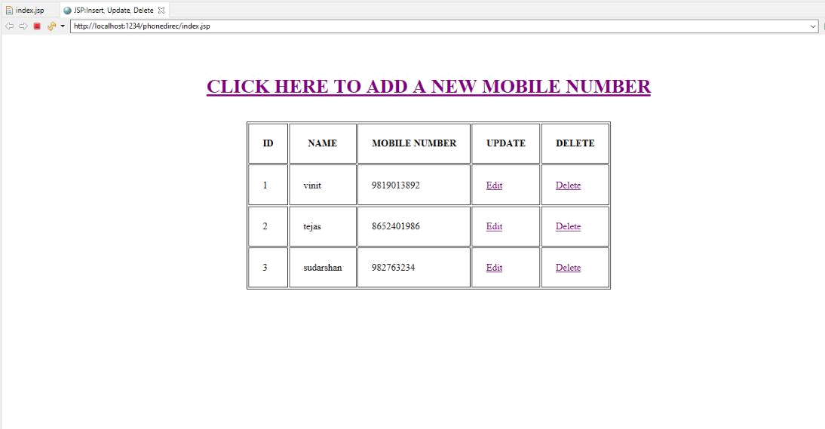
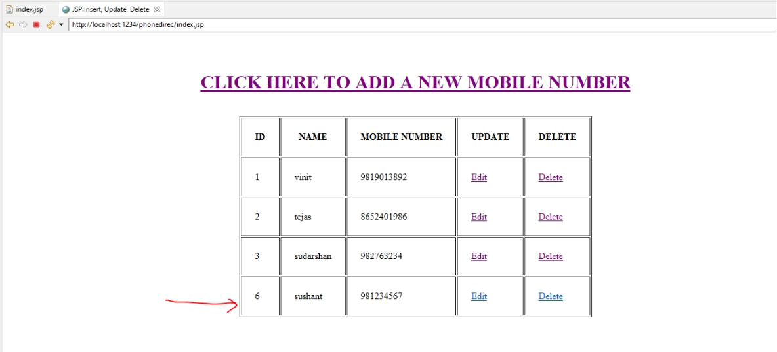

Adding new record to database

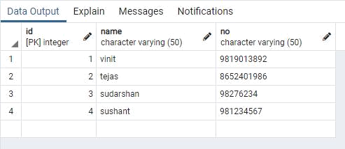


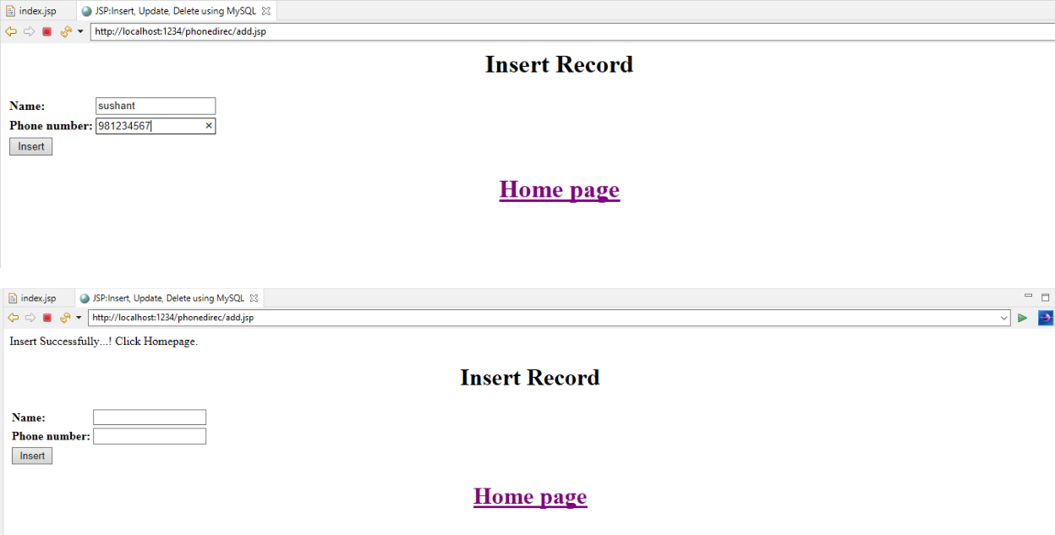




Problem Statement 2. Write a JSP page to display the Registration form (Make your own assumptions)

Database table (studentreg1) :

CREATE TABLE studentreg1

(

id SERIAL PRIMARY KEY,

first_name varchar(50),

last_name varchar(50),

phn_number varchar(20),

address varchar(20),

course varchar(20),

college_name varchar(20)

);

Add.jsp :

<%@ page import="java.sql.*" %>

<%

try

{

String driver ="org.postgresql.Driver";

String url ="jdbc:postgresql://localhost:5432/postgres";

String username ="postgres";

String password ="admin";

Connection con =null;

Class.forName(driver).newInstance();

con = DriverManager.getConnection(url,username,password); System.out.println("Opened database successfully");

if(request.getParameter("btn_add")!=null) //check button click event not null {
String first_name,last_name,phn_number,address,course,college_name;

first_name=request.getParameter("txt_first_name"); //txt_name

last_name=request.getParameter("txt_last_name"); //txt_owner

phn_number=request.getParameter("txt_phn_number");

address=request.getParameter("txt_address");

course=request.getParameter("txt_course");

college_name=request.getParameter("txt_college_name");

PreparedStatement pstmt=null; //create statement

pstmt=con.prepareStatement("insert into

studentreg1(first_name,last_name,phn_number,address,course,college_name)values(?,?,?,?,?,?)"); // insert query
pstmt.setString(1,first_name);

pstmt.setString(2,last_name);

pstmt.setString(3,phn_number);

pstmt.setString(4,address);

pstmt.setString(5,course);

pstmt.setString(6,college_name);

pstmt.executeUpdate(); //execute query

con.close(); //close connection

out.println("Insert Successfully...!");// after insert record successfully message

}

}

catch(Exception e)

{

out.println(e);

}

%>

<html>

<head>

<!-- javascript for form validation-->

<script>

function validate()

{

var first_name = document.myform.txt_first_name;

var last_name = document.myform.txt_last_name;

var phn_number = document.myform.txt_phn_number;

var address = document.myform.txt_address;

var course = document.myform.txt_course;

var college_name = document.myform.txt_college_name;

if (first_name.value == "")

{

window.alert("please enter a first name ?");

name.focus();

return false;

}

if (last_name.value == "")

{

window.alert("please enter a last name ?");

name.focus();

return false;

}

if (phn_number.value == "")

{

window.alert("please enter a mobile number ?");

name.focus();

return false;

}

if (address.value == "")

{

window.alert("please enter address ?");

name.focus();

return false;

}

if (course.value == "")

{

window.alert("please enter course ?");

name.focus();

return false;

}

if (college_name.value == "")

{

window.alert("please enter college name ?");

name.focus();

return false;

}

}

</script>

</head>

<body bgcolor="deea94">

<div align="center">

<form method="post" name="myform" onsubmit="return validate();">

<center>

<h1><u>STUDENT REGISTRATION FORM</u></h1> </center>

<br>

<table>

<tr>

<td><b>First Name: </b></td>

<td><input type="text" name="txt_first_name"></td>

</tr>

<tr>

<td><b>Last Name:</b></td></b>

<td><input type="text" name="txt_last_name"></td>

</tr>

<tr>

<td><b>Phone number:</b></td></b>

<td><input type="text" name="txt_phn_number"></td> </tr>

<tr>

<td><b>Address:</b></td></b>

<td><input type="text" name="txt_address"></td>

</tr>

<tr>

<td><b>Course:</b></td></b>

<td><input type="text" name="txt_course"></td>

</tr>

<tr>

<td><b>College Name:</b></td></b>

<td><input type="text" name="txt_college_name"></td> </tr>

<tr>

<td><br><input type="submit" name="btn_add" value="Submit"></br></td> </tr>

</table>

<center>

<p><a><span>&#8595;</span> <u>Click Below to list all the</u> <span>&#8595;</span></a></p> <p><a href="index.jsp">Registered Students Details</a></p> </center>
</form>

</div>

</body>

</html>

Index.jsp :

<%@page import="java.sql.*" %>

<%

try

{

String driver ="org.postgresql.Driver";

String url ="jdbc:postgresql://localhost:5432/postgres";

String username ="postgres";

String password ="admin";

Connection con =null;

Class.forName(driver).newInstance();

con = DriverManager.getConnection(url,username,password); System.out.println("Opened database successfully");

if(request.getParameter("delete")!=null)

{

int id=Integer.parseInt(request.getParameter("delete"));

PreparedStatement pstmt=null; //create statement

pstmt=con.prepareStatement("delete from studentreg1 where id=? "); // delete query

pstmt.setInt(1,id);

pstmt.executeUpdate(); //execute query

con.close(); //close connection

}

}

catch(Exception e)

{

out.println(e);

}

%>

<html>

<head>

<title>JSP:Insert, Update, Delete </title>

</head>

<body bgcolor="F9CDAD">

<br>

<br>

<br>

<center>

<h1><u>DETAILS OF REGISTERED STUDENTS</u></h1>

</center>

<br><br>

<center>

<table border='1' cellpadding='23'>

</center>

<tr>

<th>ID</th>

<th>First Name</th>

<th>Last Name</th>

<th>Mobile Number</th>

<th>Address</th>

<th>Course</th>

<th>College Name</th>

</tr>

<%

try

{

String driver ="org.postgresql.Driver";

String url ="jdbc:postgresql://localhost:5432/postgres";

String username ="postgres";

String password ="admin";

Connection con =null;

Class.forName(driver).newInstance();

con = DriverManager.getConnection(url,username,password);

PreparedStatement pstmt=null; //create statement

pstmt=con.prepareStatement("select * from studentreg1"); //select query

ResultSet rs=pstmt.executeQuery(); //execute query and set in resultset object rs.

while(rs.next())

{

%>

<tr>

<td><%=rs.getInt(1)%></td>

<td><%=rs.getString(2)%></td>

<td><%=rs.getString(3)%></td>

<td><%=rs.getString(4)%></td>

<td><%=rs.getString(5)%></td>

<td><%=rs.getString(6)%></td>

<td><%=rs.getString(7)%></td>

</tr>

<%

}

}

catch(Exception e)

{

out.println(e);

}

%>

</table>

</body>

</html>

OUTPUT :
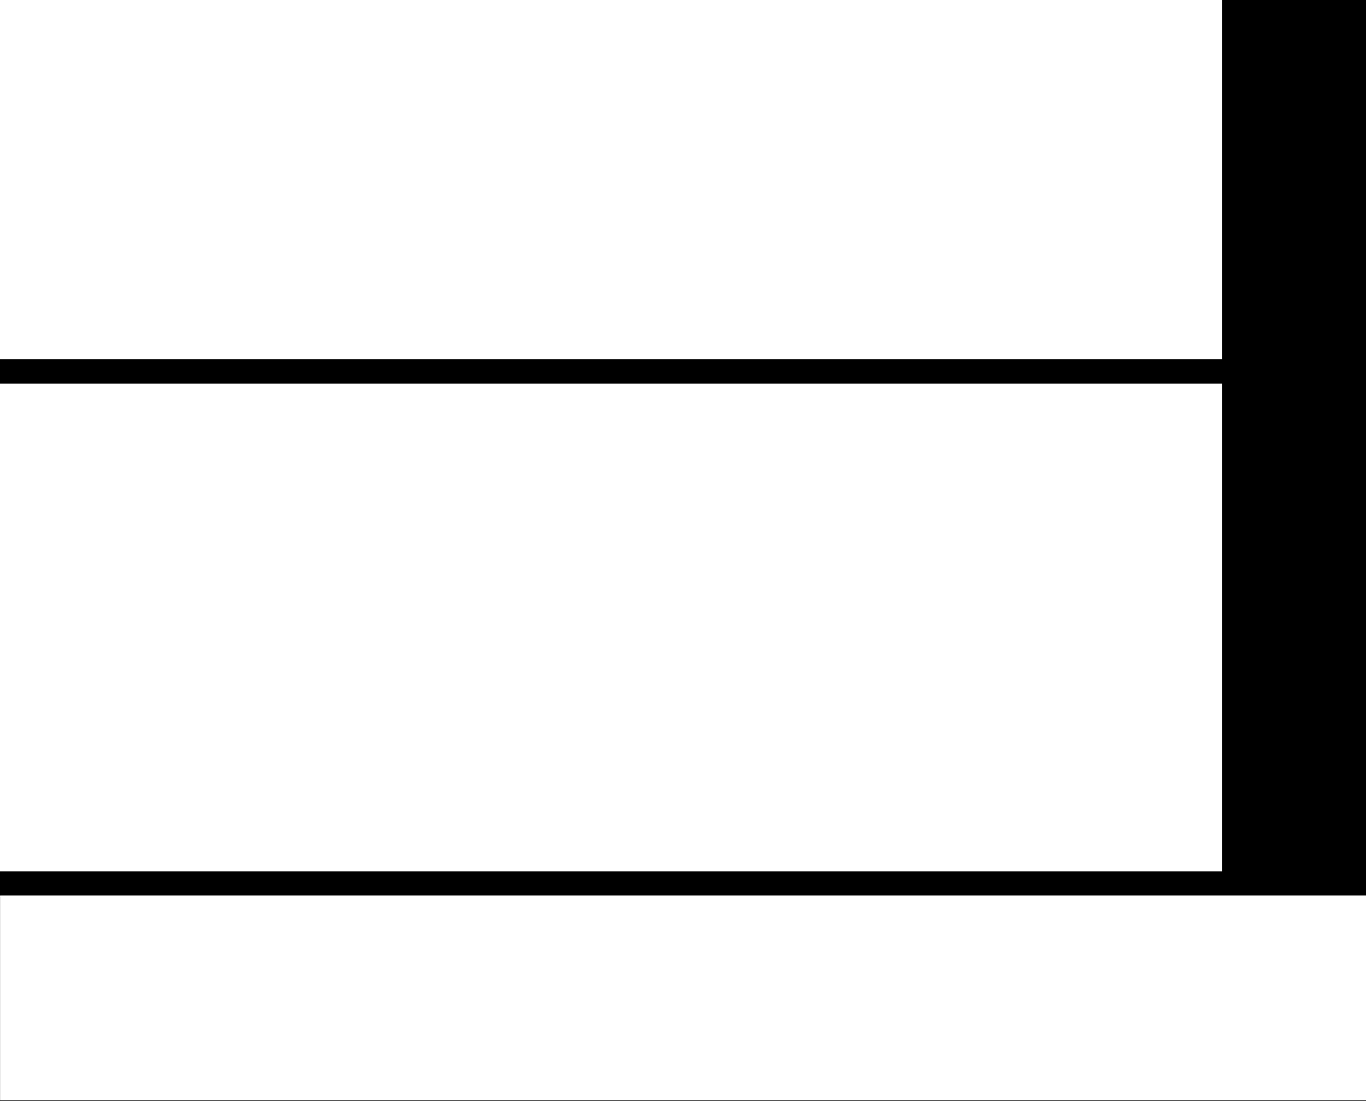
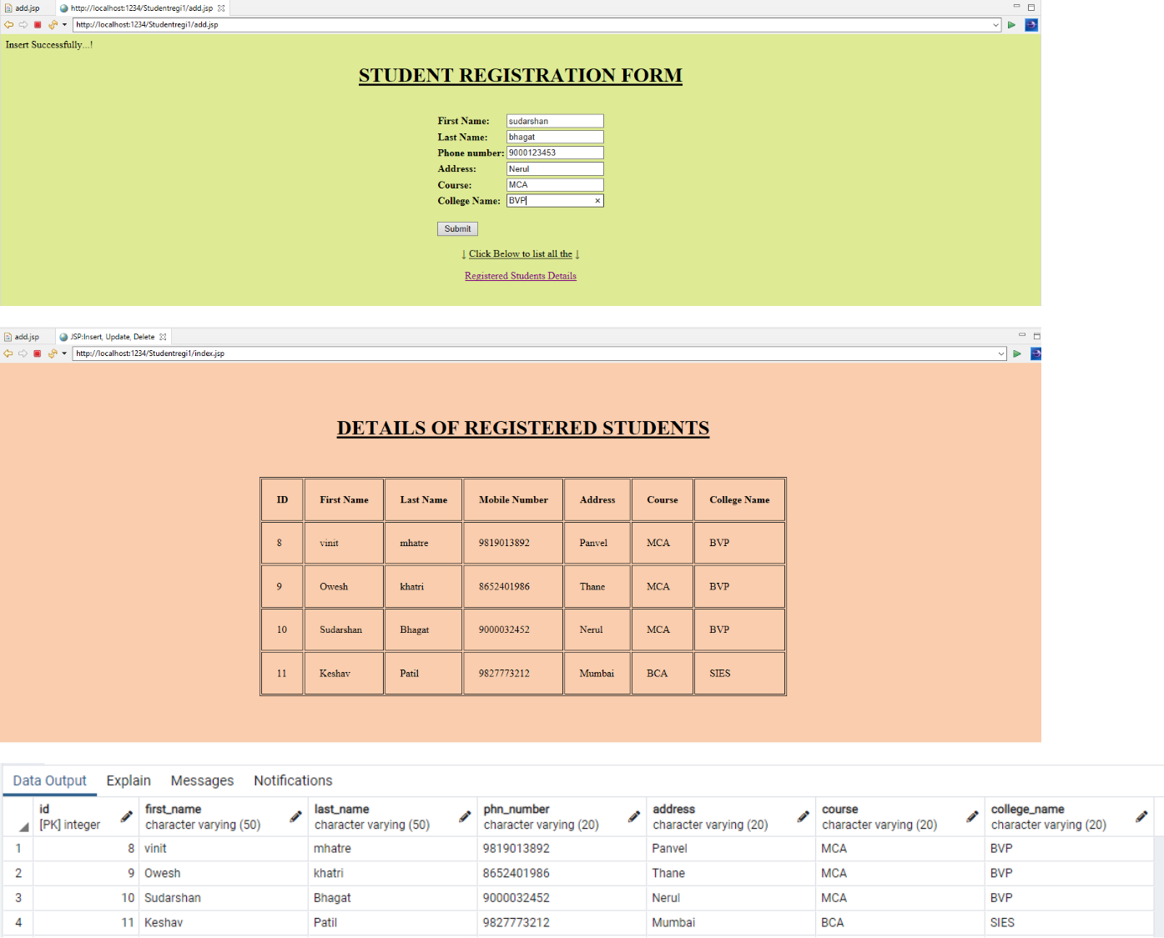

Problem Statement 3. Write a JSP program to add, delete and display the records from StudentMaster (RollNo, Name, Semester, Course) table.

Database table(student1) :

CREATE TABLE student1

(

id SERIAL PRIMARY KEY,

rno varchar(50),

name varchar(50),

semester varchar(50),

course varchar(50)

);

Index.jsp :

<%@page import="java.sql.*" %>

<%

try

{

String driver ="org.postgresql.Driver";

String url ="jdbc:postgresql://localhost:5432/postgres";

String username ="postgres";

String password ="admin";

Connection con =null;

Class.forName(driver).newInstance();

con = DriverManager.getConnection(url,username,password); System.out.println("Opened database successfully");

Trishna Tamanna Biswal(B-6)

if(request.getParameter("delete")!=null)

{

int id=Integer.parseInt(request.getParameter("delete"));

PreparedStatement pstmt=null; //create statement

pstmt=con.prepareStatement("delete from student1 where id=? "); // delete query

pstmt.setInt(1,id);

pstmt.executeUpdate(); //execute query

con.close(); //close connection

}

}

catch(Exception e)

{

out.println(e);

}

%>

<html>

<head>

<title>JSP:Insert, Update, Delete </title>

</head>

<body>

<center>

<h1><a href="add.jsp">Add Record</a></h1>

</center>

<table>

<tr>

<th>ID</th>

<th>Roll No</th>

Trishna Tamanna Biswal(B-6)

<th>Name</th>

<th>Sem</th>

<th>Course</th>

<th>Update</th>

<th>Delete</th>

</tr>

<%

try

{

String driver ="org.postgresql.Driver";

String url ="jdbc:postgresql://localhost:5432/postgres";

String username ="postgres";

String password ="admin";

Connection con =null;

Class.forName(driver).newInstance();

con = DriverManager.getConnection(url,username,password);

PreparedStatement pstmt=null; //create statement

pstmt=con.prepareStatement("select * from student1"); //select query

ResultSet rs=pstmt.executeQuery(); //execute query and set in resultset object rs.

while(rs.next())

{

%>

<tr>

<td><%=rs.getInt(1)%></td>

<td><%=rs.getString(2)%></td>

<td><%=rs.getString(3)%></td>

<td><%=rs.getString(4)%></td>

<td><%=rs.getString(5)%></td>

<td><a href="update.jsp?edit=<%=rs.getInt(1)%> ">Edit</a></td>

<td><a href="?delete=<%=rs.getInt(1)%> ">Delete</a></td>

</tr>

<%

}

}

catch(Exception e)

{

out.println(e);

}

%>

</table>

</body>

</html>

Add.jsp :

<%@ page import="java.sql.*" %>

<%

try

{

String driver ="org.postgresql.Driver";

String url ="jdbc:postgresql://localhost:5432/postgres";

String username ="postgres";

String password ="admin";

Connection con =null;

Class.forName(driver).newInstance();

con = DriverManager.getConnection(url,username,password); System.out.println("Opened database successfully"); if(request.getParameter("btn_add")!=null) //check button click event not null {
String rno,name,semester,course; rno=request.getParameter("txt_rno"); name=request.getParameter("txt_name"); //txt_name semester=request.getParameter("txt_sem"); //txt_owner course=request.getParameter("txt_course"); //txt_owner

PreparedStatement pstmt=null; //create statement

pstmt=con.prepareStatement("insert into student1(rno,name,semester,course)values(?,?,?,?)"); // insert query

pstmt.setString(1,rno);

pstmt.setString(2,name);

pstmt.setString(3,semester);

pstmt.setString(4,course);

pstmt.executeUpdate(); //execute query

con.close(); //close connection

out.println("Insert Successfully...! Click Back link.");// after insert record successfully message

}

}

catch(Exception e)

{

out.println(e);

}

%>

<html>

<head>

<title>JSP:Insert, Update, Delete using MySQL</title>

<!-- javascript for form validation-->

<script>

function validate()

{

var rno = document.myform.txt_rno;

var name = document.myform.txt_name;

var semester = document.myform.txt_sem;

var course = document.myform.txt_course;

if (rno.value == "")

{

window.alert("please enter rno ?");

name.focus();

return false;

}

if (name.value == "")

{

window.alert("please enter name ?");

name.focus();

return false;

}

if (semester.value == "")

{

window.alert("please enter sem ?");

owner.focus();

return false;

}

if (course.value == "")

{

window.alert("please enter course ?");

owner.focus();

return false;

}

}

</script>

</head>

<body>

<form method="post" name="myform" onsubmit="return validate();"> <center>
<h1>Insert Record</h1>

</center>

<table>

<tr>

<td>Roll No</td>

<td><input type="text" name="txt_rno"></td>

</tr>

<tr>

<td>Name</td>

<td><input type="text" name="txt_name"></td>

</tr>

<tr>

<td>Sem</td>

<td><input type="text" name="txt_sem"></td>

</tr>

<tr>

<td>Course</td>

<td><input type="text" name="txt_course"></td>

</tr>

<tr>

<td><input type="submit" name="btn_add" value="Insert"></td>

</tr>

</table>

<center>

<h1><a href="index.jsp">Back</a></h1>

</center>

</form>

</body>

</html>

Update.jsp :

<%@ page import="java.sql.*" %>

<%

try

{

String driver ="org.postgresql.Driver";

String url ="jdbc:postgresql://localhost:5432/postgres";

String username ="postgres";

String password ="admin";

Connection con =null;

Class.forName(driver).newInstance();

con = DriverManager.getConnection(url,username,password); System.out.println("Opened database successfully"); if(request.getParameter("btn_update")!=null) //check button click event not null {
int hide,rno,name,semester,course;;

String rno_up,name_up,semester_up,course_up;

hide=Integer.parseInt(request.getParameter("txt_hide")); //it is hidden id get for update record

rno_up=request.getParameter("txt_rno");

name_up=request.getParameter("txt_name"); //txt_name

semester_up=request.getParameter("txt_semester");

course_up=request.getParameter("txt_course");

PreparedStatement pstmt=null; //create statement

pstmt=con.prepareStatement("update student1 set rno=?,name=?, semester=?, course=? where id=?"); // update query

pstmt.setString(1,rno_up);

pstmt.setString(2,name_up);

pstmt.setString(3,semester_up);

pstmt.setString(4,course_up);

pstmt.setInt(5,hide);

pstmt.executeUpdate(); //execute query

con.close(); //connection close

out.println("Update Successfully...! Click Back link."); //after update record successfully message

}

}

catch(Exception e)

{

out.println(e);

}

%>

<html>

<head>

<title>JSP:Insert, Update, Delete using MySQL</title>

<!-- javascript for form validation-->

<script>

function validate()

{

var rno = document.myform.txt_rno;

var name = document.myform.txt_name;

var semester = document.myform.txt_semester;

var course = document.myform.txt_course;

if (rno.value == "")

{

window.alert("please enter rno ?");

name.focus();

return false;

}

if (name.value == "")

{

window.alert("please enter name ?");

name.focus();

return false;

}

if (semester.value == "")

{

window.alert("please enter sem ?");

owner.focus();

return false;

}

if (course.value == "")

{

window.alert("please enter course ?");

owner.focus();

return false;

}}

</script>

</head>

<body>

<form method="post" name="myform" onsubmit="return validate();"> <center>
<h1>Update Record</h1>

</center>

<table>

<%

try

{

String driver ="org.postgresql.Driver";

String url ="jdbc:postgresql://localhost:5432/postgres";

String username ="postgres";

String password ="admin";

Connection con =null;

Class.forName(driver).newInstance();

con = DriverManager.getConnection(url,username,password); System.out.println("Opened database successfully"); if(request.getParameter("edit")!=null) {
int id=Integer.parseInt(request.getParameter("edit"));

String rno,name,semester,course;

PreparedStatement pstmt=null; // create statement

pstmt=con.prepareStatement("select * from student1 where id=?"); // sql select query

pstmt.setInt(1,id);

ResultSet rs=pstmt.executeQuery(); // execute query store in resultset object rs.

while(rs.next())

{

id=rs.getInt(1);

rno=rs.getString(2);

name=rs.getString(3);

semester=rs.getString(4);

course=rs.getString(5);

%>

<tr>

<td>Roll NO</td>

<td><input type="text" name="txt_rno" value="<%=rno%>"></td>

</tr>

<tr>

<td>Name</td>

<td><input type="text" name="txt_name" value="<%=name%>"></td>

</tr>

<tr>

<td>Sem</td>

<td><input type="text" name="txt_semester" value="<%=semester%>"></td>

</tr>

<tr>

<td>Course</td>

<td><input type="text" name="txt_course" value="<%=course%>"></td>

</tr>

<tr>

<td><input type="submit" name="btn_update" value="Update"></td> </tr>
<input type="hidden" name="txt_hide" value="<%=id%>">

<%

}

}

}

catch(Exception e)

{

out.println(e);

}

%>

</table>

<center>

<h1><a href="index.jsp">Back</a></h1>

</center>

</form>

</body></html>

Output:
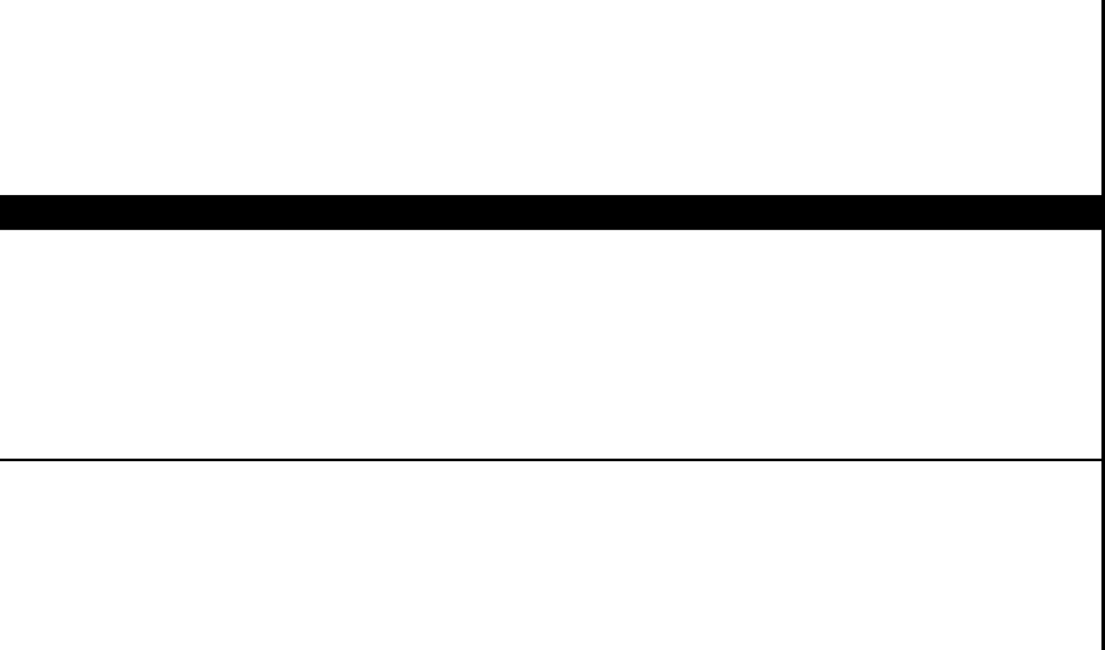
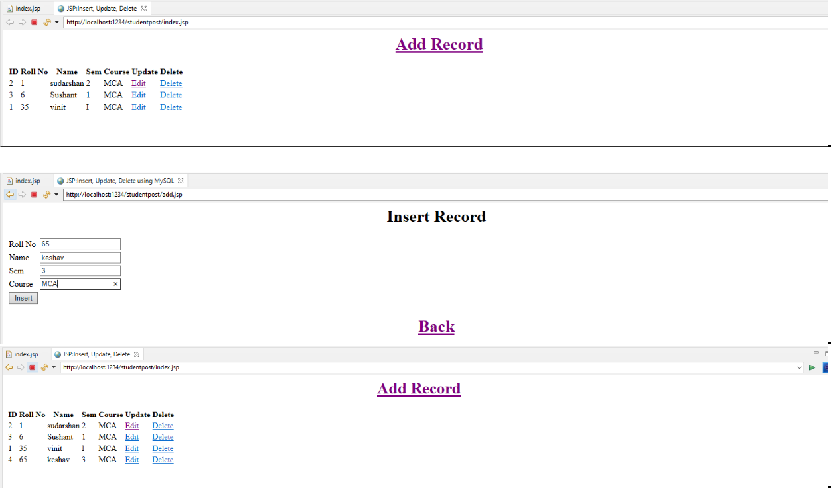

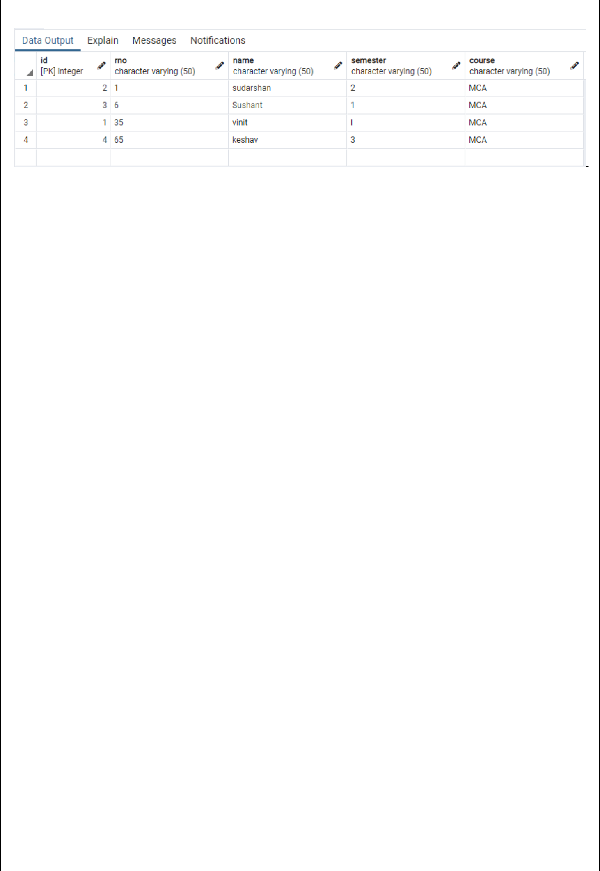

Problem Statement 4. Design loan calculator using JSP which accepts Period of Time (in years) and Principal Loan Amount. Display the payment amount for each loan and then list the loan balance and interest paid for each payment over the term of the loan for the following time period and interest rate:

a. 1 to 7 year at 5.35%

b. 8 to 15 year at 5.5%

c. 16 to 30 year at 5.75%

Cal.jsp :

<%@page contentType="text/html" pageEncoding="UTF-8"%> <!DOCTYPE HTML PUBLIC "-//W3C//DTD HTML 4.01 Transitional//EN"
"http://www.w3.org/TR/html4/loose.dtd">

<html>

<head>

<meta http-equiv="Content-Type" content="text/html; charset=UTF-8"> <title>JSP Page</title>
</head>

<body><br><br><center>

<form action="test.jsp "><pre>

<h1>Principle :: <input type=text name=principle value=0 " ><br>

No. of Years :: <input type=text name=year value=0 " ><br>

Rate of Interest :: <input type=text name=interest value=0 " > %<br> <br>
<input type=submit value="Submit"></h1>

</pre></form></center>

</body>

</html>

Test.jsp:

<%@page contentType="text/html" pageEncoding="UTF-8"%> <!DOCTYPE HTML PUBLIC "-//W3C//DTD HTML 4.01 Transitional//EN" "http://www.w3.org/TR/html4/loose.dtd">

<html>

<head>

<meta http-equiv="Content-Type" content="text/html; charset=UTF-8">

<title>JSP Page</title>

</head>

<body><br><br><center><pre><H1>

<%

String ns= request.getParameter("principle");

String ns1= request.getParameter("year");

String ns2= request.getParameter("interest");

int n1=Integer.parseInt(ns);

int n2=Integer.parseInt(ns1);

float n3 = Float.valueOf(ns2);

double si=((n1*n2*n3)/100);

double x;

x=n1+si;

double r = (n3)/(12*100);

int mon;

mon=((n2)*12);

double emi= (n1*r*Math.pow(1+r,mon))/(Math.pow(1+r,mon)-1);

%>
<%
out.println("Principle = | "+n1);
out.println(" Years = | "+n2);
out.println(" Rate of Interest = "+n3);
out.println("<br> ");
out.println("Loan Amount = | "+n1);
out.println(" Interest Paid = | "+si);
out.println(" Total Loan Amount = "+x);

out.println("<br> ");

out.print(" Loan Tenure in months= " +mon);

out.println("<br> ");

out.print(" EMI is= "+emi+"\n");

%>

</H1>

</pre>

</center>

</body> </body>

</html>

Output:

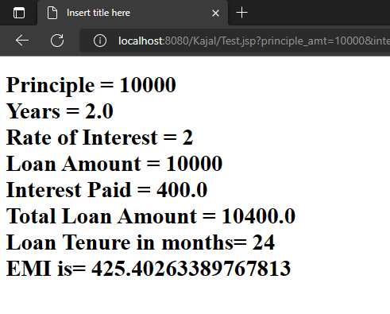



Problem Statement 5. Write a program using JSP that displays a webpage consisting Application form for change of Study Center which can be filled by any student who wants to change his/ her study center. Make necessary assumptions

<%@ page language="java" contentType="text/html; charset=ISO-8859-1"

pageEncoding="ISO-8859-1"%>

<!DOCTYPE html>

<html>

<head>

<meta charset="ISO-8859-1">

<title>Study Center</title>

<link rel="stylesheet" href="https://cdn.jsdelivr.net/npm/bootstrap-icons@1.4.0/font/bootstrap-icons.css"> <link href="https://cdn.jsdelivr.net/npm/bootstrap@5.0.0-beta2/dist/css/bootstrap.min.css" rel="stylesheet" integrity="sha384-BmbxuPwQa2lc/FVzBcNJ7UAyJxM6wuqIj61tLrc4wSX0szH/Ev+nYRRuWlolflfl" crossorigin="anonymous">

</head>

<body>

<center>

<h1>Change of Study Center</h1>

<form action="main.jsp" method="post">

<table>

<tr>

<td>UID No.</td>

<td><input type="text" name="uid" required/></td>

</tr>

<tr>

<td>

Current Center

</td>

<td>

<select name="currentCenter" required>

<option selected disabled hidden></option>

<option value="MUMBAI">MUMBAI</option>

<option value="PUNE">PUNE</option>

<option value="GUJRAT">GUJRAT</option>

</select>

</td>

</tr>

<tr>

<td>

New Center

</td>

<td>

<select name="newCenter" required>

<option selected disabled hidden></option>

<option value="MUMBAI">MUMBAI</option>

<option value="PUNE">PUNE</option>

<option value="GUJRAT">GUJRAT</option>

</select>

</td>

</tr>

</table>

<input type="submit" value="Submit"/>

</form>

</center>

<%

if(request.getParameter("uid") != null&& request.getParameter("currentCenter") != null&& request.getParameter("newCenter") != null){
out.println("<center><br>Your request to change Study Center from <br>" +

request.getParameter("currentCenter") + " to " + request.getParameter("newCenter") + "<br> has been sent to the

Administrator.</center>");

}

%>

</body>

</html>

Output:

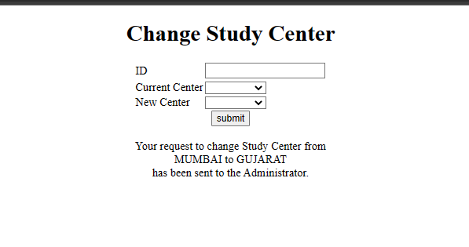

Problem Statement 6. Write a JSP program that demonstrates the use of JSP declaration, scriptlet, directives, expression, header and footer.

Main.jsp :

<%@ page language="java" contentType="text/html; charset=ISO-8859-1"

pageEncoding="ISO-8859-1"%>

<!DOCTYPE html>

<html>

<head>

<meta charset="ISO-8859-1">

<title>JSP EXAMPLE</title>

</head>

<body>

<%@ include file = "header.jsp" %>

<center>

<%! int data=50; %>

<%= "Value of the variable is:"+data %>

<%!

double circle(int n){ return 3.14*n*n;}

%></br>

<%= "Area of circle is:"+ circle(3) %></br>

<%!

int rectangle(int l,int b){ return l*b;}

%>

<%= "Area of rectangle is:"+rectangle(3,4

- %></br>

<%!

int perimeter(int x,int y){ int peri=2*(x+y); return peri;}
%>

<%= "Perimeter of rectanlge:"+perimeter(5,6

) %> </br>

<p>Thanks for visiting my page.</p>

</center>

<%@ include file = "footer.jsp" %>

</body>

</html>

Header.jsp :

<%@ page language="java" contentType="text/html; charset=ISO-8859-1"

pageEncoding="ISO-8859-1"%>

<!DOCTYPE html>

<%!

int pageCount = 0;

void addCount() {

pageCount++;

}

%>

<% addCount(); %>

<html>

<head>

<title>JSP declaration, scriptlet, directives, expression, header and footer Example</title>

</head>

<body>

<center>

<h2><u>The include Directive Example</u></h2>

<p><b>This site has been visited <%= pageCount %> times.</b></p>

</center>

<br/><br/>

</body>

</html>

Footer.jsp :

<%@ page language="java" contentType="text/html; charset=ISO-8859-1"

pageEncoding="ISO-8859-1"%>

<!DOCTYPE html>

<html>

<head>

<meta charset="ISO-8859-1">

<title>Insert title here</title>

</head>

<body>

<br/><br/>

<center> <p><b>Vinit Mhatre 35</b></p> </center> </body></html>

Output:

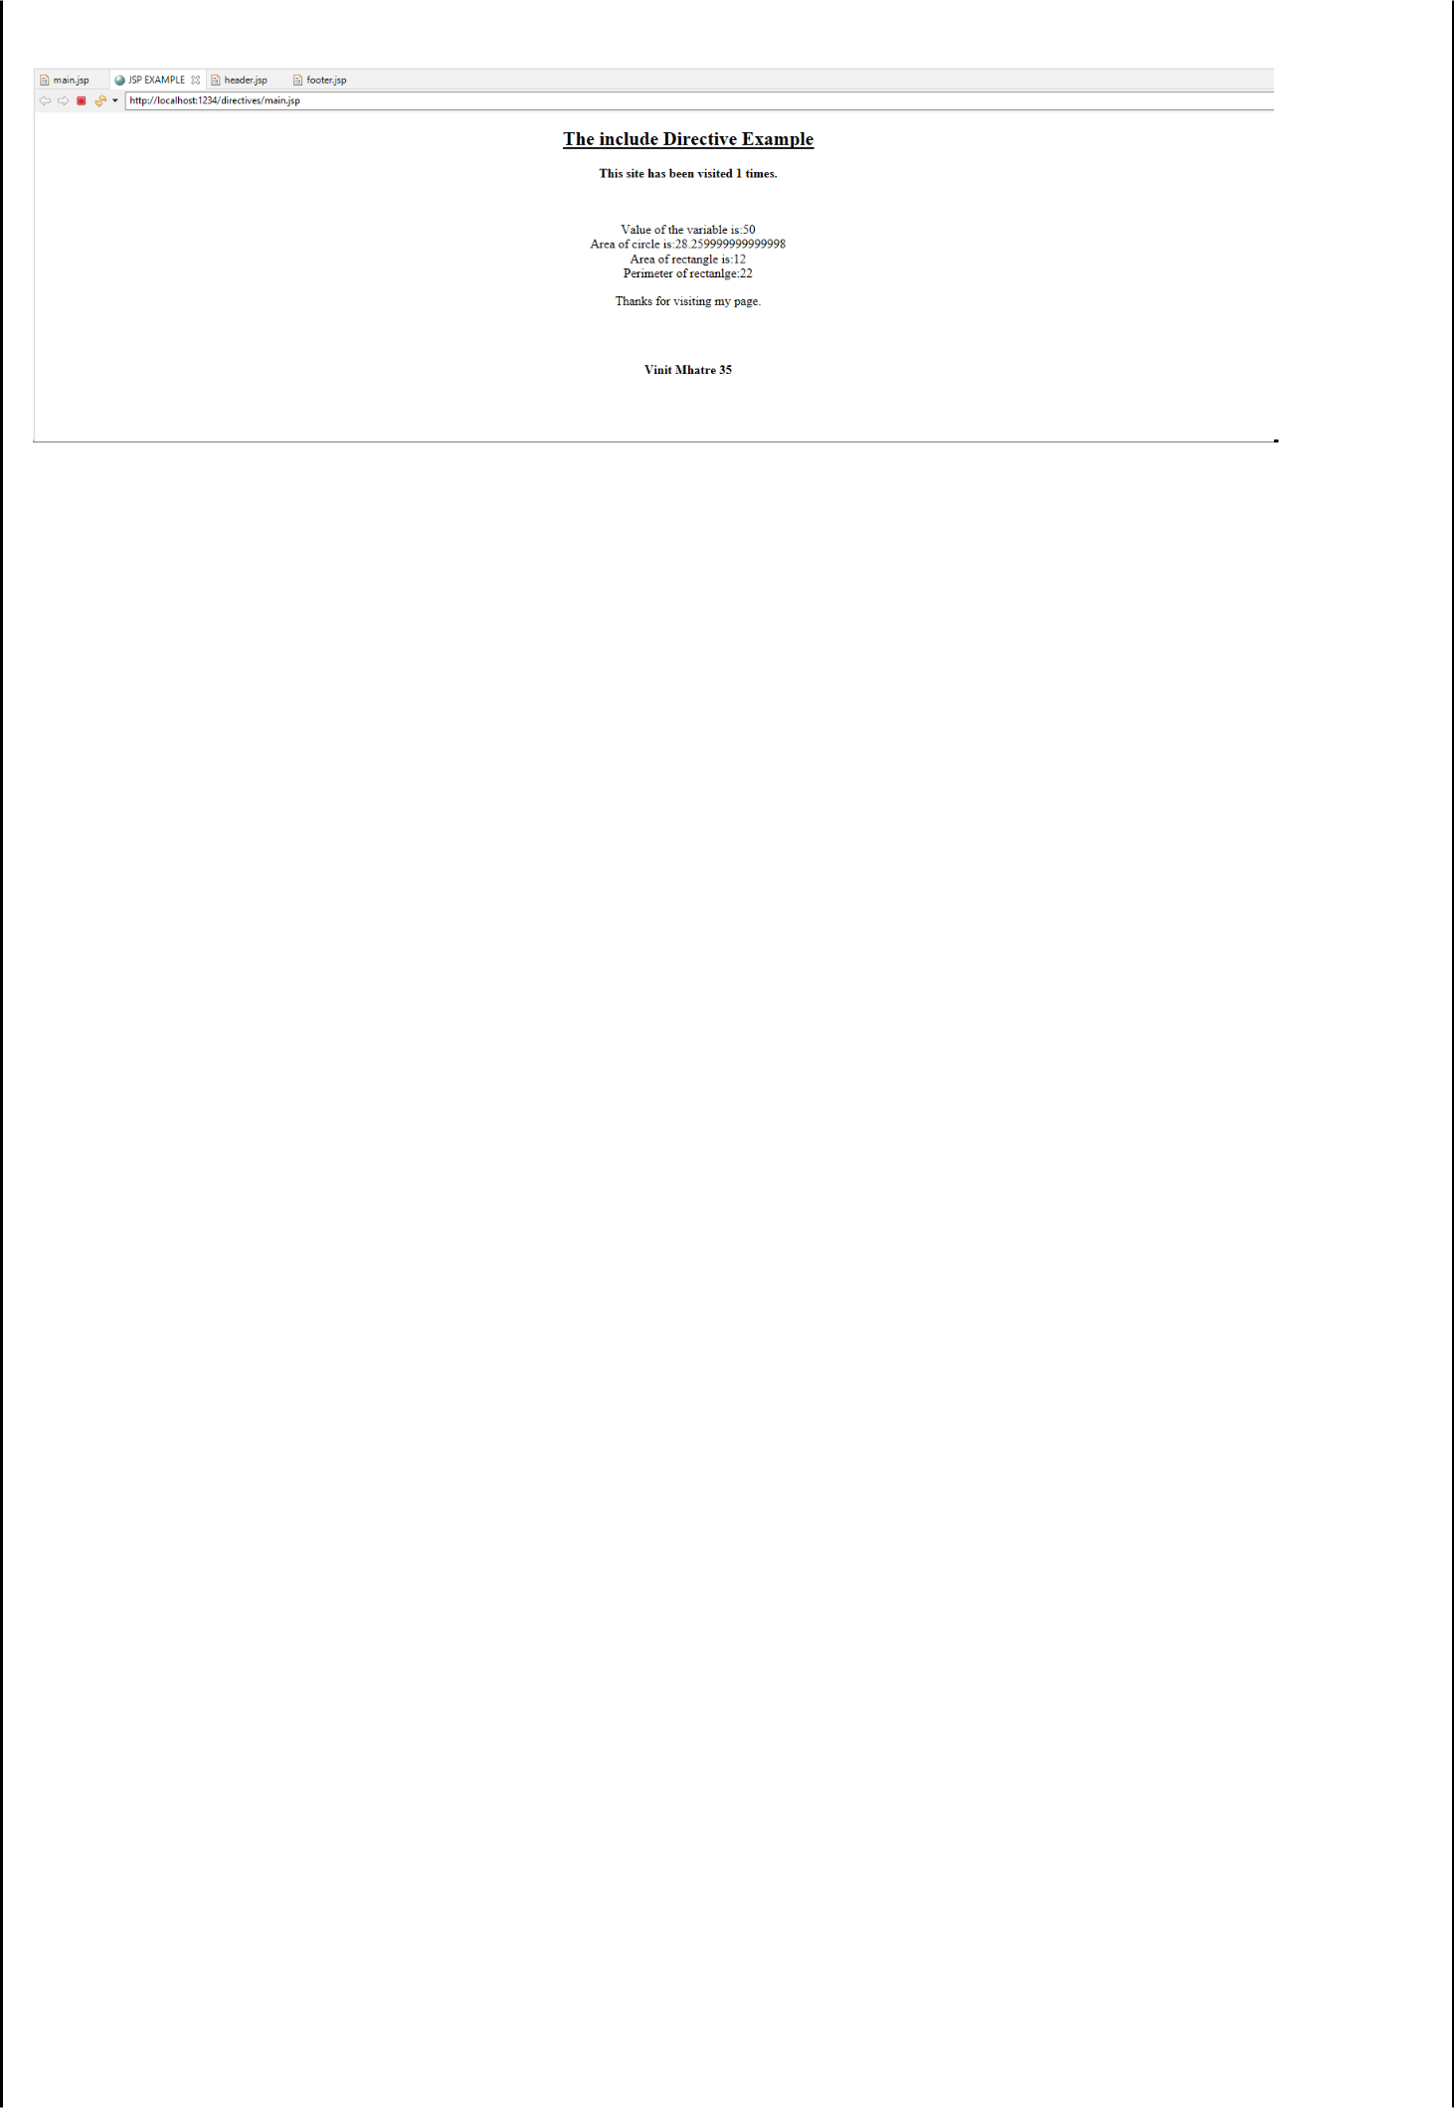

Problem Statement 7. Write a JSP program that demonstrates the use of session or cookies.

Cookie.jsp :

<%@ page language="java" contentType="text/html; charset=ISO-8859-1"

pageEncoding="ISO-8859-1"%>
<!DOCTYPE html PUBLIC "-//W3C//DTD HTML 4.01 Transitional//EN" "http://www.w3.org/TR/html4/loose.dtd">

<html>
<head>
<meta http-equiv="Content-Type" content="text/html; charset=ISO-8859-1">
<title>Cookie</title>
</head>
<body><center>
<br><br><br><br><br>
<form action="action.jsp" method="GET">
<h1>Program that demonstrates the use of session or cookies.</h1> Username: <input type="text" name="username"> <br><br>

Email: <input type="text" name="email" />
<br><br>
<input type="submit" value="Submit" />
</center>
</form>
</body>
</html>

Action.jsp :

<%@ page language="java" contentType="text/html; charset=ISO-8859-1"

pageEncoding="ISO-8859-1"%>
<!DOCTYPE html PUBLIC "-//W3C//DTD HTML 4.01 Transitional//EN" "http://www.w3.org/TR/html4/loose.dtd"> <%

Cookie username = new Cookie("username",

request.getParameter("username"));
Cookie email = new Cookie("email",
request.getParameter("email"));

username.setMaxAge(60*60*10);

email.setMaxAge(60*60*10);

- Add both the cookies in the response header. response.addCookie( username ); response.addCookie( email );

%>

<html>

<head>
<meta http-equiv="Content-Type" content="text/html; charset=ISO-8859-1">
<title>Cookie JSP</title>
</head>
<body>
<br><br><br><br><br><br><br><br><br><br><br><br><br><br><br><br>

<center>
<b>Username:</b>
<%= request.getParameter("username")%><br><br>
<b>Email:</b>
<%= request.getParameter("email")%>
</center>
</body>
</html>

Output:

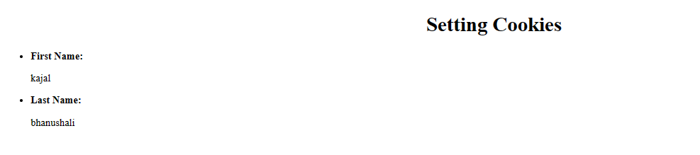

Assignment No. 7

Spring Framework

- Write a program to print “Hello World” using spring framework.

- Write a program to demonstrate dependency injection via setter method.

- Write a program to demonstrate dependency injection via Constructor.

Problem Statement 1 : Write a program to print “Hello World” using spring framework.

Solution :

HelloWorld.java

package spring1;

public class HelloWorld {

String name;

public String getName() {

return name;
}

public void setName(String name) {

this.name = name;
}

@Override

public String toString() {
return "Hello World, I'm " + name + ".";
}
}

appctx3.xml

<?xml version="1.0" encoding="UTF-8"?>

<beans xmlns="http://www.springframework.org/schema/beans" xmlns:xsi="http://www.w3.org/2001/XMLSchema-instance" xsi:schemaLocation="http://www.springframework.org/schema/beans

http://www.springframework.org/schema/beans/spring-beans.xsd">

<bean id="hw" class="spring1.HelloWorld">

<property name="name" value="kajal"/>
</bean>

</beans>

TestHelloWorld.java

package spring1;

import org.springframework.context.support.ClassPathXmlApplicationContext;

public class TestHelloWorld {

public static void main(String[] args) {

ClassPathXmlApplicationContext app = new ClassPathXmlApplicationContext("appctx3.xml");

HelloWorld hw = (HelloWorld) app.getBean("hw");

System.out.println(hw.toString());

}

}

Output :

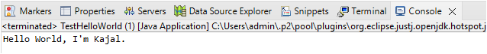

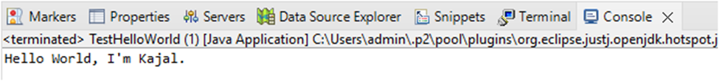

Problem Statement 2 : Write a program to demonstrate dependency injection via setter method.

Solution:

Account.java

package spring1;

public class Account {

int id;

String name;
int balance;

public Account(int id, String name, int balance) {

super();
this.id = id;
this.name = name;
this.balance = balance;
}
public int getId() {
return id;
}
public void setId(int id) {
this.id = id;
}
public String getName() {
return name;
}
public void setName(String name) {
this.name = name;
}
public int getBalance() {
return balance;
}
public void setBalance(int balance) {
this.balance = balance;
}
@Override
public String toString() {
return "Account [id=" + id + ", name=" + name + ", balance=" + balance + "]";
}

}

appctx2.xml

<?xml version="1.0" encoding="UTF-8"?>

<beans xmlns="http://www.springframework.org/schema/beans" xmlns:xsi="http://www.w3.org/2001/XMLSchema-instance" xsi:schemaLocation="http://www.springframework.org/schema/beans

http://www.springframework.org/schema/beans/spring-beans.xsd">

<bean id="Account" class="spring1.Account">

<constructor-arg name="id" value="1"></constructor-arg> <constructor-arg name="name" value="kajal"></constructor-arg> <constructor-arg name="balance" value="69000"></constructor-arg>

</bean>

</beans>

AccountTest.java

package spring1;

import org.springframework.context.ApplicationContext;

import org.springframework.context.support.ClassPathXmlApplicationContext;

public class Accounttest {

public static void main(String[] args) {

ApplicationContext con = new ClassPathXmlApplicationContext("appctx2.xml"); Account acc = (Account) con.getBean("Account");

System.out.println(acc.toString());

}

}

Output :

Problem Statement 3 : Write a program to demonstrate dependency injection via Constructor.

Solution:

Singer.java

package spring1;

public class Singer {

String name;
int age;
public String getName() {
return name;
}
public void setName(String name) {
this.name = name;
}
public int getAge() {
return age;
}
public void setAge(int age) {
this.age = age;
}
void displayInfo()
{
System.out.println("Name:" +name+" Age:" +age);
}
}

appctx.xml

<?xml version="1.0" encoding="UTF-8"?>

<beans xmlns="http://www.springframework.org/schema/beans" xmlns:xsi="http://www.w3.org/2001/XMLSchema-instance" xsi:schemaLocation="http://www.springframework.org/schema/beans

http://www.springframework.org/schema/beans/spring-beans.xsd"> <bean id="Singer" class="spring1.Singer">
<property name="name" value="kajal"></property> <property name="age" value="20"></property> </bean>

</beans>

SingerTest.java

package spring1;

import org.springframework.context.ApplicationContext;

import org.springframework.context.support.ClassPathXmlApplicationContext;

public class SingerTest {

private static ApplicationContext ctx;

public static void main(String[] args) {

// TODO Auto-generated method stub

ctx=new ClassPathXmlApplicationContext("appctx.xml"); Singer singer=(Singer)ctx.getBean("Singer");
singer.displayInfo();

}

}

Output :


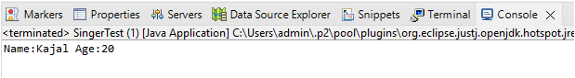

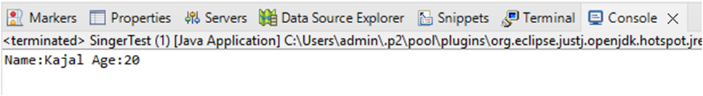

Assignment No 8

Aspect Oriented Programming

- Write a program to demonstrate Spring AOP – before advice.

- Write a program to demonstrate Spring AOP – after advice.

- Write a program to demonstrate Spring AOP – around advice.

- Write a program to demonstrate Spring AOP – after returning advice.

- Write a program to demonstrate Spring AOP – after throwing advice.

- Write a program to demonstrate Spring AOP – pointcuts.



Problem Statement 1 : Write a program to demonstrate Spring AOP – before advice.

Solution :

beforeaop.java

package bvimit.edu;

import org.aspectj.lang.JoinPoint;

import org.aspectj.lang.annotation.Aspect;

import org.aspectj.lang.annotation.Before;

import org.aspectj.lang.annotation.Pointcut;

@Aspect

public class beforeaop {

@Pointcut("execution(int beforeoperation.*(..))")

public void p(){}

@Before("p()")

public void myadvice(JoinPoint jp)

{

System.out.println("before advice");

}

}

beforeoperation.java

package bvimit.edu;

public class beforeoperation {

public void msg() {System.out.println("method 1");}
public int m(){System.out.println("method 2 with return");return 2;} public int k(){System.out.println("method 3 with return");return 3;} }

aopctx1.xml

<?xml version="1.0" encoding="UTF-8"?>

<beans xmlns="http://www.springframework.org/schema/beans" xmlns:xsi="http://www.w3.org/2001/XMLSchema-instance" xsi:schemaLocation="http://www.springframework.org/schema/beans

http://www.springframework.org/schema/beans/spring-beans.xsd">

<bean id="opBean" class="bvimit.edu.beforeoperation"> </bean>

<bean id="trackMyBean" class="bvimit.edu.beforeaop"></bean>

<bean

class="org.springframework.aop.aspectj.annotation.AnnotationAwareAspectJAutoProxyCreator"></bean>

</beans>

beforetest.java

package bvimit.edu;

import org.springframework.context.ApplicationContext;

import org.springframework.context.support.ClassPathXmlApplicationContext;

public class beforetest {

public static void main(String[] args) {

ApplicationContext context = new ClassPathXmlApplicationContext("aopctx1.xml");

beforeoperation e = (beforeoperation) context.getBean("opBean");

System.out.println("calling m1......");

e.msg();

System.out.println("calling m2......");

e.m();

System.out.println("calling m3......");

e.k();

}

}

Output :

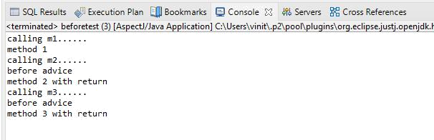

Problem Statement 2 : Write a program to demonstrate Spring AOP – after advice.

Solution :

Afteraopdata.java

package bvimit.edu;

import org.aspectj.lang.JoinPoint;

import org.aspectj.lang.annotation.After;

import org.aspectj.lang.annotation.Aspect;

import org.aspectj.lang.annotation.Pointcut;

@Aspect

public class afteraopdata {

@Pointcut("execution(int afteroperation.*(..))")

public void p(){}

@After("p()")

public void myadvice(JoinPoint jp)

{

System.out.println("after advice");

}

}

afteroperation.java

package bvimit.edu;

public class afteroperation {

public void msg() {System.out.println("method 1");}
public int m(){System.out.println("method 2 with return");return 2;} public int k(){System.out.println("method 3 with return");return 3;} }

aopctx.xml

<?xml version="1.0" encoding="UTF-8"?>

<beans xmlns="http://www.springframework.org/schema/beans" xmlns:xsi="http://www.w3.org/2001/XMLSchema-instance" xsi:schemaLocation="http://www.springframework.org/schema/beans

http://www.springframework.org/schema/beans/spring-beans.xsd">

<bean id="opBean" class="bvimit.edu.afteroperation"> </bean>

<bean id="trackMyBean" class="bvimit.edu.afteraopdata"></bean>

<bean

class="org.springframework.aop.aspectj.annotation.AnnotationAwareAspectJAutoProxyCreator"></bean>

</beans>

aftertest.java

package bvimit.edu;

import org.springframework.context.ApplicationContext;

import org.springframework.context.support.ClassPathXmlApplicationContext;

public class aftertest {

public static void main(String[] args) {

ApplicationContext context = new ClassPathXmlApplicationContext("aopctx.xml");

afteroperation e = (afteroperation) context.getBean("opBean");

System.out.println("calling m1......");

e.msg();

System.out.println("calling m2......");

e.m();

System.out.println("calling m3......");

e.k();

}

}

Output :

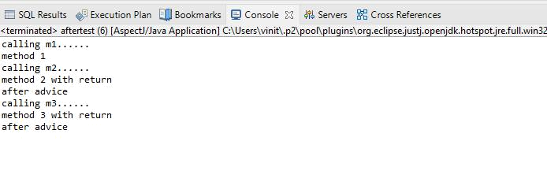

Problem Statement 3 : Write a program to demonstrate Spring AOP – around advice.

Solution :

Bankaopdata.java

package bvimit.edu;

import org.aspectj.lang.ProceedingJoinPoint;

import org.aspectj.lang.annotation.Around;

import org.aspectj.lang.annotation.Aspect;

import org.aspectj.lang.annotation.Pointcut;

@Aspect

public class Bankaopdata {

@Pointcut("execution(* Bank.*(..))")

public void a() {}

@Around("a()")

public Object myadvice(ProceedingJoinPoint p)throws Throwable

{

System.out.println("Around concern Before calling actual method"); Object obj=p.proceed();
System.out.println("Around Concern After calling actual method"); return obj;
}

}

Bank.java

package bvimit.edu;

public class Bank {

public void welcome() {System.out.println("welcome to bank");} public int icici() {System.out.println("icici bank interest rate");return 7;} public int pnb() {System.out.println("pnb bank interest rate");return 6;}

}

Bankaopdata.xml

<?xml version="1.0" encoding="UTF-8"?>

<beans xmlns="http://www.springframework.org/schema/beans" xmlns:xsi="http://www.w3.org/2001/XMLSchema-instance" xsi:schemaLocation="http://www.springframework.org/schema/beans

http://www.springframework.org/schema/beans/spring-beans.xsd">

<bean id="opBean" class="bvimit.edu.Bank"> </bean>

<bean id="trackMyBean" class="bvimit.edu.Bankaopdata"></bean>

<bean

class="org.springframework.aop.aspectj.annotation.AnnotationAwareAspectJAutoProxyCreator"></bean> </beans>

Banktest.java

package bvimit.edu;

import org.springframework.context.ApplicationContext;

import org.springframework.context.support.ClassPathXmlApplicationContext;

public class Banktest {

private static ApplicationContext context;

public static void main(String[] args) {

context = new ClassPathXmlApplicationContext("Bankaopdata.xml");

Bank e =(Bank) context.getBean("opBean");

System.out.println("Calling welcome method...");
e.welcome();
System.out.println("Calling icici method...");
e.icici();
System.out.println("Calling pnb method...");
e.pnb();
}

}

Output :

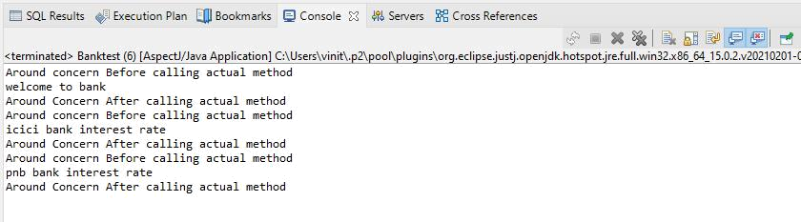

Problem Statement 4 : Write a program to demonstrate Spring AOP – after returning advice.

Solution :

Bankaopdata.java

package bvimit.edu;

import org.aspectj.lang.JoinPoint;

import org.aspectj.lang.ProceedingJoinPoint;
import org.aspectj.lang.annotation.AfterReturning;
import org.aspectj.lang.annotation.Around;
import org.aspectj.lang.annotation.Aspect;
import org.aspectj.lang.annotation.Pointcut;

@Aspect

public class Bankaopdata {

@AfterReturning(

pointcut ="execution(* Bank.*(..))",
returning="result")
public void myadvice(JoinPoint jp,Object result)
{
System.out.println("AfterReturning concern");
System.out.println("Result in advice" +result);
}
}

Bank.java

package bvimit.edu;

public class Bank {

public void welcome() {System.out.println("welcome to bank");} public int icici() {System.out.println("icici bank interest rate");return 7;} public int pnb() {System.out.println("pnb bank interest rate");return 6;}

}

Bankaopdata.xml

<?xml version="1.0" encoding="UTF-8"?>

<beans xmlns="http://www.springframework.org/schema/beans" xmlns:xsi="http://www.w3.org/2001/XMLSchema-instance" xsi:schemaLocation="http://www.springframework.org/schema/beans

http://www.springframework.org/schema/beans/spring-beans.xsd">

<bean id="opBean" class="bvimit.edu.Bank"> </bean>

<bean id="trackMyBean" class="bvimit.edu.Bankaopdata"></bean>

<bean

class="org.springframework.aop.aspectj.annotation.AnnotationAwareAspectJAutoProxyCreator"></bean> </beans>

Banktest.java

package bvimit.edu;

import org.springframework.context.ApplicationContext;

import org.springframework.context.support.ClassPathXmlApplicationContext;

public class Banktest {

private static ApplicationContext context;

public static void main(String[] args) {

context = new ClassPathXmlApplicationContext("Bankaopdata.xml");

Bank e =(Bank) context.getBean("opBean"); //System.out.println("Calling welcome method..."); e.welcome();

//System.out.println("Calling icici method...");
e.icici();
//System.out.println("Calling pnb method...");
e.pnb();
}

}

Output :

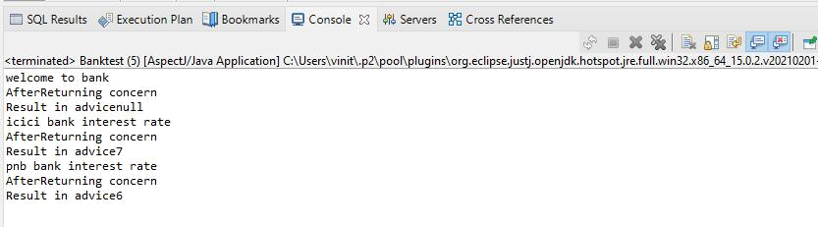

Problem Statement 5 : Write a program to demonstrate Spring AOP – after throwing advice.

Solution :

Operationaop_at.java

package bvimit.edu;

import org.aspectj.lang.JoinPoint;
import org.aspectj.lang.annotation.AfterThrowing; import org.aspectj.lang.annotation.Aspect;

@Aspect

public class Operationaop_at {
@AfterThrowing(
pointcut = "execution(* Operation_at.*(..))", throwing = "error")
public void myadvice(JoinPoint jp, Throwable error)
{
System.out.println("AfterThrowing concern");
System.out.println("Exception is: "+error);
System.out.println("end of after throwing advice....");
}
}

Operation_at.java

package bvimit.edu;

public class Operation_at {

public void validate(int att)throws Exception{

if(att<75) {
throw new ArithmeticException("Not eligible for exam");
}
else {
System.out.println("Eligible for exam");
}
}
}

validctx.xml

<?xml version="1.0" encoding="UTF-8"?>

<beans xmlns="http://www.springframework.org/schema/beans" xmlns:xsi="http://www.w3.org/2001/XMLSchema-instance" xsi:schemaLocation="http://www.springframework.org/schema/beans

http://www.springframework.org/schema/beans/spring-beans.xsd">

<bean id="opBean" class="bvimit.edu.Operation_at"></bean>

<bean id="trackMyBean" class="bvimit.edu.Operationaop_at"></bean>

<bean

class="org.springframework.aop.aspectj.annotation.AnnotationAwareAspectJAutoProxyCreator"></bean>< /beans>

TestValidation.java

package bvimit.edu;

import org.springframework.context.ApplicationContext;

import org.springframework.context.support.ClassPathXmlApplicationContext;

public class OperationTest_at {

private static ApplicationContext context;

public static void main(String[] args) {

ApplicationContext context = new ClassPathXmlApplicationContext("validctx.xml"); Operation_at op = (Operation_at) context.getBean("opBean"); System.out.println("calling validate....");
try {

op.validate(85);

}catch(Exception e){System.out.println(e);}

System.out.println("calling validate again....");

try {

op.validate(25);

}catch(Exception e){System.out.println(e);}

}

}

Output :

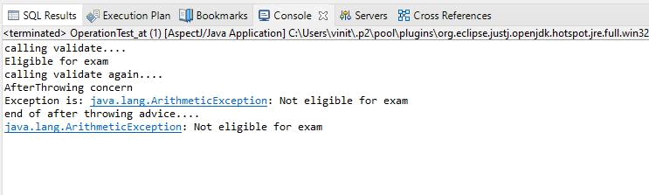

Problem Statements 6: Write a program to demonstrate Spring AOP –pointcuts.

Solution:

Operation_pc.java

package bvimit.edu;

publicclass Operation_pc {

publicvoid msg() {System.out.println("method 1");}

publicint m() {System.out.println("method 2 with return");return 2;} publicint k() {System.out.println("method 3 with return");return 3;} }

Aopdata_pc.java

package bvimit.edu;

import org.aspectj.lang.JoinPoint;

import org.aspectj.lang.annotation.After;

import org.aspectj.lang.annotation.Pointcut;

import org.aspectj.lang.annotation.Aspect;

import org.aspectj.lang.annotation.Before;

@Aspect

public class Aopdata_pc {

@Pointcut("execution(int Operation.*(..))")

public void p(){}

@After("p()")

public void myadvice(JoinPoint jp)

{

System.out.println("After advice");

}

@Pointcut("execution(* Operation.*(..))")

public void i(){}

@Before("i()")

public void myadvice1(JoinPoint jp)

{

System.out.println("Before advice");

}

}

Test_pc.java

package bvimit.edu;

import org.springframework.context.ApplicationContext;

import org.springframework.context.support.ClassPathXmlApplicationContext;

public class Test_pc {

public static void main(String[] args) {

ApplicationContext context = new ClassPathXmlApplicationContext("aopctx_pc.xml"); Operation_pc e=(Operation_pc)context.getBean("opBean"); System.out.println("calling m1...");

e.msg();

System.out.println("calling m2...");

e.m();

System.out.println("calling m3...");

e.k();

}

}

aopctx_pc.xml

<?xml version="1.0" encoding="UTF-8"?>

<beans xmlns="http://www.springframework.org/schema/beans" xmlns:xsi="http://www.w3.org/2001/XMLSchema-instance" xsi:schemaLocation="http://www.springframework.org/schema/beans

http://www.springframework.org/schema/beans/spring-beans.xsd">

<bean id="opBean" class="bvimit.edu.Operation_pc"></bean>

<bean id="trackMyBean" class="bvimit.edu.Aopdata_pc"></bean>

<bean

class="org.springframework.aop.aspectj.annotation.AnnotationAwareAspectJAutoProxyCreator"></bean>

</beans>

Output:

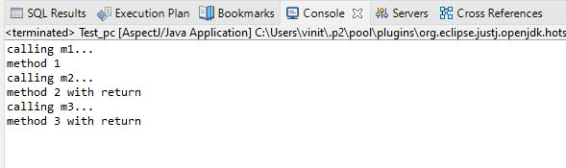

Assignment No 9

Spring JDBC

- Write a program to insert, update and delete records from the given table.

- Write a program to demonstrate PreparedStatement in Spring JdbcTemplate.

- Write a program in Spring JDBC to demonstrate ResultSetExtractor Interface.

- Write a program to demonstrate RowMapper interface to fetch the records from the database.

Problem Statement 1 : Write a program to insert, update and delete records from the given table.

Solution :

Movie1.java

package org.me;

public class Movie1 {

int mid;

String title;
String actor;
public Movie1(int mid, String title, String actor) {
super();
this.mid = mid;
this.title = title;
this.actor = actor;
}
public Movie1() {
super();
// TODO Auto-generated constructor stub
}
public int getMid() {
return mid;
}
public void setMid(int mid) {
this.mid = mid;
}
public String getTitle() {
return title;
}
public void setTitle(String title) {
this.title = title;
}
public String getActor() {
return actor;
}
public void setActor(String actor) {
this.actor = actor;
}

}

MovieDAO.java

package org.me;

import org.springframework.jdbc.core.*;

public class MovieDAO {
JdbcTemplate jdbcTemplate;

public void setJdbcTemplate(JdbcTemplate jdbcTemplate) { this.jdbcTemplate = jdbcTemplate;

}
public int insMovie(Movie1 m1)
{
String insSql="insert into mymovies1 values("+m1.getMid()+",'"+m1.getTitle()+"','"+m1.getActor()+"')";

return jdbcTemplate.update(insSql);

}

public int updateMovie(Movie1 m1){

String query="update mymovies1 set title='"+m1.getTitle()+"',actor='"+m1.getActor()+"' where mid='"+m1.getMid()+"' ";
return jdbcTemplate.update(query);
}

public int deleteMovie(Movie1 m1){

String query="delete from mymovies1 where mid='"+m1.getMid()+"' "; return jdbcTemplate.update(query);
}
}

appctx.xml

<?xml version="1.0" encoding="UTF-8"?>

<beans xmlns="http://www.springframework.org/schema/beans" xmlns:xsi="http://www.w3.org/2001/XMLSchema-instance" xsi:schemaLocation="http://www.springframework.org/schema/beans

http://www.springframework.org/schema/beans/spring-beans.xsd">

<bean id="ds" class="org.springframework.jdbc.datasource.DriverManagerDataSource"> <property name="driverClassName" value="org.postgresql.Driver" />
<property name="url" value="jdbc:postgresql://localhost:5432/postgres" /> <property name="username" value="postgres" /> <property name="password" value="admin" />
</bean>

<bean id="jdbcTemplate" class="org.springframework.jdbc.core.JdbcTemplate"> <property name="dataSource" ref="ds"></property> </bean>

<bean id="mymovie" class="org.me.MovieDAO">

<property name="jdbcTemplate" ref="jdbcTemplate"></property> </bean> </beans>

MovieTest.java

package org.me;

import org.springframework.context.ApplicationContext;

import org.springframework.context.support.ClassPathXmlApplicationContext;

public class MovieTest {

private static ApplicationContext appCon;

public static void main(String[] args) {

// TODO Auto-generated method stub

appCon = new ClassPathXmlApplicationContext("appctx.xml"); MovieDAO m1=(MovieDAO)appCon.getBean("mymovie");

//insert query

Movie1 t1=new Movie1(10,"Mirzapur","P");

System.out.println(m1.insMovie(t1));

//update query

//int status=m1.updateMovie(new Movie1(10,"war","hritik")); // System.out.println(status);

//delete

  - Movie1 t2=new Movie1(); //t2.setMid(5);
//int status=m1.deleteMovie(t2);

- System.out.println(status);

}

}

Output :

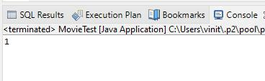

Database :

CREATE TABLE mymovies1

(

mid int,

title varchar(50),

actor varchar(50),

PRIMARY KEY (mid)

);

Final Table After Execution :

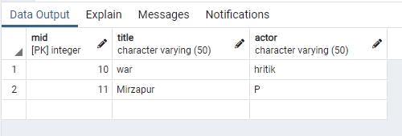

Problem Statement 2 : Write a program to demonstrate PreparedStatement in Spring JdbcTemplate.

Solution :

Movie1.java

package org.me;

public class Movie1 {

int mid;

String title;
String actor;
public Movie1(int mid, String title, String actor) {
super();
this.mid = mid;
this.title = title;
this.actor = actor;
}
public Movie1() {
super();
}
public int getMid() {
return mid;
}
public void setMid(int mid) {
this.mid = mid;
}
public String getTitle() {
return title;
}
public void setTitle(String title) {
this.title = title;
}
public String getActor() {
return actor;
}
public void setActor(String actor) {
this.actor = actor;
}

}

MovieDAO1.java

package org.me;

import java.sql.PreparedStatement;

import java.sql.SQLException;

import org.springframework.dao.DataAccessException;

import org.springframework.jdbc.core.JdbcTemplate;

import org.springframework.jdbc.core.PreparedStatementCallback;

public class MovieDAO1 {

JdbcTemplate jdbcTemplate;

public void setJdbcTemplate(JdbcTemplate jdbcTemplate) {

this.jdbcTemplate = jdbcTemplate;

}

public Boolean saveMovieByPreparedStatement(final Movie1 e){

String query="insert into movies values(?,?,?)";

return jdbcTemplate.execute(query,new PreparedStatementCallback<Boolean>(){

@Override

public Boolean doInPreparedStatement(PreparedStatement ps)

throws SQLException, DataAccessException {

ps.setInt(1,e.getMid());

ps.setString(2,e.getTitle());

ps.setString(3,e.getActor());

return ps.execute();

}

});

}

}

appctx1.java

<?xml version="1.0" encoding="UTF-8"?>

<beans xmlns="http://www.springframework.org/schema/beans" xmlns:xsi="http://www.w3.org/2001/XMLSchema-instance" xsi:schemaLocation="http://www.springframework.org/schema/beans

http://www.springframework.org/schema/beans/spring-beans.xsd">

<bean id="ds" class="org.springframework.jdbc.datasource.DriverManagerDataSource"> <property name="driverClassName" value="org.postgresql.Driver" />
<property name="url" value="jdbc:postgresql://localhost:5432/postgres" /> <property name="username" value="postgres" /> <property name="password" value="pass" />
</bean>

<bean id="jdbcTemplate" class="org.springframework.jdbc.core.JdbcTemplate">

<property name="dataSource" ref="ds"></property> </bean>

<bean id="mymovie" class="org.me.MovieDAO1">

<property name="jdbcTemplate" ref="jdbcTemplate"></property>
</bean>
</beans>

MovieTest1.java

package org.me;

import org.springframework.context.ApplicationContext;

import org.springframework.context.support.ClassPathXmlApplicationContext; public class MovieTest1 {

private static ApplicationContext appCon;

public static void main(String[] args) {

// TODO Auto-generated method stub

appCon = new ClassPathXmlApplicationContext("appctx1.xml"); MovieDAO1 m1=(MovieDAO1)appCon.getBean("mymovie"); m1.saveMovieByPreparedStatement(new Movie1(5,"Bhaijaan","Slemon"));

}

}

Output :

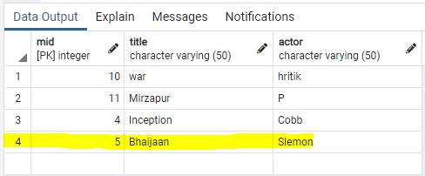

Problem Statement 3 : Write a program in Spring JDBC to demonstrate ResultSetExtractor Interface.

Solution :

Movie2.java

package org.me;

public class Movie2 {

int mid;

String title;
String actor;
public int getMid() {
return mid;
}
public void setMid(int mid) {
this.mid = mid;
}
public String getTitle() {
return title;
}
public void setTitle(String title) {
this.title = title;
}
public String getActor() {
return actor;
}
public void setActor(String actor) {
this.actor = actor;
}
public String toString(){
return mid+" "+title+" "+actor;

}

}

MovieDAO2.java

package org.me;

import java.sql.ResultSet;

import java.sql.SQLException;

import java.util.ArrayList;

import java.util.List;

import org.springframework.dao.DataAccessException; import org.springframework.jdbc.core.JdbcTemplate; import org.springframework.jdbc.core.ResultSetExtractor; public class MovieDAO2 {

Trishna Tamanna Biswal(B-6)

JdbcTemplate jdbcTemplate;

public void setJdbcTemplate(JdbcTemplate jdbcTemplate) {

this.jdbcTemplate = jdbcTemplate;

}

public List<Movie2> getAllMovie(){

return jdbcTemplate.query("select * from mymovies1",new ResultSetExtractor<List<Movie2>>(){

@Override

public List<Movie2> extractData(ResultSet rs) throws SQLException,

DataAccessException {

List<Movie2> list=new ArrayList<Movie2>();

while(rs.next()){

Movie2 e=new Movie2();

e.setMid(rs.getInt(1));

e.setTitle(rs.getString(2));

e.setActor(rs.getString(3));

list.add(e);

}

return list;

}

});

}

}

appctx2.java

<?xml version="1.0" encoding="UTF-8"?>

<beans xmlns="http://www.springframework.org/schema/beans" xmlns:xsi="http://www.w3.org/2001/XMLSchema-instance" xsi:schemaLocation="http://www.springframework.org/schema/beans

http://www.springframework.org/schema/beans/spring-beans.xsd">

<bean id="ds" class="org.springframework.jdbc.datasource.DriverManagerDataSource"> <property name="driverClassName" value="org.postgresql.Driver" /> <property name="url" value="jdbc:postgresql://localhost:5432/postgres" />

<property name="username" value="postgres" /> <property name="password" value="password" /> </bean>

<bean id="jdbcTemplate" class="org.springframework.jdbc.core.JdbcTemplate"> <property name="dataSource" ref="ds"></property> </bean>

<bean id="mymovie" class="org.me.MovieDAO2">

<property name="jdbcTemplate" ref="jdbcTemplate"></property>
</bean>
</beans>

MovieTest2.java

package org.me;

import java.util.List;

import org.springframework.context.ApplicationContext;

import org.springframework.context.support.ClassPathXmlApplicationContext; public class MovieTest2 {
private static ApplicationContext appCon;

public static void main(String[] args) {

appCon = new ClassPathXmlApplicationContext("appctx2.xml"); MovieDAO2 m1=(MovieDAO2)appCon.getBean("mymovie"); List<Movie2> list=m1.getAllMovie();

for(Movie2 e:list)

System.out.println(e);

}

}

Output :

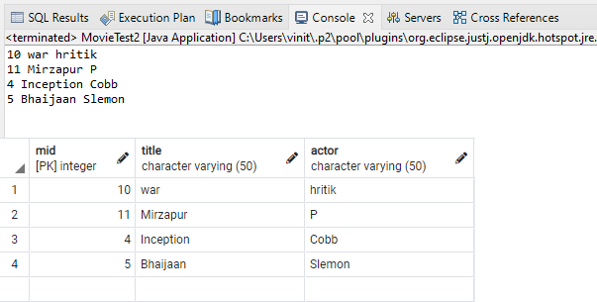

Problem Statement 4 :Write a program to demonstrate RowMapper interface to fetch the records from the database.

Solution :

Movie3.java

package org.me;

public class Movie3 {

int mid;

String title;
String actor;
public Movie3(int mid, String title, String actor) {
super();
this.mid = mid;
this.title = title;
this.actor = actor;
}

public Movie3() {

super();
// TODO Auto-generated constructor stub
}
public int getMid() {
return mid;
}
public void setMid(int mid) {
this.mid = mid;
}
public String getTitle() {
return title;
}
public void setTitle(String title) {
this.title = title;
}
public String getActor() {
return actor;
}
public void setActor(String actor) {
this.actor = actor;
}
}

MovieDAO3.java

package org.me;

import java.sql.ResultSet;

import java.sql.SQLException;

import java.util.List;

import org.springframework.jdbc.core.JdbcTemplate; import org.springframework.jdbc.core.RowMapper; public class MovieDAO3 {
JdbcTemplate jdbcTemplate;

public void setJdbcTemplate(JdbcTemplate jdbcTemplate) { this.jdbcTemplate = jdbcTemplate;
}

public List<Movie2> getAllEmployeesRowMapper(){

return jdbcTemplate.query("select * from mymovies1",new RowMapper<Movie2>(){ @Override
public Movie2 mapRow(ResultSet rs, int rownumber) throws SQLException { Movie2 e=new Movie2();
e.setMid(rs.getInt(1));

e.setTitle(rs.getString(2));

e.setActor(rs.getString(3));

return e;

}

});

}

}

appxtx3.xml

<?xml version="1.0" encoding="UTF-8"?>

<beans xmlns="http://www.springframework.org/schema/beans" xmlns:xsi="http://www.w3.org/2001/XMLSchema-instance" xsi:schemaLocation="http://www.springframework.org/schema/beans

http://www.springframework.org/schema/beans/spring-beans.xsd">

<bean id="ds" class="org.springframework.jdbc.datasource.DriverManagerDataSource"> <property name="driverClassName" value="org.postgresql.Driver" />
<property name="url" value="jdbc:postgresql://localhost:5432/postgres" /> <property name="username" value="postgres" />
<property name="password" value="password" /> </bean>

<bean id="jdbcTemplate" class="org.springframework.jdbc.core.JdbcTemplate"> <property name="dataSource" ref="ds"></property> </bean>

<bean id="mymovie" class="org.me.MovieDAO3">

<property name="jdbcTemplate" ref="jdbcTemplate"></property>
</bean>
</beans>

MovieTest3.java

package org.me;

import java.util.List;

import org.springframework.context.ApplicationContext;

import org.springframework.context.support.ClassPathXmlApplicationContext; public class MovieTest3 {
private static ApplicationContext appCon;

public static void main(String[] args) {

appCon = new ClassPathXmlApplicationContext("appctx3.xml"); MovieDAO3 m1=(MovieDAO3)appCon.getBean("mymovie"); List<Movie2> list=m1.getAllEmployeesRowMapper();

for(Movie2 e:list)

System.out.println(e);

}

}

Output :

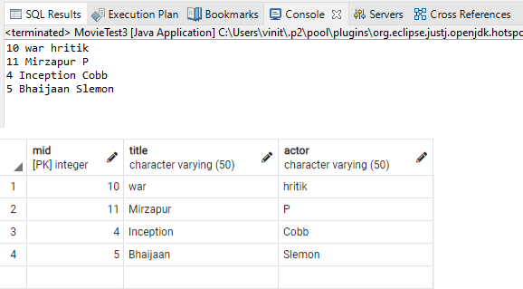

Assignment No 10

Spring Boot and RESTful Web Services

- Write a program to create a simple Spring Boot application that prints a message.

- Write a program to demonstrate RESTful Web Services with spring boot

Problem Statement 1 : Write a program to create a simple Spring Boot application that prints a message.

Solution :

BoothelloApplication.java

package com.example.demo;

import org.springframework.boot.SpringApplication;

import org.springframework.boot.autoconfigure.SpringBootApplication;

@SpringBootApplication

public class BoothelloApplication {

public static void main(String[] args) { SpringApplication.run(BoothelloApplication.class, args);

}

}

HelloWorldController.java

package com.example.demo;

import org.springframework.web.bind.annotation.RequestMapping; import org.springframework.web.bind.annotation.RestController;

@RestController

public class HelloWorldController {

@RequestMapping("/")

public String hello()

{

return "Vinit is here !";

}

}

Output :

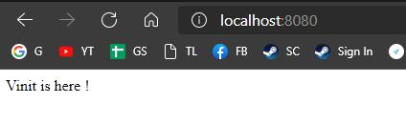

Problem Statement 2 : Write a program to demonstrate RESTful Web Services with spring boot

Solution :

HelloWorldBean.java

package com.example.demo;

public class HelloWorldBean {

public String message;

//constructor of HelloWorldBean
public HelloWorldBean(String message)
{
this.message=message;
}
//generating getters and setters
public String getMessage()
{
return message;
}
public void setMessage(String message)
{
this.message = message;
}
@Override
//generate toString
public String toString()
{
return String.format ("HelloWorldBean [message=%s]", message);
}
}

HelloWorldController.java

package com.example.demo;

import org.springframework.web.bind.annotation.GetMapping;

import org.springframework.web.bind.annotation.RestController;

//Controller

@RestController

public class HelloWorldController

{

//using get method and hello-world as URI

@GetMapping(path="/hello-world")

public String helloWorld()

{

return "Vinit is here!";

}

@GetMapping(path="/hello-world-bean")

public HelloWorldBean helloWorldBean()

{

return new HelloWorldBean("Kaise ho? xD"); //constructor of HelloWorldBean } } RestfulwebserviceApplication.java

package com.example.demo;

import org.springframework.boot.SpringApplication;

import org.springframework.boot.autoconfigure.SpringBootApplication;

@SpringBootApplication

public class RestfulwebserviceApplication {

public static void main(String[] args) { SpringApplication.run(RestfulwebserviceApplication.class, args);
}

}

Output :

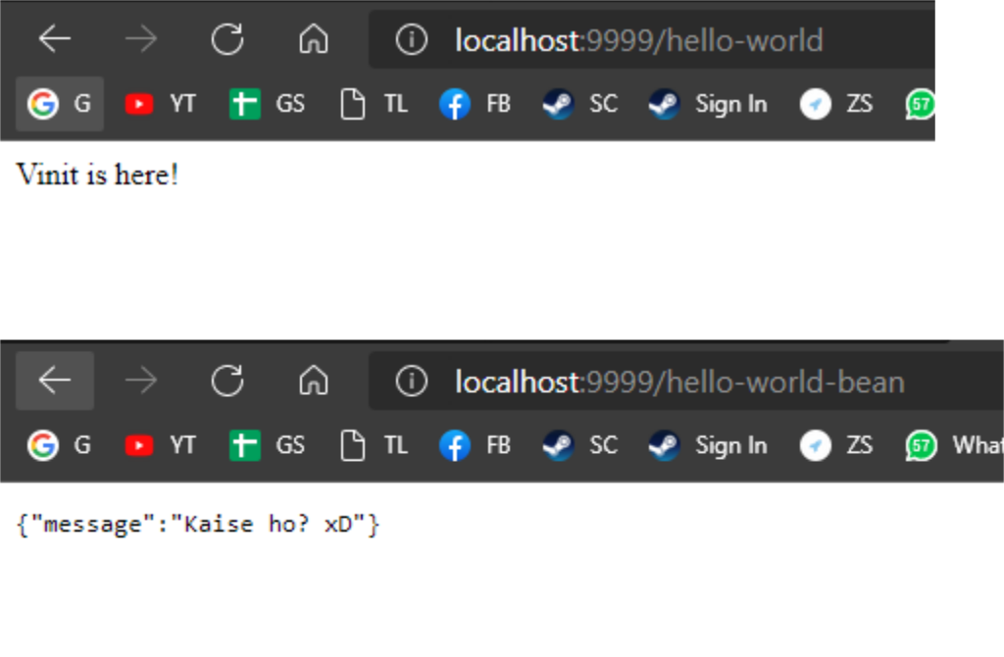

Testing API with PostMan.

EndPoint : http://localhost:9999/hello-world-bean

