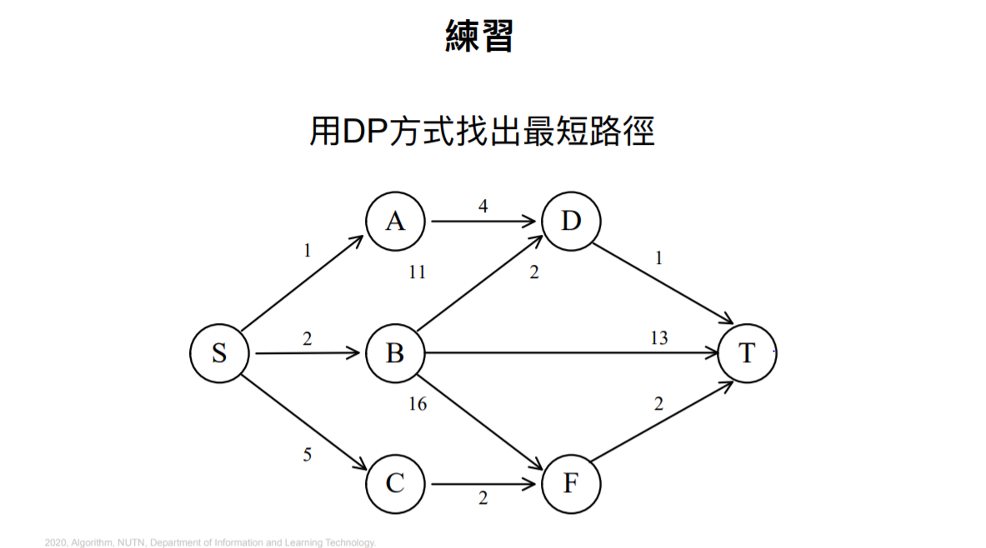**Dynamic Programming**

**d(S,A) = 1**

**d(S,B) = 2**

**d(S,C) = 5**

**d(S,T) = min{1+d(A,T), 2+d(B,T), 5+d(C,T) }**

**d(A,T) = d(A,D) + d(D,T) = 5**

**d(B,T) = min{d(B,D) + d(D,T), d(B,T), d(B,F) + d(F,T)} = 12**

**d(C,T) = d(C,F) + d(F,T) = 4**

**d(S,T) = min{1+5, 2+12, 5+4} = 6**

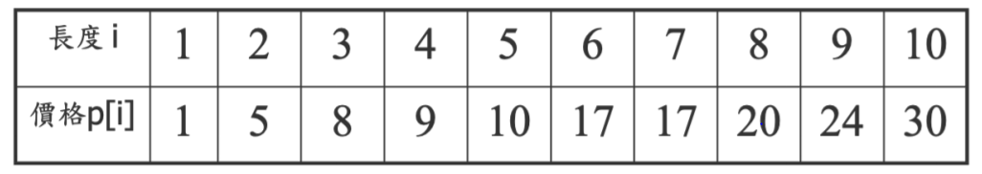

**N = 7有幾種可能**

**假設r[n]假設長度為n時所能得到的最高價錢**

**r[1] = 1**

**r[2] = max(r[1] * 2, p[2]) = 5**

**r[3] = max(r[1] * 3, r[1] + r[2], p[3])] = 8**

**r[4] = max(r[1] + r[3], r[2]*2, p[4]) = 10**

**r[5] = max(r[1] + r[4], r[2] + r[3], p[5]) = 13**

**r[6] = max(r[1] + r[5], r[2] + r[4], r[3] * 2, p[6]) = 17**

**r[7] = max(r[1] + r[6], r[2] + r[5], r[3] + r[4], p[7]) = 18**