 

**Declaration**

I, Ajith Srikanth , 2nd  year student of B.Tech – Mechatronics, SRM Institute of Science & Technology, Kathakulathur, Chennai  humbly declare that this report is based on the learning during my internship at Bosch Rexroth Pvt Ltd, Sanand MIDC, Ahmedabad carried by me and no part of it has been presented previously anywhere.

The report was prepared under the guidance of my mentor Mr. Rupesh Shah (DCIN/SLE5 , DCIN SLE6), Bosch Rexroth Pvt Ltd.

It is also declared that this report has been prepared for academic purpose alone and has not been/will not be submitted elsewhere for any other purposes.

Ajith Srikanth

Register No : RA1811018010007  
B.Tech Mechatronics - 1st Year completed

SRM Institute of Science and Technology, Kathakulathur, Chennai.

**Acknowledgment**

This report would not have been possible without the essential and gracious support of my Mentor Mr. Rupesh Shah from Bosch Rexroth Pvt Ltd. His willingness to motivate me contributed tremendously during my internship and project report. I also would like to thank him for showing me valuable guidance during the internship period.

Besides I would like to thank you the Management of Bosch Rexroth Pvt Ltd for providing me good learning environment to complete this project report. It gave me opportunity to learn about the basics of Hydraulics.

I would also like to show my gratitude to Mr. Vignesh Mudalair and Mr. Darsh N Shah for helping throughout the Project.

Finally, I would like to thank my family, friends & mentor for their understanding and support towards completing this report.

**TABLE OF CONTENTS**

**Introduction 1**

**Concepts To Remember**

Definition of Hydraulics 1

Basic Terms 1

Laws and Principles 1

Components Of Hydraulics 3

Hydraulic System 3

**Symbols 4**

**Hydraulic Fluids**

Requirements 8

**Componenets 9**

**Hydraulic Pumps 9**

**Hydraulic Motors 10**

**Hydraulic Cylinders 10**

**Accumulators and Actuators 11**

**Check Valves 11**

**Direction Control Valves 12**

**Pressure Control Valves 12**

**Flow Control Valves 12**

**Filtration and Filters 13**

**Hydraulic Power Units 13**

**Connectors 13**

**Study 14**

**Circuit Reading #**

**Plant Visit #**

**Press Break Machine #**

Subsection 3.3.a #

Subsection 3.3.b #

Subsection 3.3.c #

**Introduction**

Definition of Hydraulics:

Transmission & control of forces & movements by means of fluids is called hydraulics

Or

Anything which is in affiliation with fluids is called hydraulics.

Basic Physical Terms:

* Force – The product of Mass and acceleration. F=m.a
* Velocity- The distance covered in the given amount of time. V=s/t
* Acceleration- The rate of change of velocity which can either be positive or negative.
* Pressure- The force acting per unit area. P= F/A
* Energy
  + Potential energy- The amount of work Stored is dependent upon the weight force of the object and the height. U=m.g.h
  + Kinetic Energy- The work stored is contained in the movement of the object. K.E=(m.v^2)/2
* Power- The work done per unit time. P=W/t
* Work – Product of distance and the force applied on that body which acts in the direction of the force. W= Fscosᴓ Where ᴓ is the angle between the force and direction of displacement.

Laws to Remember:

* Flow Law- Equal volume flow through a pipe of varying diameter over the same period.
* Law of Conservation energy- The law of conservation of energy is a law of science that states that energy cannot be created or destroyed, but only changed from one form into another or transferred from one object to another.

Some Additional Principles:

* Hydromechanics - The science of the mechanics of water and fluids in general, including hydrostatics or the mathematical theory of fluids in equilibrium, and hydromechanics, the theory of fluids in motion.
* Hydrostatics - Fluid statics or hydrostatics is the branch of fluid mechanics that studies "fluids at rest and the pressure in a fluid or exerted by a fluid on an immersed body".
* Hydrokinetics - The branch of hydrodynamics that deals with the laws governing liquids or gases in motion.
* Fluid Power - Fluid power is the use of fluids under pressure to generate, control, and transmit power. Fluid power is subdivided into hydraulics using a liquid such as mineral oil or water, and pneumatics using a gas such as air or other gases.

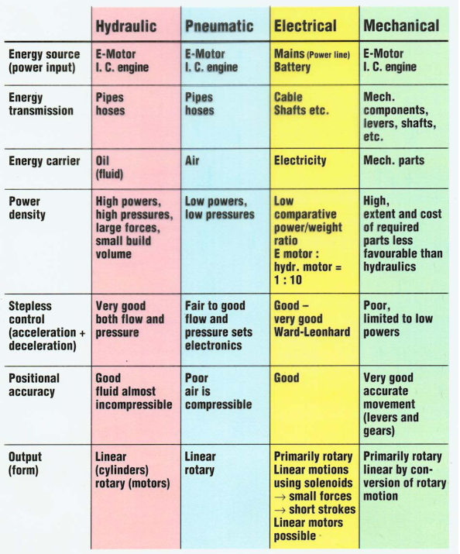

Components of a Hydraulic System:

* Hydraulic Pump
* Fluid Tank
* Check Valve
* Pressure Relief Valve
* Hydraulic Cylinders
* Flow Control Valve
* Direction Control Valve
* Filters
* Accumulators
* Power Unit

Hydraulics Systems:

In a hydraulic system, mechanical energy is converted into hydraulic energy and then transferred or processed in a loop and converted back to mechanical energy. Pumps are used to convert energy. The fluid is fed through the pipes, hose and bores within a control block which is known as a manifold block. In addition, some more accessories are added like filters, tanks, coolers, heating elements, accumulators , actuators and measuring instruments. A power unit and the manifold block are the main components.

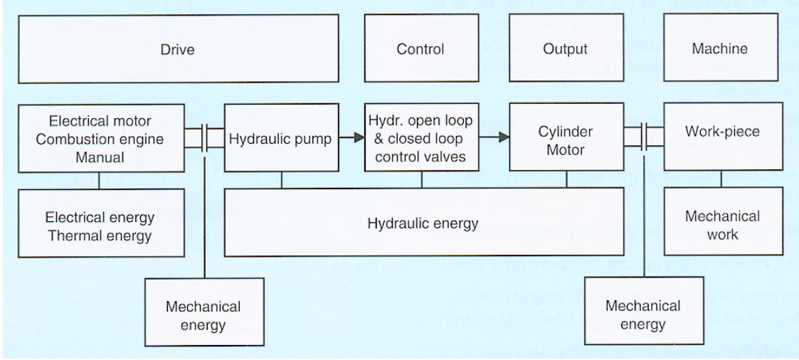

Symbols:

Graphical symbols are used in a hydraulic circuit. Symbols are neither dimensional nor specific for any position. Some important symbols are shown below:

| **Name/Description** | **Symbol** |
| --- | --- |
| Continuous line  Electrical line or reverse current line; Pressure or Return Line |  |
| Dash Line  Control Line or Drain Line or Transition Position |  |
| Diagonal Arrow  Adjustable or Variable Motor, Pumps, Springs, Solenoid |  |
| Curved Arrow  Rotatory Movement, Direction of Rotation viewed from Shaft end |  |
| Triangle  Filled, hydraulic |  |
| Triangle  Unfilled, Pneumatic |  |
| Closed Connection |  |
| Test Point |  |
| Temperature Display or Control |  |
| Drive Unit |  |
| Spring |  |
| Throttling |  |
| Check Valve  Non-Return Valve / Not Loaded |  |
| Check Valve  Spring Loaded |  |
| Internal Control Line |  |
| External Control Line |  |
| Pneumatic/Hydraulic operation |  |
| Thermometer |  |
| Flow Indicator |  |
| Flow meter |  |
| Pressure Indicator |  |
| Single Solenoid |  |
| Flow Control Valve  Throttle and Adjustable Valve |  |
| Logic Element |  |
| Shut Off Valve |  |
| Pressure control Valve  Pressure relief valve, Directly Operated, Internal Pilot Oil Supply |  |
| Pressure Relief Valve  Direct Operated, Internal Pilot Oil Supply, External Drain Pot |  |
| 2-way Pressure Reducing Valve  Directly Operated; Internal Pilot Oil Supply |  |
| 2-way Pressure Reducing Valve  Pilot Operated; Internal Pilot Oil Supply, External Oil Return |  |
| 3-way Pressure Reducing Valve  Directly Operated; Internal Pilot Oil Supply |  |
| Electric Motor |  |
| Hydraulic Pump |  |
| Fixed Displacement Pump  1 Direction Flow and Rotation |  |
| Variable displacement pump  2 Direction Flow, 1 Direction Rotation, Case Drain Port |  |
| 3/2 Direction Control Valve  3 Ports,2 Spool,1 Transition; Solenoid Operation, Initial Position Defined By spring |  |
| 4/3 Servo Valve |  |

Some Commonly Used Direction Control Valve:

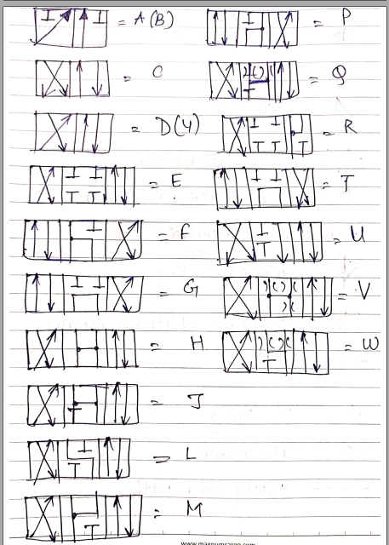

Hydraulic fluids

A hydraulic fluid or hydraulic liquid is the medium by which power is transferred in hydraulic machinery. Common hydraulic fluids are based on mineral oil or water.

Hydraulic Fluid Requirements:

* Viscosity
* Temperature
* Cost and Availability
* Fire Resistance
* Non-Toxic and Good Dielectric
* Ecologically Accepted
* Non-Hygroscopic
* No Formation of Sticky Substance or Slit
* Stability Against:
* Shearing
  + Low Compressibility
  + Thermal Loads
  + Thermal Conductivity
  + Oxidation and Corrosion

**Components**

1. **Hydraulic Pumps**

A hydraulic pump is a mechanical source of power that converts mechanical power into hydraulic energy. It generates flow with enough power to overcome pressure induced by the load at the pump outlet.



1. **Hydraulic Motors**

Hydraulic motors are rotary actuators that convert hydraulic, or fluid energy into mechanical power.



1. **Hydraulic Cylinders**

A hydraulic cylinder is a mechanical actuator that is used to give a unidirectional force through a unidirectional stroke.



1. **Hydraulic Accumulators:**

A hydraulic accumulator is a pressure storage reservoir in which a non-compressible hydraulic fluid is held under pressure that is applied by an external source.

Function:

* Energy Storage
* Fluid Reserve
* Emergency Operation
* Compensating the Flow
* Maintaining constant Pressure
* Compensation of Oil Leakage

Types of Accumulator with Separating Element:

1. Bladder Accumulator
2. Diaphragm Type accumulator
3. Piston Accumulator
4. **Actuators:**

They perform a swerving motion across a shaft end when pressurized with hydraulic fluids. The movement is limited and hence the application is also limited.

Types:

* Vane Type
* Single Vane
* Double Vane
* Radial/Tangential Piston Type
* Parallel Piston Type
* Axial Piston Type
* In-Line Piston Part-Turn Actuator
  + With Connecting Rod-Crank Drive
  + With Rack and Pinion Drive

1. **Check Valve:**

They are used mainly to stop the flow in one direction and to allow free flow in the opposite direction and are also known as non-return valves.

Categories:

* Simple Check Valve
* Pilot Operated Check Valve
  + With Drain Port
  + Without Drain Port
* Double Pilot Operated Valve
  + With Case Drain Port
  + Without Case Drain Port
* Anti-Cavitation Valves (Filling Valves)

1. **Directional Control Valves**

They are used to start, stop and change the direction of the flow of a pressure medium.

Categories:

* Spool Valves
  + Pilot Operated
  + Directly Operated
* Poppet Valves
  + Pilot Operated
  + Directly Operated

There are 2,3 and 4 port DC valves. They are positional and changed either by pilot operating it or manually operating it. They are changed as in when required by the system.

1. **Pressure Control Valves**

They are influenced the system pressure in a system or a part of a system in a predetermined manner. This is achieved by changing the size of the throttle opening metering notches.

Categories:

* Pressure Control Valves (Control Task)
* Pressure Switching Valves (Switching Task)
* Pressure Relief Valve
  + Direct Operated
  + Pilot Operated
* Pressure Sequence Valve
  + Direct Operated
  + Pilot Operated
* Pressure Shut Off Valve
* Direct Operated
  + Pilot Operated
* Pressure Reducing Valve
  + Direct Operated
  + 2-Way Pilot Operated
  + 3-Way Pilot Operated

1. **Flow Control Valve:**

Used to influence the speed of movement of actuators by changing the opening to flow at the throttling point.

Categorised as:

* 2-way Flow Control Valve
* 3-way Flow Control Valve

1. **Filtration Technology**

Filters are devices which separate solid particles from fluids. They can be of any size. There are different types of filters used for different materials. Even the air is filtered when used in the machinery.

Cause of Contamination:

* During Production of Components
* During System Assembly
* During Operation of System

Filtration Methods:

1. Gravity Filtering
2. Pressure line Filtering
3. Centrifuges
4. Filter Presses
5. Filter Materials
6. **Hydraulic Power Units**

A Power Unit is the main part of the system. Every unit is diverse due to the different components or different manifold blocks. Every circuit has a different power unit. Hence power units are custom made.

There are :

* Small Power units
* Modular Standard Power Units
* Standard Power Unit
* Project Power Unit
* Compact Power Unit

1. **Connectors:**

A Hydraulic system should be connected to form a hydraulic circuit by the means of suitable connections. Some connectors are listed below:

* Valves for Pipeline Mounting
* Valves With threaded Connection and as cartridges
* Valves for Sub-plate Mounting

**study**

Plant visit

MOE-1

Line 1- Elara Line

Valves Made:

NG6

WE6

Processes Done:

Machining

Debugging

Chamfering

Honing

Washing

Water base painting

Inspection

Packing

Line 2-

Valves Made:

Modular 6

Z2S6

Z2FS6

ZDR6 DA

ZDR6 DP

Line 3-

Valves Made:

NG16

NG22

NG25

Line 4-

Valves Made:

Modular 10

Z2FS10

Z2S10

ZDR10

Line 5-

Valves Made:

DB5 10

DB5 20

DB5 30

DRE 20

Manifold Block Machining

MOE 2 – Assembly Line

MOE 3 – Cylinder

Power Unit & Manifold (PM)