KiCAD Workshop
SkullSpace, 2016
Troy Denton
Table of Contents
Intro 1
Requirements 1
The Circuit 2
High-level Idea 2
Design Goals 2
Schematic Diagram 3
Component Selection 4
KiCAD Usage 5
Overview of workflow 5
Getting Started & Schematic Entry 7
Creating Custom Symbols 8
Footprint Association 10
Editing Footprints 12
Placing Components 14
Laying Traces 15
Copper Pours 17
Running DRC 18
Creating Mounting Holes 19
Exporting Design Files 20

Intro
Welcome to the workshop! The purpose of today’s activities is to familiarize you with the basics of KiCAD. While there will be some light discussion on electronic design, this is not the focus of the workshop – we are only concerned with schematic entry and PCB layout. We will be implementing a basic adjustable voltage power supply based on the MC33167T IC.

Requirements
- KiCAD (Latest stable version, v4.0.4 was used to create the materials)
- A mouse is highly recommended for laptop users

The Circuit

High-level Idea
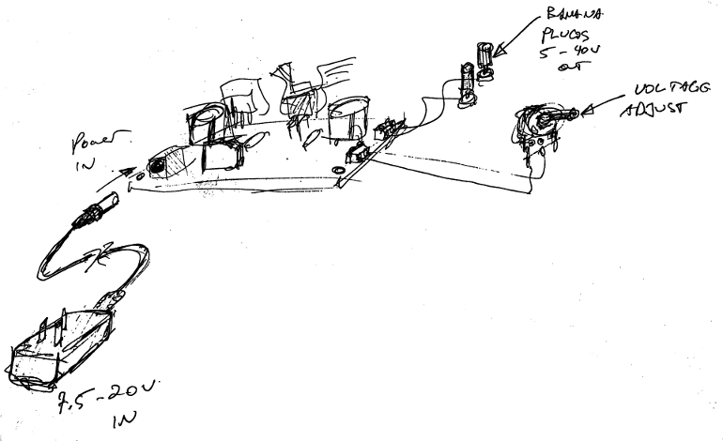

Design Goals
- Accept a wide range of input voltages
  - Designed for ~7.5V - 20VDC
- Accept a generic barrel-plug DC power supply of any polarity
- 1A+ output current capacity
  - Design for ~ 4A
    - In practice, heat sinks will be required for reasonable use
- Adjustable voltage output
  - Designed for 5V – 40V
- Be relatively simple to lay out

Schematic Diagram
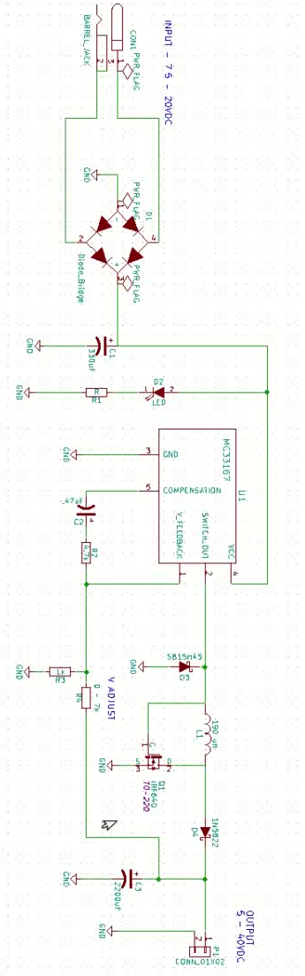

Component Selection

Component | KiCAD Symbol | Part Number | Datasheet
CON1 | BARREL_JACK | 33DCJ-0202-A | 33DCJ-0202-A Drawing
C1 | CP | ESK337M050AH4AA | ESK Series
C2 | CP | 860010672004 | 860010672004 Drawing
C3 | CP | UVR1J222MHD | UVR Series
D1 | DIODE_BRIDGE | GBU6J-BP | GBU6A-GBU6M(GBU)
D2 | LED | Generic 5mm LED
D3 | D_Schottky | SB15H45 | SB15H45
D4 | D_Schottky | 1N5822RL | 1N582x
L1 | INDUCTOR | 2200HT-181-H-RC | 2200HT Series
P1 | CONN_01X02 | Generic terminal
Q1 | (Custom) | IRF640 | IRF640, SiHF640
R1 | R | Generic 10mm, 1K
R2 | R | Generic 10mm, 4.7K
R3 | R | Generic 10mm, 1K
R4 | R | Generic Linear Poteniometer (off-board), <=7K
U1 | (Custom) | MC33167THG | MC34167, 33167

KiCAD Usage

Overview of workflow
KiCAD is organized as a number of separate programs that integrate with each other; for our work today, we will be using the bolded entries:
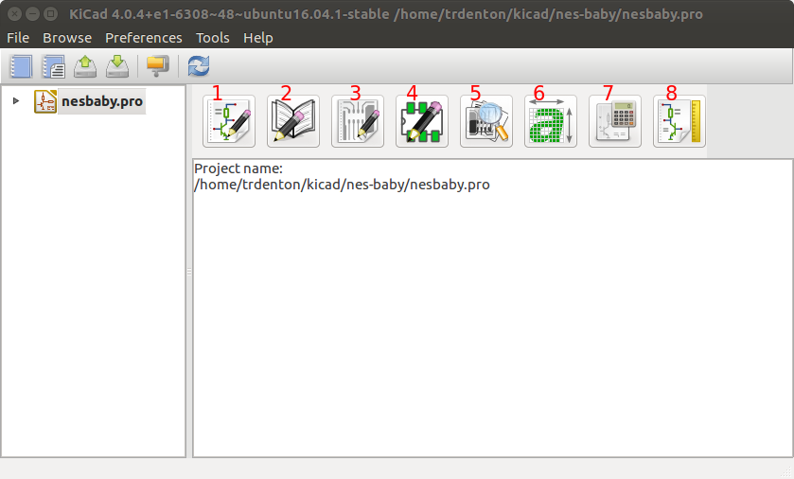

- EESchema – the schematic design tool
- Schematic Library Editor – used to create & edit new schematic symbols
- PCBnew – Printed Circuit Board Editor
- GerbView – a tool for viewing Gerber files
- Bitmap2Component – tool for converting bitmaps for use in schematics, PCBs
- PCB Calculator – various tools for common design calculations (eg. trace width calculator, Resistor color code interpreter)
- Pl Editor – Worksheet layout editor (ie schematic diagram templates)

The basic workflow of a PCB project looks something like this*:
- Enter Schematic in EESchema;
  - add required components to schematic; create components that do not exist in stock libraries
  - wire components together as a schematic diagram
  - Annotate components (ie, give them each a unique number)
  - Run Design Rules Check
  - Associate footprints to schematic symbols (ie. it’s copper “footprint” on the PCB)
  - Save netlist file
- Layout PCB in PCBnew,
  - load netlist file
  - Place components in desired locations
  - Create net class rules for design rule check (eg, “power connections need to be this big”)
  - Connect components with traces
  - Add ground pours, mounting holes, etc
  - Run Design Rules Check
  - Export design files for manufacture

* complex designs often iterate between schematic and PCB layout a few times

Getting Started & Schematic Entry
Follow along on youtube
- Create a new project in KiCAD ( File > New Project). Create the project in it’s own folder (for your own sanity)
- Open the .sch file that it creates for you by double-clicking on it
- Begin placing and connecting components
  - To place a new component,click the button, or press “a” (for add component)
  - If the component is a custom one, refer to Creating Custom Symbols
  - A “choose component” menu will pop up, begin typing the name of the part to narrow down through the component libraries.
  - Example: To place the Diode Bridge (D1), typing “bridge” will narrow down the selection. Select the bridge and hit “OK” (or hit enter)
  - You will now be moving the component around the schematic with your mouse. Left-click to place the part.
    - Hit “r” to rotate the part 90 degrees, “x” to mirror w.r.t. the X axis, “y” for the y axis
    - If you need to move a part after placing it, hover over the part with your mouse and hit “m”.
    - If you need to cancel the current move operation and/or placement, hit “Esc”
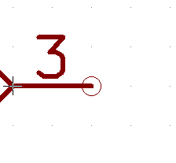

  - Wire components together by selecting the wire tool ( ).
    - to begin a wire, either click on the “connection circle” (See right) of the component of interest, or hover over it and press “w”.
    - To end the wire, click on either another wire, or another “connection circle”.
    - Clicking while routing the wire will allow customization of the path it takes
- Refer to the Component Selection table for KiCAD schematic symbol names
- Refer to the Schematic Diagram and video as a guide for the schematic

Creating Custom Symbols
Creating the MC33167 happens at 1:56
Creating the IRF640 happens at 8:14
To create your own symbol:
- Open the Library Editor
- Click “Create New Component”
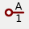
- Add pins with
  - These represent the physical connection pins of the part you are creating. Make sure you use the same pin number as the datasheet! Use a descriptive, but short name as well – eg, “GND” or “VCC”
  - For proper DRC compatibility, select the correct “Electrical Type” for the pin. This will not impact the final PCB directly, it’s just a mechanism to let KiCAD “Sanity check” your schematic. Example, it will warn you if two outputs are connected together.
    - Input: An electrical input (e.g. the noninverting input on an opamp)
    - Output: an electrical output (e.g. the output pin of an opamp)
    - BiDirectional – a pin where current flow can happen in either direction
    - Tri-State – a pin that can function as input, output, or high-impedance
    - Passive – Electrically passive (does not require additional power to perform it’s function). Resistors, Capacitors, inductors fall into this category.
    - Unpecified – When you don’t know what’s going to connect to it; think of a connector pass-through
    - Po wer Input – “Vcc” and “Ground” pins belong to this; don’t think of actual current flow.
    - Power Output – For a regulator pin, e.g. “V Out” pin of a 7805
    - Open collector – Used in various driver IC’s, a datasheet will specify this
    - Open Emitter – Used in various driver IC’s, a datasheet will specify this
    - Not Connected – some parts will have pins that are not electrically connected (e.g. for mounting, or it was just easier to make it that way)
- Add any graphical components to the symbol with


- To save the component, either select a working library with and save the component as usual, or click “Save component to new library”

- To include the library in your schematic, in EESchema select “Preferences” > “Component Libraries”, click “add”, and select the library you’ve just saved (or downloaded)

Footprint Association
Follow along on youtube
In this step we must tell KiCAD which footprint a certain component will have; For example, a resistor on the schematic diagram can be implemented as either a surface-mount resistor, or a through-hole resistor:

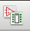
To open the footprint association window, click the button in EESchema.

The footprint association window has three panes:
- Rightmost pane is a list of available footprints (“Footprint Pane”)
- The middle pane is a list of all schematic components (“Component Pane”)
- The leftmost pane selects a category of footprints, which can be used to filter the rightmost pane (“Library Pane”)
To perform an association:
- Select the component in the middle pane
- Double-click the chosen footprint in the right pane

There are three filter buttons that can all be used in any combination:

will filter the footprint pane by keywords (ie, it looks for relevant text in the name of the footprint, like “Capacitor”. This is based on the selection in the Component Pane)
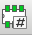
will filter the footprint pane to those footprints which have the same number of pins as the selection in the Component Pane
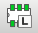
will filter the footprint pane to those footprints contained in the library selected in the Library Pane
Be sure to hit save when you are done! Note – sometimes you do not yet know the required footprint, or only have a rough idea. You can always change the footprint association later (directly in PCBnew)

Editing Footprints
Follow along on youtube
Footprints are composed of:
- Pads – this is a representation of the physical solder pad for a component’s pin. It can be a through-hole or surface-mount pad. They must be spaced out to meet the component’s specifications, and numbered correctly as well (e.g. KiCAD assumes that “pin 1” of the schematic component is connected to “pad 1” of the footprint. It is based on number, not name!)
- Graphics – these can be placed to give mounting directions or other aesthetic appeal to the silkscreen layer of the PCB
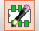
To create your own footprint :
- Open the Footprint Editor
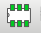
- Click on “New Footprint”:
- Enter the footprint name

- Add pads with the button
- You can change the properties (size, layer) of the pad by right clicking the component and selecting “Properties” (or hover over with the mouse and hit “e”).
- Lay out the pads in the proper topography; Refer to the part’s datasheet to get dimensions (links are in Component Selection ). Make use of the Grid to snap to fixed increments (e.g. 2.54 mm is a common spacing between pins. It depends on the part)

  - You can change the grid size with a drop-down in the top right:
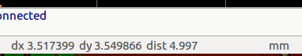
  - To measure the distance between points, you can move your mouse to a point, and hit “space”. The window’s lower status bar will show you the current delta between the setpoint and the current position:

  - The “X” and “Y” fields next to the dx/dy fields above show the absolute position of your mouse; to change the “anchor point” (where 0,0 is), click the anchor button ( ) and click on the new (0,0) point.

  - You can use the line and text tools to place graphics on the silkscreen layers as well. This can serve as a guide for alignment/populating components:

- When you are done creating your component, click “Create new library and save footprint”, and give your new library a name.
- To import your new library into your PCB design, go to PCBNew and click “Preferences -> Footprint Libraries Manager”.
  - Click “Append with wizard”, and navigate to your library
    - The library will be a folder named “YYYY.pretty”, where YYYY is the name you gave the library. Select it and click Next.
    - You will be taken to a Review/confirmation screen. Click next.
    - Select whether you want the library to be global (included in every kicad project you create henceforth) or specific to the current project only
    - Click “finish”
- To change the footprint of a component that is already on the PCB, right click on it, select “Properties”, and hit “Change Footprint(s)”, then “View Footprints”. You can then browse to your library + footprint

Placing Components
Follow along on youtube
Just like the schematic diagram, move the components around with the “m” key and the mouse. Try to lay them out in a way that minimizes the number of traces required – this is a skill that comes with practice! The recommend layout looks like so:
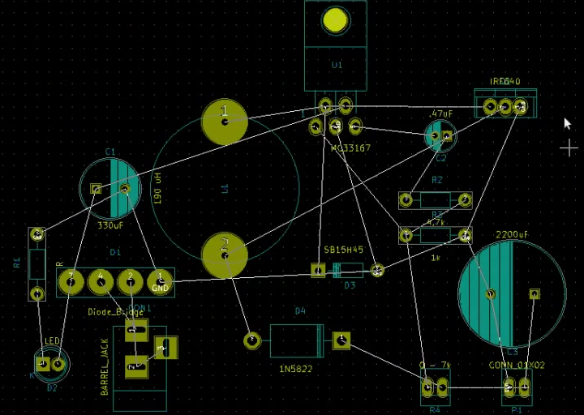

Laying Traces
Follow along on youtube
- To aide in DRC, it is good practice to add each “net” to a “Net class”
  - This will also automatically set the trace width as you lay traces
  - Check out the video to see how this is done
- To lay traces, select the “tracks and vias” tool:
  - Place traces by clicking on pads, and everywhere where you want the trace to “stop”. Double-click to end the trace. If your trace is violating a design constraint (eg too close to another trace), it will display so in red text in the lower left of the screen.
  - The trace tool “captures” your mouse, locking you into laying traces. If you need to exit this mode, you can hit the “esc” key
  - To switch betwen layers, hit the “v” key. The current layer is shown in the right-hand pane:
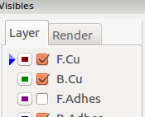

  - If you hit “v” while laying a track, it will create a via to switch between copper layers. This is useful to route traces when previous traces get in your way:
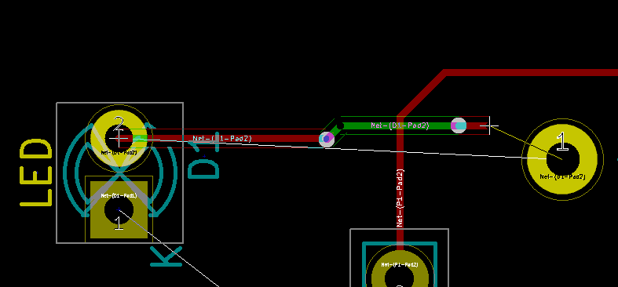
  - Traces can only be made on copper layers (eg. F.Cu or B.Cu for a two-layer PCB)
- When KiCAD detects that two parts arent connected when they should be, it will draw a white line between the relevant Pads. This is called the “Rat’s nest”. You can toggle this behaviour with the rats nest buttons:
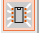
  - will toggle displaying the rat’s nest relevant to the selected footprint
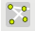
  - will toggle displaying the rat’s nest for the entire PCB
- For simple PCBs, you often do not need to route ground traces. You can instead use what is known as a “copper pour” to connect all the ground pads together. This has many electrical benefits as well.
- When everything but the ground traces are laid, your PCB will look like so:
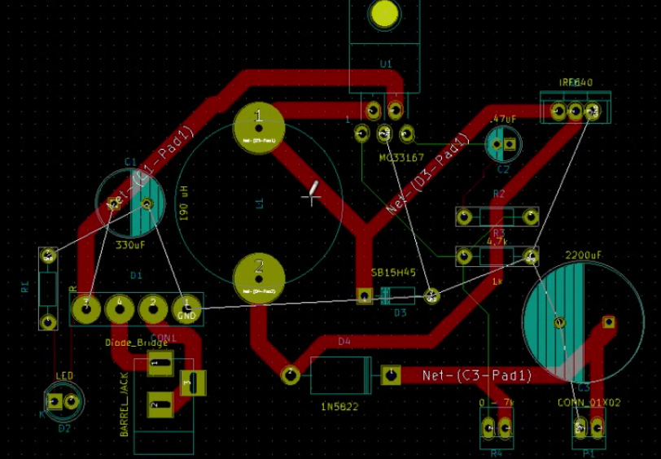

Copper Pours
- To begin a copper pour, it is recommended to have your “Edge Cut” layer entered first. This is entered so that the PCB manufacturer will know how to cut out the shape of your board from a larger substrate. It is also useful to align your copper pours to the outline of your board. Check out the video to see how the edge cuts are done
- The copper pour on the front layer is shown here
- The copper pour on the back layer is shown here
- The general process for creating a copper pour region:

  - Use the copper pour tool:
  - Once you click on start point, a pop-up dialog will prompt you to select the layer and “Net” for the copper pour. To perform a ground pour on the front copper layer, ensure you select “F. Cu” and “GND” for the Layer and Net, respectively.
  - Use the mouse to draw a polygon, clicking places a vertex
  - Double-click to end the copper pour
  - To fill in the pour zones, select the copper pour tool, right click on the PCB, and select “fill or re-fill all zones”
  - You can remove the copper pours by selecting “Remove filled areas in all zones”. You can re-fill them back in later, this just allows you to view the PCB without the pours filled in.
- When your copper pours are completed, your board should look like so:
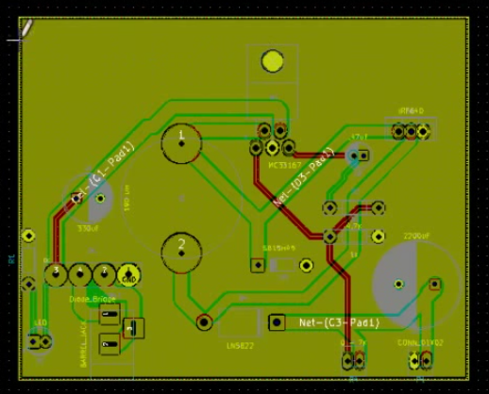

Running DRC

- To begin the design rules check, click the DRC button:
- Click “Start DRC” to have KiCAD check your PCB against your netclasses, netlist, etc.
- Any Errors will be reported; clicking on the error will center the PCB view to where KiCAD thinks the error is
- Click “List unconnected” and kicad will enumerate nets that arent connected
- It is good practice to resolve all errors before exporting your design

Creating Mounting Holes
- Most PCB’s will require some mounting holes, so that it can be screwed/bolted into an enclosure.
- This can be accomplished by placing large wire-pads on the PCB. You can add arbitrary footprints by clicking the “Add Footprint” button:
  - In the pop-up dialog, click “Select by browser”
  - In the library browser, select “Wire_Pads” in the left-hand pane. Locate the “SolderWirePad_single_2-5mmDrill” footprint in the middle pane. Double-click it to insert it into the PCB.
  - Repeat this process to create as many mounting holes as you’d like

Exporting Design Files
- To export the PCB design files from PCBnew, select “File > Plot”
- Select the appropriate plot format (Gerber is commonly accepted by manufacturers)
- Select an output directory (this will be filled with a gerber file for each layer)
- Select the appropriate layers for your design. Common ones to include are:
  - F.Cu (front copper)
  - B.Cu (back copper)
  - B.SilkS (silk screen)
  - F.SilkS (silk screen)
  - B.Mask (solder mask)
  - F.Mask (solder mask)
  - Edge.Cuts
- Click “Plot” to plot the files
- Click “Generate Drill File” - this is another design output that tells the manufacturer’s machinery where to drill holes. Choose a format supported by your manufacturer - “Gerber” is always a good bet.

