OOP LAB
Session 1
Part 1

Lab 1:

import java.util.*;

public class Lab1
{
public static boolean isPrime(int x){
for(int i = 2; i<=x/2; i++){
if(x%i ==0)
return false;
}
return true;
}

public static void main(String[] args) {
Scanner sc = new Scanner(System.in);
int n;
int i = 2;

System.out.print("Enter N: ");
n = sc.nextInt();

while(n!=0){
if(isPrime(i) == true){
System.out.print(i + " ");
n--;
}
i++;
}
System.out.println();
}
}

Output:

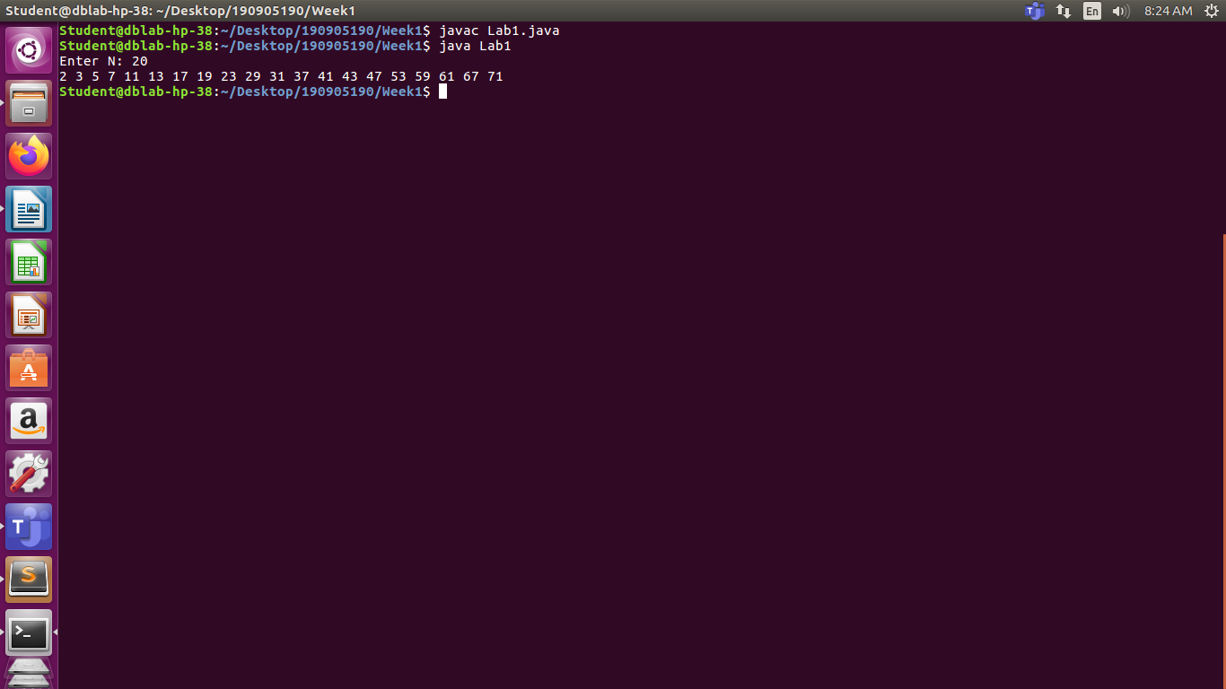

Lab 2:

Q1)

import java.util.*;

public class Lab2
{
public static void main(String[] args)
{
Scanner sc = new Scanner(System.in);
int N;
System.out.print("Enter size of array: ");
N = sc.nextInt();
System.out.println("Enter Array elements");
int arr[] = new int[N];
for (int i = 0;i<N;i++)
{
arr[i] = sc.nextInt();
}

for(int i = 0; i<N; i++)
{
for(int j = i+1; j<N; j++)
{
if(arr[i]>arr[j])
{
int temp = arr[i];
arr[i] = arr[j];
arr[j] = temp;
}
}
}

System.out.print("Ascending: ");
for (int i = 0;i<N;i++)
{
System.out.print(arr[i] + " ");
}

for(int i = 0; i<N; i++)
{
for(int j = i+1; j<N; j++)
{
if(arr[i]<arr[j])
{
int temp = arr[i];
arr[i] = arr[j];
arr[j] = temp;
}
}
}

System.out.println();

System.out.print("Descending: ");
for (int i = 0;i<N;i++)
{
System.out.print(arr[i] + " ");
}

System.out.println();
}
}

Output:

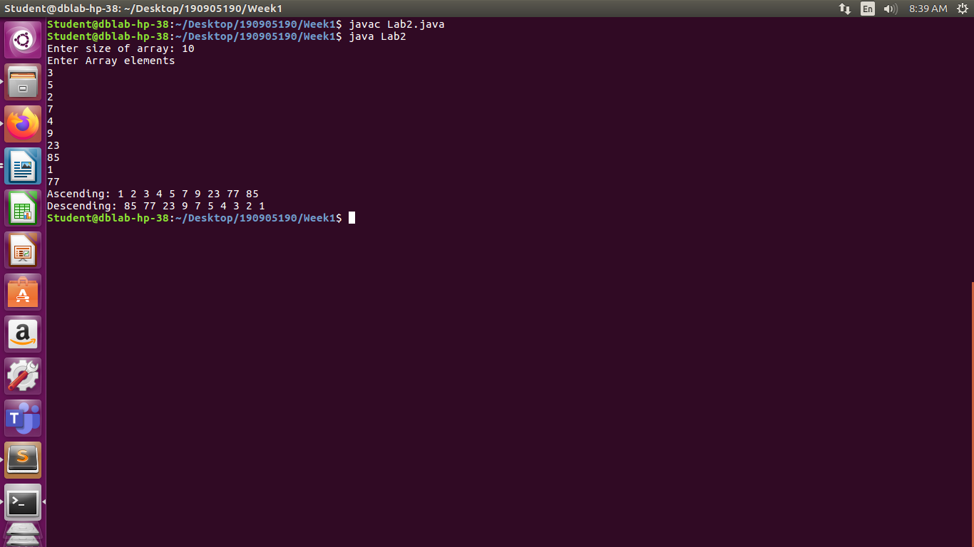
Q4)

import java.util.*;

public class Lab2_2
{
public static void main(String[] args)
{
Scanner sc = new Scanner(System.in);
int N, M;
System.out.println("Enter Dimensions of Matrices");
N = sc.nextInt();
M = sc.nextInt();

int mat1[][] = new int[N][M];
int mat2[][] = new int[N][M];
int mat3[][] = new int[N][M];

System.out.println("Enter Matrix 1: ");
for (int i = 0;i < N ;i++ )
{
for (int j = 0;j < M ;j++ )
{
System.out.print("[" + (i+1) + "][" + (j+1) + "]: ");
mat1[i][j] = sc.nextInt();
}
}

System.out.println("\nEnter Matrix 2: ");
for (int i = 0;i < N ;i++ )
{
for (int j = 0;j < M ;j++ )
{
System.out.print("[" + (i+1) + "][" + (j+1) + "]: ");
mat2[i][j] = sc.nextInt();
}
}
System.out.println();
for (int i = 0;i < N ;i++ )
{
for (int j = 0;j < M ;j++ )
{
mat3[i][j] = mat1[i][j] + mat2[i][j];
}
}
System.out.println("Sum of Matrices: ");
for (int i = 0;i < N ;i++ )
{
for (int j = 0;j < M ;j++ )
{
System.out.print(mat3[i][j] + " ");
}
System.out.println();
}
}
}

Output :

