OOP LAB
Session 1
Part 2
Lab 3 :

Q1)

import java.util.*;

class Complex
{
int x, y;
Complex(int x, int y)
{
this.x = x;
this.y = y;
}

void display()
{
System.out.println(x + " + " + y + "i");
}

Complex add(Complex ob1, Complex ob2)
{
Complex ob3 = new Complex(0, 0);
ob3.x = ob1.x + ob2.x;
ob3.y = ob1.y + ob2.y;
return ob3;
}

Complex subtract(Complex ob1, Complex ob2)
{
Complex ob3 = new Complex(0, 0);
ob3.x = Math.abs(ob1.x - ob2.x);
ob3.y = Math.abs(ob1.y - ob2.y);
return ob3;
}

public static void main(String[] args) {
Scanner sc = new Scanner(System.in);
int a1, b1, a2, b2;
System.out.println("Enter Complex Number 1");
a1 = sc.nextInt();
b1 = sc.nextInt();
Complex c1 = new Complex(a1, b1);
c1.display();
System.out.println("Enter Complex Number 2");
a2 = sc.nextInt();
b2 = sc.nextInt();
Complex c2 = new Complex(a2, b2);
c2.display();
Complex c3 = new Complex(0, 0);
c3 = c3.add(c1, c2);
System.out.println("Sum of Numbers: ");
c3.display();
Complex c4 = new Complex(0, 0);
c4 = c4.subtract(c1, c2);
System.out.println("Difference: ");
c4.display();
}
}

Output:

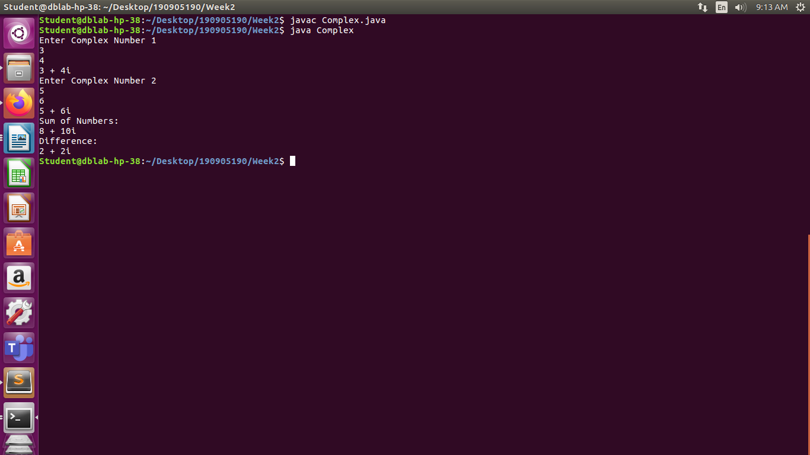
Q2)

import java.util.*;

class Time
{
int h, m, s;
Time(int h, int m, int s)
{
this.h = h;
this.m = m;
this.s = s;
}

void display()
{
String hh = "" + h, mm = "" + m, ss = "" + s;
if(h<10)
hh = "0" + h;
if(m<10)
mm = "0" + m;
if(s<10)
ss = "0" + s;
System.out.println(hh + ":" + mm + ":" + ss);
}

Time add(Time ob1, Time ob2)
{
Time ob3 = new Time(0, 0, 0);
ob3.h = ob1.h + ob2.h;
ob3.m = ob1.m + ob2.m;

if(ob3.m > 59){
ob3.h = ob3.h + ob3.m/60;
ob3.m = ob3.m % 60;
}
ob3.s = ob1.s + ob2.s;

if(ob3.s > 59){
ob3.m = ob3.m + ob3.s/60;
ob3.s = ob3.s % 60;
}
if(ob3.m > 59){
ob3.h = ob3.h + ob3.m/60;
ob3.m = ob3.m % 60;
}
return ob3;
}

Time subtract(Time ob1, Time ob2)
{
Time ob3 = new Time(0, 0, 0);
int seconds1 = ob1.h*60*60 + ob1.m*60 + ob1.s;
int seconds2 = ob2.h*60*60 + ob2.m*60 + ob2.s;
int diffseconds = Math.abs(seconds1 - seconds2);
ob3.h = diffseconds / 3600;
diffseconds = diffseconds % 3600;
ob3.m = diffseconds / 60;
diffseconds = diffseconds %60;
ob3.s = diffseconds;
return ob3;
}

void compare(Time ob1, Time ob2)
{
int seconds1 = ob1.h*60*60 + ob1.m*60 + ob1.s;
int seconds2 = ob2.h*60*60 + ob2.m*60 + ob2.s;
int diffseconds = seconds1 - seconds2;
if(diffseconds<0)
System.out.println("Time 2 is greater");
else if(diffseconds > 0)
System.out.println("Time 1 is greater");
else
System.out.println("Both Time objects are equal");
}

public static void main(String[] args) {
Scanner sc = new Scanner(System.in);
int h1, h2, m1, m2, s1, s2;
System.out.println("Enter Time 1: ");
h1 = sc.nextInt();
m1 = sc.nextInt();
s1 = sc.nextInt();
Time t1 = new Time(h1, m1, s1);
t1.display();
System.out.println("Enter Time 2: ");
h2 = sc.nextInt();
m2 = sc.nextInt();
s2 = sc.nextInt();
Time t2 = new Time(h2, m2, s2);
t2.display();
Time t3 = new Time(0, 0, 0);
t3 = t3.add(t1, t2);
System.out.println("Sum of Time: ");
t3.display();
Time t4 = new Time(0, 0, 0);
t4 = t4.subtract(t1, t2);
System.out.println("Difference of Time: ");
t4.display();
t1.compare(t1, t2);
}
}

Output:

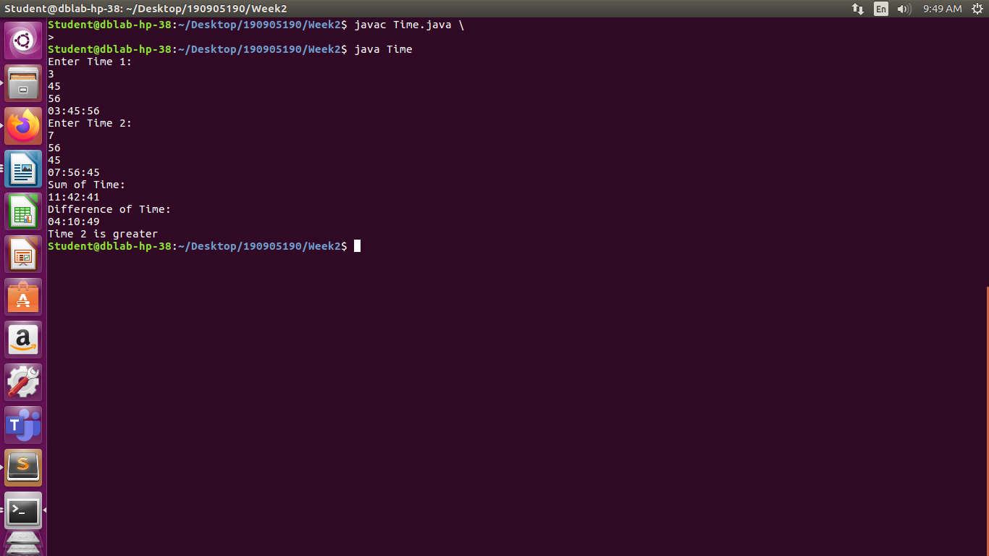
Lab 4:

Q1)

import java.util.*;

class Complex
{
int x, y;

Complex(){
this.x = 0;
this.y = 0;
}

Complex(int x, int y)
{
this.x = x;
this.y = y;
}

void display()
{
System.out.println(x + " + " + y + "i");
}

Complex add(Complex ob1, Complex ob2)
{
Complex ob3 = new Complex();
ob3.x = ob1.x + ob2.x;
ob3.y = ob1.y + ob2.y;
return ob3;
}

Complex subtract(Complex ob1, Complex ob2)
{
Complex ob3 = new Complex();
ob3.x = Math.abs(ob1.x - ob2.x);
ob3.y = Math.abs(ob1.y - ob2.y);
return ob3;
}

public static void main(String[] args) {
Scanner sc = new Scanner(System.in);
int a1, b1, a2, b2;
System.out.println("Enter Complex Number 1");
a1 = sc.nextInt();
b1 = sc.nextInt();
Complex c1 = new Complex(a1, b1);
c1.display();
System.out.println("Enter Complex Number 2");
a2 = sc.nextInt();
b2 = sc.nextInt();
Complex c2 = new Complex(a2, b2);
c2.display();
Complex c3 = new Complex();
c3 = c3.add(c1, c2);
System.out.println("Sum of Numbers: ");
c3.display();
Complex c4 = new Complex();
c4 = c4.subtract(c1, c2);
System.out.println("Difference: ");
c4.display();
}
}

Output:

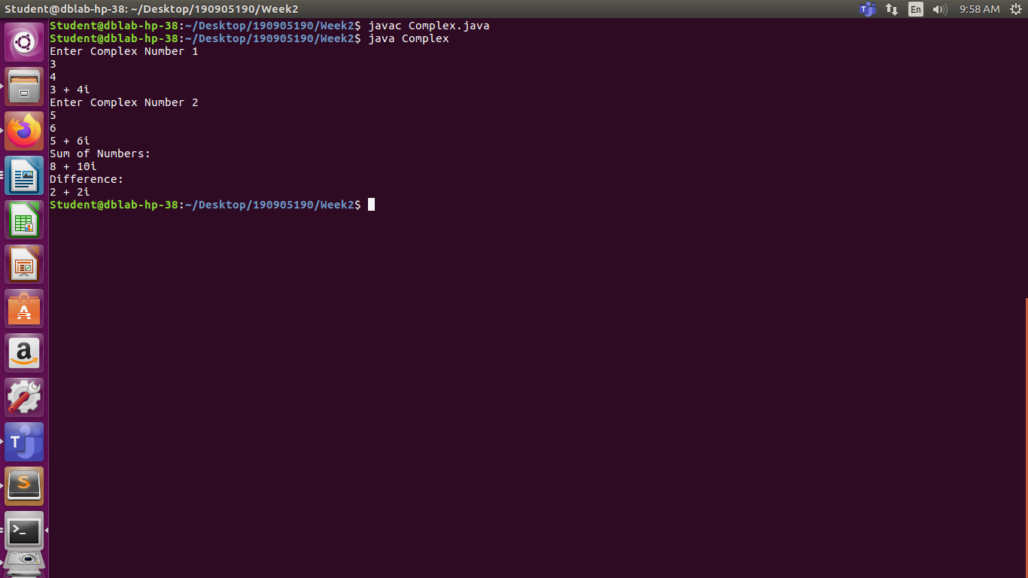
Q4)

import java.util.*;

class Counter
{
static int count = 0;
Counter(){
count = count + 1;
}

static void showCount(){
System.out.println("Current Count: " + count);
}

public static void main(String[] args) {
Counter o1 = new Counter();
Counter o2 = new Counter();
showCount();
Counter o3 = new Counter();
showCount();
Counter o4 = new Counter();
Counter o5 = new Counter();
showCount();

}
}
Output:

