OOP LAB
Session II
Part I

Lab 5
Design a class which represents a student. Every student record is made up of the following fields.
  - Registration number (int)
  - Full Name (String)
  - Date of joining (Gregorian calendar)
  - Semester (short)
  - GPA (float)
  - CGPA (float)
Whenever a student joins he will be given a new registration number. Registration number is calculated as follows. If year of joining is 2012 and he is the 80th student to join then his registration number will be 1280.
Write member functions to do the following.
- Provide default and parameterized constructors to this class
- Write display method which displays the record. Test the class by writing suitable main method.
- Create an array of student record to store minimum of 5 records in it. Input the records and display them.

Source Code :
import java.util.*;
// import java.util.GregorianCalendar;
class Student{
int reg_no;
String name;
GregorianCalendar doj;
short sem;
float gpa;
float cgpa;

Student()
{
reg_no = 0;
name = "";
doj = new GregorianCalendar();
sem = 1;
gpa = 0.0f;
cgpa = 0.0f;
}

Student(int sno, String name, GregorianCalendar doj, short sem, float gpa, float cgpa)
{
this.doj = doj;
this.name = name;
String reg = doj.get(Calendar.YEAR) % 100 + "" + sno;
reg_no = Integer.parseInt(reg);
this.sem = sem;
this.gpa = gpa;
this.cgpa = cgpa;
}

void printDate()
{
System.out.println(reg_no);
System.out.println(doj.getTime());
}

void displayRecord()
{
System.out.println("Student Name: " + name);
System.out.println("Date of Joining: " + doj.get(Calendar.DATE) + "/" + doj.get(Calendar.MONTH) + "/"
+ doj.get(Calendar.YEAR));
System.out.println("Registration Number: " + reg_no);
System.out.println("Semester: " + sem);
System.out.println("GPA: " + gpa);
System.out.println("CGPA: " + cgpa);

}

public static void main(String[] args) {
Student obj[] = new Student[5];
int sno;
String name;
GregorianCalendar doj;
short sem;
float gpa, cgpa;
int day, month, year;
Scanner sc = new Scanner(System.in);
for(int i = 0; i<5; i++){
System.out.println("Enter Student " + (i+1) + " Details: ");
System.out.print("Enter Name: ");
name = sc.next();sc.nextLine();
System.out.print("Enter Date of Joining: ");
day = sc.nextInt();
month = sc.nextInt();
year = sc.nextInt();
doj = new GregorianCalendar(year, month, day);
System.out.print("Enter Student Number: ");
sno = sc.nextInt();
System.out.print("Enter Semester: ");
sem = sc.nextShort();
System.out.print("Enter GPA: ");
gpa = sc.nextFloat();
System.out.print("Enter CGPA: ");
cgpa = sc.nextFloat();

obj[i] = new Student(sno, name, doj, sem , gpa, cgpa);
}
for (int i = 0;i<5; i++)
{
obj[i].displayRecord();
}
}
}

Output:
It was observed when the month was passed as 12, the output month displayed was 0 and the year was incremented by 1. This is because the GregorianCalendar class indexes months from 0 to 11, thus after 11, the month indexing returns to 0, and year is incremented by one.
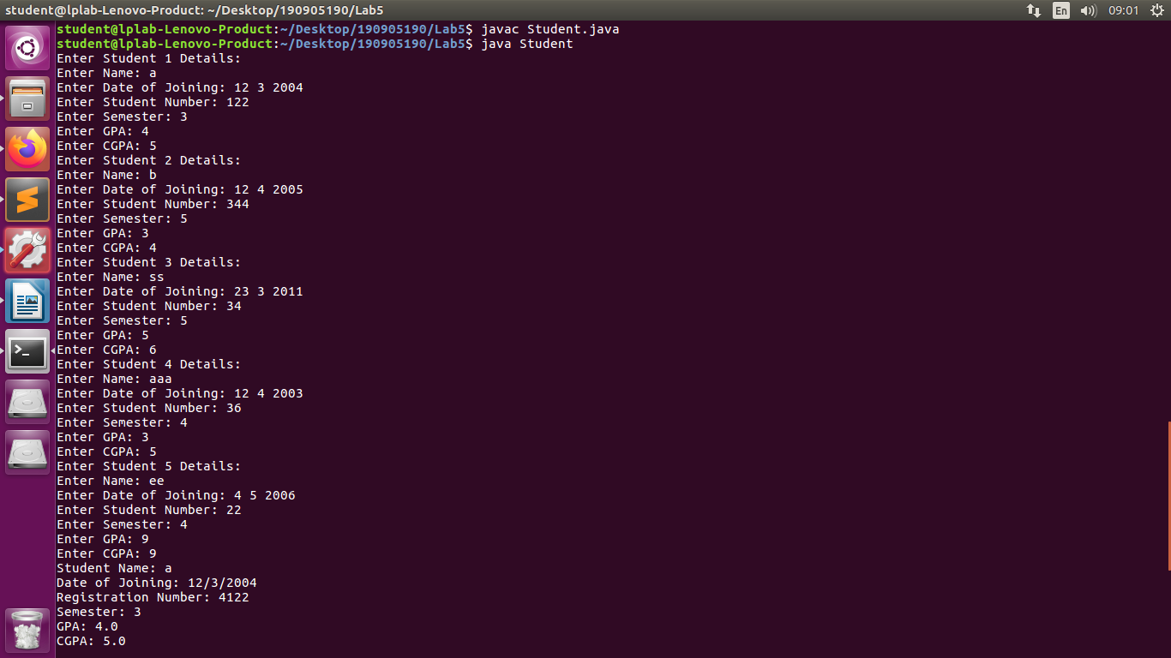
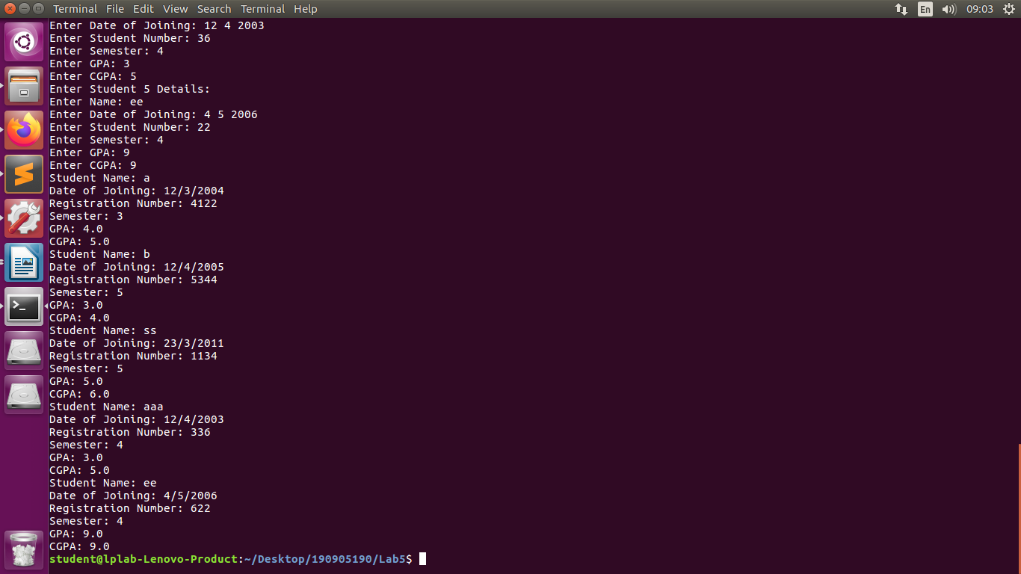

Lab 7:
Design an interface called Series with the following methods
  - Get Next (returns the next number in series)
  - reset(to restart the series)
  - set Start (to set the value from which the series should start)
Design a class named By Twos that will implement the methods of the interface Series such that it generates a series of numbers, each two greater than the previous one. Also design a class which will include the main method for referencing the interface.
Source Code:
File name: “Series.java”
interface Series
{
int getNext();
void reset();
void setStart(int s);
}
File name: “ByTwos.java”
class ByTwos implements Series
{
int start, current;
public int getNext(){
current = current +2;
return current;
}
public void reset(){
current = start;
}

public void setStart(int s){
start = s;
}
}
File name : “DriverLab7.java”
import java.util.*;

class DriverLab7
{
public static void main(String[] args)
{
Scanner sc = new Scanner(System.in);
int st;
System.out.print("Enter Start: ");
st = sc.nextInt();
ByTwos bt = new ByTwos();
bt.setStart(st);
bt.reset();
for (int i = 0;i<5;i++)
{
int num;
num = bt.getNext();
System.out.println("After getNext: " + num);
}
bt.reset();
System.out.println("After Reset");
for (int i = 0;i<6;i++)
{
int num;
num = bt.getNext();
System.out.println("After getNext: " + num);
}
}
}

Output :

