OOP LAB
Session II
Part II

Lab 6
Q1)
Create a Person class with private instance variables for the person’s name and birth date. Add appropriate accessor methods for these variables. Then create a subclass College Graduate with private instance variables for the student’s GPA and year of graduation and appropriate accessors for these variables. Include appropriate constructors for your classes. Then create a class with main() method that demonstrates your classes.
Source Code:

File name: “Person.java”

class Person
{
private String name;
private String dob;

Person(){

}

void setName(String n){
name = n;
}

String getName(){
return name;
}

void setDob(String d){
dob = d;
}

String getDob(){
return dob;
}

void display(){
System.out.println("Name: " + getName());
System.out.println("DOB: " + getDob());
}
}

File name: “CollegeGraduate.java”

class CollegeGraduate extends Person {
private float gpa;
private int gradyear;

CollegeGraduate(){
super();
}

void setGPA(float g){
gpa = g;
}

void setGradYear(int y){
gradyear = y;
}

float getGPA(){
return gpa;
}

int getGradYear(){
return gradyear;
}

void display(){
super.display();
System.out.println("GPA: " + getGPA());
System.out.println("Graduation Year: " + getGradYear());
}
}

File name : “DriverLab6.java”

import java.util.*;
class DriverLab6
{
public static void main(String[] args) {
Scanner sc = new Scanner(System.in);
CollegeGraduate clg = new CollegeGraduate();
System.out.println("Enter Name: ");
String name = sc.nextLine();
clg.setName(name);
System.out.println("Enter Date of Birth: ");
String dob = sc.nextLine();
clg.setDob(dob);
System.out.println("Enter GPA: ");
float gpa = sc.nextFloat();
clg.setGPA(gpa);
System.out.println("Enter Graduation Year: ");
int grad = sc.nextInt();
clg.setGradYear(grad);
clg.display();
}
}

Output :

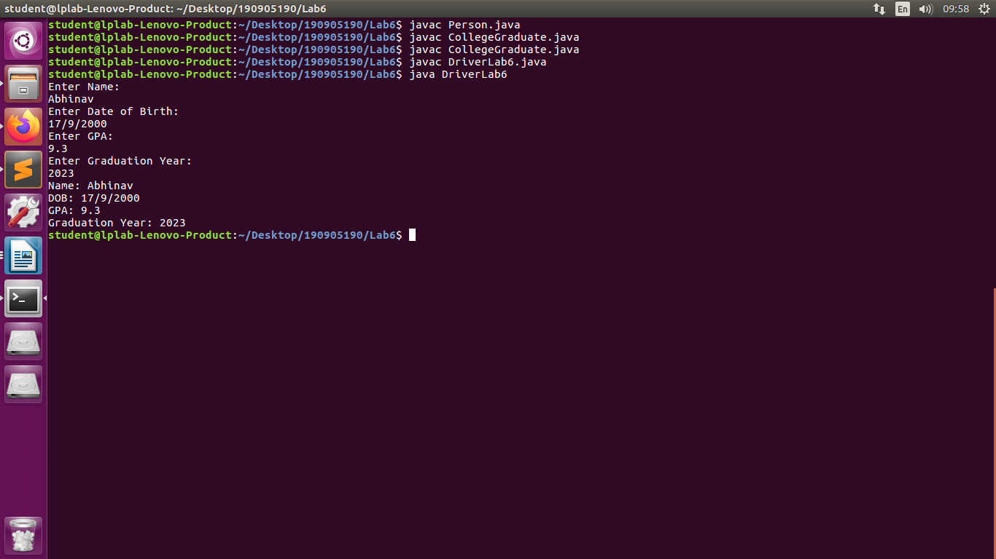

Q2)

Define a class Maximum with the following overloaded methods
max (which finds maximum among three integers and returns the maximum integer)
max (which finds maximum among three floating point numbers and returns the maximum among them)
max (which finds the maximum in an array and returns it)
max (which finds the maximum in a matrix and returns the result)
Place this in a package called p1. Let this package be present in a folder called “myPackages”, which is a folder in your present working directory (eg: c\student\3rdsem \mypackages\p1). Write a main method to use the methods of Max class in a package p1.

Source Code:

package mypackages.p1;
class Maximum
{
public int max(int a, int b, int c)
{
int m = (a > b) ? ((a > c) ? a : c) : ((b > c) ? b : c);
return m;
}

public float max(float a, float b, float c)
{
float m = (a > b) ? ((a > c) ? a : c) : ((b > c) ? b : c);
return m;
}

public int max(int arr[])
{
int m = arr[0];
for(int i = 0; i<arr.length; i++)
{
if(m < arr[i])
m = arr[i];
}
return m;
}

public int max(int arr[][])
{
int m = arr[0][0];
for (int i = 0;i<arr.length ;i++ )
{
for(int j = 0; j<arr[0].length; j++)
{
if(m < arr[i][j])
m = arr[i][j];
}
}
return m;
}

public static void main(String[] args) {
Maximum m = new Maximum();
System.out.println(m.max(23, 32, 22));
System.out.println(m.max(23.6f, 32.3f, 22.1f));
int ar[] = {1, 2, 3, 4, 5, 6, 7, 8, 9, 10};
System.out.println(m.max(ar));
int ar2[][] = {{1, 2, 3, 4, 5},{7, 8, 9, 10, 11}};
System.out.println(m.max(ar2));
}
}

Output:
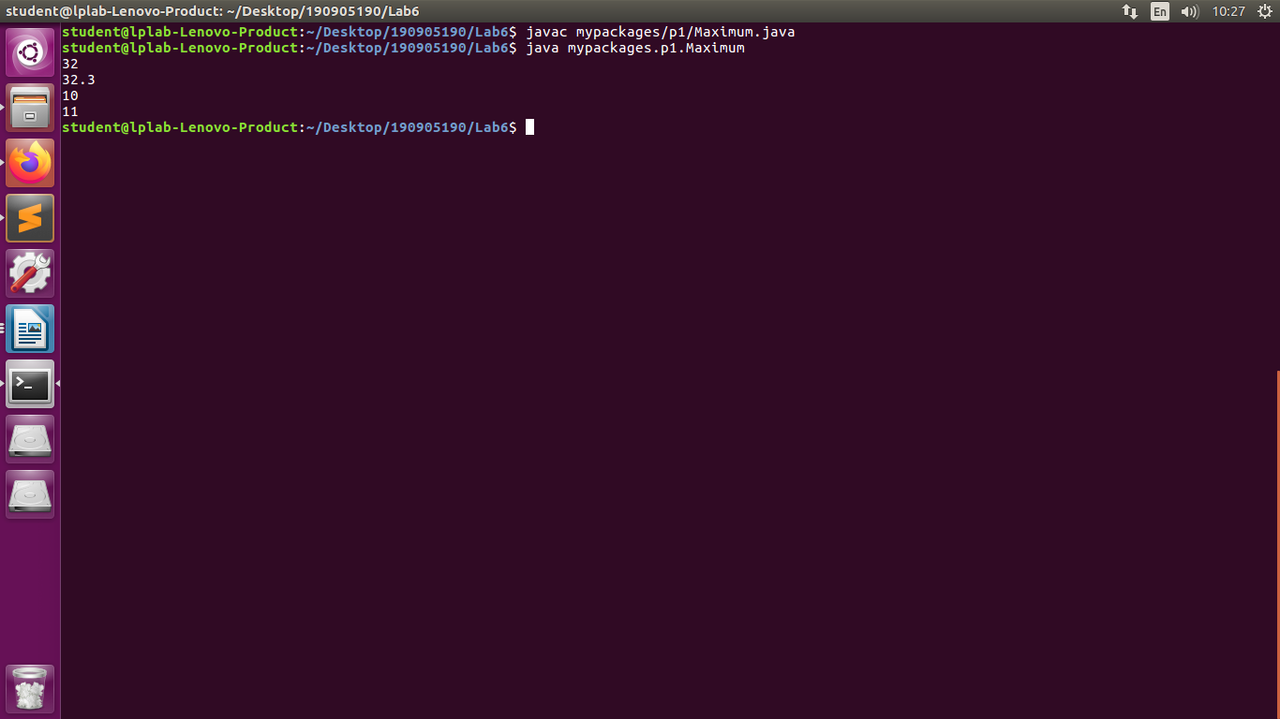

Q3)

Create an abstract class Figure with abstract method area and two integer dimensions. Create three more classes Rectangle, Triangle and Square which extend Figure and implement the area method. Show how the area can be computed dynamically during run time for Rectangle, Square and Triangle to achieve dynamic polymorphism. (Use the reference of Figure class to call the three different area methods)
Source Code :
File name : “Figure.java”

abstract class Figure {
int dim1, dim2;
Figure(int dim1, int dim2){
this.dim1 = dim1;
this.dim2 = dim2;
}
abstract void area();
}

File name : “Rectangle.java”

class Rectangle extends Figure
{
Rectangle(int l, int b)
{
super(l, b);
}

void area()
{
System.out.println("Area of Rectangle: " + (dim1 * dim2));
}
}
File name : “Triangle.java”

class Triangle extends Figure
{
Triangle(int b, int h)
{
super(b, h);
}

void area()
{
double ar = 0.5*dim1*dim2;
System.out.println("Area of Triangle: " + ar);
}
}

File name : “Square.java”

class Square extends Figure
{
Square(int s)
{
super(s, s);
}

void area()
{
System.out.println("Area of Square: " + (dim1 * dim2));
}
}

File name : “DriverLab6_3.java”

class DriverLab6_3
{
public static void main(String[] args)
{
Rectangle rect = new Rectangle(3, 4);
Figure s1 = rect;
s1.area();
Triangle tri = new Triangle(2, 3);
s1 = tri;
s1.area();
Square sqr = new Square(10);
s1 = sqr;
s1.area();
}
}

Output :

