OOP LAB

Lab 7

Q1)

Design a stack class. Provide your own stack exceptions namely Push Exception and Pop Exception, which throw exceptions when the stack is full and when the stack is empty respectively. Show the usage of these exceptions in handling a stack object in the main.

Source Code:
import java.util.*;

class PushException extends Exception
{
private int error;

public PushException(int error)
{
this.error = error;
}

public int getError()
{
return this.error;
}
}

class PopException extends Exception
{
private int error;

public PopException(int error)
{
this.error = error;
}

public int getError()
{
return this.error;
}
}

public class Stack
{
int items[];
int top;
int maxSize;

public Stack(int maxSize)
{
this.maxSize = maxSize;
this.items = new int[maxSize];
this.top = -1;
}

void push(int x)
{
try
{
if(this.top == maxSize - 1)
throw new PushException(1);
else
{
this.top++;
this.items[this.top] = x;
}
}
catch(PushException err)
{
System.out.println("Process terminated. Error Code: " + err.getError());
System.out.println("The Stack is Full !");
}
}

int pop()
{
int p = -999;
try
{
if(this.top == -1)
throw new PopException(1);
else
{
p = this.items[this.top];
top--;
}
}
catch (PopException err) {
System.out.println("Process terminated. Error Code: " + err.getError());
System.out.println("The Stack is Empty !");
}
return p;
}

void display()
{
for(int i = 0; i<= this.top; i++)
{
System.out.print(this.items[i] + "\t");
}
System.out.println();
}

public static void main(String[] args)
{
Scanner sc = new Scanner(System.in);
Stack stack;
int max;
System.out.println("Enter Size of the Stack: ");
max = sc.nextInt();
stack = new Stack(max);
System.out.println("Stack initialised with size = " + stack.maxSize);
int ch = 99;
do
{
System.out.print("Operations: \t");
System.out.print("1) Push\t");
System.out.print("2) Pop\t");
System.out.print("3) Display\t");
System.out.print("0) Exit\n");
System.out.print("Enter Choice: ");
ch = sc.nextInt();

switch(ch)
{
case 1:
int ele;
System.out.print("Enter Element to push: ");
ele = sc.nextInt();
stack.push(ele);
break;
case 2:
int ele1 = stack.pop();
if(ele1 != -999)
System.out.println("Element Popped: " + ele1);
break;
case 3:
System.out.print("Stack Elements: ");
stack.display();
break;
case 0:
System.out.println("Exit");
break;
default:
System.out.println("Illegal Choice!");
break;

}

}while(ch != 0);
}
}
Output:

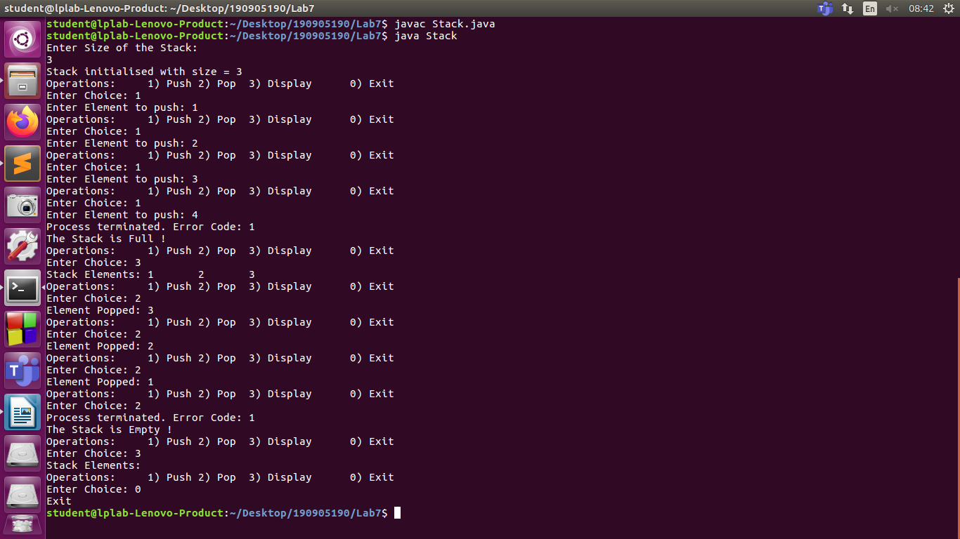

Q2)

Define a class CurrentDate with data members day, month and year. Define a method createDate() to create date object by reading values from keyboard. Throw a user defined exception by name InvalidDayException if the day is invalid and InvalidMonthException if month is found invalid and display current date if the date is valid. Write a test program to illustrate the functionality.

Source Code:
import java.util.*;

class InvalidDayException extends Exception
{
private int error;

public InvalidDayException(int error)
{
this.error = error;
}

public int getError()
{
return this.error;
}
}

class InvalidMonthException extends Exception
{
private int error;

public InvalidMonthException(int error)
{
this.error = error;
}

public int getError()
{
return this.error;
}
}

public class CurrentDate
{
int day;
int month;
int year;

public CurrentDate()
{
this.day = 1;
this.month = 1;
this.year = 2000;
}

public CurrentDate(int day, int month, int year)
{
try
{
if(this.isDateValid(day, month, year) == true)
{
this.day = day;
this.month = month;
this.year = year;
this.display();
}
}
catch(InvalidDayException err)
{
System.out.println("Program Exited with code: " + err.getError());
System.out.println("The day entered was not within valid range");
}
catch (InvalidMonthException err)
{
System.out.println("Program Exited with code: " + err.getError());
System.out.println("The month entered was not within valid range");
}
}

boolean isDateValid(int d, int m, int y) throws InvalidMonthException, InvalidDayException
{
int mdays[] = {0, 31, 28, 31, 30, 31, 30, 31, 31, 30, 31, 30, 31};
boolean b = false;
if(y % 4 == 0 || y % 400 == 0 && y % 100 != 0)
{
mdays[2] = 29;
}

if(m < 1 || m > 12)
{
b = false;
throw new InvalidMonthException(1);
}
else
{
if(d < 1 || d > mdays[m])
{
b = false;
throw new InvalidDayException(1);
}
else
{
b = true;
}
}
return b;
}

void display()
{
String dd = "" + this.day;
String mm = "" + this.month;
String yy = "" + this.year;
if(this.day < 10)
dd = "0" + this.day;
if(this.month < 10)
mm = "0" + this.month;
System.out.println("Date: " + dd + "/" + mm + "/" + yy);
}

public static void main(String[] args)
{
Scanner sc = new Scanner(System.in);
CurrentDate date = new CurrentDate();
int d, m, y;
System.out.print("Enter Day, Month and Year: ");
d = sc.nextInt();
m = sc.nextInt();
y = sc.nextInt();
date = new CurrentDate(d, m, y);
}
}

Output:

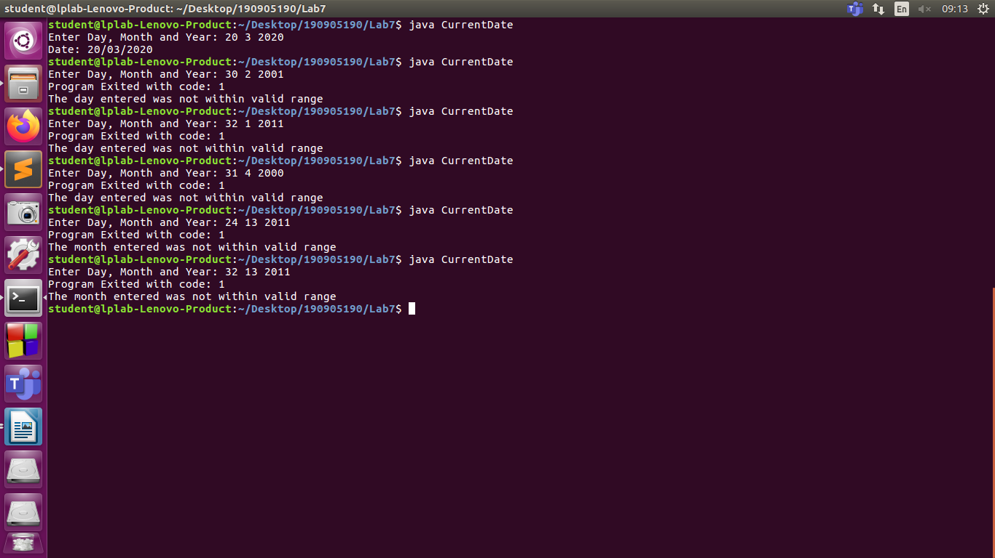
Q3)
Design a Student class with appropriate data members as in Lab 5. Provide your own exceptions namely Seats Filled Exception, which is thrown when Student registration number is >XX25 (where XX is last two digits of the year of joining) Show the usage of this exception handling using Student objects in the main. (Note: Registration number must be a unique number)
Source Code:
import java.util.*;
// import java.util.GregorianCalendar;

class SeatFilledException extends Exception
{
private int error;

public SeatFilledException(int error)
{
this.error = error;
}

public int getError()
{
return this.error;
}
}
class Student{
int reg_no;
String name;
GregorianCalendar doj;
short sem;
float gpa;
float cgpa;
int sno;
boolean e;
Student()
{
this.sno = 0;
this.reg_no = 0;
this.name = "";
this.doj = new GregorianCalendar(1, 1, 1970);
this.sem = 1;
this.gpa = 0.0f;
this.cgpa = 0.0f;
this.e = false;
}
Student(int sno, String name, GregorianCalendar doj, short sem, float gpa, float cgpa)
{
try
{
if(this.isSeatFull(sno) == false)
{
this.doj = doj;
this.sno = sno;
this.name = name;
String reg = doj.get(Calendar.YEAR) % 100 + "" + sno;
this.reg_no = Integer.parseInt(reg);
this.sem = sem;
this.gpa = gpa;
this.cgpa = cgpa;
this.e = false;
}
else
{
this.sno = 0;
this.reg_no = 0;
this.name = "";
this.doj = new GregorianCalendar(1, 1, 1970);
this.sem = 1;
this.gpa = 0.0f;
this.cgpa = 0.0f;
this.e = true;
}
}
catch(SeatFilledException err)
{
System.out.println("Program Exited with Code: " + err.getError());
System.out.println("The seats are full!");
this.sno = 0;
this.reg_no = 0;
this.name = "";
this.doj = new GregorianCalendar(1, 1, 1970);
this.sem = 1;
this.gpa = 0.0f;
this.cgpa = 0.0f;
this.e = true;
}
}
boolean isSeatFull(int sno) throws SeatFilledException
{
boolean b = false;
if(sno > 25)
{
b = true;
throw new SeatFilledException(1);
}
return b;
}
void printDate()
{
System.out.println(reg_no);
System.out.println(doj.getTime());
}
void displayRecord()
{
String date = doj.get(Calendar.DATE) + "/" + doj.get(Calendar.MONTH) + "/" + doj.get(Calendar.YEAR);
System.out.println(name+"\t"+date+"\t"+reg_no+"\t"+sem+"\t"+gpa+"\t"+cgpa);
// System.out.println("Student Name: " + name);
// System.out.println("Date of Joining: " + doj.get(Calendar.DATE) + "/" + doj.get(Calendar.MONTH) + "/"
// + doj.get(Calendar.YEAR));
// System.out.println("Registration Number: " + reg_no);
// System.out.println("Semester: " + sem);
// System.out.println("GPA: " + gpa);
// System.out.println("CGPA: " + cgpa);

}
public static void main(String[] args) {
Student obj[] = new Student[5];
int sno;
String name;
GregorianCalendar doj;
short sem;
float gpa, cgpa;
int day, month, year;
Scanner sc = new Scanner(System.in);
for(int i = 0; i<5; i++){
System.out.println("Enter Student " + (i+1) + " Details: ");
System.out.print("Enter Name: ");
name = sc.next();sc.nextLine();
System.out.print("Enter Date of Joining: ");
day = sc.nextInt();
month = sc.nextInt();
year = sc.nextInt();
doj = new GregorianCalendar(year, month, day);
System.out.print("Enter Student Number: ");
sno = sc.nextInt();
System.out.print("Enter Semester: ");
sem = sc.nextShort();
System.out.print("Enter GPA: ");
gpa = sc.nextFloat();
System.out.print("Enter CGPA: ");
cgpa = sc.nextFloat();

obj[i] = new Student(sno, name, doj, sem , gpa, cgpa);
}
System.out.println("Name\tDate of Joining\tReg_No\tSem\tGPA\tCGPA");
for (int i = 0;i<5; i++)
{
if(obj[i].e != true)
obj[i].displayRecord();
}
}
}
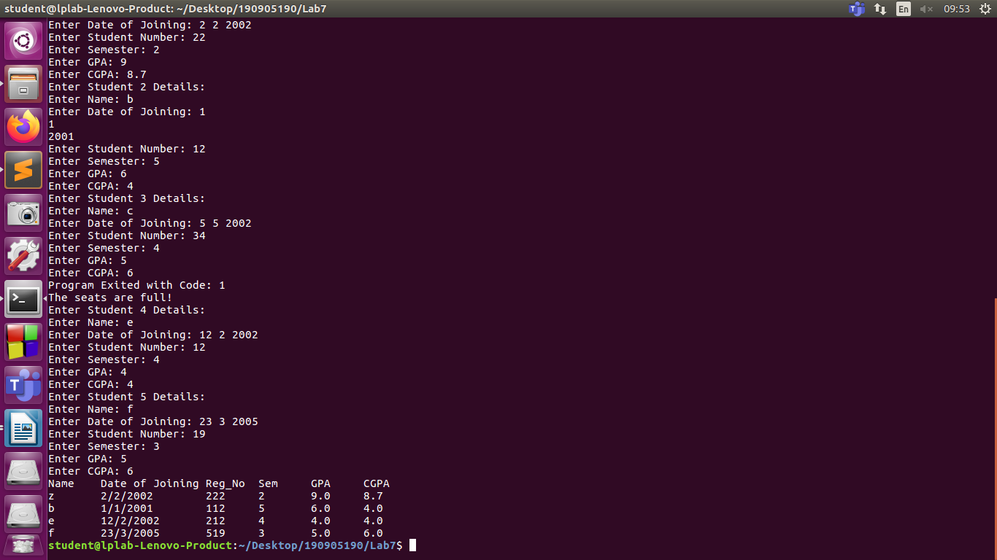
Ouput:

