OOP LAB

Lab 8

Q1)

Source Code:
class MultiTables extends Thread
{
private int num;
Thread t;

public MultiTables(int num)
{
this.num = num;
System.out.println("Thread " + this.num + " created.");
}

public void printMultiTables()
{
for(int i = 0; i<11; i++)
{
System.out.println(this.num + " * " + i + " = " + +(i*this.num));
}
}

public void run()
{
System.out.println("Running Thread " + this.num);
this.printMultiTables();
}

public void startThrd()
{
System.out.print("Starting thread " + this.num + "\n");
if(t == null)
{
t = new Thread(this, "Thread " + this.num);
t.start();
}
}
}

public class Tables
{
public static void main(String[] args) {
MultiTables t1 = new MultiTables(5);
MultiTables t2 = new MultiTables(7);
t1.startThrd();
try
{
t1.join();
}
catch (InterruptedException e)
{
e.printStackTrace();
}
t2.startThrd();
}
}

Output:

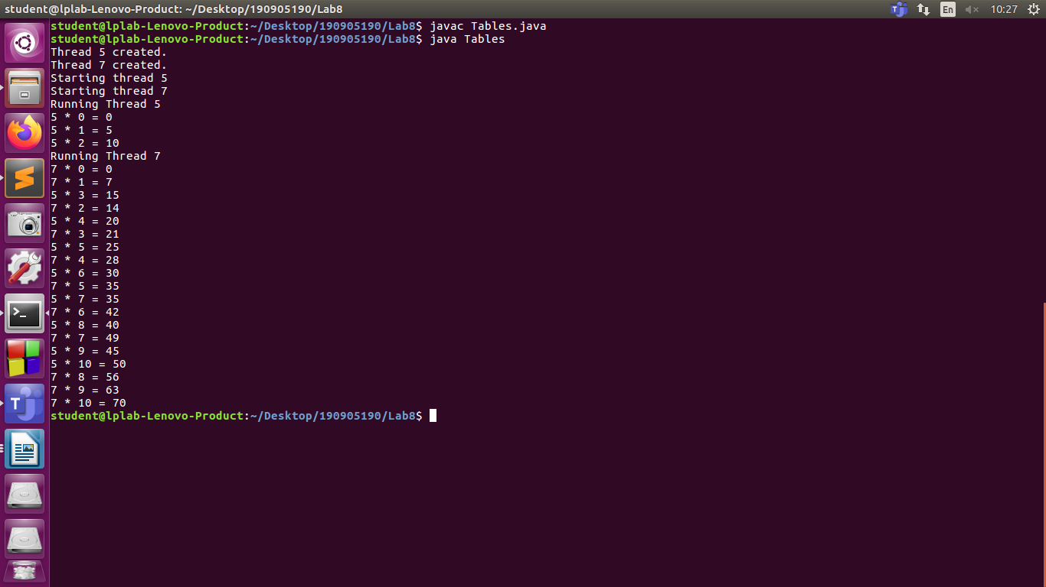
Q2)

Write and execute a java program to create and initialize a matrix of integers. Create n threads( by implementing Runnable interface) where n is equal to the number of rows in the matrix. Each of these threads should compute a distinct row sum. The main thread computes the complete sum by looking into the partial sums given by the threads.

Source Code:
import java.util.Scanner;
class Matrix{
private int mat[][];

public Matrix(int n, int m)
{
mat = new int[n][m];
}

public int[] getRow(int i)
{
return mat[i];
}

public void input(){
Scanner sc = new Scanner(System.in);
System.out.println("Enter the matrix:");
for(int i=0; i<mat.length; i++)
{
for(int j=0; j<mat[i].length; j++)
mat[i][j] = sc.nextInt();
}
}
}

class RowSum implements Runnable
{
private int arr[];
private int sum;

RowSum(int a[])
{
arr = a;
sum = 0;
}

public int getRowSum()
{
return sum;
}

public void run()
{
System.out.println("Running a new thread");
for (int i : arr)
sum += i;
}
}

class MatrixSum
{
public static void main(String [] args)
{
Scanner sc = new Scanner(System.in);
System.out.print("Enter the dimensions of the matrix:");
int n = sc.nextInt();
int m = sc.nextInt();
Matrix matrix = new Matrix(n,m);
matrix.input();
Thread threads[] = new Thread[n];
RowSum rowsum[] = new RowSum[n];
for(int i=0; i<n; i++)
{
rowsum[i] = new RowSum(matrix.getRow(i));
threads[i] = new Thread(rowsum[i]);
threads[i].start();
}
int sum = 0;
try
{
for(int i=0;i<n; i++)
{
threads[i].join();
sum += rowsum[i].getRowSum();
}
}
catch (InterruptedException e)
{
e.printStackTrace();
}
System.out.println("Total sum = "+sum);
}
}

Ouput:

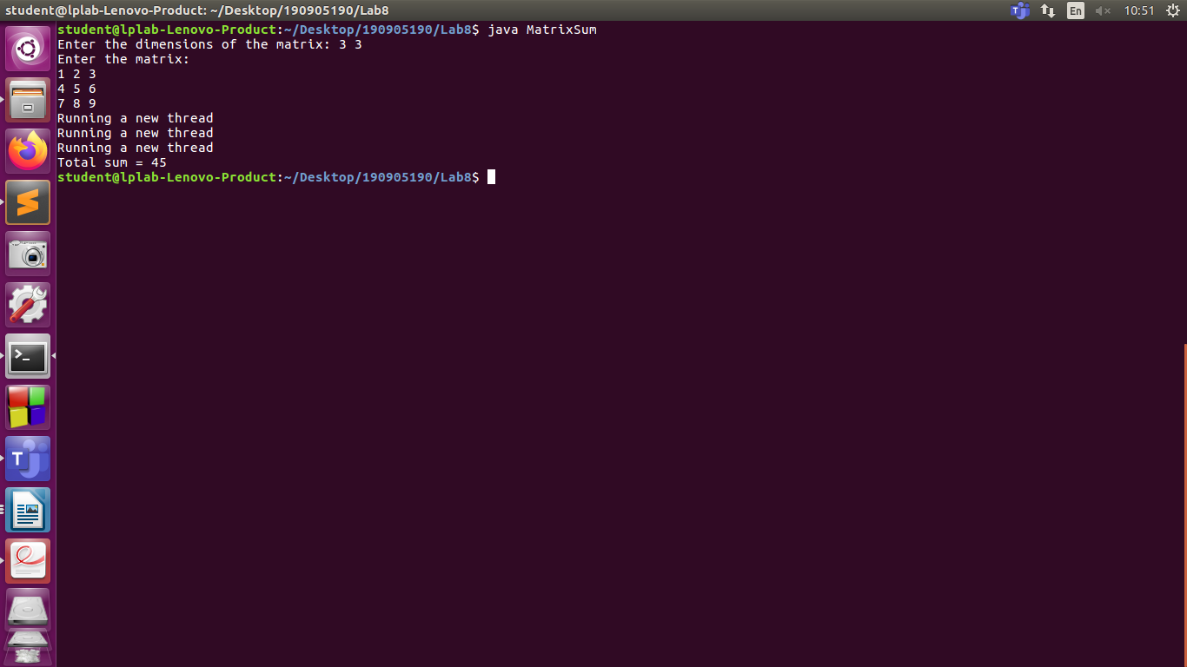
Q3)
Write and execute a java program to implement a producer and consumer problem using Inter-thread communication.

Source Code:
class Ob
{
int n;
boolean setValue = false;

synchronized int get()
{
while(!setValue)
{
try
{
wait();
}
catch(InterruptedException e)
{
e.printStackTrace();
}

}
System.out.println("Value Recieved: " + n);
setValue = false;
notify();
return n;
}

synchronized void put(int n)
{
while (setValue)
{
try
{
wait();
}
catch(InterruptedException e)
{
e.printStackTrace();
}

}
this.n = n;
System.out.println("Put Value: " + n);
setValue = true;
notify();
}
}

class Consumer implements Runnable
{
Ob o;
Consumer(Ob o)
{
this.o = o;
new Thread(this, "Cons").start();
}

public void run()
{
while(true)
o.get();
}
}

class Producer implements Runnable
{
Ob o;
Producer(Ob o)
{
this.o = o;
new Thread(this, "Prod").start();
}

public void run()
{
int i = 0;
while(i < 10)
{
o.put(i++);
}
}
}

public class PC
{
public static void main(String[] args) {
Ob o = new Ob();
new Producer(o);
new Consumer(o);
}
}

Output:

