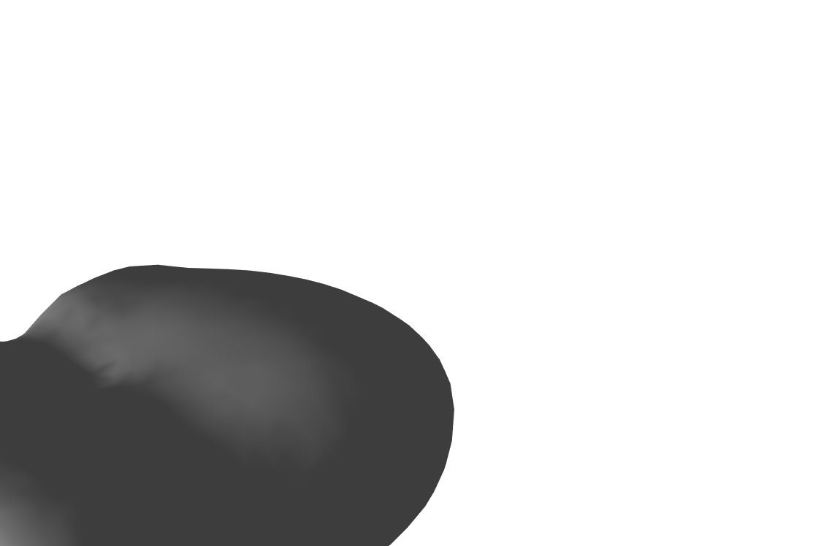

SPACECRAFT TRAJECTORY DESIGN NEAR ASTEROID 4769 CASTALIA

SHANKAR KULUMANI AND TAEYOUNG LEE

I. Introduction

Small solar system bodies, such as asteroids and comets, are of signicant interest to the sci-entic community; These small bodies oer great insight into the early formation of the solar sys-tem. This insight oers additional detail into the formation of the Earth and also the probable formation of other planetary bodies. Of particu-lar interest are those near-Earth asteroids (NEA) which inhabit heliocentric orbits in the vicinity of the Earth. These easily accessible bodies provide attractive targets to support space industrializa-tion, mining operations, and scientic missions. NEAs potentially contain many materials such as those useful for propulsion, construction, or for use in semiconductors. Also, many bodies contain highly protable materials, such as pre-cious or strategic metals [4]. In addition, these NEAs are also of concern for their potential to impact the Earth. Asteroids and comets are the greatest threat to future civilizations and as a result there is a focused eort to mitigate these risks [5]. In spite of the great interest in asteroids, the operation of spacecraft in their vicinity is a challenging problem.

While there has been signicant study of in-terplanetary transfer trajectories, relatively less analysis has been conducted on operations in the vicinity of asteroids. The dynamic envi-ronment around asteroids is strongly perturbed and challenging for analysis and mission oper-ation. Due to their low mass, which results in a low gravitational attraction, asteroids may have irregular shapes and potentially chaotic spin states. Furthermore, since the magnitude of the gravitational attraction is relatively small, non-gravitational eects, such as solar radiation pres-sure or third-body eects, become much more signicant. As a result, the orbital environment

is generally quite complex and it is dicult to generate analytical insights.

I.I. Research Question. In this paper, we ex-tend the design method previously developed in the three-body problem to motion about aster-oids. The authors present a systematic method of generating optimal transfer orbits about asteroids. Our systematic approach avoids the diculties in selecting an appropriate initial guess for opti-mization. We instead utilize the concept of the reachability set to enable a simple methodology of selecting initial conditions to achieve general orbital transfers. This method allows us to avoid the diculties inherent in choosing valid initial conditions for the computation of optimal trans-fer trajectories. We develop the optimal control formulation and apply this method to an example transfer about asteroid 4769 Castalia, which is shown in Figure 1.

Figure 1. 4769 Castalia

I.II. Motivation. The potential for asteroid im-pact presents one of the largest threats to the future of humanity. Interplanetary space, while relatively empty by human standards, is lled with debris and the Earth is in a \cosmic shoot-ing gallery". There is a continual bombardment of the Earth by a large range of planetary ma-terial. This was vividly demonstrated in 2013 by the Chelyabinsk air burst, where a 10m to 20m asteroid exploded over the Russian city of

PhD Candidate, Department of Mechanical and Aerospace Engineering, Email: [skulumani@gwu.edu.](mailto:skulumani@gwu.edu) Assistant Professor, Department of Mechanical and Aerospace Engineering, Email: [tylee@gwu.edu.](mailto:tylee@gwu.edu)

1

2 SHANKAR KULUMANI AND TAEYOUNG LEE

Chelyabinsk on 15 February 2013. This event released the equivalent of approximately 590kt of TNT and is one of the few Earth impacts with eyewitness testimony. In spite of the meteorite exploding at over 100km, the shock wave was powerful enough to knock people o their feet and caused widespread damage to the surround-ing area.

It is only a matter of time before a much more devastating body arrives at the Earth. As a result, it is imperative to develop spacecraft methodolo-gies to avert any future impact scenarios. There is a growing body of research investigating a vari-ety of impact mitigation techniques [5, 3]. A key requirement of these future missions is the ability to eectively design spacecraft trajectories. In addition, a completely new design paradigm is required as the typical methods developed for use around the Earth or other large bodies is not applicable. In this work, we present a systematic design method to design trajectories around these small bodies. This type of work is ideal for future asteroid mitigation missions.

II. Orbital Transfer Example

xf

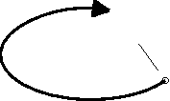

J

x0

Figure 2. Reachability Set

We utilize the concept of a reachability set to design our transfer trajectories. Figure 2 il-lustrates this methodology. Without any con-trol input, the trajectories will follow the system dynamics and intersect the Poincare section at x0 = xn. The addition of a control input allows the spacecraft to depart from the natural dynam-ics and intersect the section at another location denoted by the dashed circle. We use the cost function J to dene a distance metric on the Poincare section. Maximization of J, or the min-imization of J, along various directions, which are parameterized using d, on the Poincare sec-tion allows us to generate the largest reachability set under the bounded control input. We then select a trajectory from the reachable set which lies closest to the desired target. By repeating

the calculation we can determine a transfer about asteroid 4769 Castalia.

We present an example transfer of a space-craft about the asteroid 4769 Castalia. We model the thruster of the spacecraft as a generic accel-eration vector in the body-xed asteroid frame. The acceleration magnitude is chosen to emulate a physically realizable thruster system, such as those found on many operational ion or hall eect thrusters [2, 1].

Trajectory

2 5

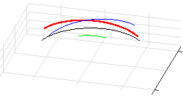

0

1

z

-1 0

-5 0 x 5 -5 y

Figure 3. Transfer Trajectory

The objective is to transfer the spacecraft between two periodic equatorial orbits about Castalia. Figure 3 shows the initial, xi, and target, xt, periodic orbits which lie in the equato-rial plane of Castalia. Our goal is to transfer from a lower altitude to a higher altitude while remain-ing in the equatorial plane of the asteroid. This type of scenario would occur frequently during mapping and observation missions to asteroids.

We can see in Figure 3 that this transfer re-quires four iterations of the reachable set com-putation. Each reachability set progressively ap-proaches the target periodic orbit. The nal computation intersects the target periodic orbit on our chosen Poincare section and allows for a complete orbital transfer between the two orbits of 4769 Castalia.

References

1. Edgar Y Choueiri, New Dawn for Electric Rockets, Sci-entic American 300 (2009), no. 2, 58{65.

2. Dan M Goebel and Ira Katz, Fundamentals of Electric Propulsion: Ion and Hall Thrusters, vol. 1, John Wiley & Sons, 2008.

3. A. Pitz, B. Kaplinger, G. Vardaxis, T. Winkler, and B. Wie, Conceptual design of a hypervelocity asteroid intercept vehicle (haiv) and its ight validation mission, Acta Astronautica 94 (2014), no. 1, 42{56.

4. Shane D Ross, Near-Earth Asteroid Mining, Space (2001).

5. Bong Wie, Dynamics and control of gravity tractor spacecraft for asteroid deection, Journal of Guidance, Control, and Dynamics 31 (2008), no. 5, 1413{1423.