**PART 1**

***Place a check mark next to the correct number.[1]***

***Please return the survey to the MAE Department Office after completing the course.***

1. Students showed the knowledge expected from the prerequisites

1__ 2__ 3_X_ 4__ 5__

1. The prerequisites to the course were sufficient and appropriate

1__ 2__ 3X 4__ 5__

1. All the topics specified in the course outline handed out were taught

1__ 2__ 3__ 4__ 5_X

1. The course learning objectives were the same as when last taught

1__ 2__ 3_X_ 4__ 5__

1. The classroom and laboratory facilities were adequate

1_X_ 2__ 3__ 4__ 5__

1. The students were actively engaged in the class (they asked questions, etc.)

1__ 2__ 3__ 4_X_ 5__

1. What was the average attendance?

(0-20%) 1__ 2__ 3__ 4__ 5_X_ (80-100%)

***For answers with a score of 3 or below, please provide the question number and an explanation below:***

1. Students did not have the necessary skills in the areas of basic algebra, dealing with fractions, basic Newton dynamics, describing motion using kinematics, scientific programming (simulating differential equations, plotting, basic computations), differential equations.

2. The prerequisites are the same as the previous year the course was taught. As a result this means that the previous courses are not preparing the students appropriately.

4. I modified the course learning objectives to cover the material I deem critical for a first course in linear systems and control theory. The material should adequately prepare students to apply the methods to the design of control systems for linear systems.

5. The classroom was unacceptable. The course was held in 1957 E 214 rather than in SEH. The desks are too small and there is inadequate writing space to for any technical work. The whiteboard was also inadequate as it did not provide the required amount of space to effectively convey the material. Furthermore, the scheduling office, managed to double book the assigned room for the final with another course. Finally, the MAE department, the office of the Dean, and the scheduling office all combined to ensure that none of my many requests for better facilities were considered.

To make the situation even more clear, observe the image below. Students are cramped, forced to use their knees to hold reference material or somehow juggle several notebooks, textbooks and the exam all while attempting to do techinical work.

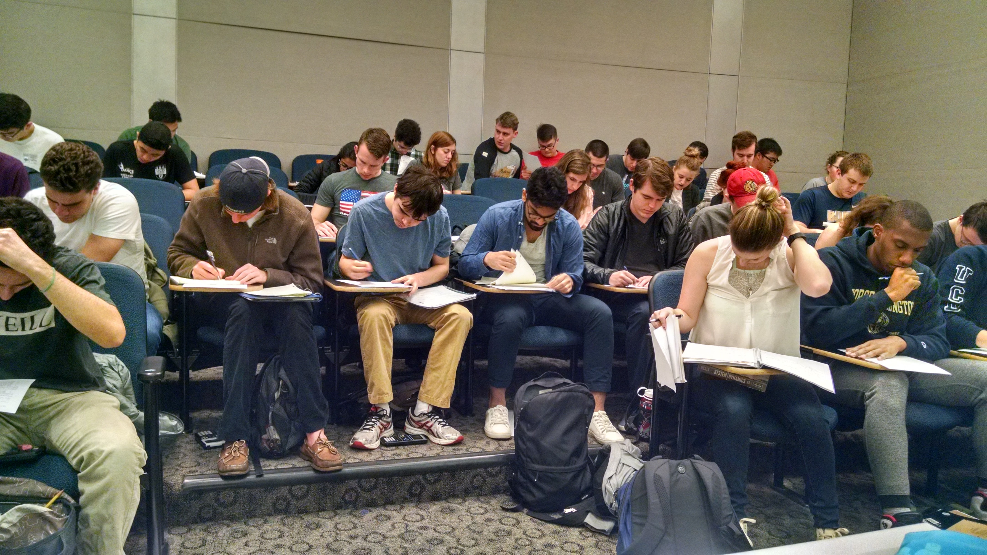

**PART 2**

A) Please complete Table 1, providing:

* in the first column the CLO (as it appears in the student online course evaluation)
* in the second column your direct assessment of each CLO (from exam question or project report)
* in the third column indirect assessment (from student online course evaluation)

**Table 1. Summary of course learning objectives assessment[2]**

|  |  |  |  |  |
| --- | --- | --- | --- | --- |
|  | CLO (Course Learning Objective) | Direct Assessment (instructor) | Indirect Assessment (student) | Student Outcome  a-k |
| 1 | Derive EOMS | 4.83 | 4.4 |  |
| 2 | Solve differential equations | 4.15 | 4 |  |
| 3 | Predict performance for linear systems | 4.31 | 4 |  |
| 4 | Bode Plot | 3.90 | 4.1 |  |
| 5 | Meet system requirements by choosing poles | 2.79 | 3.9 |  |
| 6 |  |  |  |  |
| 7 |  |  |  |  |
| 8 |  |  |  |  |
| 9 |  |  |  |  |
| 10 |  |  |  |  |

B) Please provide recommendations for course improvement (if any).

CLO5 was very low. There seems to have been a disconnect in the process of determining the relationship between pole locations and performance specifications. Improvements are possible by providing more opportunity for visualizing the system. Most students did not have programming skills, and I did not make it required. As a result, many students did not understand the qualitative behavior of linear systems as pole locations are changed.

CLO5 was also low. The creation of bode plots is an involved process which requires knowledge of the approximation techniques, as well as an attention to detail in creating a professional and useful plot. Much of the issue in generating the plot is actually in simple drawing the detail onto the paper. Again there seems to have been a disconnect in drawing an accurate plot, which then allows a student to extract information from the plot. The qualitative nature of the process was not as throughly emphasized. In the future, I hope to spend more time illustrating the process, and using visual aid to enable the students to gain a qualitative understanding of the process.

C) Please provide status of prior recommendations (if applicable)

This is the first time I am teaching this course. In the future I hope to include more programming/visualizations for the students. This should hopefully allow for a better understanding of the qualitative nature of linear systems.

|  |  |  |  |  |  |  |  |  |  |  |  |  |  |  |
| --- | --- | --- | --- | --- | --- | --- | --- | --- | --- | --- | --- | --- | --- | --- |
|  | | | | | | | | **Problem** | **Total** |  |  |  |  |  |
|  | **1** | **2** | **3** | **4** | **5** | **6** | **7** | **8** |  |  |  |  |  |  |
| Max points | 10 | 5 | 20 | 20 | 10 | 5 | 10 | 20 | 100 |  |  |  |  |  |
|  | 5 | 3 | 15 | 12 | 10 | 5 | 9 | 19 | 78 |  |  |  |  |  |
|  | 2 | 5 | 20 | 17 | 10 | 5 | 8 | 19 | 86 |  |  | Objectives | Question | Average Score |
|  | 6 | 5 | 12 | 15 | 10 | 5 | 9 | 18 | 80 |  |  | Determine the equations of motion | 5, 6 | 4.83030303 |
|  | 4 | 5 | 15 | 12 | 10 | 5 | 1 | 18 | 70 |  |  | Derive and solver differential equations | 7, 8 | 4.15460373 |
|  | 0 | 5 | 15 | 17 | 10 | 5 | 10 | 19 | 81 |  |  | Describe and predict response | 2 | 4.307692308 |
|  | 7 | 5 | 20 | 18 | 10 | 5 | 8 | 18 | 91 |  |  | Bode frequency plot | 3,4 | 3.895454545 |
|  | 7 | 5 | 15 | 17 | 10 | 5 | 8 | 19 | 86 |  |  | Design changes to meet performance specs | 1 | 2.787037037 |
|  | 6 | 0 | 19 | 8 | 10 | 5 | 5 | 19 | 72 |  |  |  |  |  |
|  |  |  |  |  |  |  |  |  |  |  |  |  |  |  |
|  | 7 | 5 | 18 | 18 | 10 | 5 | 7 | 18 | 88 |  |  |  |  |  |
|  | 5 | 3 | 15 | 12 | 10 | 5 | 9 | 19 | 78 |  |  | Max Score | 5 |  |
|  | 7 | 5 | 20 | 18 | 8 | 5 | 10 | 19 | 92 |  |  |  |  |  |
|  | 6 | 5 | 15 | 12 | 10 | 5 | 9 | 19 | 81 |  |  |  |  |  |
|  | 5 | 5 | 12 | 15 | 10 | 4 | 4 | 19 | 74 |  |  |  |  |  |
|  | 7 | 5 | 12 | 15 | 10 | 5 | 9 | 19 | 82 |  |  |  |  |  |
|  | 8 | 3 | 18 | 18 | 10 | 5 | 0 | 18 | 80 |  |  |  |  |  |
|  | 7 | 5 | 20 | 18 | 10 | 5 | 6 | 18 | 89 |  |  |  |  |  |
|  | 7 | 5 | 20 | 18 | 10 | 5 | 6 | 18 | 89 |  |  |  |  |  |
|  | 7 | 3 | 15 | 17 | 10 | 5 | 9 | 18 | 84 |  |  |  |  |  |
|  | 6 | 3 | 15 | 12 | 8 | 5 | 5 | 19 | 73 |  |  |  |  |  |
|  | 8 | 3 | 20 | 12 | 10 | 5 | 6 | 19 | 83 |  |  |  |  |  |
|  | 5 | 3 | 15 | 12 | 10 | 5 | 9 | 19 | 78 |  |  |  |  |  |
|  | 7 | 3 | 20 | 19 | 10 | 5 | 7 | 17 | 88 |  |  |  |  |  |
|  | 4 | 3 | 10 | 3 | 10 | 5 | 5 | 17 | 57 |  |  |  |  |  |
|  | 1 | 5 | 15 | 15 | 10 | 5 | 6 | 19 | 76 |  |  |  |  |  |
|  | 5 | 3 | 15 | 15 | 10 | 5 | 8 | 17 | 78 |  |  |  |  |  |
|  | 3 | 5 | 12 | 15 | 8 | 5 | 3 | 19 | 70 |  |  |  |  |  |
|  | 6 | 5 | 15 | 16 | 9 | 5 | 0 | 18 | 74 |  |  |  |  |  |
|  | 7 | 5 | 20 | 18 | 10 | 5 | 5 | 18 | 88 |  |  |  |  |  |
|  | 6 | 3 | 20 | 15 | 10 | 5 | 5 | 15 | 79 |  |  |  |  |  |
|  | 9 | 3 | 15 | 12 | 10 | 5 | 9 | 18 | 81 |  |  |  |  |  |
|  | 7 | 3 | 20 | 12 | 10 | 5 | 4 | 19 | 80 |  |  |  |  |  |
|  | 7 | 5 | 15 | 17 | 8 | 5 | 6 | 18 | 81 |  |  |  |  |  |
|  | 7 | 5 | 18 | 18 | 10 | 5 | 6 | 18 | 87 |  |  |  |  |  |
|  | 1 | 5 | 15 | 18 | 10 | 5 | 4 | 19 | 77 |  |  |  |  |  |
|  | 7 | 5 | 15 | 15 | 8 | 5 | 5 | 19 | 79 |  |  |  |  |  |
|  | 7 | 5 | 18 | 18 | 10 | 5 | 6 | 18 | 87 |  |  |  |  |  |
|  | 3 | 5 | 15 | 15 | 7 | 5 | 7 | 19 | 76 |  |  |  |  |  |
|  | 4 | 3 | 10 | 17 | 10 | 5 | 9 | 19 | 77 |  |  |  |  |  |
|  | 3 | 0 | 15 | 15 | 10 | 5 | 10 | 17 | 75 |  |  |  |  |  |
|  | 6 | 3 | 20 | 17 | 10 | 5 | 10 | 19 | 90 |  |  |  |  |  |
|  | 6 | 5 | 20 | 18 | 10 | 5 | 5 | 18 | 87 |  |  |  |  |  |
|  | 3 | 5 | 15 | 18 | 10 | 5 | 6 | 19 | 81 |  |  |  |  |  |
|  | 7 | 5 | 12 | 12 | 10 | 5 | 9 | 19 | 79 |  |  |  |  |  |
|  | 3 | 5 | 20 | 15 | 10 | 5 | 0 | 18 | 76 |  |  |  |  |  |
|  | 3 | 0 | 20 | 12 | 10 | 3 | 9 | 13 | 70 |  |  |  |  |  |
|  | 7 | 5 | 20 | 15 | 7 | 5 | 8 | 18 | 85 |  |  |  |  |  |
|  | 2 | 5 | 12 | 12 | 8 | 5 | 3 | 18 | 65 |  |  |  |  |  |
|  | 7 | 5 | 20 | 18 | 10 | 5 | 8 | 18 | 91 |  |  |  |  |  |
|  | 6 | 3 | 20 | 12 | 10 | 5 | 2 | 19 | 77 |  |  |  |  |  |
|  | 7 | 3 | 15 | 12 | 10 | 5 | 7 | 18 | 77 |  |  |  |  |  |
|  | 7 | 5 | 20 | 19 | 10 | 5 | 8 | 18 | 92 |  |  |  |  |  |
|  | 3 | 5 | 12 | 10 | 8 | 5 | 3 | 18 | 64 |  |  |  |  |  |
|  | 8 | 3 | 15 | 10 | 10 | 5 | 4 | 18 | 73 |  |  |  |  |  |
|  | 3 | 5 | 10 | 16 | 10 | 3 | 5 | 19 | 71 |  |  |  |  |  |
|  | 7 | 5 | 15 | 17 | 8 | 5 | 8 | 19 | 84 |  |  |  |  |  |
| Mean | 5.57 | 4.31 | 16.27 | 14.89 | 9.58 | 4.91 | 6.67 | 18.25 | 79.76 |  |  |  |  |  |

The course object score is computed as follows:

Determine equations of motion – Corresponding to Question 5 and 6.

4.8 = (9.58 + 4.91)/(10 + 5) * 5

1. Please provide assessment on a scale for from 1 to 5, where, in response to the statement given, 1=strongly disagree, 2= disagree, 3=neither, 4= agree, 5= strongly agree.
2. Please provide assessment on a scale for from 1 to 5, where, in response to the statement “the course learning objective was accomplished”, 1=strongly disagree, 2= disagree, 3=neither, 4= agree, 5= strongly agree.