Software Construction Lab 8

## S. M. Kumail Raza

## BESE 5A

### Reg# 112120

Git Repository: https://github.com/skumailraza/sc

## Introduction:

In this lab, you will create a Gradebook using Spring and Hibernate. A skeleton code with persistent classes and DAOs has been provided for easy start-up. Using the skeleton code design your console based application to be able to manage grades, courses, students and teachers.

## Approach:

A gradebook is used to keep track of grade achieved by a student, in course contents. As a result when modeling a gradebook, courses, teachers, students, course learning outcomes and the achieved marks, against some obtained marks are all necessary. The skeleton code provided to you, uses annotations to provide persistent classes for all of these entities. Also provided for your convenience are the Data Access Objects (DAOs) for these entities which will allow you to store an entity or retrieve it.

## Design:

The design consists of the following classes:

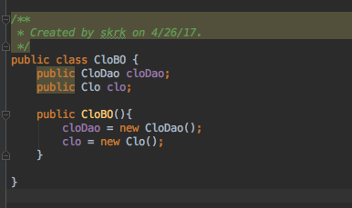

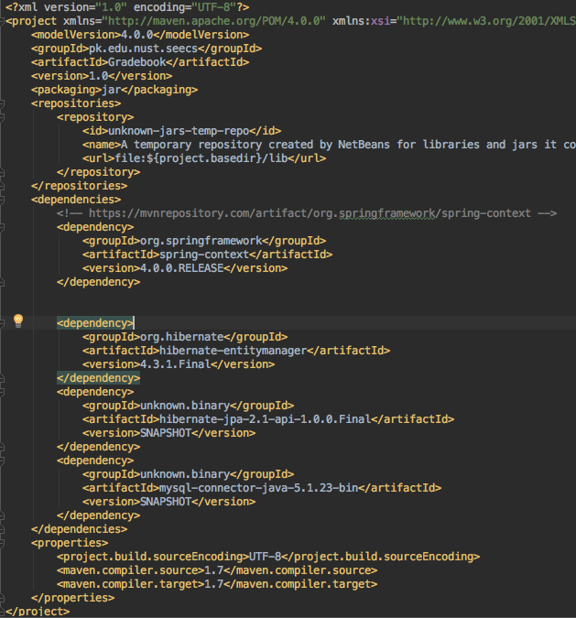

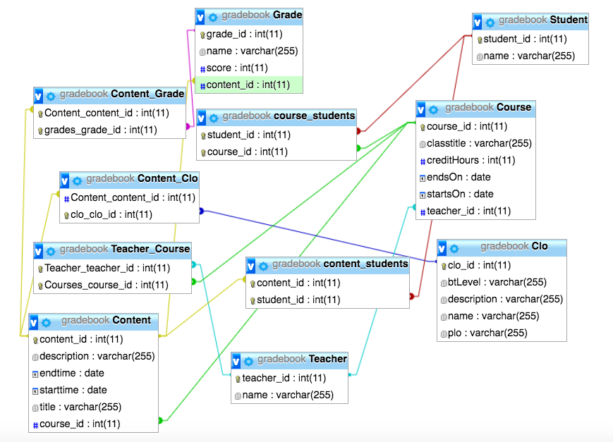

I use Hibernate Query Language to run the queries.

* The code executes the current system.
* The Clos are added into the data base.
* The entities are added into the database.

Define BOs to allow addition or updating of courses, teachers, students, contents, CLOs and Grades.

Store all the available grades from your current courses, along with other associated information, available via LMS or CMS.

Allow the user to export the data by printing it on the screen or generating a CSV file for it.

Used only HCQL for retrieval operations.

## Analysis:

The project uses hibernate to resolve dependencies of business objects. It uses spring to avoid dependency lookup. The

## How to run:

Run the app class’s main method to start.

Run the executioner class to execute operations.