Defect Type | Code | Design | Number of Defects
Sprint1 | 31 | 4 | 35
Logic Error | 23 |  | 23
Partial Implemented | 3 |  | 3
Text Message | 3 |  | 3
UI Design Issue |  | 4 | 4
Business Rule | 2 |  | 2
Sprint2 | 33 | 2 | 35
Logic Error | 22 |  | 22
Partial Implemented | 6 |  | 6
Text Message | 1 |  | 1
UI Design Issue |  | 1 | 1
Business Rule | 2 |  | 2
Data Error | 2 |  | 2
Compatibility Issue |  | 1 | 1

One-way ANOVA: Number of Defects versus Defect Type

Method

Null hypothesis All means are equal
Alternative hypothesis At least one mean is different
Significance level α = 0.05

Equal variances were assumed for the analysis.

Factor Information

Factor Levels Values
Defect Type_1 7 Business Rule, Compatibility Issue, Data Error, Logic Error, Partial
Implemented, Text Message, UI Design Issue

Analysis of Variance

Source DF Adj SS Adj MS F-Value P-Value
Defect Type_1 6 678.17 113.028 49.14 0.000
Error 5 11.50 2.300
Total 11 689.67

Model Summary

S R-sq R-sq(adj) R-sq(pred)
1.51658 98.33% 96.33% *

Means

Defect Type_1 N Mean StDev 95% CI
Business Rule 2 2.000 0.000 (-0.757, 4.757)
Compatibility Issue 1 1.000 * (-2.898, 4.898)
Data Error 1 2.000 * (-1.898, 5.898)
Logic Error 2 22.500 0.707 (19.743, 25.257)
Partial Implemented 2 4.50 2.12 ( 1.74, 7.26)
Text Message 2 2.00 1.41 ( -0.76, 4.76)
UI Design Issue 2 2.50 2.12 ( -0.26, 5.26)

Pooled StDev = 1.51658

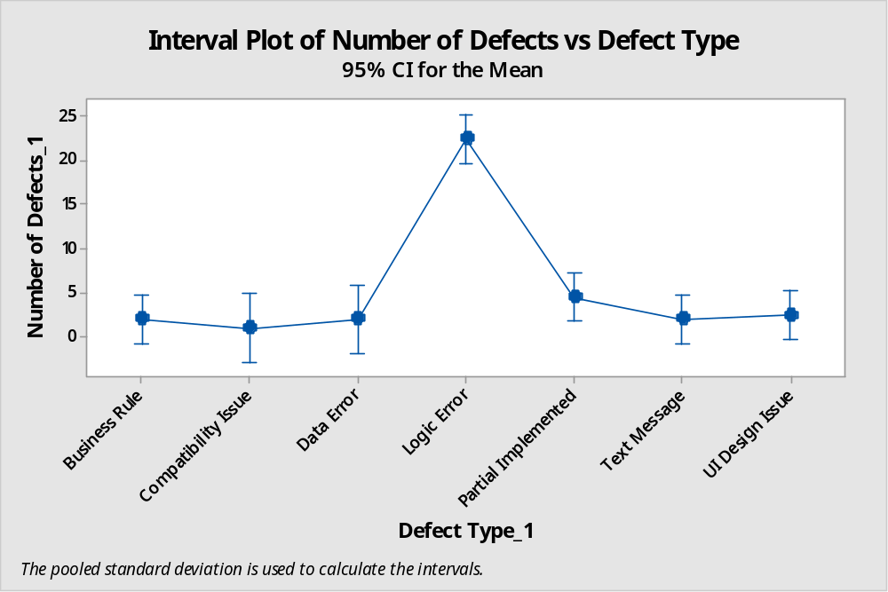
Result – Logical error is most contributed defect category need to be focused in next sprint
Action points –
Code Review should be perform by senior or peer level team member.

Sprint3 | 37 | 1 | 38
Logic Error | 20 |  | 20
Partial Implemented | 8 |  | 8
Text Message | 2 |  | 2
UI Design Issue |  | 1 | 1
Business Rule | 1 |  | 1
Data Error | 6 |  | 6
Sprint4 | 27 | 2 | 29
Logic Error | 14 |  | 13
Missing Function | 1 |  | 2
Partial Implemented | 3 |  | 3
Text Message | 2 |  | 2
UI Design Issue |  | 2 | 2
Business Rule | 6 |  | 6
Data Error | 1 |  | 1
One-way ANOVA: Number of Defects versus Defect Type

Method

Null hypothesis All means are equal
Alternative hypothesis At least one mean is different
Significance level α = 0.05

Equal variances were assumed for the analysis.

Factor Information

Factor Levels Values
Defect Type 7 Business Rule, Data Error, Logic Error, Missing Function, Partial
Implemented, Text Message, UI Design Issue

Analysis of Variance

Source DF Adj SS Adj MS F-Value P-Value
Defect Type 6 325.19 54.20 5.20 0.032
Error 6 62.50 10.42
Total 12 387.69

Model Summary

S R-sq R-sq(adj) R-sq(pred)
3.22749 83.88% 67.76% *

Means

Defect Type N Mean StDev 95% CI
Business Rule 2 3.50 3.54 ( -2.08, 9.08)
Data Error 2 3.50 3.54 ( -2.08, 9.08)
Logic Error 2 16.50 4.95 ( 10.92, 22.08)
Missing Function 1 2.000 * (-5.897, 9.897)
Partial Implemented 2 5.50 3.54 ( -0.08, 11.08)
Text Message 2 2.000 0.000 (-3.584, 7.584)
UI Design Issue 2 1.500 0.707 (-4.084, 7.084)

Pooled StDev = 3.22749

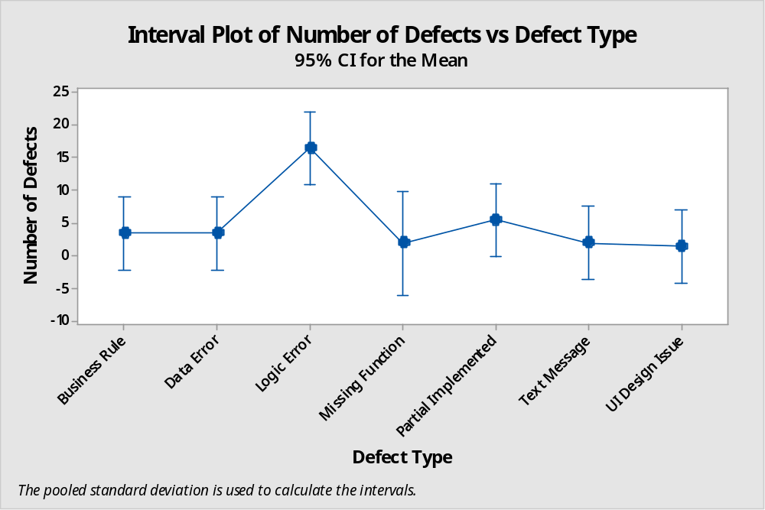
Result – Logical error is most contributed defect category need to be focused in next sprint
Action points –
Code Review should be perform by PM or Outside of team Member.

