NOIDA

Created on April 21 2016

Table of Contents

1.0. Log-In
2.0. Forgot Password
3.0. Enter OTP
4.0. Reset Password
5.0. Super Admin adds Admin Role
6.0. Super Admin edits Admin Role
7.0. Super Admin view Admin Role
8.0. Super Admin Maps users
9.0. Super Admin adds users
10.0. Super Admin edits users
11.0. Super Admin views users
12.0. Super Admin deactivate the role
13.0. Super Admin locks user account
14.0. Super Admin deactivate the user
15.0. Admin adds the roles
16.0. Admin edits the roles
17.0. Admin views the roles
18.0. Admin Maps Menu
19.0. Admin Maps Users
20.0. Admin deactivates role
21.0. Admin views application users
22.0. Admin revokes users
23.0. Admin view users

1.0. Log-In

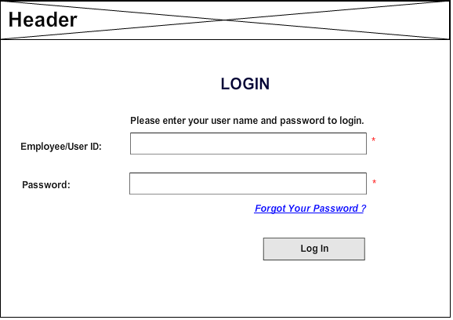

2.0. Forgot Password

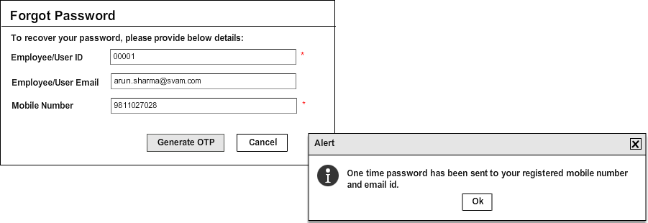

3.0. Enter OTP

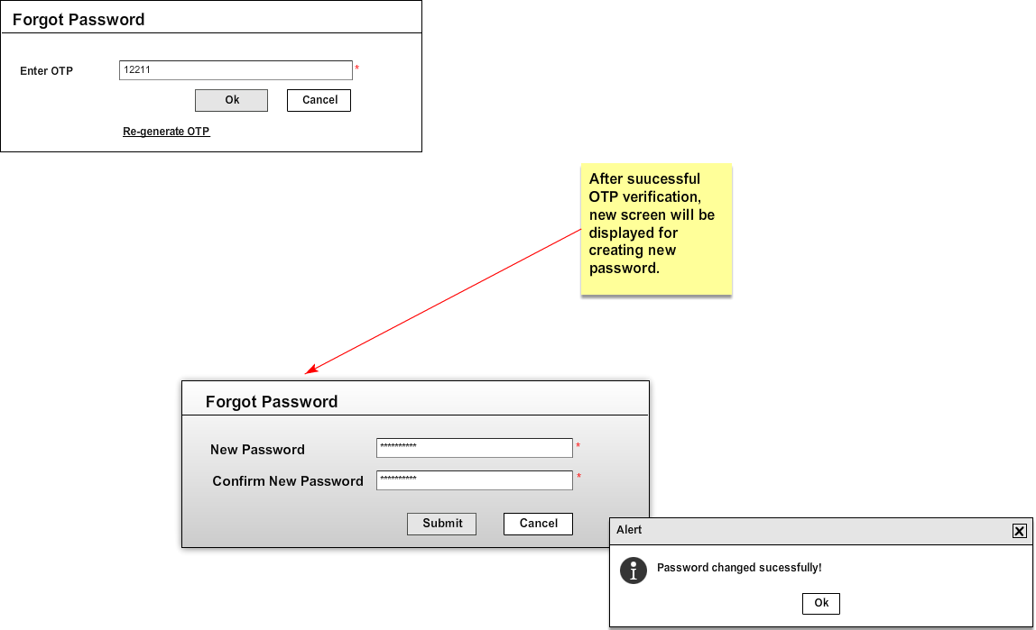

4.0. Reset Password

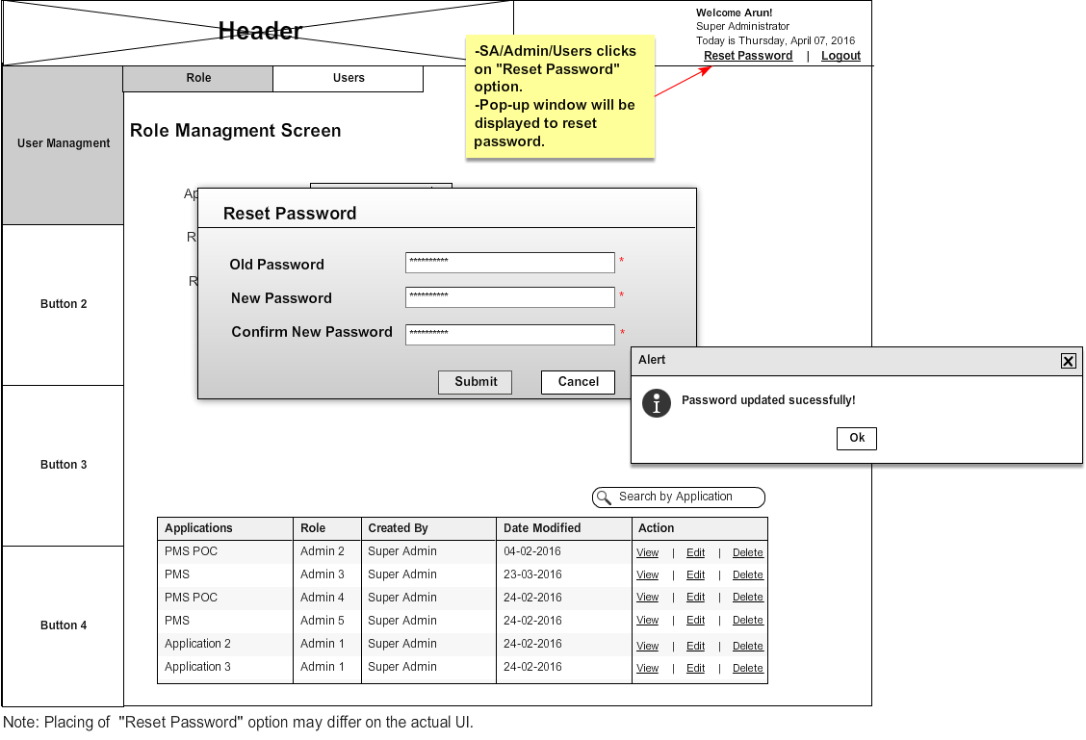

5.0. Super Admin adds Admin Role

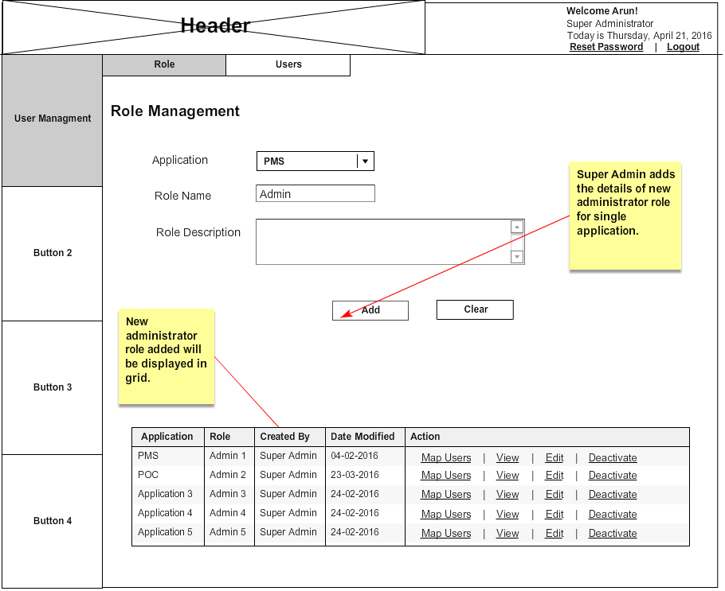

6.0. Super Admin edits Admin Role

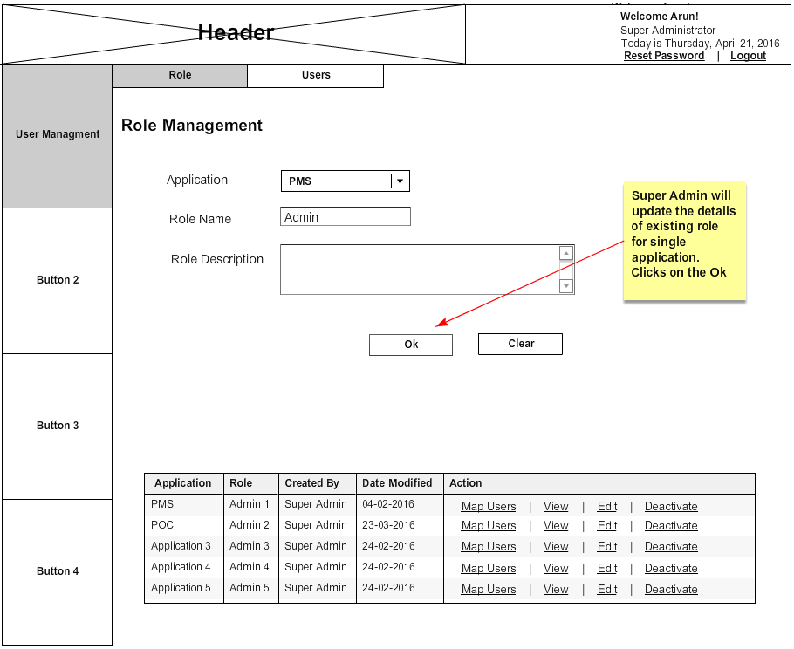

7.0. Super Admin view Admin Role

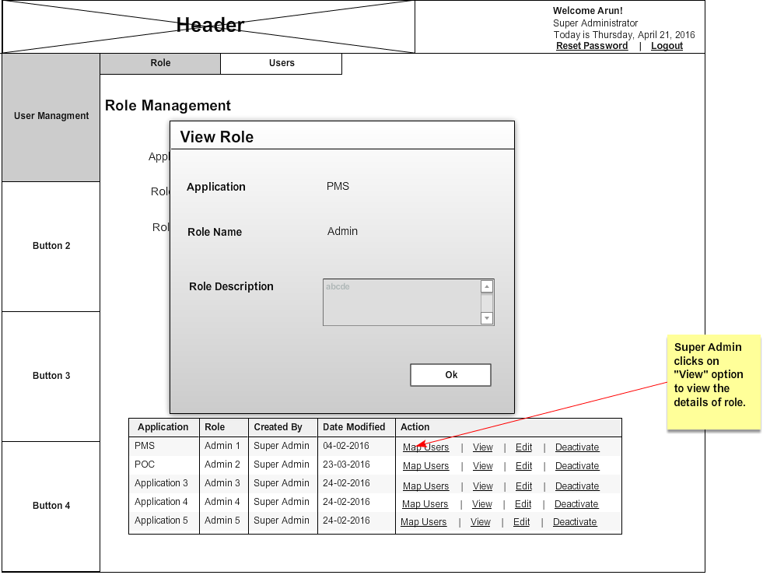

8.0. Super Admin Maps users

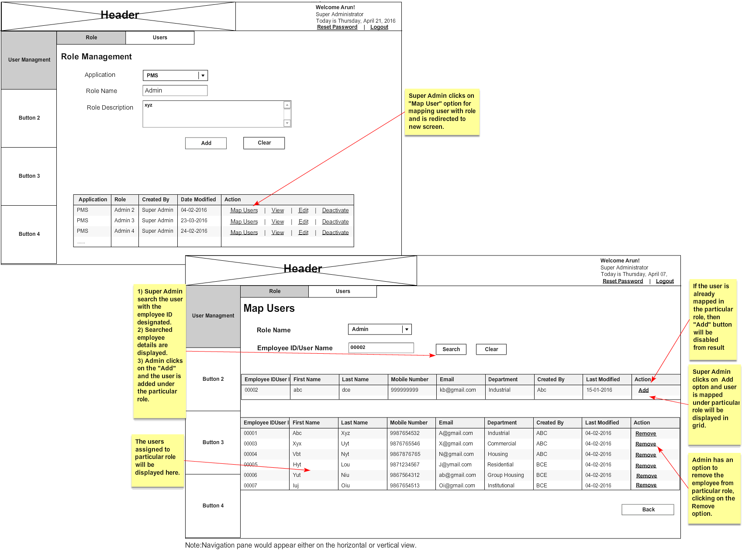

9.0. Super Admin adds users

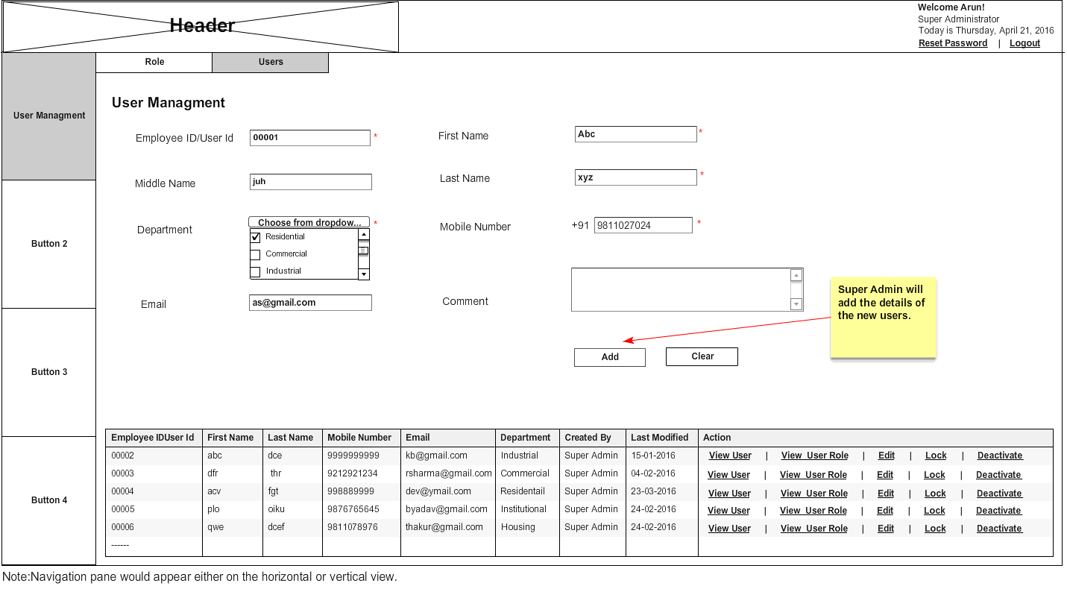

10.0. Super Admin edits users

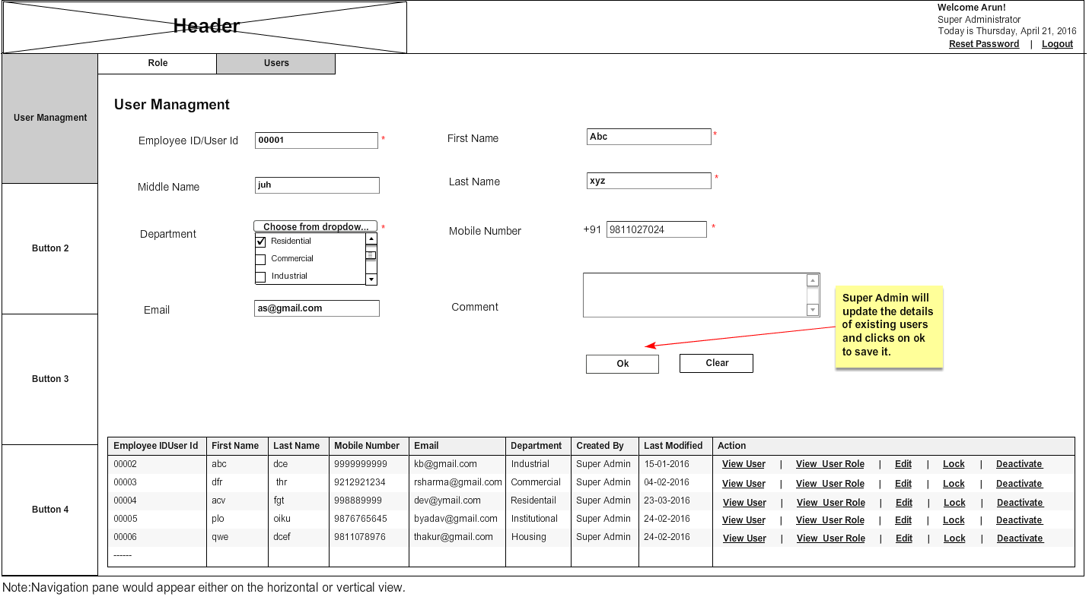

11.0. Super Admin views users

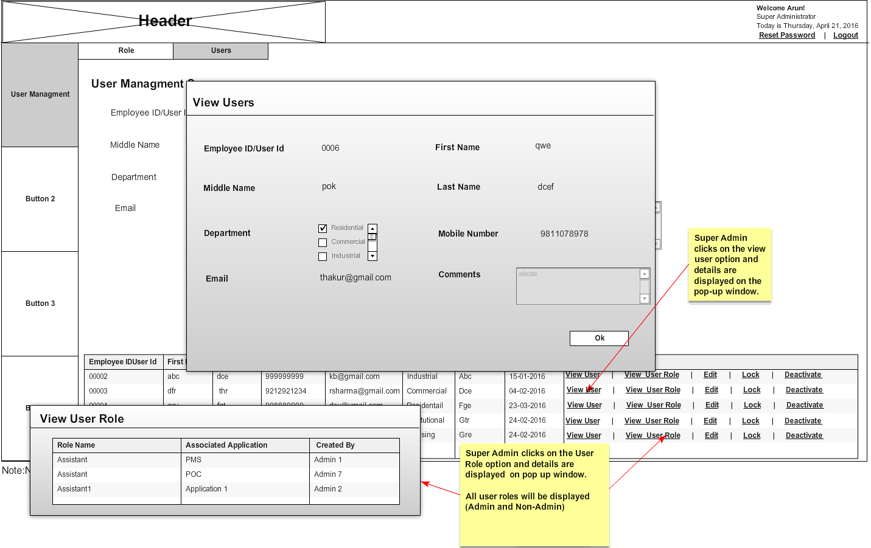

12.0. Super Admin deactivate the role

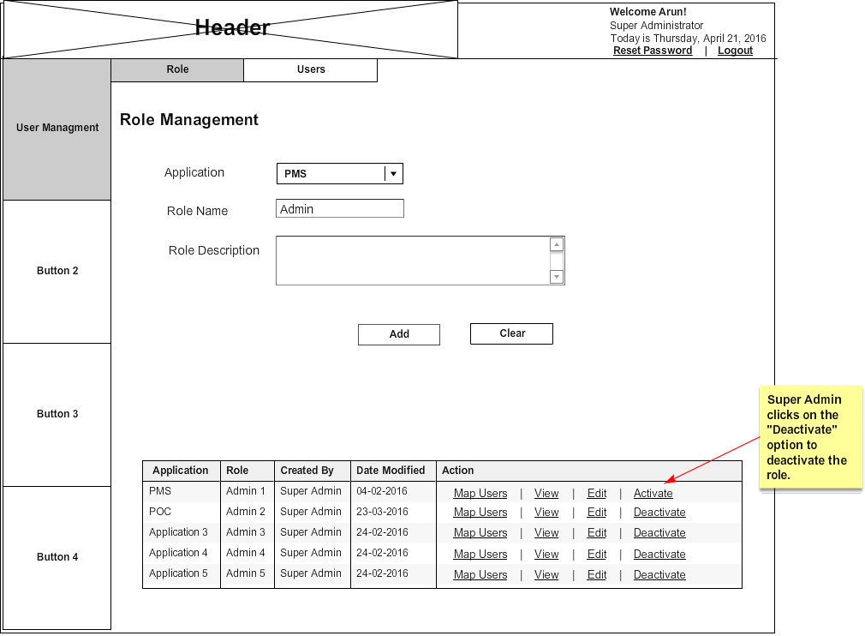

13.0. Super Admin locks user account

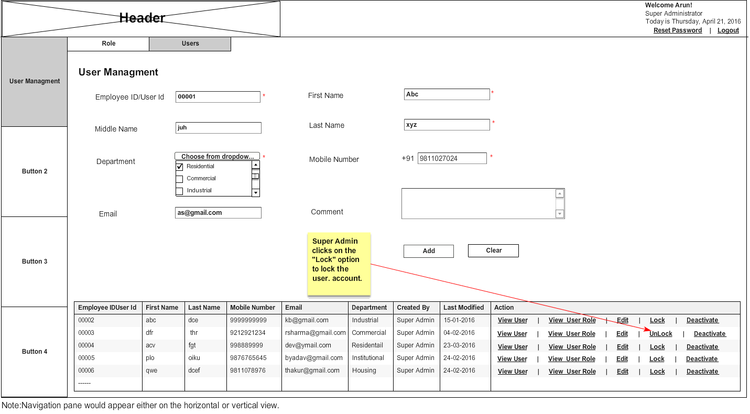

14.0. Super Admin deactivate the user

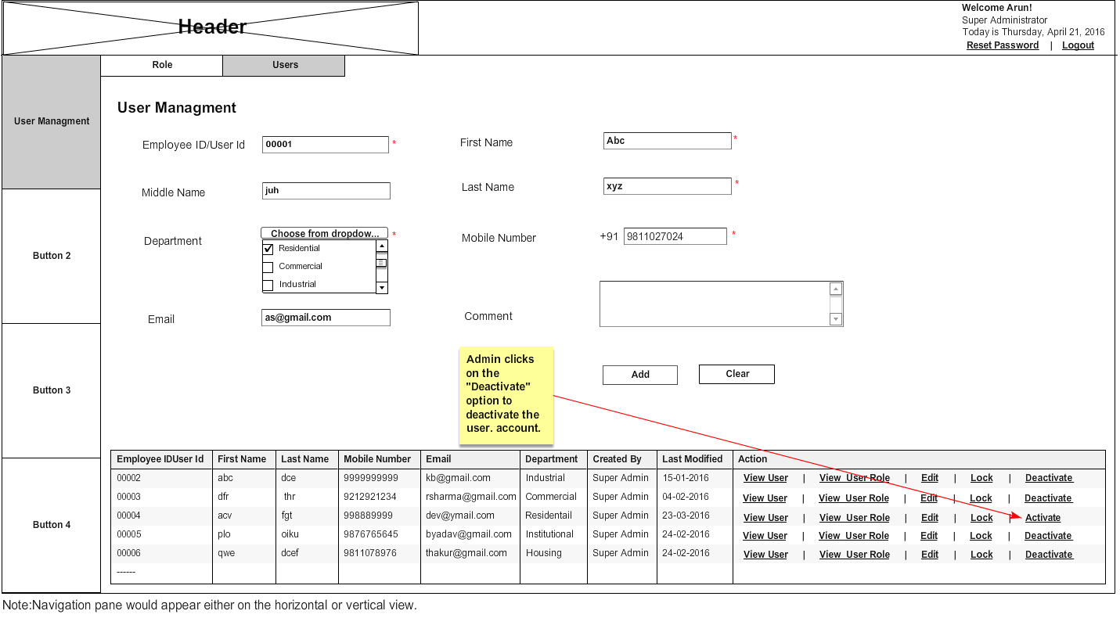

15.0. Admin adds the roles

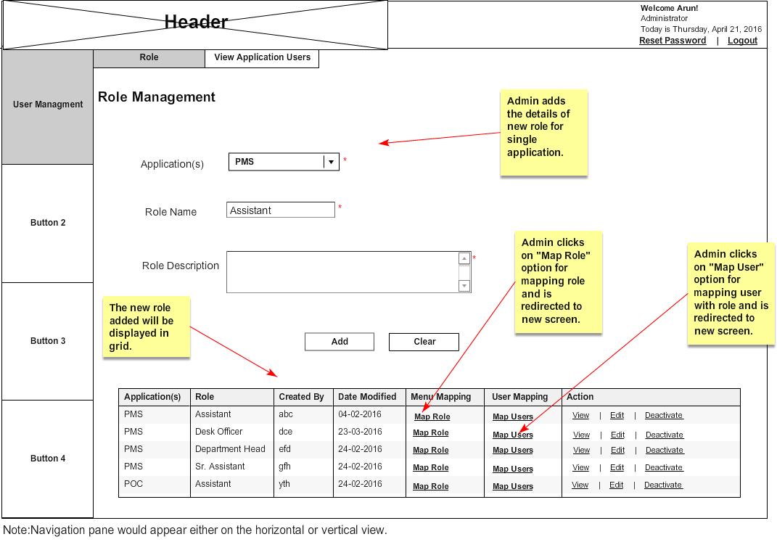

16.0. Admin edits the roles

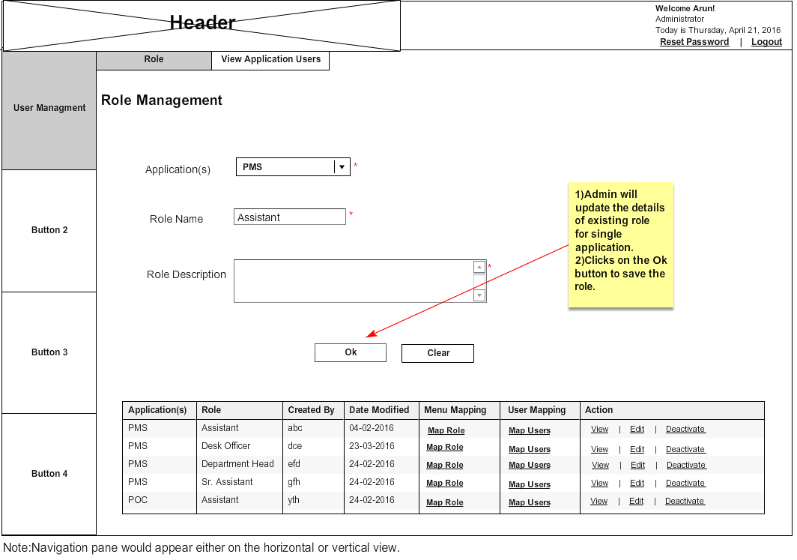

17.0. Admin views the roles

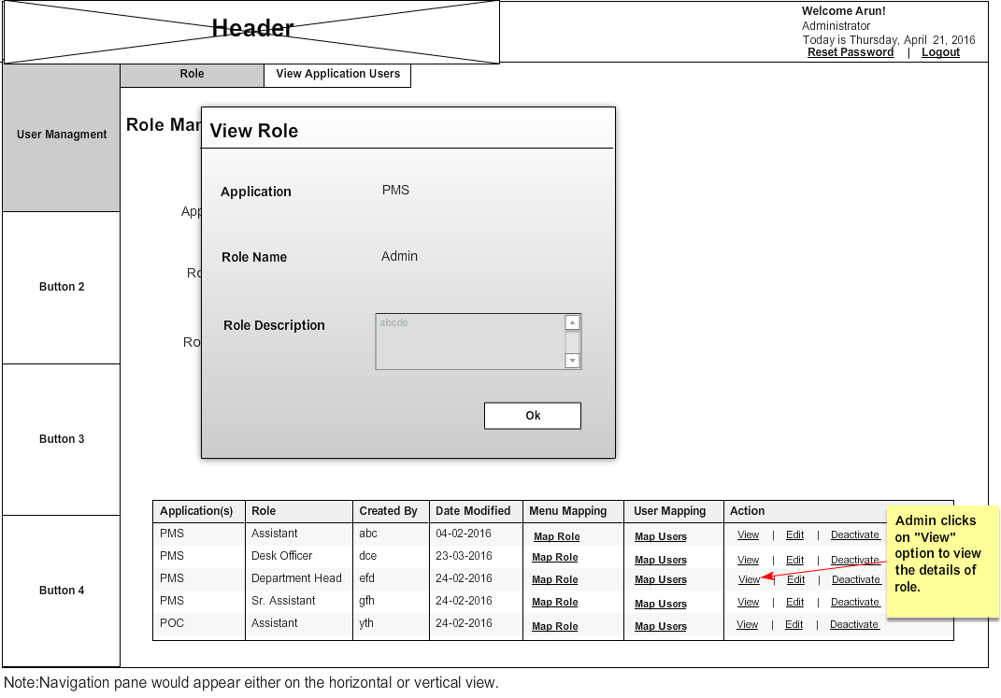

18.0. Admin Maps Menu

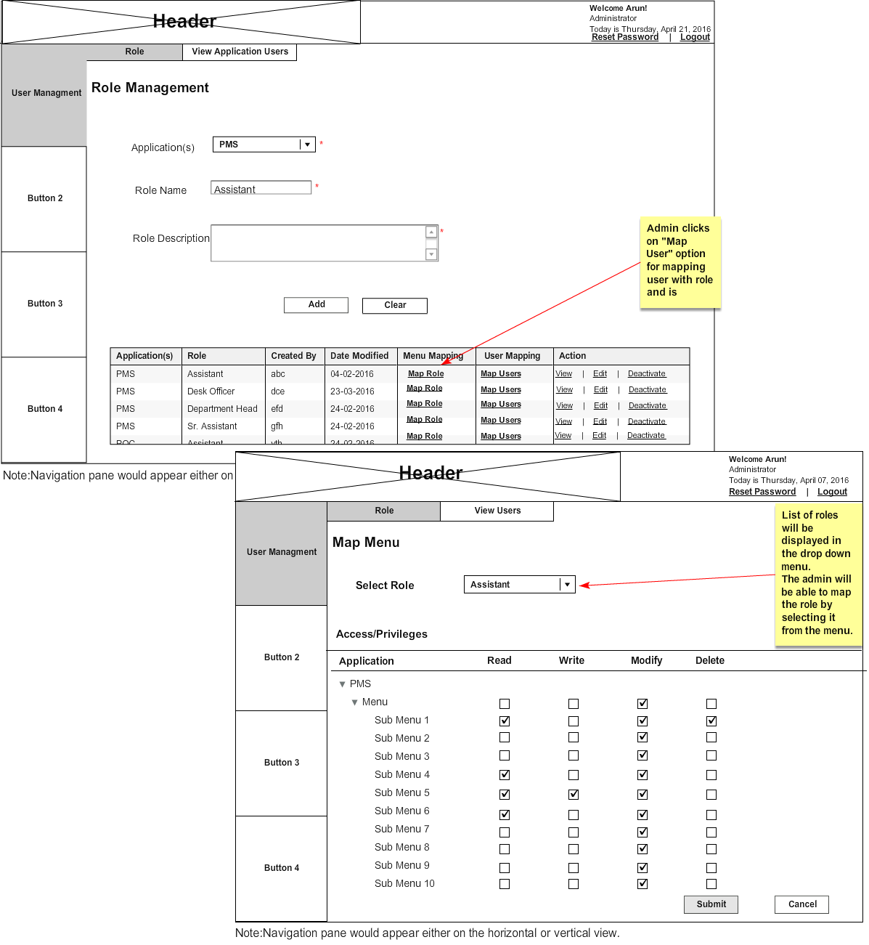

19.0. Admin Maps Users

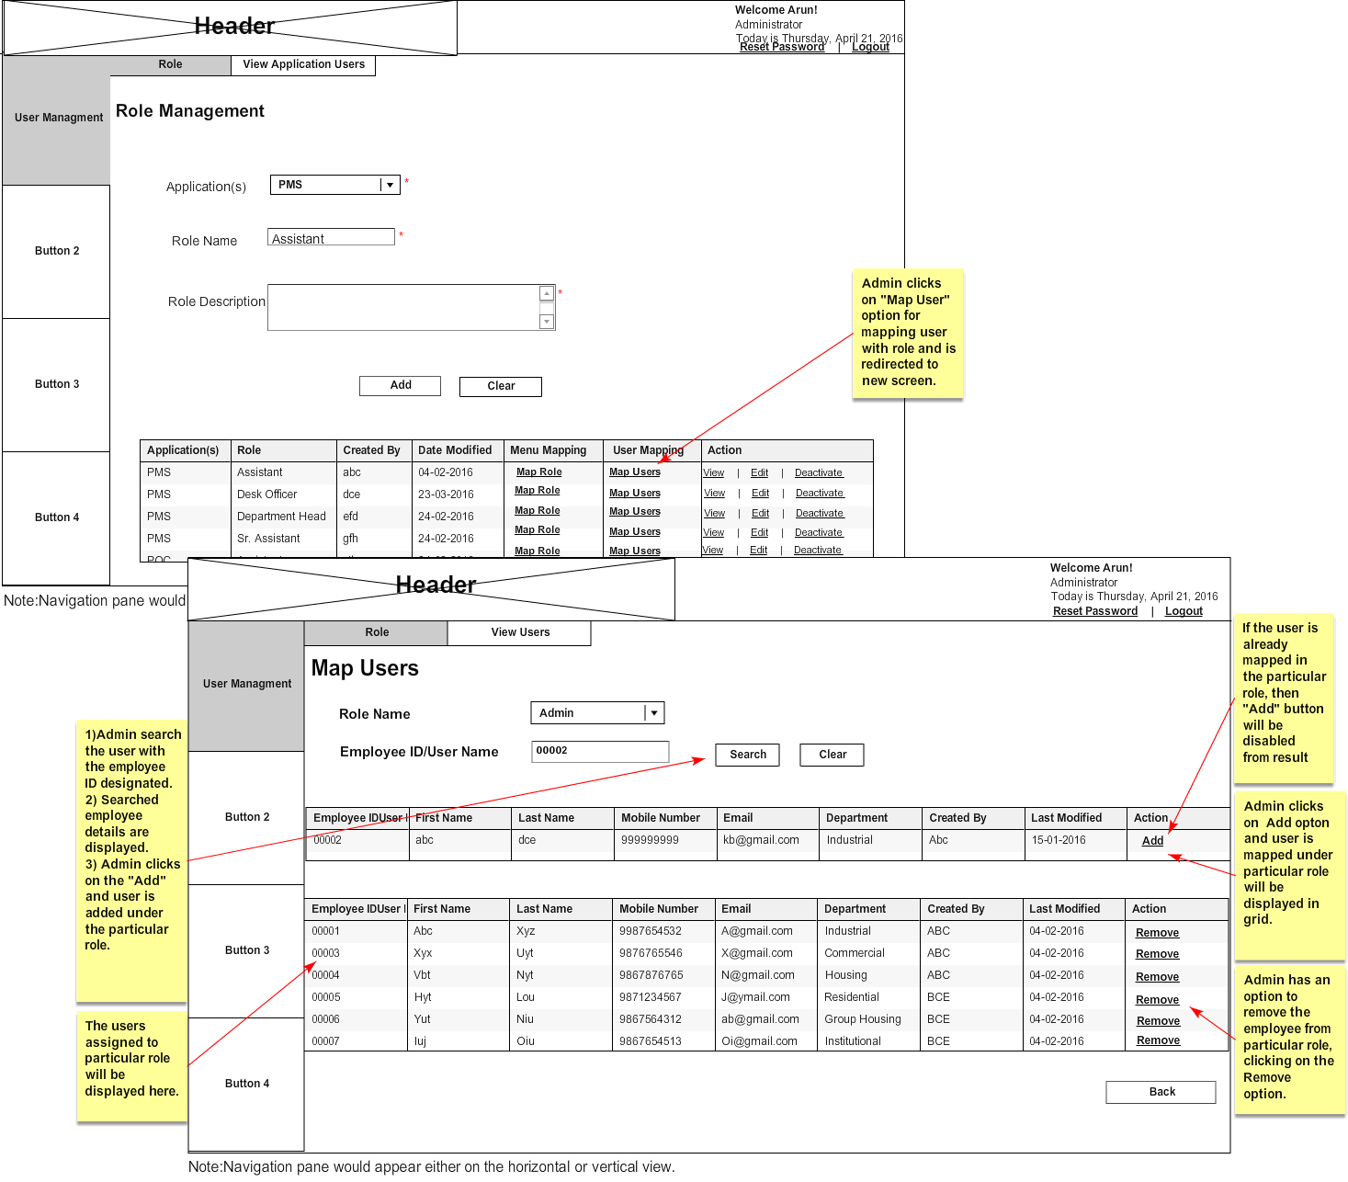

20.0. Admin deactivates role

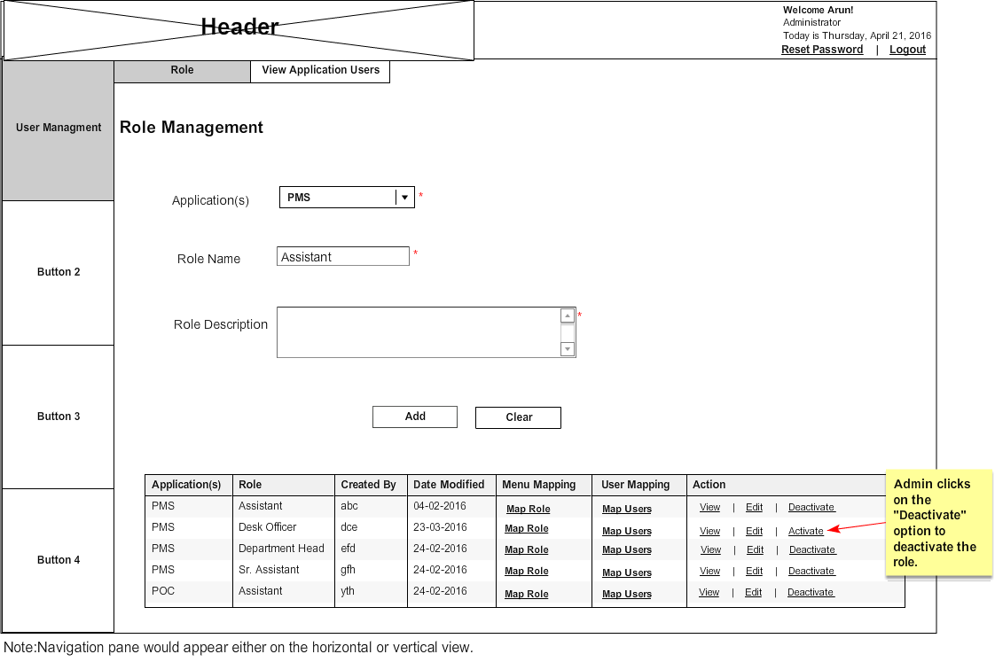

21.0. Admin views application users

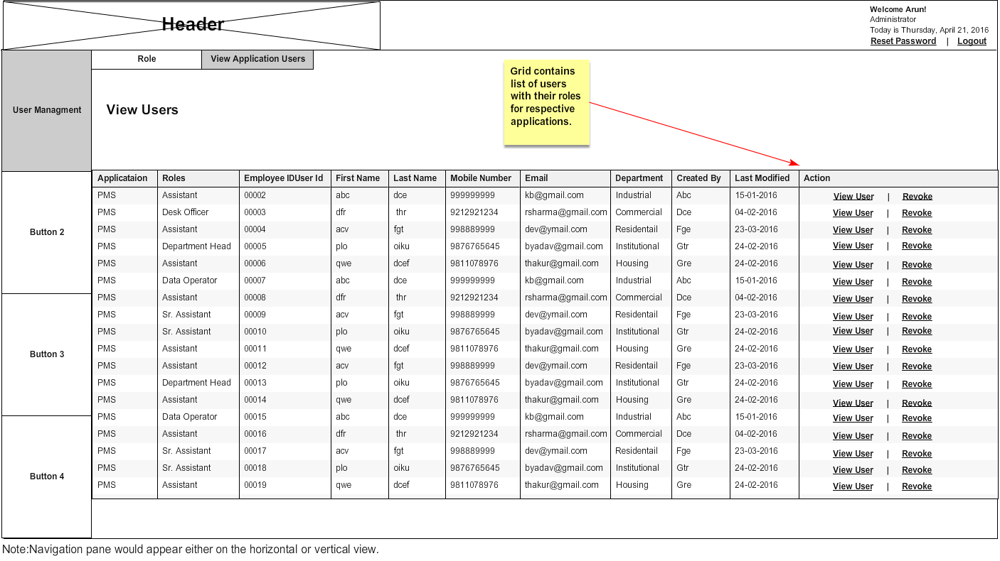

22.0. Admin revokes users

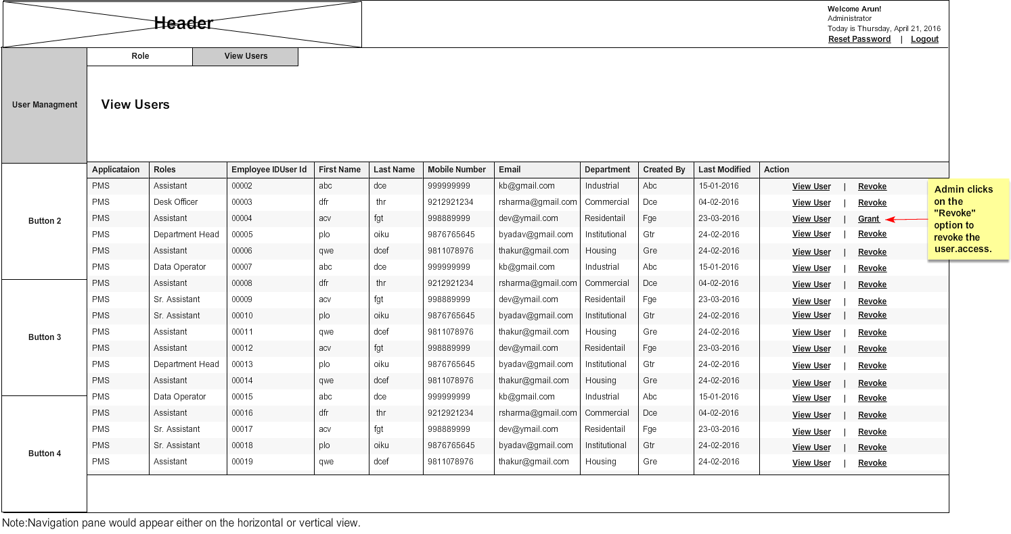

23.0. Admin view users

