- Session variables are may produce Null Reference error
var user = (CurrentUserDetail)Session["CurrentUser"];
_MastersService.SaveNotificationForScheme(notification, user.UserName);
return RedirectToAction("Manage");

flag = _schemeService.AddQuota(quotaDepartmentId, quotaId, value, UnitId, schemeId, ((CurrentUserDetail)Session["CurrentUser"]).UserID);
- Too much If-ELSE statements, can be replaced wiyh SWITCH statement.

MenuMappingAdminController.cs

if (count < 5)
{
if (subMenuDetail[0] == "chkRead")
{
if (subMenuDetail[3] == "IsCheckedTrue")
menuMappingDetail.IsRead = true;
else
menuMappingDetail.IsRead = false;
}
if (subMenuDetail[0] == "chkWrite")
{
if (subMenuDetail[3] == "IsCheckedTrue")
menuMappingDetail.IsWrite = true;
else
menuMappingDetail.IsWrite = false;
}
if (subMenuDetail[0] == "chkModify")
{
if (subMenuDetail[3] == "IsCheckedTrue")
menuMappingDetail.IsModify = true;
else
menuMappingDetail.IsModify = false;
}
if (subMenuDetail[0] == "chkDelete")
{
if (subMenuDetail[3] == "IsCheckedTrue")
menuMappingDetail.IsDelete = true;
else
menuMappingDetail.IsDelete = false;
}
}

- Hardcode values are there at many places. Like the code snippet above.

- Exception handling and logging are not placed at top layers.

- Can be replaced with single call to FirstOrDefault() without Where()
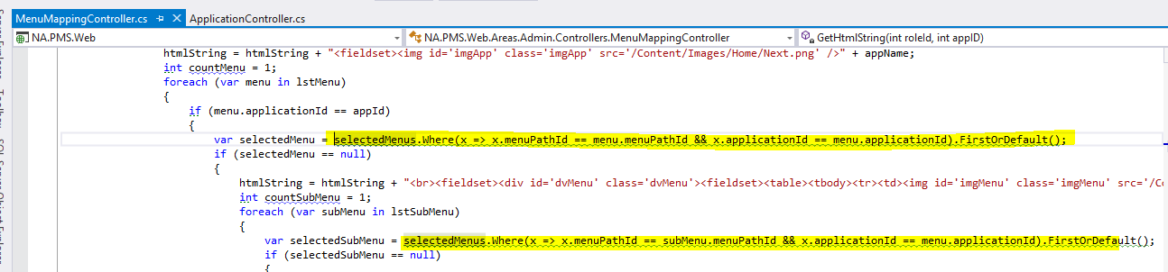
- Name '_ManageUsersService' does not match rule 'Instance fields (private)'. Suggested name is '_manageUsersService'
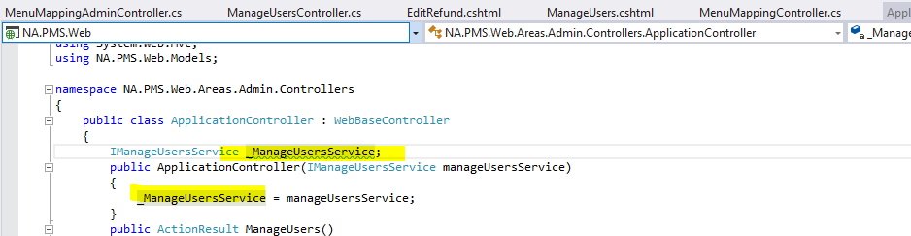
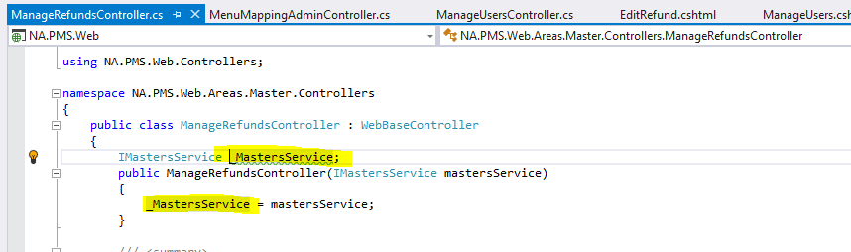
May be at many places.
- Namespace does not correspond to file location, should be: 'NA.PMS.Web.Controllers.Common'
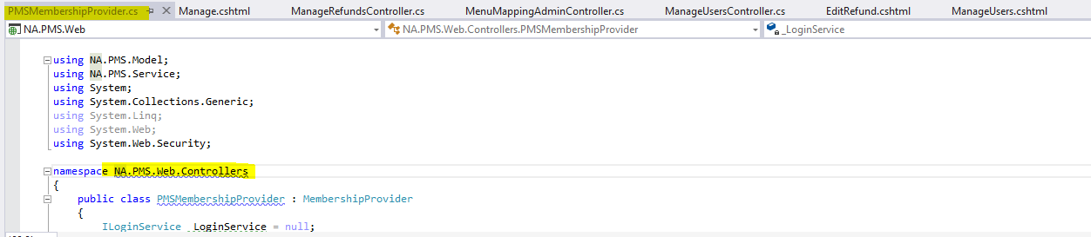

- Possible multiple enumeration of IEnumerable
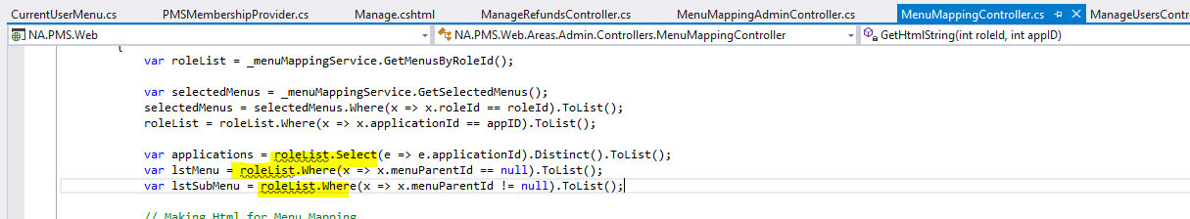
Solution:
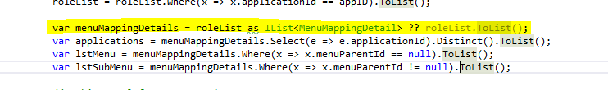
- Possible 'System.NullReferenceException'
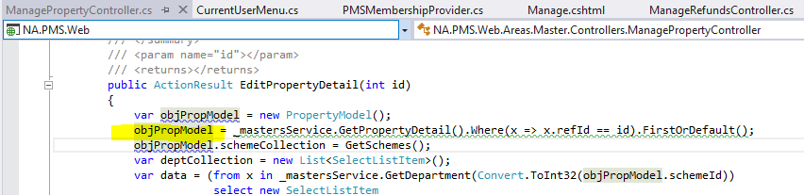
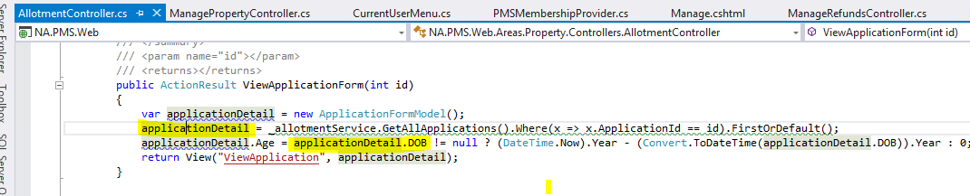
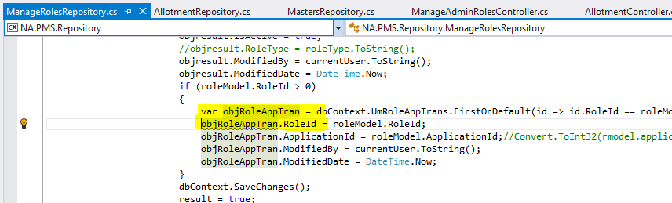
Found at many files.

- Empty object or collection initializer list is redundant
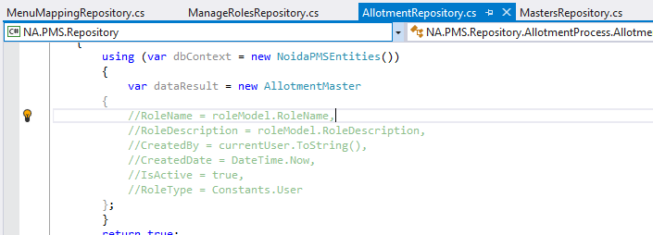
- Destination has the same value before assignment
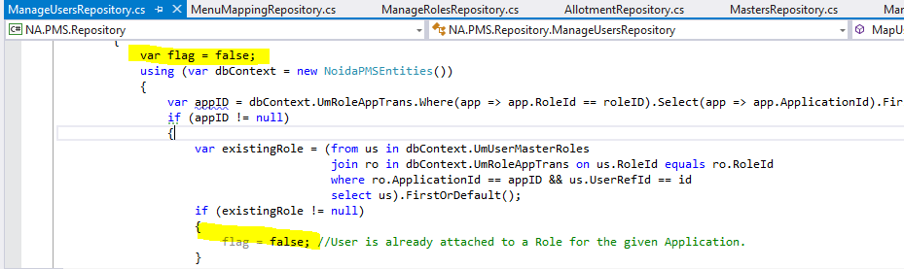
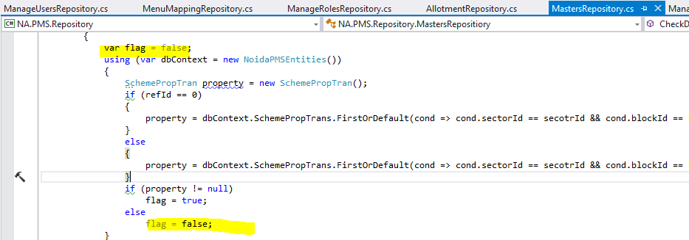
- Not good naming conventions
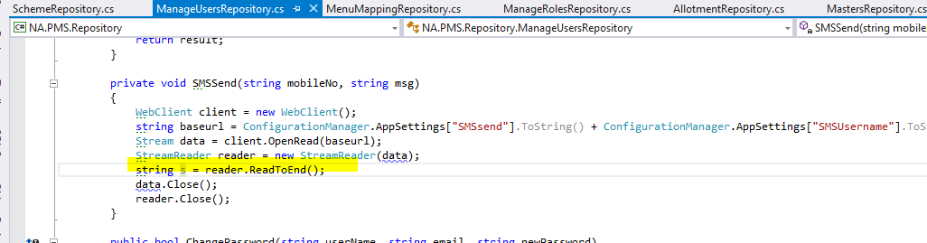
- Dead Code at many places
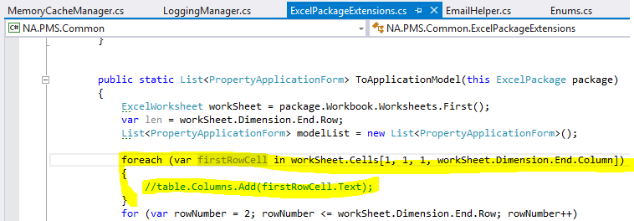
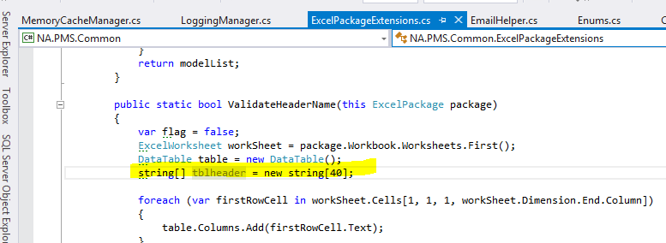

- Using directive is not required by the code and can be safely removed from all .CS files.
