# SMTPClient-CN-Assignment

Name: Sourab Kumar

USN: 1KS16CS101

**Instruction of Execution:**

python smtpclient.py -f randomsourabkumar1997@gmail.com -d s.kumar001997@gmail.com -i trial.txt trial1.txt -s smtp.gmail.com

above is the way to execute the python script from the command line.

**General from:**

python smtpclient.py -f <from email address> -d <recipient-1 email address> <recipient 2 email address>… -I <file1> <file2>.. -s <server IP address>

**Problems faced:**

* Understanding of how SMTP works.
* Java being my comfort zone, I tried experimenting and writing the program in Python just to have feel of real-life application working.
* Not sending of email to random authentic emails with any authentication.
* Confusing login with authentication.

**Resolving the Problems:**

Took a lot of clarity from the teacher on SMTP, went through the study materials too. I wasn’t able to run SMTP locally on my ubuntu OS, couldn’t figure out the reason. Instead of investing time on resolving the issue I found ways to send the email directly through Gmail or Outlook servers. While using these servers you need to authentic your existence by passing your email and password as parameters for method called login() in smtplib.   
Once the authentication is successful. The email gets sent to the given email addresses.

**Results:**

**Command Line:**

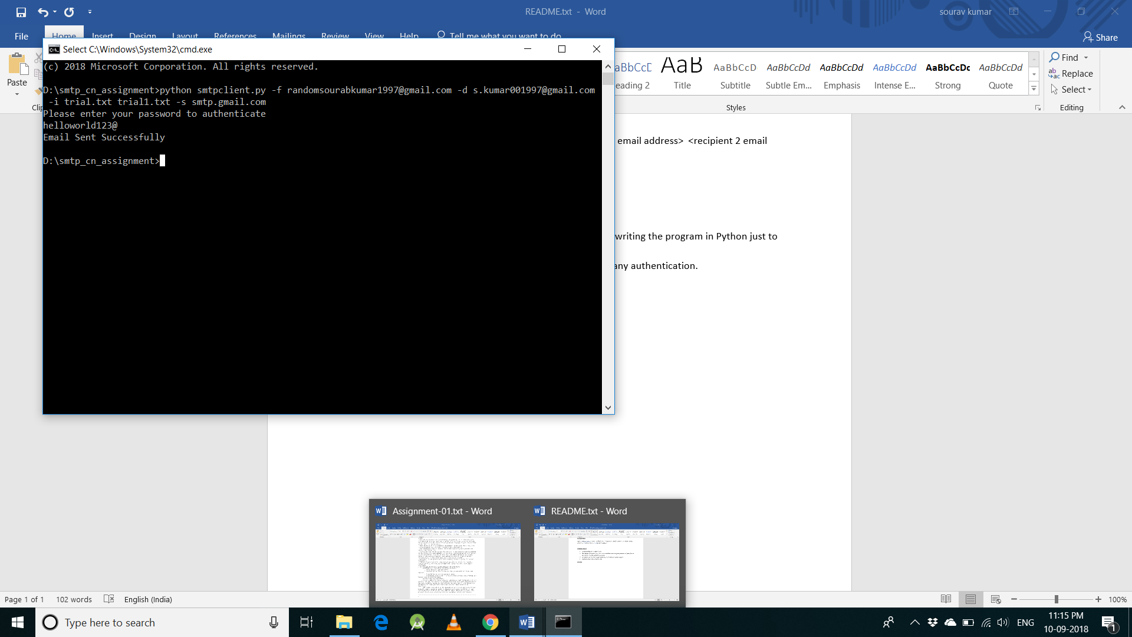

**Trial.txt**

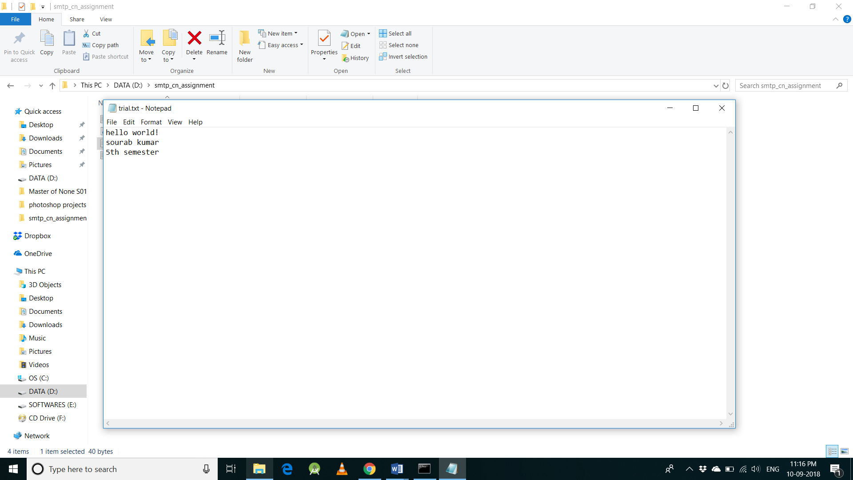

**Trial1.txt**

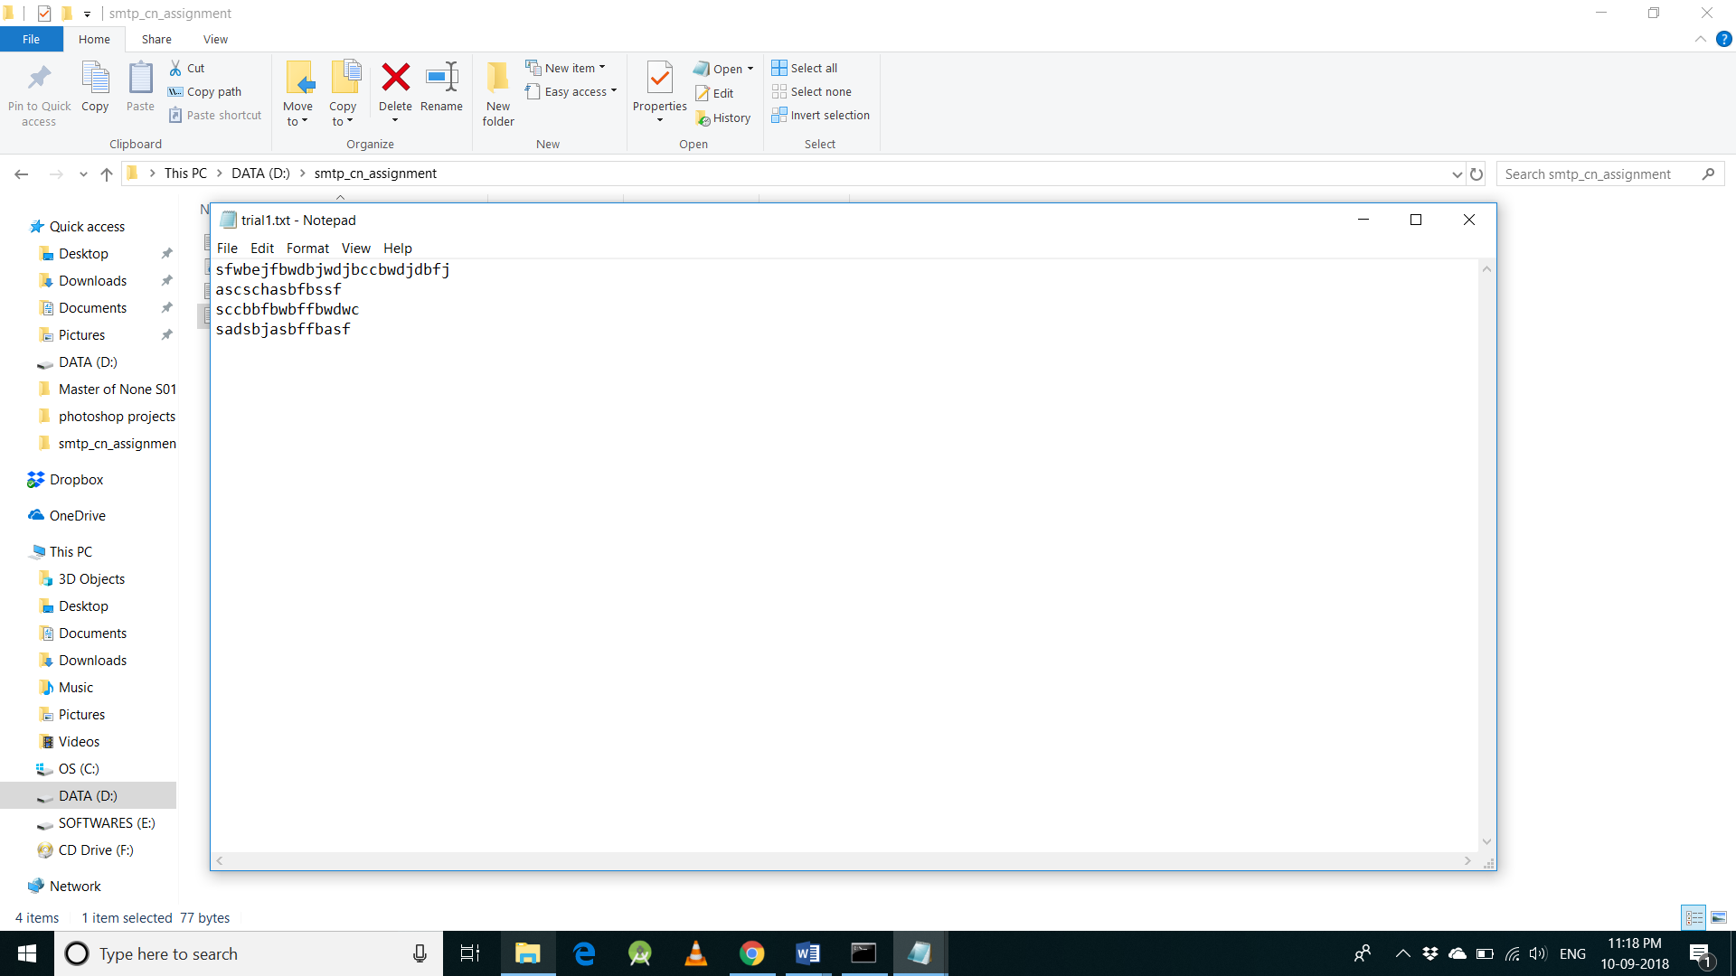

**Received E-mail**

