Project SetUp

Architecture :

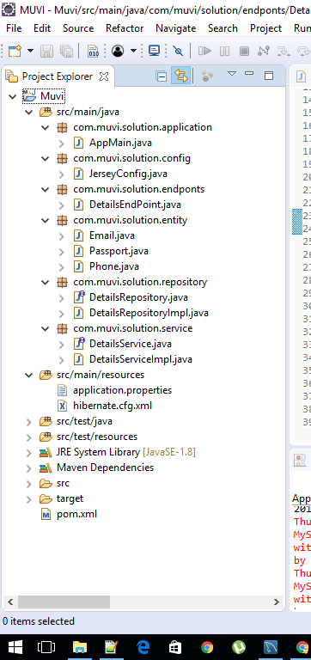

*Steps:*

*Created a maven project .added dependencies in pom.xml*

*Sample url for accessing the endpoint*

[*http://localhost:8080/muvi/details/add?email=aaaa&phone=123&passport=aaa*](http://localhost:8080/muvi/details/add?email=aaaa&phone=123&passport=aaa)

*Please find project source code on git*

[*https://github.com/skumar1901/Muvi-Project.git*](https://github.com/skumar1901/Muvi-Project.git)

*asynchronous call handling is implemented in* DetailsRepositoryImpl

