Sarthak Kumar

022-265-144

DBS301

Prof. Tanvir Alam

CREATE TABLES Question

DIVISION

|  |  |  |
| --- | --- | --- |
| **Column Name** | DIVISION_ID | DIVISION_NAME |
| **Key Type** | **PK** |  |
| **Null/Unique** |  | **NN, U** |
| **FK Table** |  |  |
| **FK Column** |  |  |
| **Validation** |  |  |
| **Datatype** | **NUMBER** | **VARCHAR** |
| **Length** | **3** | **25** |
| **Sample data** |  |  |
|  | **10** | **East Coast** |
|  | **20** | **Quebec** |
|  | **30** | **Ontario** |

WAREHOUSE

|  |  |  |  |  |  |
| --- | --- | --- | --- | --- | --- |
| **Column Name** | WAREHOUSE_ID | CITY | RATING | FOUND_DATE | DIVISION_ID |
| **Key Type** | **PK** |  | **CK** |  | **FK** |
| **Null/Unique** |  | **NN, U** |  | **NN** | **NN** |
| **FK Table** |  |  |  |  | **DIVISION** |
| **FK Column** |  |  |  |  | **DIVISION_ID** |
| **Validation** |  |  | **A, B, C, D** |  |  |
| **Datatype** | **NUMBER** | **VARCHAR** | **CHAR** | **DATE** | **NUMBER** |
| **Length** | **3** | **15** | **1** |  | **3** |
| **Sample Data** | **1** | **Montreal** | **A** | **SYSDATE()** | **10** |
|  | **7** | **Fredericton** | **B** |  | **10** |
|  | **10** | **Toronto** | **A** |  | **30** |

SECTION

|  |  |  |  |  |
| --- | --- | --- | --- | --- |
| **Column Name** | WAREHOUSE_ID | SECTION_ID | DESCRIPTION | CAPACITY |
| **Key Type** | **PK, FK** | **PK** |  |  |
| **Null/Unique** |  |  | **NN** |  |
| **FK Table** | **WAREHOUSE** |  |  |  |
| **FK Column** | **WAREHOUSE_ID** |  |  |  |
| **Datatype** | **NUMBER** | **NUMBER** | **VARCHAR** | **NUMBER** |
| **Length** | **3** | **2** | **50** | **8** |

1 Write the required SQL statements to create tables WAREHOUSE, DIVISION and SECTION.

Follow these general rules in the process:

A. Create all CHECK (incl. NOT NULL) and UNIQUE as column level constraints

Constraint names needed for CHECK constraints. The other constraints (NN and UK) do not need a name.

B. Create all PK and FK constraints at the table level and give them proper names.

PUT ANSWERS starting here

**CREATE TABLE DIVISION(**

**DIVISION_ID NUMBER(3),**

**DIVISION_NAME VARCHAR(25) NOT NULL UNIQUE,**

**CONSTRAINT DIV_DIVISION_ID_PK**

**PRIMARY KEY(DIVISION_ID)**

**);**

**CREATE TABLE WAREHOUSE(**

**WAREHOUSE_ID NUMBER(3),**

**CITY VARCHAR(15) NOT NULL UNIQUE,**

**RATING CHAR(1)**

**CONSTRAINT WHR_RATING_CHK CHECK(RATING IN ('A','B','C','D')),**

**FOUND_DATE DATE NOT NULL,**

**DIVISION_ID NUMBER(3) NOT NULL,**

**CONSTRAINT WHR_WAREHOUSE_ID_PK**

**PRIMARY KEY(WAREHOUSE_ID),**

**CONSTRAINT WHR_DIVISION_ID_FK**

**FOREIGN KEY(DIVISION_ID)**

**REFERENCES DIVISION(DIVISION_ID)**

**);**

**CREATE TABLE SECTION(**

**WAREHOUSE_ID NUMBER(3),**

**SECTION_ID NUMBER(2),**

**DESCRIPTION VARCHAR(50) NOT NULL,**

**CAPACITY NUMBER(8),**

**CONSTRAINT SECT_WAREHOUSE_ID_FK**

**FOREIGN KEY(WAREHOUSE_ID)**

**REFERENCES WAREHOUSE(WAREHOUSE_ID),**

**CONSTRAINT SECT_COMPOSITE_PK**

**PRIMARY KEY(WAREHOUSE_ID, SECTION_ID)**

**);**

**2** After creating all tables add column MGR_ID to table SECTION as a FK column, that is related to the PK column EMPLOYEE_ID in table EMPLOYEE

**ALTER TABLE SECTION**

**ADD MGR_ID NUMBER(6)**

**CONSTRAINT SECTION_MGR_ID_FK**

**REFERENCES EMPLOYEES(EMPLOYEE_ID);**

3 Modify the CHECK constraint on column RATING in table WAREHOUSE, so that it also may accept a new value F.

**ALTER TABLE WAREHOUSE**

**DROP CONSTRAINT WHR_RATING_CHECK;**

**ALTER TABLE WAREHOUSE**

**ADD CONSTRAINT WHR_RATING_CHECK**

**CHECK(RATING IN ('A','B','C','D','F'));**

4 Create a new **Sequence** called **Whse_id_seq** that will generate unique numbers for PK values in table WAREHOUSE, so that the numbers start at 410 with the step of 10 and upper limit is 700 and will have NO values stored in the memory.

**CREATE SEQUENCE WHSE_ID_SEQ**

**INCREMENT BY 10**

**START WITH 410**

**MAXVALUE 700**

**NOCYCLE**

**NOCACHE;**

5 Add new row to table WAREHOUSE by using this sequence for a city in Atlanta with unknown rating. You will assume today’s date as a foundation date. You cannot enter a specific date.

**Insert record to DIVISION first as DIVISION_ID is FK of WAREHOUSE.

**INSERT INTO DIVISION VALUES(10,'Europe');**

**Rating is with CHECK constraint. It does not accept unknown rating.

**INSERT INTO WAREHOUSE (WAREHOUSE_ID, CITY, RATING, FOUND_DATE,DIVISION_ID)**

**VALUES(WHSE_ID_SEQ.NEXTVAL,'Atlanta','A',SYSDATE,10);**

6 Create table CITIES **from table LOCATIONS,** but only for location numbers less than 2000 (do NOT create this table from scratch). 🡪 You will have 5 to 18 rows

**CREATE TABLE CITIES AS**

**(SELECT * FROM LOCATIONS WHERE LOCATION_ID < 2000);**

7 Issue command to show the structure of the table CITIES

**DESCRIBE CITIES;**

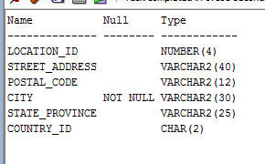

8 Issue the SELECT command on cities and show result here.

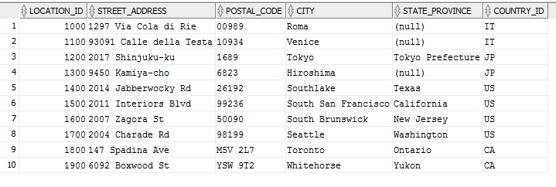

9 Create a View called **WhsSec_Man_vu** that will display for each Warehouse_id and Section_id, the City, Division and manager’s Last_name. Alias for Last_name should be LName and for Division should be Group.

**CREATE VIEW WHSSEC_MAN_VU AS(**

**SELECT WAREHOUSE_ID,**

**SECTION_ID,**

**CITY,**

**DIVISION_NAME AS "GROUP",**

**LAST_NAME AS "LName"**

**FROM WAREHOUSE JOIN SECTION USING(WAREHOUSE_ID)**

**JOIN DIVISION USING(DIVISION_ID)**

**JOIN EMPLOYEES**

**ON MGR_ID = EMPLOYEE_ID**

**);**

10 What is the SELECT command to issue if in 2 months I want to test if a view was actually was created

**SELECT VIEW_NAME FROM USER_VIEWS;**

11 If you want to modify the view what is the first line of the command

**CREATE OR REPLACE VIEW WHSSEC_MAN_VU AS (**

12 Issue a SET operator to show the rows that were in LOCATIONS but not in CITIES

**SELECT * FROM LOCATIONS**

**MINUS**

**SELECT * FROM CITIES;**

Using the following diagram as a hint and not a perfect representation.

Answer 13, 13, 15 and 16

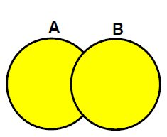

13 All the rows in A and all the rows in B with no duplicates is the set operator called [**UNION**]

14 All the rows in A and all the rows in B with duplicates [**UNION ALL**]

15 The rows in common to BOTH A and B tables [**INTERSECT**]

16 Rows that are in A but not in B would use the word [**MINUS**]