Lab links

https://acloud.guru/course/event-driven-security/dashboard

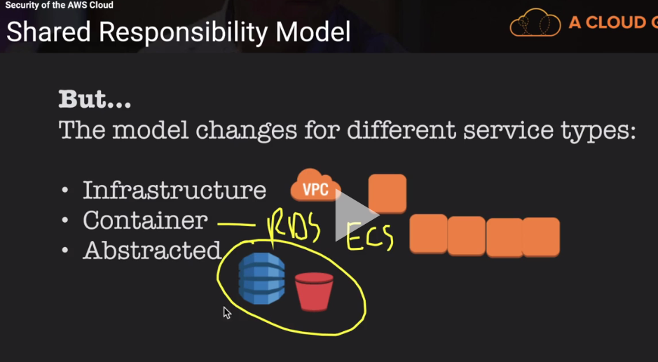

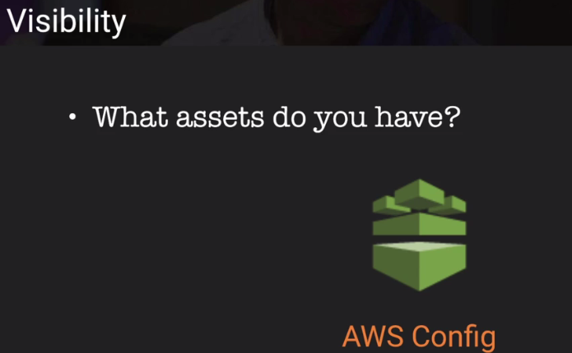

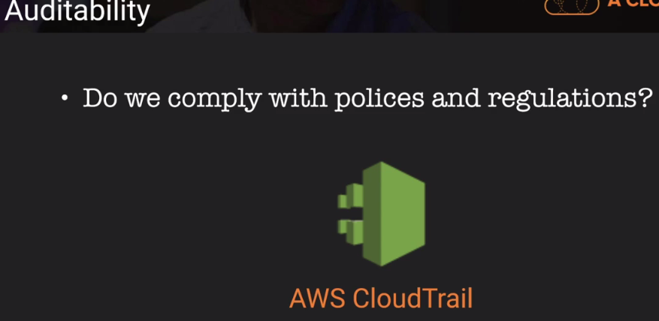

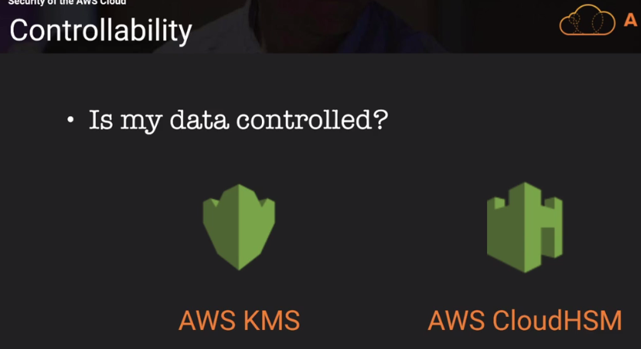

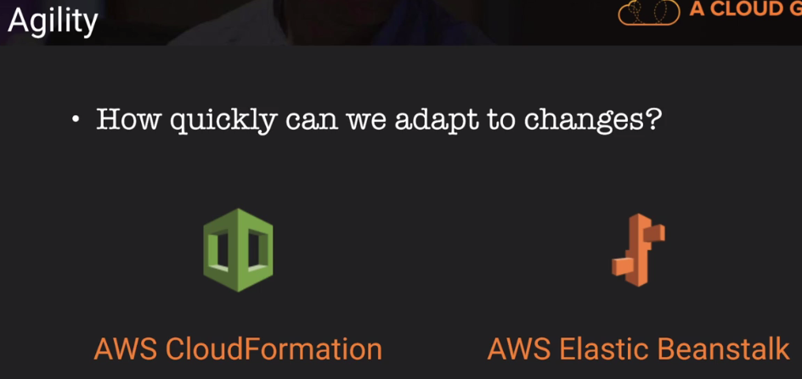

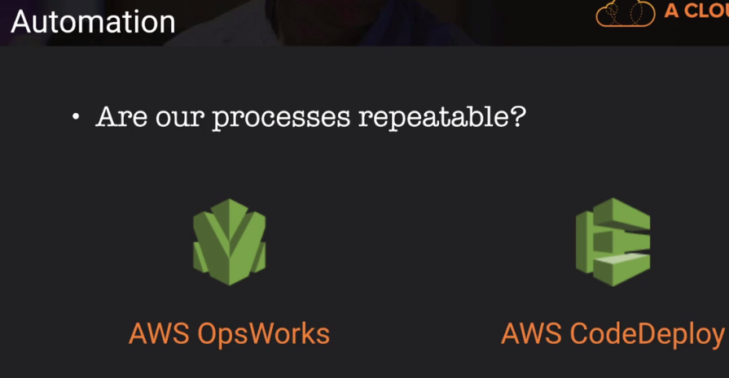

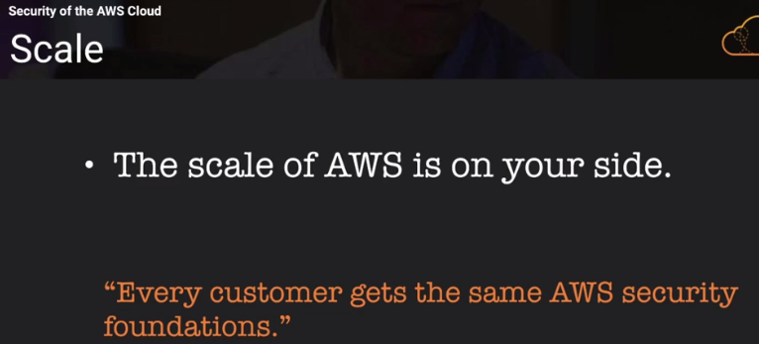

Global API call 🡪 IAM

API call 🡪 Calling S3, Dynamo DB

Ssh/RDS to ec2 instnace is not an API call, CloudTrials logs API call activity

Digest file with CloudTrail is used to check who deleted or modify logs files

CloudTrail 🡪 I am auditable

CloudWatch 🡪I am Visibility 🡪 to check what happening in your account. CloudWatch uses custom logs or logs from CloudTrail

AWS Config 🡪

What is going on in ur AWS account and AWS config record in S3

0120-4188952

