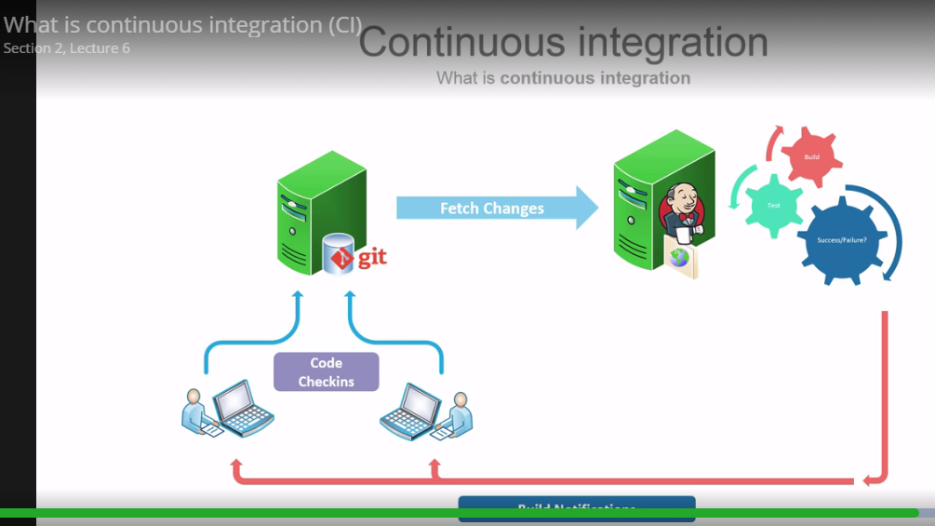

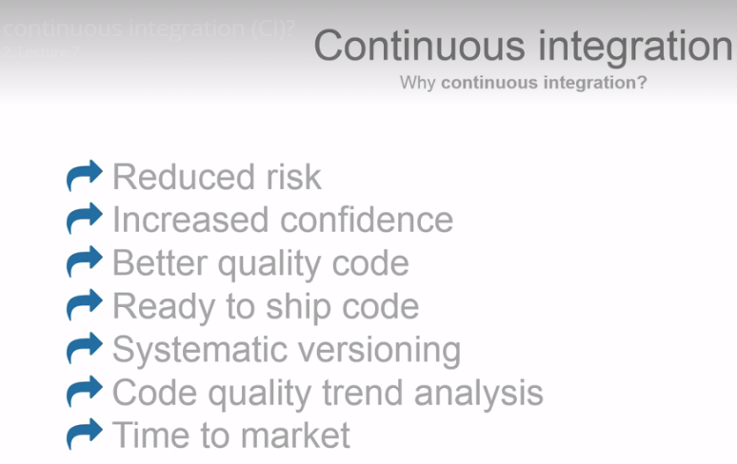

Jenkins is as CI framework











CI-Server 🡪 continuous Integrity

It is server which clone the repository from github and build (compile) the code also execute the use cases and send notification to developer if anything fails in code.

We can use CI server to test code in various environments like windows, Linux, Solaris and MAC at the same time

CIS server can be used to generate the report

CI Server can track metrics like line coverage means how many line of code covered by test

CI Server i.e Jenkins server can deploy code to staging server a env like prod

Mven is a build tool

**All files used in this series can be obtained from the following GitHub Gist:**  
  
<https://gist.github.com/jsuwo/9038610>  
  
Part 1: Introduction to Continuous Integration  
<http://youtu.be/1JSOGJQAhtE>  
  
Part 2: Setting Up an Amazon EC2 Instance  
<http://youtu.be/zojMg2c6k3Q>  
  
Part 3: Configuring Jenkins  
<http://youtu.be/0ZS2BL5R3Ow>  
  
Part 4: Creating a Jenkins Maven 2/3 Project  
<http://youtu.be/SRAQzs41ct4>  
  
Part 5: Configuring a GitHub Web Hook and Setting Up JaCoCo Code Coverage Reports  
<http://youtu.be/IZ99VwrF6t4>

**===================Inatallation of Jenkins==============**

https://www.youtube.com/watch?v=1JSOGJQAhtE

1. installing jenkins on EC2 instance

2. Install java

apt-get install openjdk-7-jre

3. Install Jenkins

wget -q -O - http://pkg.jenkins-ci.org/debian/jenkins-ci.org.key | sudo apt-key add -

sudo sh -c 'echo deb http://pkg.jenkins-ci.org/debian binary/ > /etc/apt/sources.list.d/jenkins.list'

sudo apt-get update

sudo apt-get install jenkins

4.Installing Apache

sudo apt-get install apache2

sudo a2enmod proxy

sudo a2enmod proxy_http

5. Change jenkins.conf file to proxy from 80 to 8080 port

/etc/apache2/sites-available/jenkins.conf

<VirtualHost *:80>

ServerName HOSTNAME

ProxyRequests Off

<Proxy *>

Order deny,allow

Allow from all

</Proxy>

ProxyPreserveHost on

ProxyPass / http://localhost:8080/

</VirtualHost>

6. Enable Jenkins.config

sudo a2ensite jenkins

sudo service apache2 reload

7.Installing Java / Maven / Git

sudo add-apt-repository ppa:webupd8team/java

sudo apt-get update

sudo apt-get install oracle-java7-installer maven git-core

Apache Maven 3.0.5

Maven home: /usr/share/maven

Java version: 1.7.0_80, vendor: Oracle Corporation

Java home: /usr/lib/jvm/java-7-oracle/jre

Default locale: en_US, platform encoding: UTF-8

OS name: "linux", version: "3.13.0-91-generic", arch: "amd64", family: "unix"

sanjeev-->user

sanjeev-->password