PROJECT REPORT

SOFTWARE INSTALLATION REQUEST
using ServiceNow

Final Project Documentation

Project information | Details
Project name | Software Installation Request - ServiceNow
Participant | Individual participant - 323103312149@gvpce.ac.in
Report date | 13 October 2026
Platform | ServiceNow: Service Catalog, Flow Designer, Service Portal
Repository | https://github.com/skumarpasala/Software-Installation-Request--ServiceNow

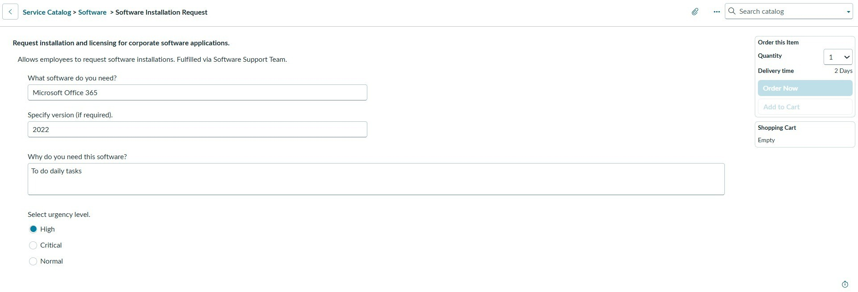

CONTENTS
- Introduction 3
  - Project Overview 3
  - Purpose 3
- Ideation Phase 4
  - Problem Statement 4
  - Empathy Map Canvas 4
  - Brainstorming 5
- Requirement Analysis 5
  - Customer Journey Map 5
  - Solution Requirements 6
  - Data Flow Diagram 7
  - Technology Stack 8
- Project Design 9
  - Problem-Solution Fit 9
  - Proposed Solution 10
  - Solution Architecture 10
- Project Planning and Scheduling 11
  - Project Planning 11
- Functional and Performance Testing 12
  - Performance Testing 13
- Results 13
  - Output Screenshots 13
- Advantages and Disadvantages 16
- Conclusion 16
- Future Scope 16
- Appendix 17
- Source Code (Configuration Artifact) 17
- Dataset Link 17
- GitHub and Project Demo Link 17
- Glossary 18

- Introduction

Project Overview
Licensed software is part of everyday work, but a request for it is rarely just an installation. Someone has to confirm which product and version is needed, why it is needed, how urgent it is, and who is authorised to approve it. When these details travel through email and chat, they are easily lost, approvals are hard to find afterwards, and the requester cannot tell where the request stands.
This project implements that process on ServiceNow. Employees raise a request through a Service Catalog item, Software Installation Request (internally named Licensed Software Request), which collects the software name, version, justification and urgency. A Flow Designer flow is triggered by the catalog item. It asks for approval on the Requested Item, emails the requester, and creates a Catalog Task for the Software Support Team. Each step is held in standard ServiceNow records (REQ, RITM, approval, SCTASK), so a request can be traced from submission to completion.
The work is configuration rather than application code. It is packaged as the update set
Software_Installation_Request_v1 and documented across five phases in the project repository.

Item | Detail
Catalog item | Software Installation Request (XML name: Licensed Software Request), category Software
Variables | software_name, Version_Required, License_Justification, Urgency; also request_type, software_application, business_justification, device_asset_tag
Request types | New License Assignment; Reinstall / Existing License
Automation | Flow Designer flow with Service Catalog trigger: approval, catalog-variable lookup, email notifications, Catalog Task creation
Fulfillment | Catalog Task for the Software Support Team
Packaging | Update set Software_Installation_Request_v1 (sys_remote_update_set_c73bf55a3b7b83102c85920f23e45a0c.xml)

Purpose
This report documents the project from problem definition through design, build, testing and results. It separates what the repository demonstrates (screenshots, flow configuration, update-set metadata, one live request record) from behaviour that still needs formal acceptance testing.

Project objectives
    - Give employees one guided catalog entry point for software installation and licence requests.
    - Capture software, version, justification, urgency, request type and device details in a consistent form.
    - Record a manager approval decision against each Requested Item.
    - Create the fulfillment task only for approved requests, so rejected requests never reach the installation queue.
    - Keep request, approval and task records linked for traceability.
    - Package the configuration in an update set that can be reviewed and moved between compatible instances.

- Ideation Phase

Problem Statement

How might we let employees request licensed software in one consistent way, so that requests arrive complete, approvals are recorded, and approved work reaches the support team as a trackable task?
The project tackles the process problem, not the act of installing software. Its value lies in structuring the request, recording the decision and connecting approved requests to fulfillment work.

Stakeholder | Problem today | Desired outcome
Employee / requester | Unsure what information to give or how to check progress. | A guided form and a visible request status.
Manager / approver | Lacks context to judge whether the request is justified. | Clear justification and a recorded approve or reject decision.
Software support team | Receives incomplete requests and must ask for clarification. | A linked Catalog Task with the request details and an owner.
ServiceNow administrator | Needs configuration that is easy to maintain and move. | Reusable variables, flow logic and update-set packaging.

Empathy Map Canvas
The map describes the likely experience of the requester and what each point means for the design. It is a design aid based on the project scope, not interview data.

Dimension | Requester perspective | Design response
Says | "I need this software for a specific task." "How long will approval take?" | One discoverable catalog entry point with a clear title.
Thinks | "Did I give enough detail?" "Is a licence already available?" | Field help text and examples on the form.
Does | Searches the catalog, submits details, checks status, answers follow-up questions. | Request summary page with a REQ reference.
Feels | Uncertain and delayed when no acknowledgement or update appears. | Confirmation email on submission; status visible in the portal.
Pain points | Repeated questions, missing approval context, unclear ownership. | Consistent fields and linked REQ, RITM, approval and task records.
Needs | A simple form, a clear decision and a known next step. | Approval before fulfillment; task assigned to a named group.

Brainstorming
Four ways of running the process were compared on consistency, traceability, ease of use and feasibility.

Option | Strength | Limitation | Decision
Email or chat requests | Familiar and quick to start. | Fields cannot be enforced; no single status trail. | Rejected as the main channel.
Shared spreadsheet | Simple to maintain and filter. | No workflow, approvals or access control. | Useful only for reporting.
Custom standalone portal | Full control of interface and logic. | Needs separate hosting, authentication, approvals and support. | More effort than the problem needs.
ServiceNow catalog + Flow Designer | Uses platform request records, approvals and tasks; configuration is exportable. | Depends on correct roles, manager data and flow configuration. | Selected.

The core design principle is to separate approval from fulfillment. A request is reviewed first; a fulfillment task is created only on the approved path, and a rejected request ends with a recorded outcome.

- Requirement Analysis

Customer Journey Map
The journey starts when an employee recognises a need for software and ends when the request is fulfilled or rejected.

Stage | Steps | Touchpoints | User goal | Positive moment | Negative moment | Opportunity
Access | Open the catalog and the catalog item. | Service Catalog; Service Portal | Find the correct request path. | One clear entry point. | Item may be hard to find. | Clear category and title.
Enter | Choose software and version; add justification. | Catalog variables; help text | Provide complete information. | Guided fields reduce ambiguity. | Missing or unclear fields cause rework. | Consistent required fields and examples.
Submit | Submit and receive a reference. | Order confirmation; request record | Know it was received. | REQ/RITM gives a traceable reference. | No confirmation causes uncertainty. | Show confirmation and REQ/RITM numbers.
Approval | Manager reviews, approves or rejects. | Approval record; manager UI | Get a timely, clear decision. | Decision is recorded. | Wrong manager or unclear decision. | Resolve the manager; separate approve and reject paths.
Fulfill | IT works on the approved Catalog Task. | sc_task; Software group assignment | Have the work owned by the right team. | Task has a clear assignment. | Task created before approval or without an owner. | Create the task only after approval.
Track | Check status and notifications. | Outbound email; request status | Understand next step and progress. | Useful updates reduce follow-up. | Email not delivered or status unclear. | Notify the right people; show portal status.
Complete | Work is done and the outcome confirmed. | Requested Item and task state | Know whether the request is resolved. | Status reflects completion. | No clear closure message. | Close task and item with a clear outcome.

Figure 1. Customer journey map for the software request process.

Solution Requirements

Functional requirements

ID | Requirement | How it is checked
FR-01 | Offer a Service Catalog item for software installation and licence requests. | Item is visible to an authorised requester.
FR-02 | Capture software, version, justification, urgency, request type and device details; validate mandatory fields. | Submitted record holds the values entered.
FR-03 | Create a linked Request and Requested Item with a traceable reference. | REQ and RITM are linked and searchable.
FR-04 | Route the Requested Item to the requester's manager and record the decision against it. | Approval record names the item and approver.
FR-05 | Create a Catalog Task for approved requests only, linked to the item and assigned to the Software group. | Task shows the correct parent item and assignment group.
FR-06 | Keep rejected requests out of fulfillment. | Rejected request has no Catalog Task.
FR-07 | Send request-received, decision and task-assignment notifications. | Email log shows the messages.
FR-08 | Let the requester find the request and see its status. | Portal request summary shows the stage.

Non-functional requirements

ID | Area | Requirement
NFR-01 | Usability | Clear labels, help text and consistent validation on the catalog form.
NFR-02 | Security | Platform roles and ACLs limit request, approval and task data to authorised users.
NFR-03 | Reliability | Request, Requested Item, approval and task stay linked; outcomes are handled consistently.
NFR-04 | Performance | Submission and workflow actions stay responsive; targets to be defined and measured in testing.
NFR-05 | Availability | Follows the availability of the hosted ServiceNow instance.
NFR-06 | Scalability | New catalog items and request types are added through standard configuration.
NFR-07 | Portability | Configuration moves between instances as an update set.

User stories

ID | User | Story | Priority
USN-1 | Employee | Submit a software request through the Service Catalog so my need is formally recorded. | High
USN-2 | Employee | Provide software, version, device details and business justification with the request. | High
USN-3 | Manager | Receive an approval request so I can review the business need and approve or reject it. | High
USN-4 | Employee | Find my request and its status without chasing support. | High
USN-5 | Support team | Get a Catalog Task for each approved request, assigned to the Software group. | High
USN-6 | Requester / team | Receive notifications for receipt, outcome and task assignment. | Medium
USN-7 | Administrator | Package the configuration in an update set for review and promotion. | Medium
USN-8 | Tester | Verify the request, approval, task and notification paths end to end. | High

Data Flow Diagram
Request data moves from the employee to the Service Catalog and into ServiceNow request records. Flow Designer uses the Requested Item as context and routes the approval decision. Only on the approved path is a linked Catalog Task created; notifications and status views carry the outcome back to the requester.
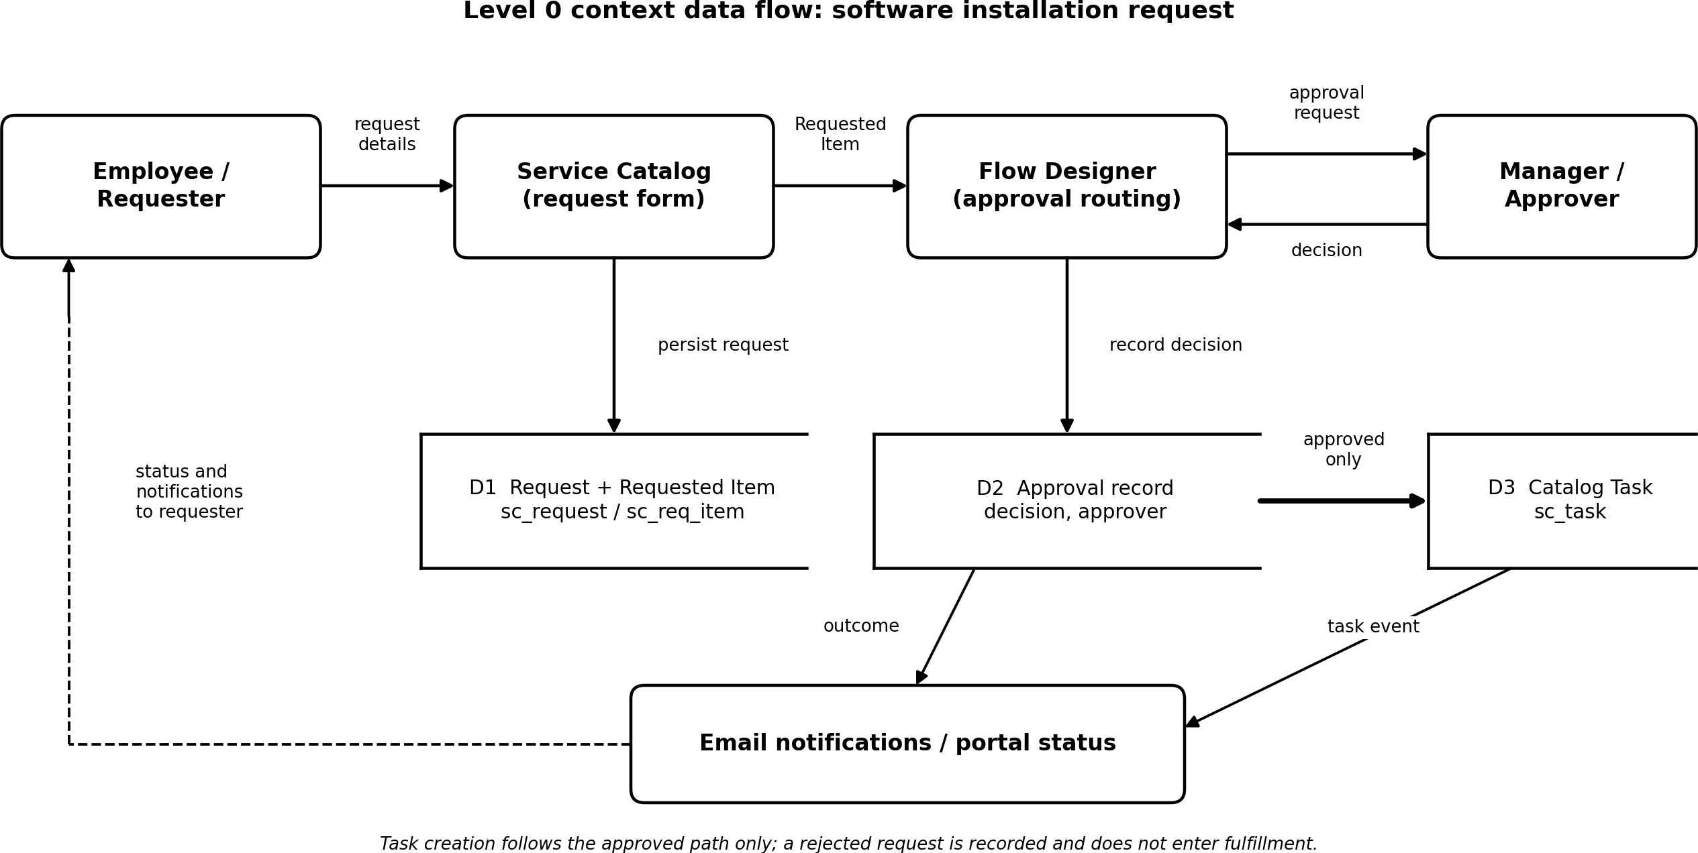
Figure 2. Level 0 data flow for request intake, approval and fulfillment.

Data store | Role in the flow | Key information
Request (sc_request) | Parent request record | Requester, REQ number
Requested Item (sc_req_item) | Catalog item instance and approval context | Catalog variables, item state, RITM number
Approval record | Holds the manager decision | Approver, decision, related Requested Item
Catalog Task (sc_task) | Fulfillment work record | Assignment group, task state, link to Requested Item
Outbound email log | Tracks generated notifications | Recipient, subject, send state

Technology Stack
The solution is built entirely on ServiceNow platform capabilities. No separate server, external API, database or machine-learning component is used.
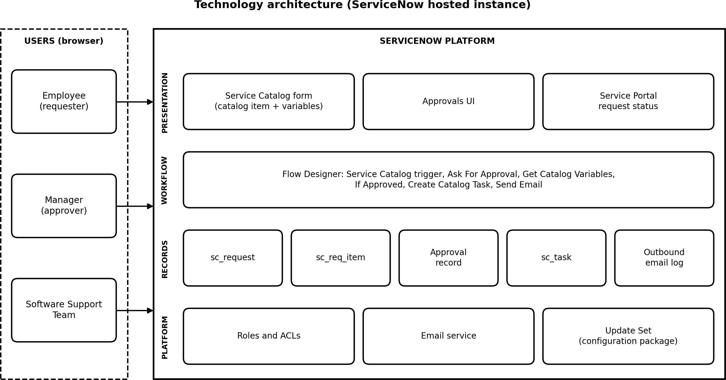
Figure 3. Technology architecture of the ServiceNow request workflow.

Component | Technology | Role
User interface | Service Catalog, Service Portal, web browser | Request form, approval UI, request status.
Intake logic | Catalog item and catalog variables | Collects inputs and creates the Request and Requested Item.
Workflow logic | Flow Designer | Runs approval, reads catalog variables, sends email, creates the Catalog Task.
Data | sc_request, sc_req_item, sc_task, approval records | Stores the request lifecycle in platform-managed tables.
Notifications | ServiceNow email service | Request-received and outcome messages.
Security | Roles and ACLs | Restrict who can view, approve and fulfil.
Configuration management | Update set XML | Packages the catalog item, variables, choices and flow for transfer.

- Project Design

Problem-Solution Fit
The difficulty is coordination and traceability, not installing a program. A guided form improves completeness, a recorded approval gives accountability, a linked task makes approved work actionable, and visible status reduces "what is happening?" enquiries.

1 TARGET USERS  Employees requesting software  - Need a simple, consistent request route.  - Managers decide whether it is justified.  - Support staff need a complete hand-off. | 2 PROBLEM / FRICTION  Information and decisions are fragmented  - Requests arrive with missing details.  - Approval and fulfillment become disconnected.  - Requesters do not know what happens next.
3 PROPOSED SERVICE  ServiceNow catalog and flow  - Collect software, version, justification and urgency.  - Record the request and route the approval.  - Create fulfillment work only on the approved path. | 4 VALUE  A traceable workflow reduces ambiguity  - More complete intake for reviewers.  - One record trail across request and task.  - Clear split between approved and rejected work.
5 RISKS AND VALIDATION
Value depends on correct configuration
- Confirm approver and role mapping in the target instance.
- Verify rejected requests create no task.
- Test notifications and status visibility.

Figure 4. Problem-solution fit canvas for the software request workflow.

Dimension | Hypothesis | How to validate
Problem | Requesters need one path, approvers need context, IT needs actionable work. | Walk through a submission and confirm the needed information is present.
Solution | Catalog, Flow Designer and linked records can carry the whole lifecycle. | Check REQ/RITM creation, approval routing, decision handling and task linkage.
Value | Clear ownership and timely notifications reduce follow-up. | Check portal status and email logs; collect user feedback.
Assumptions | Manager data, email setup, required fields and states are configured correctly. | Test approved and rejected paths and inspect records.

Proposed Solution

Parameter | Description
Problem to solve | Employees need a consistent, traceable way to request software installation or licences. Without a connected request, approval and fulfillment process, requesters are unsure of progress and IT must chase missing information.
Solution | A ServiceNow catalog item collects the software details and justification. Flow Designer asks for manager approval on the Requested Item, emails the requester, and creates a linked Catalog Task for the Software Support Team. REQ and RITM numbers and the portal give the requester a way to track progress.
What is distinctive | The value is integration rather than a new algorithm: intake, approval, standard request records, task assignment and notification run in one platform process, with no separate application or tracking database.
Benefit to users | Employees get a guided form and visible status; managers get a structured justification; the support team gets a traceable task. These benefits are expected outcomes to be confirmed by user feedback.
Business value | An internal service-management workflow with no direct revenue. The value is less manual coordination, better traceability and governance of software requests.
Scalability | Further software items, request types, approval rules and fulfillment groups can be added through catalog and flow configuration, within instance capacity and governance.

Solution Architecture
Four layers cooperate: the requester interface, the catalog and request data model, Flow Designer orchestration, and the approval and fulfillment actors. Platform records connect every stage back to the original request.
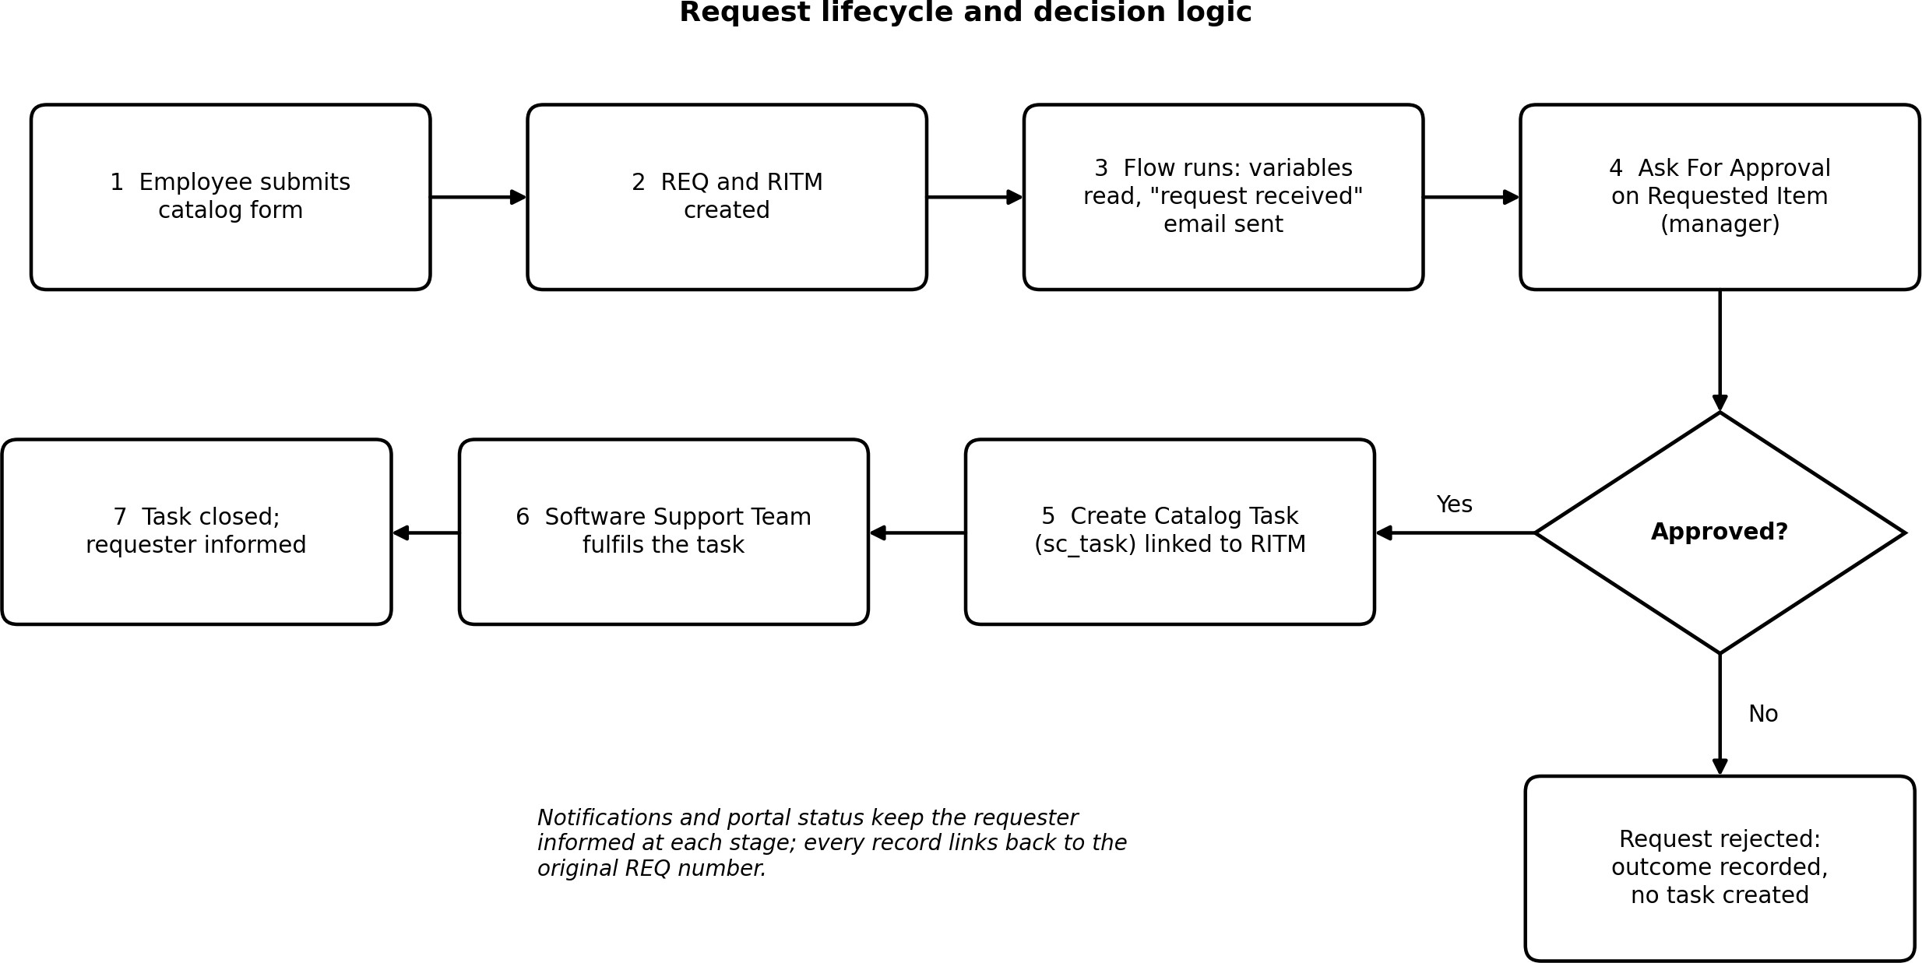
Figure 5. Request lifecycle and decision logic.

Component | Responsibility | Key records
Employee / requester | Submits the request and checks progress. | Catalog form inputs; REQ and RITM numbers
Service Catalog | Captures software and justification details. | Catalog item and variables
Flow Designer | Coordinates approval, notifications and task creation. | Trigger, approval action, condition, actions
Manager / approver | Reviews the business justification and decides. | Approval record linked to the Requested Item
Catalog Task | Represents the approved fulfillment work. | sc_task, assignment group, task state
Notifications and portal | Report receipt, decision and progress to the requester. | Outbound email; request summary page

- Project Planning and Scheduling

Project Planning
The repository organises the work into five phases, each with its own folder. The table lists what each phase contains.

Phase | Main work | Output
1. Requirement Analysis and Planning | Define the problem, users, request fields and approval expectations. | Requirements; Phase 1 update set XML
2. Backend Development and Configuration (Data Architecture) | Data-driven workflow design: business rules and flow automation logic. | Business rule configuration and automation flow screenshots
3. UI/UX Development and Customization | Catalog item and variables (software name, version, justification, urgency); category placement and search through the Service Portal (/sp); validation, tooltips and example text; request tracking by REQ number. | Catalog form and portal views
4. Data Migration, Testing and Security | Test paths, roles and approvals; package the configuration. | Update set package (v1)
5. Deployment, Documentation and Final Presentation | Deployment notes, documentation and demonstration material. | This report

Roles and responsibilities

Role | Responsibility
Requester / employee | Submit accurate software and business-need information.
Approver / manager | Review the justification and approve or reject according to policy.
Software support team | Carry out the approved task and update its status.
ServiceNow administrator | Maintain variables, flow logic, access, notifications and update-set deployment.
Tester / reviewer | Run acceptance cases, collect evidence and record defects.

Planning risks and controls

Risk | Effect | Control
Wrong manager mapping | Request reaches the wrong approver or stalls. | Test with representative requester and manager profiles.
Incomplete request fields | Support must ask for clarification. | Review mandatory fields; test realistic submissions.
Task created on rejection | Unapproved work enters fulfillment. | Test both branches and inspect linked records.
Notification mismatch | User does not receive expected updates. | Check recipient, trigger, email log and delivery.
Update-set dependency gaps | Behaviour differs in the target instance. | Preview and import into a non-production instance first.

The repository does not record sprint dates, velocity or story points, so none are reported.

- Functional and Performance Testing
The test set covers both successful and unsuccessful requests and checks that records stay linked through the lifecycle. The status column states what the repository evidence shows today; cases marked "Not yet executed" have no recorded result.

ID | Scenario | Expected result | Status
T-01 | Submit a valid request. | REQ and RITM created with the entered values. | Observed: REQ0010009 created 9 Oct 2026.
T-02 | Omit a required field. | Submission blocked or missing data flagged. | Not yet executed.
T-03 | Approval routing. | Approval record assigned to the configured manager. | Observed: REQ0010009 at stage Request Approval; portal shows 1 pending approval.
T-04 | Approve a request. | Approval recorded; linked Catalog Task created. | Not yet executed.
T-05 | Reject a request. | Rejection recorded; no Catalog Task created. | Not yet executed.
T-06 | Task assignment. | Task assigned to the Software group. | Not yet executed.
T-07 | Notifications. | Request-received email generated for the requester. | Configured in flow action 3; delivery not yet checked.
T-08 | Requester visibility. | Requester can find the request and its stage. | Observed: Service Portal request summary.
T-09 | Access control. | Unauthorised users cannot see restricted data. | Not yet executed.
T-10 | Update-set import. | Imports into a test instance without unresolved dependencies. | Not yet executed; XML state is "loaded".

For each executed case, record the environment, account and role, date and time, steps, actual result, pass or fail, a screenshot or record number, and any defect ID.

Performance Testing
No timing measurements or load profile exist for this project, so no performance figure is claimed. The measurements to take in a non-production instance are listed below.

Measurement | How to assess | Result
Catalog submission time | Time from the submit action to confirmation and record creation. | Not recorded
Approval-to-task time | Time from the approval decision to the linked task appearing. | Not recorded
Status page response | Repeat requests with representative roles and record timings. | Not recorded
Notification delay | Compare trigger time, email log time and receipt time. | Not recorded
Concurrent load | Run an approved test with a defined number of simultaneous users. | Not recorded

- Results
The repository contains screenshots of the catalog form, the flow canvas, the email action, an approval-gated flow and a live request in the Service Portal, together with the update-set export. They show the solution as built and one request in progress.

Output Screenshots
Figure 6. Catalog item form. The example entry requests Microsoft Office 365, version 2022, with High urgency; delivery time is 2 days.

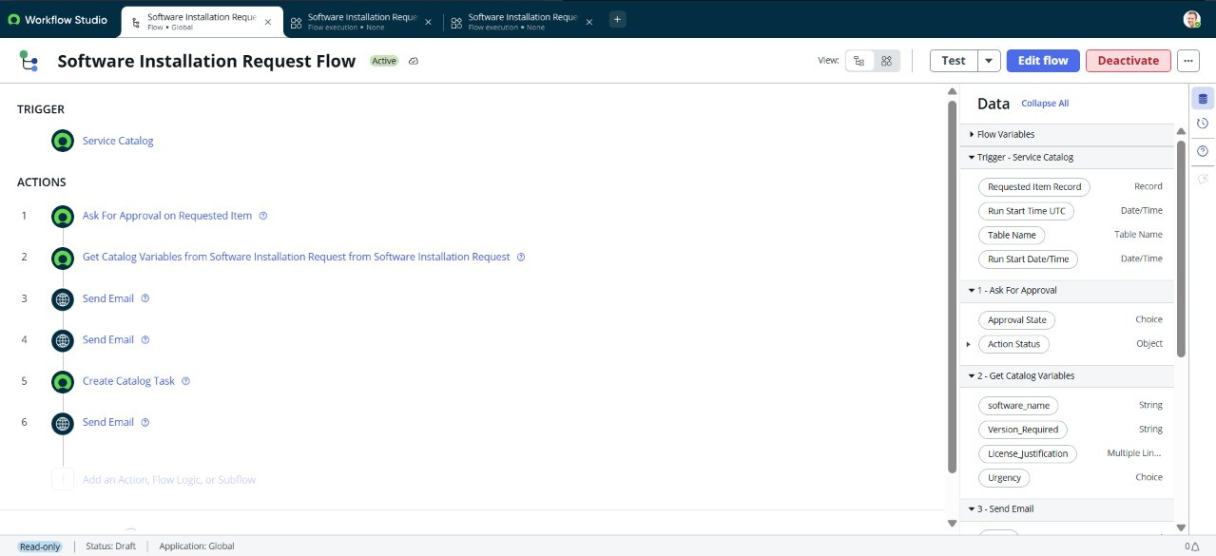
Figure 7. Software Installation Request Flow (Active). Trigger: Service Catalog. Actions: 1 Ask For Approval on Requested Item, 2 Get Catalog Variables, 3 to 4 Send Email, 5 Create Catalog Task, 6 Send Email.
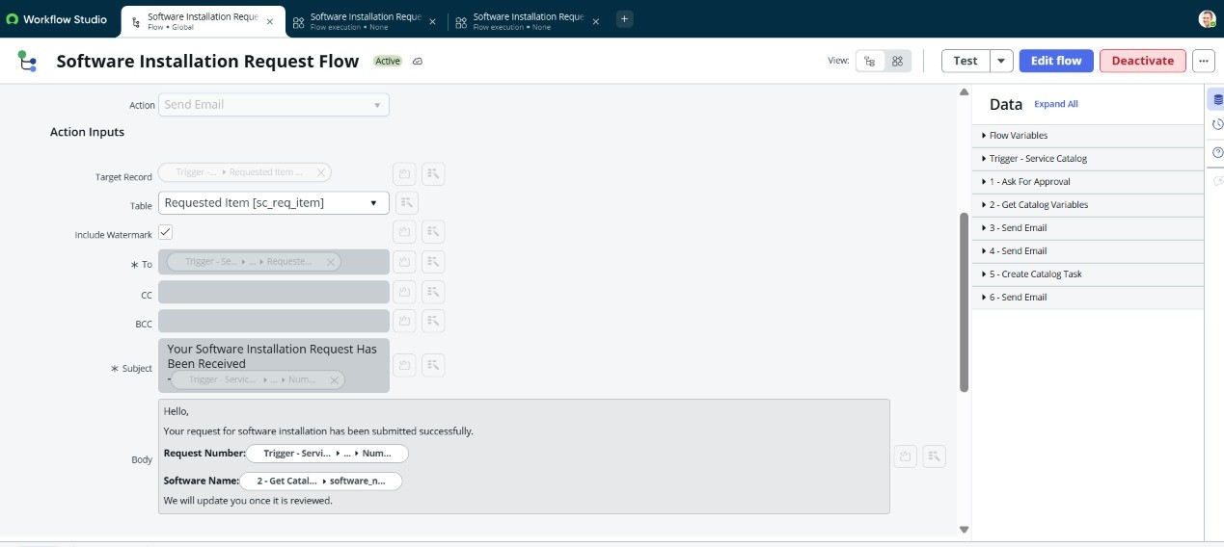
Figure 8. Send Email action. The target is the Requested Item; the subject is "Your Software Installation Request Has Been Received", and the body inserts the request number and software name.

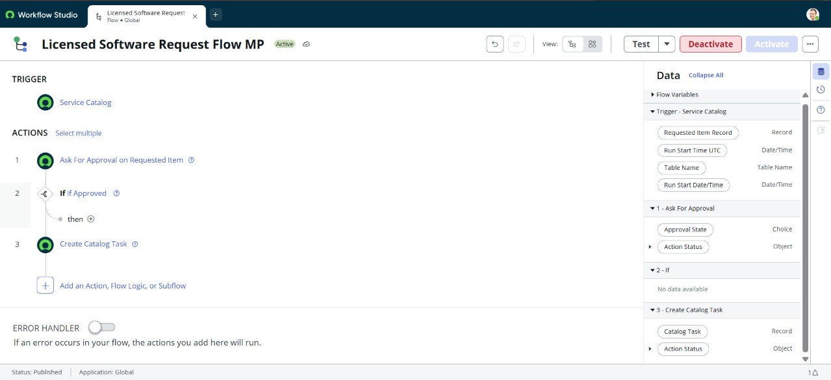
Figure 9. Flow variant with a condition: Ask For Approval on Requested Item, then "If Approved", then Create Catalog Task (status Published).
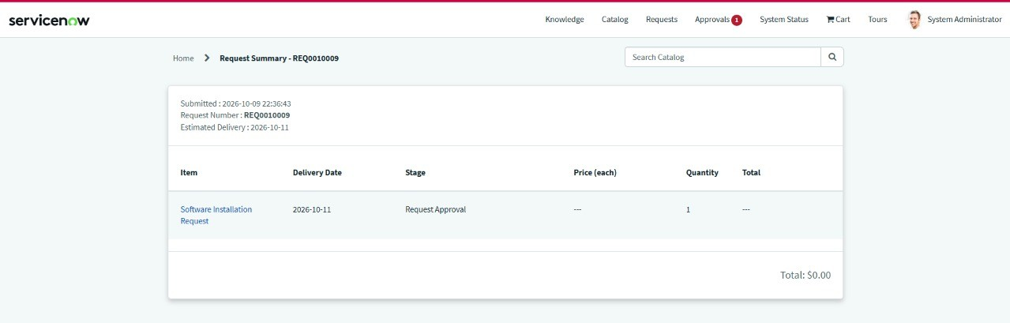
Figure 10. Service Portal request summary for REQ0010009, submitted 2026-10-09 22:36:43, stage "Request Approval", with one pending approval shown in the header.

Evidence summary

Evidence | What it shows | Still to confirm
Catalog form (Fig. 6) | Form with software, version, justification and urgency inputs. | Mandatory-field validation.
Flow canvas and email action (Figs. 7, 8) | Six-step flow with approval, variable lookup, emails and task creation. | Email delivery; the active flow's handling of a rejection.
Gated flow (Fig. 9) | Catalog Task creation placed behind an "If Approved" condition. | That the live flow contains the same gate.
Portal summary (Fig. 10) | A real request reached the approval stage with a REQ number. | Approve and reject outcomes; task linkage.
Update-set XML | Catalog item, variables, choices and flow records with identifiers. | Import and commit in a target instance.

Observation. The flow in Figure 7 lists Create Catalog Task as an unconditional action after the approval, while Figure 9 shows the task behind an "If Approved" condition. Before sign-off, confirm in the instance that the active flow only creates the task on approval, and run the rejection test (T-05).

- Advantages and Disadvantages

Advantages | Disadvantages and constraints
Consistent intake. A catalog item captures the same details for every request. | Configuration dependence. Behaviour relies on correct roles, manager data and group assignments.
Traceability. Request, Requested Item, approval and task records connect the lifecycle. | Approval bottleneck. Requests can stall if an approver is unavailable or routing data is wrong.
Controlled decision point. Approval separates justified work from work that should not proceed. | Export is not deployment. An update-set XML does not prove that import succeeded or dependencies are present.
Clear hand-off. A linked task gives the support team an actionable record. | Unverified delivery. Notifications and portal status need end-to-end testing.
Maintainability. Platform configuration and an update set are easy to review and move. | No measurements yet. There is no executed UAT log or performance data.
Extensibility. More software types, approval policies and reports can be added. | Scope. The process records and coordinates a request; it does not install software on a device.

- Conclusion
The Software Installation Request project applies ServiceNow catalog and workflow capabilities to a practical IT service-management problem. It gives employees a single guided form for software requests, records each request as linked REQ and RITM records, asks the manager for approval, notifies the requester, and creates a Catalog Task for the Software Support Team. The repository supports this with the catalog form, flow screenshots, a live request at the approval stage, and the update set Software_Installation_Request_v1.
Its contribution is process consistency and traceability rather than a new algorithm or an automatic installer. The next step is to finish acceptance testing in the target instance: approve and reject paths, task creation and assignment, email delivery, role permissions and update-set import. Recording those results, with screenshots and record numbers, will turn the design into verified behaviour.

- Future Scope

Enhancement | Description
Stronger validation | Make required fields and request-type-specific questions explicit, with helpful messages.
Approval escalation | Add reminders, escalation rules and fallback approvers for requests pending too long.
Licence inventory integration | Check licence availability and entitlement from an authoritative inventory before fulfillment.
Automated deployment | Connect approved tasks to endpoint-management tooling, keeping the approval gate.
Service-level tracking | Define response and fulfillment targets; report elapsed time, pending approvals and overdue tasks.
Reporting dashboards | Use ServiceNow reporting for request volume, approval outcomes, backlog and ageing.
User experience | Improve discoverability, explain request types, and show status in plain language.
Security and audit | Review least-privilege access, retention and audit trails before production use.
Test automation | Maintain a repeatable UAT suite, test data and defect register for each release.

These are proposals, not implemented features.

- Appendix

Source Code (Configuration Artifact)
The project is a ServiceNow configuration. Its artifact is an update-set export, sys_remote_update_set_c73bf55a3b7b83102c85920f23e45a0c.xml, which is not a conventional source-code project. Its state field is loaded; that alone does not show the update set was committed or deployed.

XML detail | Value
Update set | Software_Installation_Request_v1
Description | Capturing configurations for licensed software request catalog item and flow.
Catalog item | Licensed Software Request
Flow | Licensed Software Request Flow (internal name licensed_software_request_flow; published, active)
Request variables | software_name; Version_Required; License_Justification; Urgency; request_type; software_application; business_justification; device_asset_tag
Request-type choices | New License Assignment; Reinstall / Existing License

Selected XML excerpts (shortened)
<sys_remote_update_set action="INSERT_OR_UPDATE">
<application_name>Global</application_name>
<description>Capturing configurations for licensed software request catalog item and flow.</description>
<name>Software_Installation_Request_v1</name>
<state>loaded</state>
</sys_remote_update_set>

<sys_hub_flow action="INSERT_OR_UPDATE">
<active>true</active>
<internal_name>licensed_software_request_flow</internal_name>
<name>Licensed Software Request Flow</name>
<status>published</status>
<type>flow</type>
</sys_hub_flow>

<item_option_new action="INSERT_OR_UPDATE">
<name>software_name</name>
<question_text>What software do you need?</question_text>
<example_text>e.g., Microsoft Office 365, Adobe Photoshop</example_text>
<show_help>true</show_help>
</item_option_new>
The other variables carry the questions "Specify version (if required).", "Why do you need this software?" and "Select urgency level." Keep the original XML unchanged, import it only into a compatible instance, review collisions and dependencies, and verify the active configuration after import.

Dataset Link
Not applicable. The project is a workflow and configuration solution; no dataset or machine-learning model is used.

GitHub and Project Demo Link

Item | Link
GitHub repository | https://github.com/Mattaphanisri1912/servicenow-licensed-software-request
Project demo | Not provided

Repository layout

Folder | Contents
Phase-1-Requirement-Analysis | Phase 1 update set XML
Phase 2: Backend Development and Configurations Data Architecture | business_rule_config.png, automation_flow_design.png
Phase 3: UI/UX Development and Customization | Catalog item, variables, navigation, usability and help-text documentation
Phase 4: Data Migration, Testing and Security | Update set XML (sys_remote_update_set_c73bf55a...xml)
Phase 5: Deployment, Documentation and Final Presentation | Deployment and final documentation

Glossary

Term | Meaning
Service Catalog | ServiceNow interface for requesting services and items.
Flow Designer | ServiceNow tool for building workflow automation.
REQ | Request record for a submitted request.
RITM | Requested Item record for a catalog item within a request.
SCTASK | Catalog Task record that tracks fulfillment work.
Update set | ServiceNow mechanism for packaging configuration changes.
UAT | User acceptance testing: validation of requirements by intended users or reviewers.

