Project Development Phase
Workflow Automation Verification
Date | 13-10-2026
Team ID | Individual participant - 323103312149@gvpce.ac.in
Project Name | Software Installation Request - ServiceNow
Maximum Marks | As specified by template

Automation Summary
The project implements a rule-based ServiceNow workflow. No artificial-intelligence model, training pipeline, inference endpoint, or AI-generated decision is identified in the supplied project materials. The relevant verification target is workflow behavior.
Area | Expected behavior | Verification evidence to capture
Catalog intake | Required software and business-justification details are collected. | Catalog item form and submitted request.
Approval routing | Requested Item is sent to the configured manager for decision. | Approval record and approver identity.
Approved branch | A linked Catalog Task is created and routed to the Software fulfillment group. | RITM/SCTASK linkage and assignment group.
Rejected branch | Rejection is recorded and fulfillment does not proceed. | Approval outcome and absence of fulfillment task.
Notifications | Configured messages are generated for relevant workflow events. | Outbound email log and recipients.

AI-specific fields from the source template
Template field | Project-specific value
Model summary | Not applicable — no AI model is part of this project.
Training / validation accuracy | Not applicable — there is no model training or labelled evaluation dataset.
Fine-tuning result | Not applicable — no fine-tuning is performed.
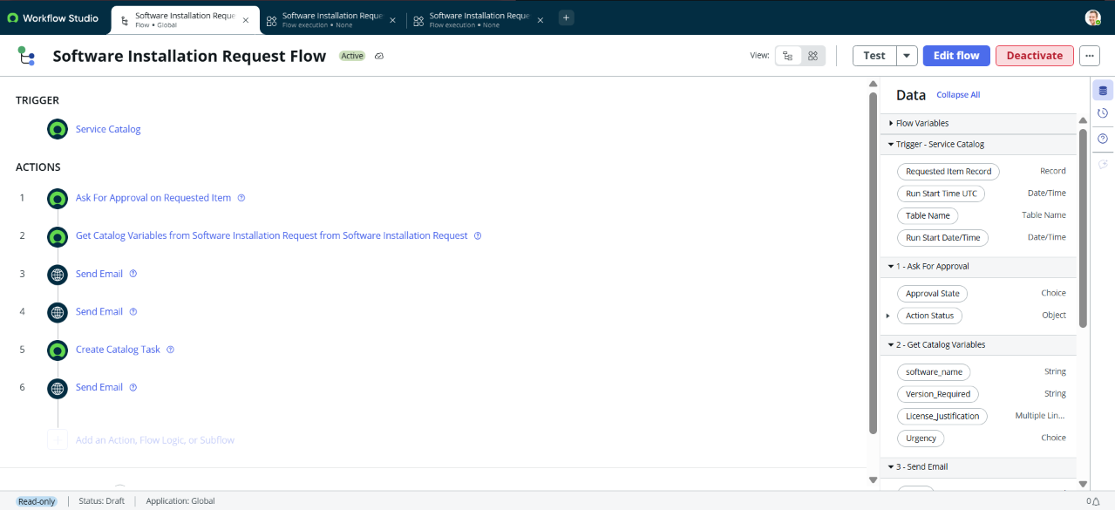
Repository evidence: ServiceNow Flow Designer configuration.

