Requirement Analysis
Customer Journey Map
Date | 13-10-2026
Team ID | Individual participant - 323103312149@gvpce.ac.in
Project Name | Software Installation Request - ServiceNow
Maximum Marks | As per template / not specified

Scenario
An employee needs software installed or a license assigned and uses ServiceNow to submit a request, obtain a manager decision, and follow the request through IT fulfillment. This journey map is a design synthesis based on the project scope and repository artifacts; it is not based on new customer interviews.
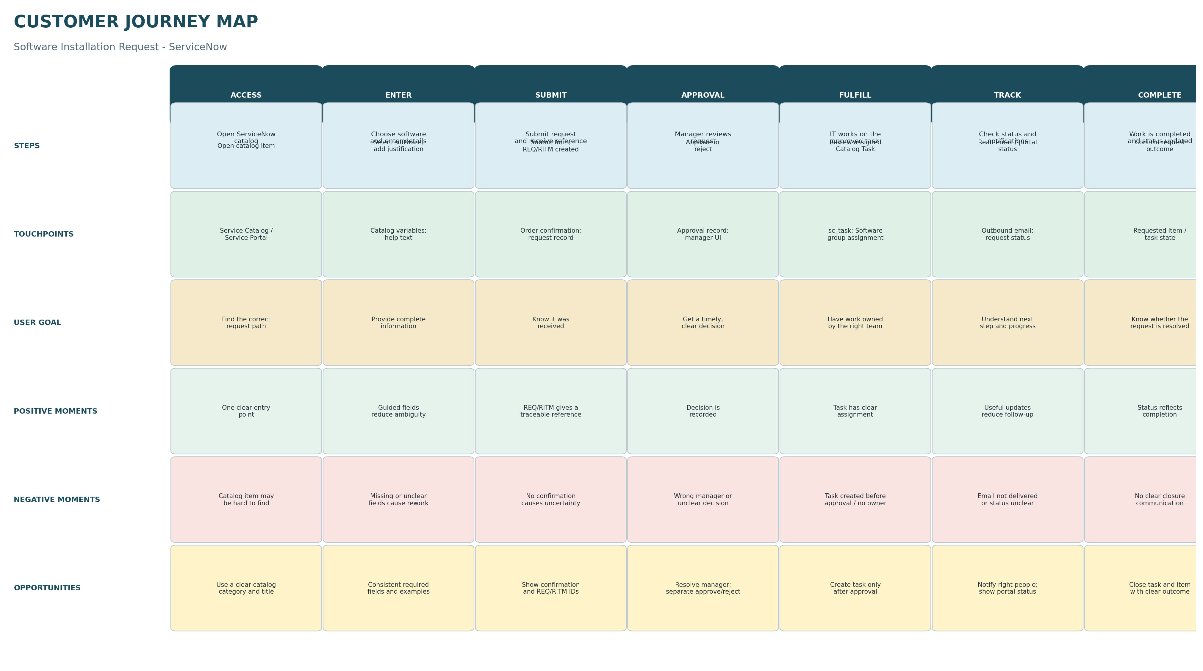
Figure 1. Journey stages, touchpoints, goals, positive and negative moments, and improvement opportunities.

Journey stages and key needs
Stage | User action | User need | System response (intended)
Access | Open Service Catalog item | Find the right request path | Present a clearly named catalog item.
Enter | Complete software and justification fields | Know what information is required | Provide consistent field labels and validation.
Submit | Submit the form | Receive confirmation and reference | Create request/Requested Item records.
Approval | Manager reviews request | Understand decision and reason | Record approval outcome; branch approved/rejected.
Fulfill | IT works on approved task | Clear ownership and task context | Create linked Catalog Task only after approval.
Track | Check email or portal | Know current progress | Generate configured notifications and expose status.
Complete | Check final state | Know the request outcome | Update task/item state and communicate completion.

Priority opportunities
- Reduce incomplete requests with clear labels, contextual help, and consistent mandatory-field rules.
- Make manager resolution and approval outcomes explicit; a rejected request must not proceed to fulfillment.
- Maintain linkage between REQ, RITM, approval, and Catalog Task records.
- Use relevant notifications and portal status visibility to reduce uncertainty and manual follow-up.

Evidence note
The source example is a one-page journey map for guided city tours, organized by stages and rows for steps, interactions, goals, positive moments, negative moments, and opportunities. This document adapts that structure to the ServiceNow request lifecycle. Journey pain points are plausible design risks to validate, not measured findings.

