Project Design Phase-II
Data Flow Diagram & User Stories
Date | 13-10-2026
Team ID | To be provided by the project team
Project Name | Software Installation Request - ServiceNow
Maximum Marks | 4 Marks

Data Flow Diagrams:
A Data Flow Diagram (DFD) describes how information enters the software request system, how the request is processed, where records are stored, and how approval and fulfillment information moves between participants.
Example: DFD Level 0 (Software Installation Request)
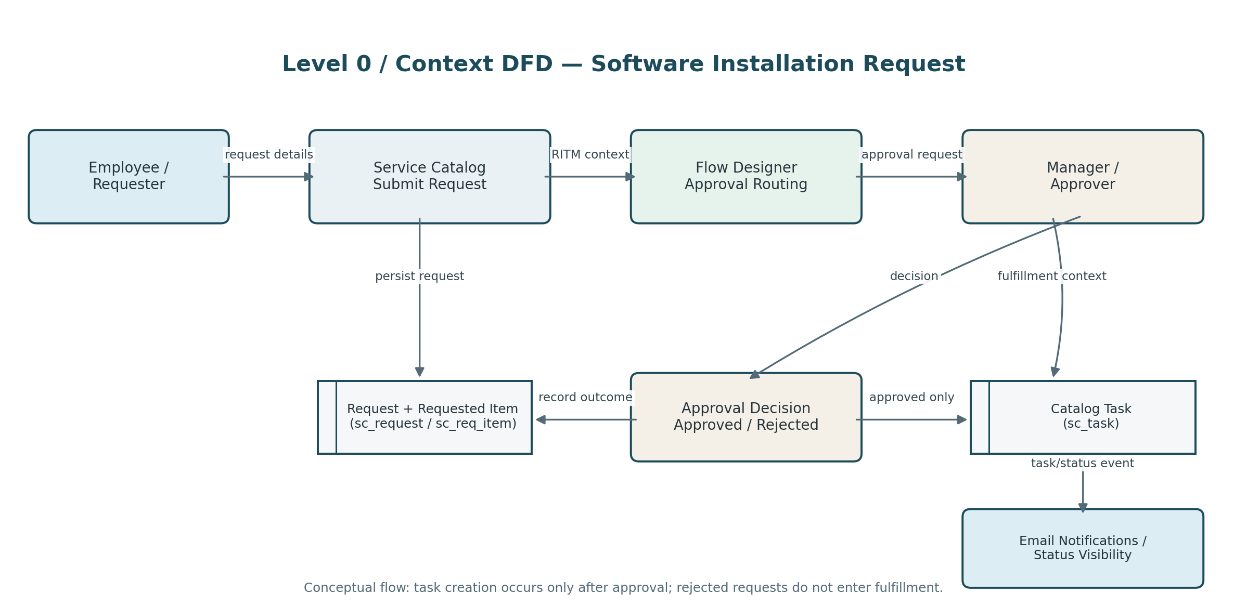
The diagram represents the intended workflow: the employee submits request details; ServiceNow stores the request and Requested Item; Flow Designer routes approval to the manager; and a catalog task is created only for an approved request. Notifications and status visibility support follow-up.

Data stores and key records
Record / table | Role in the flow | Key information
Request — sc_request | Parent request record | Requester and REQ identifier
Requested Item — sc_req_item | Catalog item instance and approval context | Catalog variables, item state, RITM identifier
Catalog Task — sc_task | Fulfillment work record | Task assignment, work status, link to Requested Item
Approval record | Captures manager decision | Approver, decision, related Requested Item
Outbound email record | Tracks generated notifications | Recipient, subject, send state where available

User Stories
The user stories below translate the project workflow into user-focused requirements. Acceptance criteria describe expected behavior for future verification; they are not claims that every test has already passed.
User Type | Functional Requirement (Epic) | Story No. | User Story / Task | Acceptance Criteria | Priority | Release
Employee / requester | Request submission | USN-1 | As an employee, I want to submit a software installation or license request through the Service Catalog so that my need is formally recorded. | A request and Requested Item are created with a traceable REQ/RITM reference. | High | Release 1
Employee / requester | Request details | USN-2 | As an employee, I want to provide the software/application, version or request type where applicable, device details where required, and business justification. | Configured required fields are validated before submission; submitted values are stored against the Requested Item. | High | Release 1
Manager / approver | Approval | USN-3 | As the requester's manager, I want to receive an approval request so that I can review the business need and approve or reject it. | The approval is linked to the Requested Item and the decision is recorded against the correct request. | High | Release 1
Employee / requester | Status tracking | USN-4 | As an employee, I want to find my submitted request and its status so that I can understand its progress without repeated manual follow-up. | The requester can locate the request using the available portal/request references and see the configured status. | High | Release 1
Software support / IT | Fulfillment task | USN-5 | As a fulfillment team member, I want an approved request to generate a catalog task assigned to the Software group so that the work has clear ownership. | An approved request creates a linked task with the configured assignment; a rejected request does not create a fulfillment task. | High | Release 1
Requester and fulfillment team | Notifications | USN-6 | As a requester or fulfillment team member, I want relevant notifications for request receipt, approval outcome, or task assignment so that I know the next step. | Email records are generated for configured recipients and events; actual delivery is verified separately. | Medium | Release 1
ServiceNow administrator | Configuration and deployment | USN-7 | As an administrator, I want catalog and flow configuration packaged in an Update Set so that it can be moved and reviewed consistently. | The Update Set contains the intended configuration and is checked for dependencies before promotion. | Medium | Release 1
ServiceNow administrator / tester | End-to-end validation | USN-8 | As a tester, I want to verify the request, approval, task, and notification paths so that the workflow behaves as designed. | Positive and negative paths are checked, including approval, rejection, record linkage, and notification generation. | High | Release 1

Priority and release note
Priority labels are proposed for planning: High items establish the core request-to-approval-to-fulfillment path; Medium items improve communication and maintainability. “Release 1” is a suggested grouping, not a verified sprint commitment.

Workflow acceptance summary
- A valid request creates traceable request and Requested Item records.
- The manager approval is associated with the correct Requested Item.
- Approval leads to a linked Catalog Task; rejection does not lead to fulfillment task creation.
- Notifications are generated for configured recipients and request status is discoverable to the requester.

