Ideation Phase
Brainstorm & Idea Prioritization Template
Date | 13-10-2026
Team ID | To be provided by the project team
Project Name | Software Installation Request - ServiceNow
Maximum Marks | 4 Marks

Brainstorm & Idea Prioritization Template:
This ideation document frames the problem and compares practical concepts for a ServiceNow-based software installation and license request process. The aim is to make requests easier to submit, route approvals to the appropriate manager, provide a traceable fulfillment task, and keep requesters informed. Ideas below are a structured design rationale based on the project artifacts, not a claim that a historical brainstorming workshop or numerical scoring exercise took place.

Step-1: Team Gathering, Collaboration and Select the Problem Statement

Problem statement
Employees need a consistent way to request approved software installations or licenses. When requests are handled through informal messages or disconnected manual steps, the requester may have limited visibility, managers may not receive a consistent approval request, and the IT team may lack a linked fulfillment record. The project proposes a ServiceNow Service Catalog item connected to manager approval and catalog-task fulfillment, with request status and notifications supporting traceability.

Stakeholders and needs
Stakeholder | Primary need
Employee / requester | Submit clear request details and track the request.
Line manager / approver | Review the business need and approve or reject the request.
Software support / fulfillment team | Receive an actionable task for approved work.
ServiceNow administrator | Maintain catalog variables, routing, notifications, and deployment configuration.

Solution direction
Use a Service Catalog form as the single entry point; capture software and justification details; route approval to the requester's manager; create a fulfillment catalog task only after approval; and provide requester/fulfillment notifications plus REQ/RITM/SCTASK tracking.
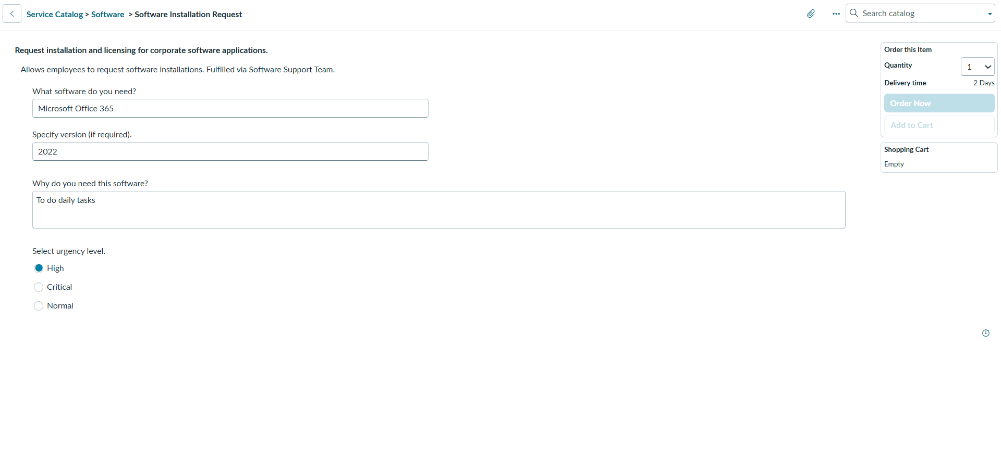
Project evidence: Service Catalog item form from the repository (Phase 3).

Step-2: Brainstorm, Idea Listing and Grouping
The ideas below are grouped by the part of the request journey they improve. The list favors practical concepts that align with the repository's ServiceNow catalog, Flow Designer, standard request records, and portal screenshots.

A. Request intake and data quality
Idea | Description
Guided catalog form | Provide a dedicated Software category catalog item with clear field labels and help text.
Structured request details | Capture software name/application, required version, business justification, and urgency or request type.
Required-field validation | Prevent submission when critical information is missing; keep required fields consistent with the form configuration.
Contextual guidance | Add tooltips and example values to reduce incomplete or ambiguous submissions.

B. Approval and decision handling
Idea | Description
Manager-based approval | Resolve the requested-for user's manager and send an approval request.
Explicit decision branches | Handle Approved and Rejected outcomes separately; do not create a fulfillment task for rejected requests.
Approval traceability | Keep the approval associated with the Requested Item so the decision can be reviewed.

C. Fulfillment and communication
Idea | Description
Task creation after approval | Create a Catalog Task and route it to the Software fulfillment group only after approval.
Requester confirmation | Send a receipt notification after submission with the request reference.
Task assignment notification | Notify the responsible fulfillment group when the catalog task is created or assigned.
Status visibility | Use the Service Portal Request Summary / Order Status views and REQ/RITM identifiers to help users follow progress.

D. Administration and deployment
Idea | Description
Reusable platform records | Use standard ServiceNow request, requested-item, and catalog-task records instead of a separate tracking database.
Update Set packaging | Package catalog item and flow configuration for controlled movement between instances.
End-to-end verification | Check form submission, approval outcome, task assignment, status records, and generated email records.

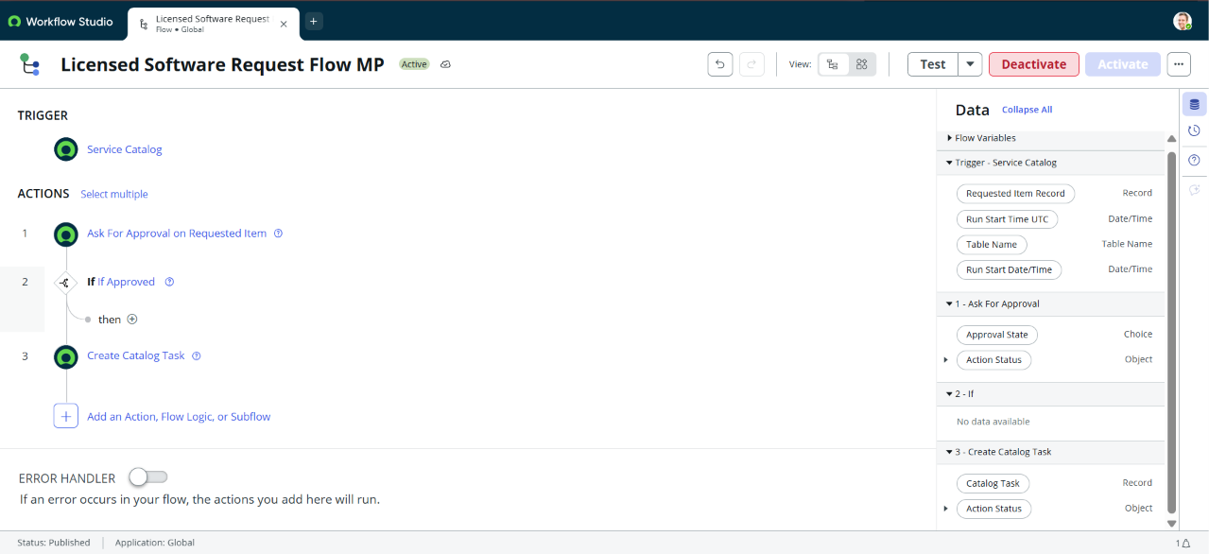
Project evidence: Flow Designer automation concept from Phase 2. The intended design separates approval decision handling from fulfillment.

Step-3: Idea Prioritization
Prioritization is qualitative and based on user impact, operational value, and feasibility within the ServiceNow platform already used by the project. No numerical scores or historical voting results are claimed.
Priority | Idea / capability | Impact | Rationale
1 — Essential | Guided catalog item with required request details | High | Creates a consistent intake and supplies the information needed for review and fulfillment.
1 — Essential | Manager approval with explicit Approved / Rejected paths | High | Provides a decision gate and prevents rejected requests from entering fulfillment.
1 — Essential | Catalog task created only after approval | High | Gives the fulfillment team an actionable, linked work record.
2 — High value | Requester confirmation and task-assignment notifications | High | Reduces uncertainty and communicates the next step to the relevant parties.
2 — High value | REQ/RITM status visibility in the portal | Medium–High | Lets requesters follow progress without relying entirely on manual updates.
2 — High value | Manager/user profile and email prerequisites | Medium–High | Supports dynamic approval routing and usable email recipients.
3 — Supporting | Tooltips, examples, and inline guidance | Medium | Improves clarity and reduces avoidable input errors.
3 — Supporting | Update Set packaging and deployment checklist | Medium | Supports repeatable promotion of configuration across ServiceNow instances.
3 — Supporting | End-to-end checks across records and email logs | High | Provides verification points for the complete request lifecycle.

Recommended implementation order
- Establish the catalog item, consistent variables, mandatory-field validation, and request record creation.
- Configure manager approval and make the approval outcome the explicit gate for fulfillment task creation.
- Add requester and fulfillment notifications, then verify recipient configuration and email logs.
- Verify request tracking in the portal and package the validated configuration in an Update Set.

Success criteria for later testing
- A complete catalog submission creates a traceable REQ and Requested Item record.
- The approval is routed to the configured manager and its outcome is recorded.
- An approved request creates a Catalog Task assigned to the Software fulfillment group; a rejected request does not create a fulfillment task.
- Relevant notifications are generated for the intended recipients, and the requester can locate the request status.
Evidence note: The repository includes catalog-form, portal, flow, task-mapping, and email-log screenshots. They support the solution direction; actual acceptance results should be recorded in the separate testing deliverables.

