Project Design Phase
Problem – Solution Fit Template
Date | 13-10-2026
Team ID | Individual participant - 323103312149@gvpce.ac.in
Project Name | Software Installation Request - ServiceNow
Maximum Marks | 2 Marks

Problem – Solution Fit Template:
Problem–Solution Fit means identifying a meaningful customer problem and proposing a solution that addresses the customer's needs and behavior. For this project, the fit hypothesis is that a single ServiceNow request journey can connect software request intake, manager approval, IT fulfillment, and progress communication.

Purpose
- Solve the software request problem in a way that fits employee, manager, and IT workflows.
- Use the existing ServiceNow Service Catalog and platform workflow as familiar access and processing channels.
- Communicate the approval decision and next step clearly to build trust in the request process.
- Reduce avoidable clarification and manual follow-up by linking request details, approval, task assignment, and status.
- Understand current friction points and validate whether the proposed workflow improves them.

Problem–Solution Fit Canvas
The canvas below summarizes the target users, problem, proposed solution, expected value, and assumptions to validate.
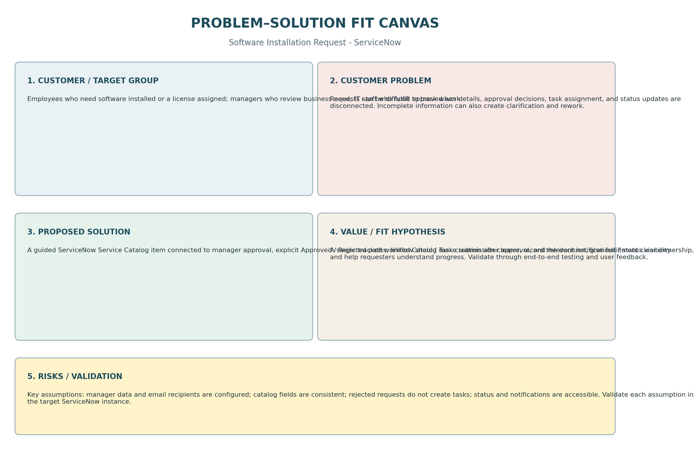

Fit hypothesis and validation
Fit dimension | Project hypothesis | How to validate
Problem | Requesters need a consistent path; approvers need context; IT needs actionable approved work. | Walk through request submission and confirm required information is present.
Solution | Service Catalog + Flow Designer + linked records can support the request lifecycle. | Verify REQ/RITM creation, approval routing, decision handling, and Catalog Task linkage.
Value | Clear ownership and timely notifications should improve transparency and reduce repeated follow-up. | Check portal status, notification generation, and gather user feedback.
Assumptions | Manager data, email configuration, required fields, and state transitions are configured correctly. | Test approved and rejected paths in the target instance; inspect records and email logs.

Conclusion
The proposed solution has a plausible problem–solution fit because it uses native ServiceNow request and workflow capabilities to connect intake, approval, and fulfillment. Fit should be considered a hypothesis until the complete approved/rejected workflow, notifications, and user experience are verified in the target instance.

References
- https://www.ideahackers.network/problem-solution-fit-canvas/
- https://medium.com/@epicantus/problem-solution-fit-canvas-aa3dd59cb4fe

