Project Design Phase
Solution Architecture
Date | 13-10-2026
Team ID | Individual participant - 323103312149@gvpce.ac.in
Project Name | Software Installation Request - ServiceNow
Maximum Marks | 4 Marks

Solution Architecture
The solution architecture bridges the software-request business need with ServiceNow platform capabilities. It defines the main users, catalog entry point, workflow orchestration, approval decision, record storage, fulfillment task, and communication touchpoints.
- Find the appropriate platform solution for a controlled software installation/license request.
- Describe the structure and behavior of the catalog, approval, request records, and fulfillment task.
- Define the request lifecycle and expected behavior for approved and rejected requests.
- Provide a clear conceptual design for configuration, testing, and deployment.

Solution Architecture Diagram
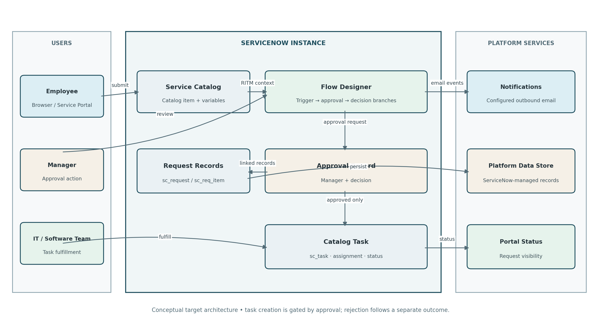
Figure 1. Conceptual architecture and data flow for the ServiceNow software installation request workflow.

Architecture Components
Component | Responsibility | Key artifacts / data
Employee / requester | Initiates software request and checks progress. | Catalog form inputs; REQ/RITM references.
Service Catalog | Captures software and justification details. | Catalog item and variables.
Flow Designer | Coordinates request processing and approval. | Trigger, manager approval, decision branches.
Manager / approver | Reviews business justification and decides. | Approval record linked to Requested Item.
Request records | Retain parent and catalog request context. | sc_request and sc_req_item.
Catalog Task | Represents approved fulfillment work. | sc_task, assignment group, task state.
Notifications / portal | Communicates request receipt, decisions, assignment, and progress. | Outbound email records; status views.

Workflow and decision rules
- Employee submits the catalog item; ServiceNow creates a Request and Requested Item with the submitted details.
- Flow Designer routes the Requested Item to the configured manager for approval.
- If approved, the flow creates a linked Catalog Task and routes it to the Software fulfillment group.
- If rejected, the flow records the rejection outcome and does not create a fulfillment task.
- Relevant notifications are generated for configured recipients; the requester can use available portal/status views to track progress.

Architecture assumptions and validation
This is the intended target architecture. Manager profile data, approval routing, field validation, task-assignment rules, email recipients, and portal access depend on instance configuration. These should be verified during functional testing. The diagram is conceptual and does not claim that every connection has been validated in a live instance.

Reference
https://aws.amazon.com/blogs/industries/voice-applications-in-clinical-research-powered-by-ai-on-aws-part-1-architecture-and-design-considerations/

