# 02-VBA Homework: The VBA of Wall Street

Sumukh Kumble

A screen shot of the first and last segments of the Stock Marker summary has been provided for each year.

## 2014 Stock Analyses

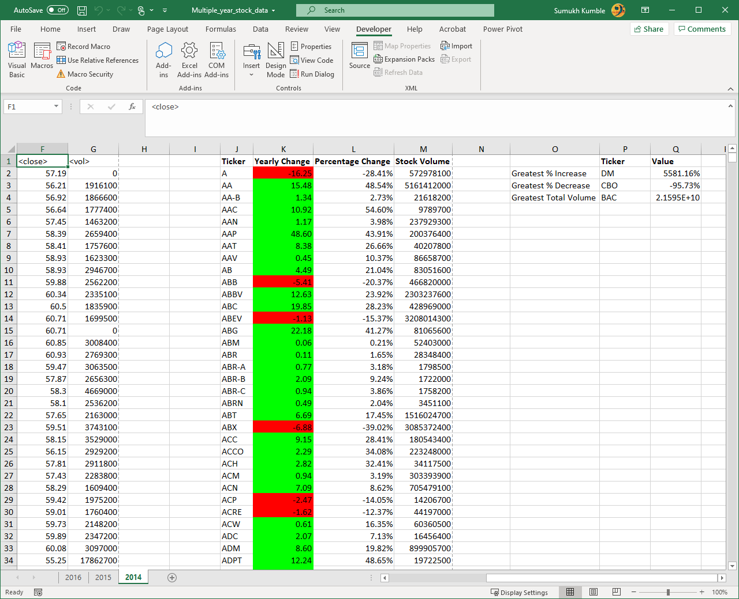

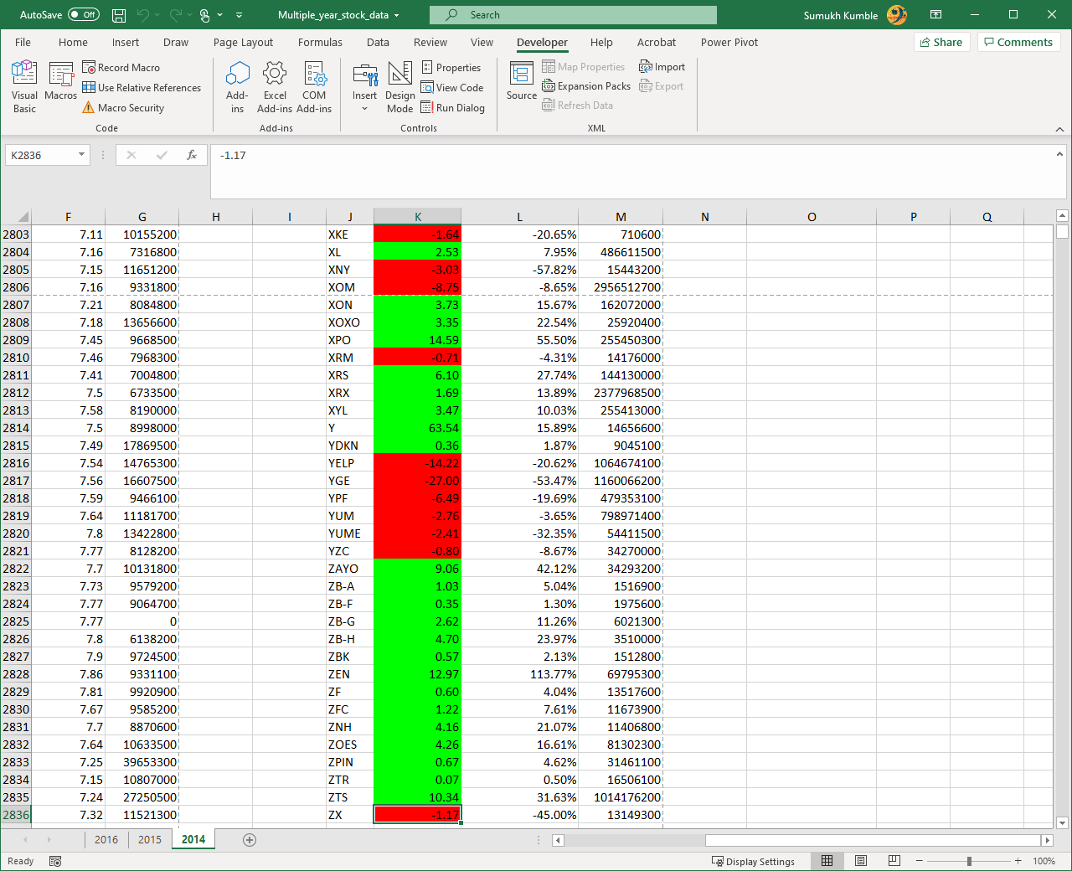

## 2015 Stock Analyses

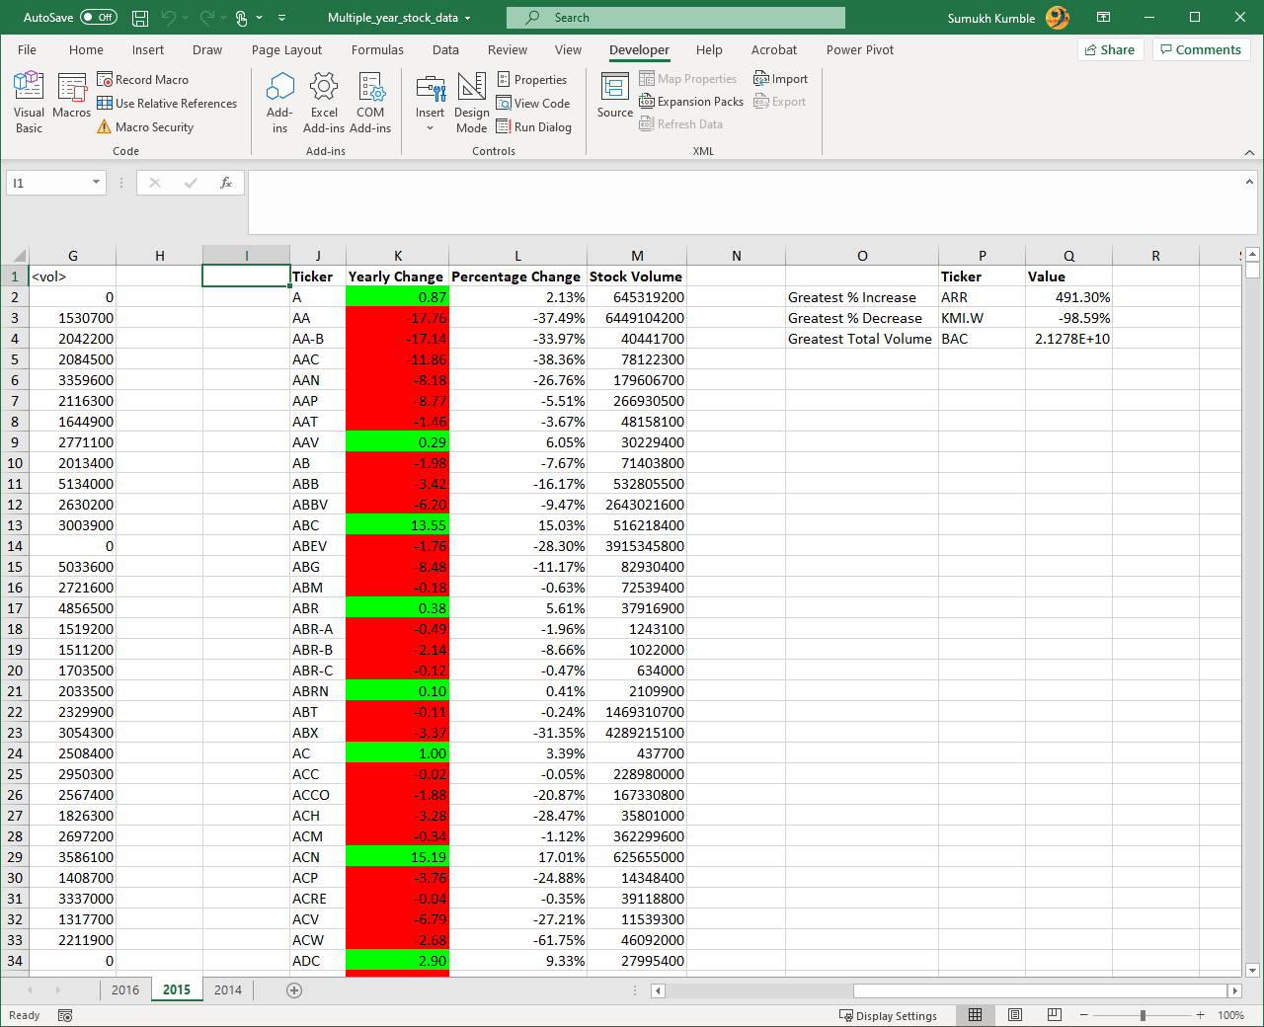

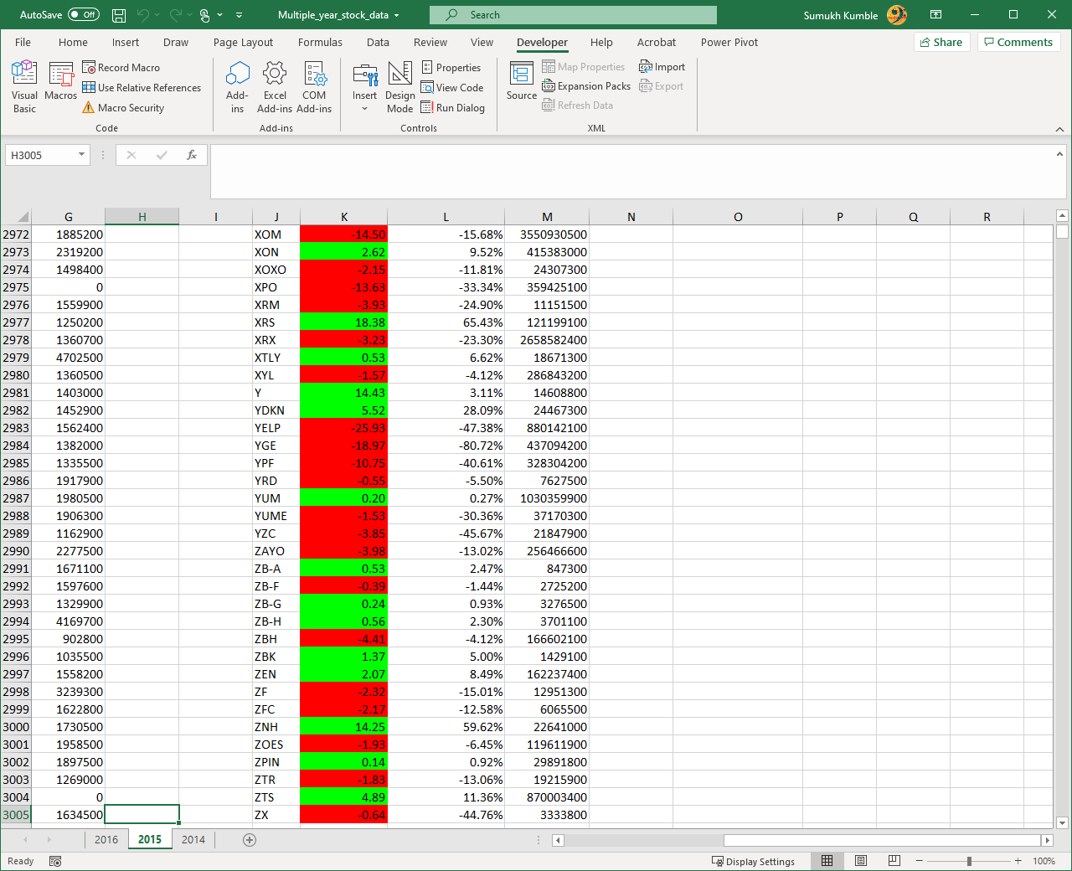

Within the Datasheet pertaining to 2015, there were instances where the opening prices was not available for certain stocks. This was taken into consideration when calculating the percentage year change and highlighted in black as shown below.

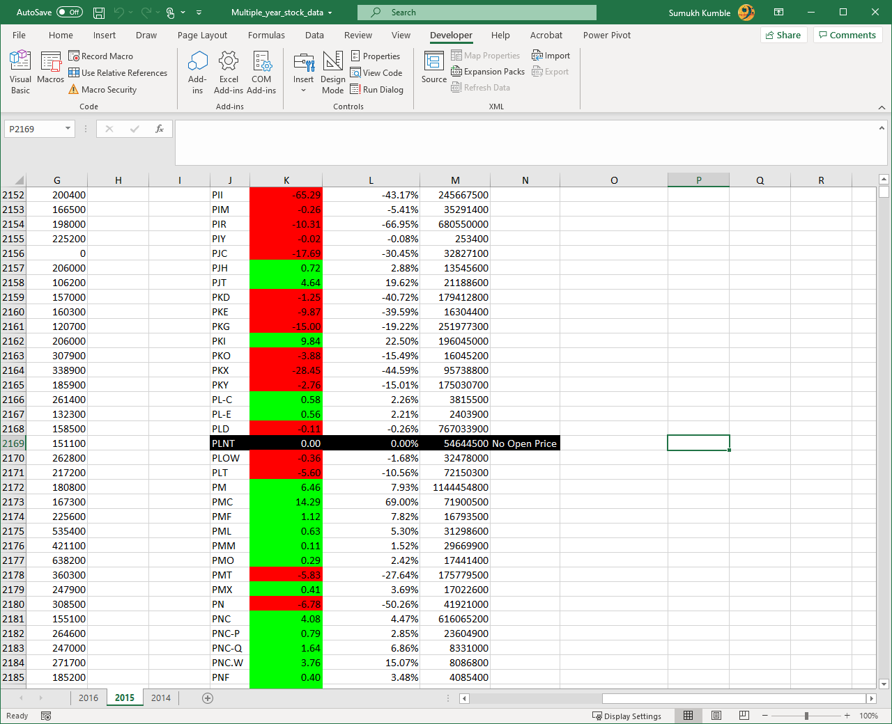

For Stocks with yearly changes at 0.00% were highlighted in magenta using conditional formatting in VBA.

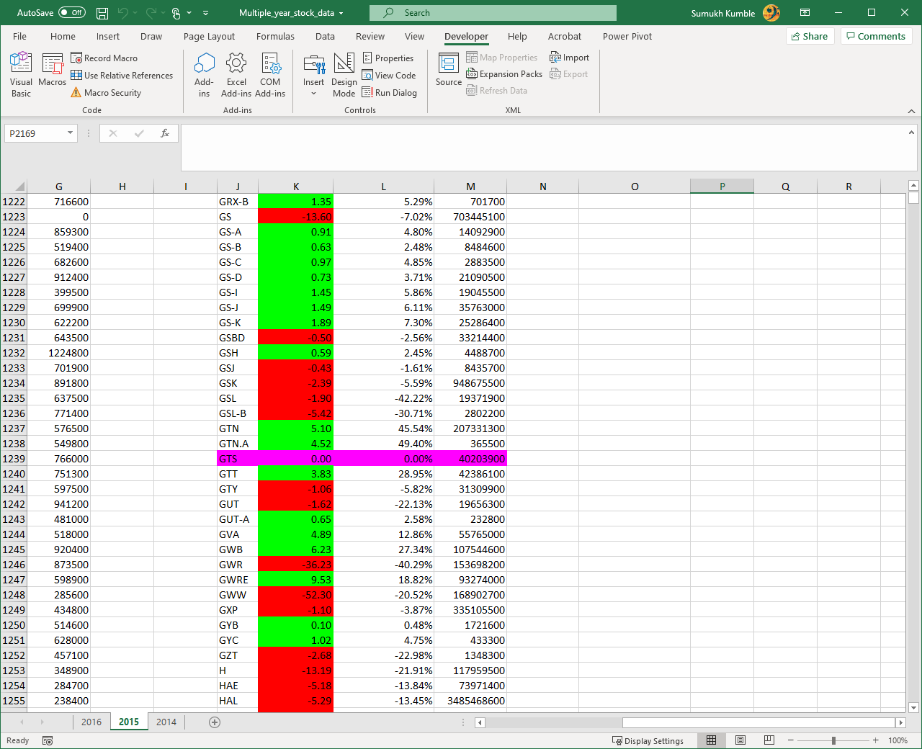

## 2016 Stock Analyses

