**Zimbabwe Risks Learning Poverty Despite Steady Gains in ECD**

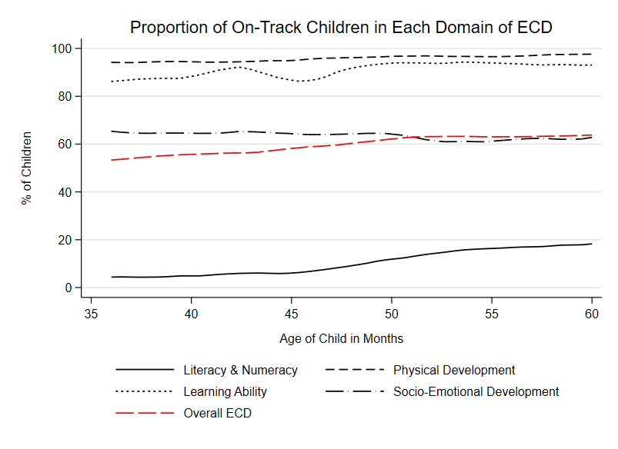

Data from 2019’s MICS6 survey in Zimbabwe provides hopeful and worrying signs for the country’s education policymakers. While more than 50% of children in any age-month in the 3–5-year group are developmentally on-track, a closer look at the four domains that comprises the MICS-ECDI raises questions about learning poverty for these children as they grow older.

The MICS-ECDI’s methodology measures if a child is on-track across four domains of ECD – literacy and numeracy, physical development, learning ability, and socio-emotional development. If a child is found to be on-track for at least three of these domains, they are considered on-track on the overall ECD parameters as well. In the above figure, we see that at any age-month, more than 80% of children are deemed to be on-track for two domains - physical and learning ability development. While physical development remains steady over the months, we observe some peaks and troughs in learning ability over the months before it stabilizes after 4 years of age. This is followed by socio-emotional development which fluctuates around 60% in any age-month. However, the literacy and numeracy domain of ECD laggers at sub-20% levels in any age-month. The levels of on-track attainment are sub-10% at the early age-month of the 3–5-year group, starts climbing after the 45-month interval, and steadily climbs to ~19% for 60-month-olds.

This demonstrates that children who are being deemed on-track for overall ECD, are primarily being driven by the other three domains instead of the literacy and numeracy domains. While this paints a hopeful picture generally, it demonstrates that a chronically low number of children can identify alphabets, recognize numbers’ symbols, or read simple popular words. While this rate improves with age and will improve at a higher rate once children start attending school, it still raises a flag about learning depravity which will hinder foundational learning by the time these children reach the age of 10 years.

To understand this further, it is important to investigate the components that determine the literacy and numeracy domain of ECD.

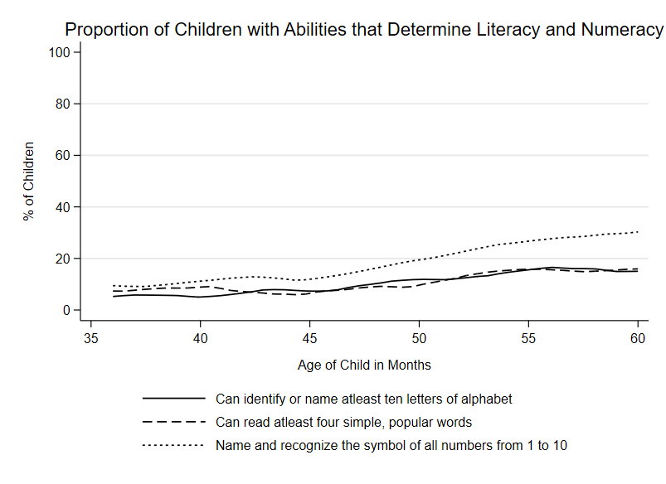

Three components determine a child’s development in the literacy and numeracy domain. One component corresponds to numeracy and two components correspond to literacy, more specifically reading ability. In the above figure we see that all three components show a steady improvement as a child ages, however, the numeracy component is always at a higher level than the other two literacy components and the gap widens with age. The two literacy components, while steadily rising, closely shadow each other without any clear indication as to which component enjoys higher attainment with age.

Given the methodology wherein attaining at least two of these three components deems a child on-track for development, it is safe to assume that amidst the low percentage of children who attain on-track status in literacy & numeracy, in most cases it is the numeracy component that is enabling the attainment. This indicates to the fact that it is reading skills that are primarily holding back under-5 children in Zimbabwe from attaining literacy and numeracy as a part of ECD. The World Bank focuses on reading skills to measure learning poverty[1] for a host of reasons most important of which is the fact that reading provides a gateway of learning to other areas including numeracy.

Thus, unless policymakers intervene urgently to aide reading skills for 3-5 year old children, they risk learning depravity and poverty as children grow up which will have devastating effects on human capital development.

1. World Bank. What is Learning Poverty? World Bank, <https://www.worldbank.org/en/topic/education/brief/what-is-learning-poverty>. Accessed 20 Aug. 2024.