VALHALLA TAX SERVICES  Comprehensive Tax Strategy Report | 
Client: Test Client
Tax Year: 2025
Prepared by: Scott Kunz, ChFC, TPCP, Enrolled Agent and Financial Advisor
Advisor Summary
This plan uses dynamic strategy logic and ROI scoring to prioritize the highest-value planning opportunities based on the client facts supplied.

Potential Future Annual Tax Savings Identified
$15,000-$30,000+ depending on income growth, documentation quality, entity timing, retirement funding, vehicle strategy, and implementation discipline.

EXECUTIVE SNAPSHOT
Metric | Current Position | Planning Opportunity
Federal Income Tax | Taxable exposure exists | Focus planning on the highest-impact tax driver
Total Tax | $24,000 | Reduce future tax drag as income changes
Schedule C Net Profit | $95,000 | Build toward retirement/entity planning trigger points
Refund / Balance | $1,200 | Improve withholding and cash-flow predictability
Top Planning Focus | Tax strategy prioritization | Use ranked recommendations and implementation timeline
TAX OPPORTUNITY SCORE
Current Tax Efficiency Score | Potential Optimized Score | Advisor Read
72/100 | 96/100 | The current tax structure contains identifiable planning opportunities that may improve long-term tax efficiency, cash-flow control, and wealth accumulation if implemented properly.
CONFIRMED TAX POSITION
Filing Status | Dependents | AGI | Taxable Income | Total Tax | Refund
MFJ | 2 | $185,000 | $142,000 | $24,000 | $1,200
Source reviewed: filed income tax return and supplied planning facts. Amounts should be verified against final filed copies before implementation.
EXECUTIVE SUMMARY
- The planning engine identifies which strategies are most relevant based on the supplied client fact pattern.
- Priority actions are ranked using estimated impact, timing, implementation difficulty, and ROI scoring.
- The report is designed to convert tax preparation facts into proactive advisory recommendations.
- The highest-value planning opportunities are highlighted first so the client knows what to act on.
Primary Planning Message
The objective is to prioritize the strategies that produce the highest planning value and convert them into a clear implementation path.

CURRENT FEDERAL TAX ANALYSIS
Tax Burden Analysis
- Adjusted gross income: $185,000.
- Taxable income: $142,000.
- Total tax: $24,000.
- Planning focus should be directed toward the highest-impact tax driver rather than generic deductions.
SCHEDULE C BUSINESS ANALYSIS
Business Metric | Amount | Advisor Read | Planning Priority
Gross Revenue | $280,000 | Strong activity level | Build structure around growth
Total Expenses | ~$185,000 | Expense ratio appears moderate | Confirm substantiation and business purpose
Net Profit | $95,000 | About 33.9% margin | Improve profitability without losing tax control
Contract Labor | $0 | Review if material | Confirm 1099/W-2 classification and documentation
Schedule C Risk Point
Business-owner planning should focus on documentation, entity timing, retirement plan integration, and self-employment tax management.

PLANNING VISUALS
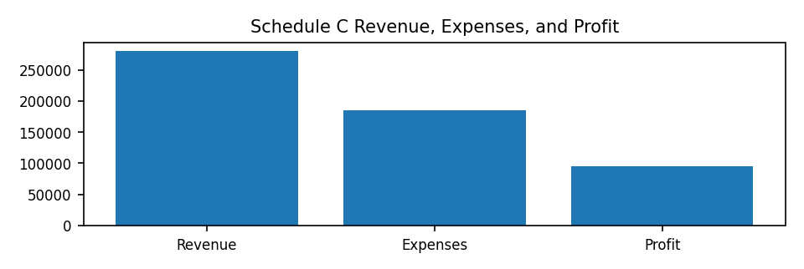
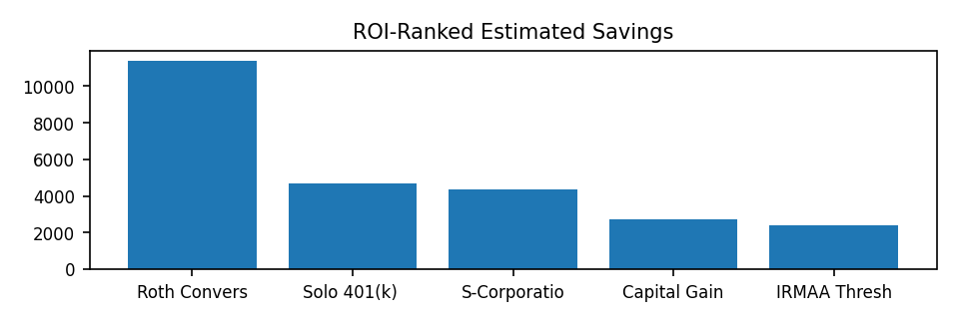

TOP PRIORITY ACTIONS
Rank | Recommendation | Estimated Impact | Timing | Why It Matters
1 | Roth Conversion Analysis | $11,360 | Low-Income Years | Current tax brackets may support partial Roth conversion opportunities with long-term tax diversification benefits.
2 | Solo 401(k) / SEP IRA | $4,655 | Current Year | Current income supports additional retirement contribution capacity with immediate federal and Arizona tax benefits.
3 | S-Corporation Election | $4,360 | Within 12 Months | Current profitability suggests self-employment tax exposure is becoming material enough to justify formal entity modeling.
4 | Capital Gain Optimization | $2,700 | Before Year-End | Strategic harvesting and bracket management may improve long-term capital gain efficiency.
5 | IRMAA Threshold Management | $2,400 | Multi-Year | Managing future Medicare premium thresholds may create meaningful retirement cash-flow improvements.
6 | Schedule C Documentation Optimization | $3,000-$10,000 risk protection value | Immediate | Protects existing deductions and reduces audit exposure.
7 | Evaluate S-Corporation Election | $5,000-$15,000 annually | Within 90 days | Self-employment tax exposure becomes material at higher profitability levels.

ROI-RANKED STRATEGY SCORECARD
Rank | Strategy | Estimated Savings | Score | Difficulty | Timeline
1 | Roth Conversion Analysis | $11,360 | 90/100 | Medium | Low-Income Years
2 | Solo 401(k) / SEP IRA | $4,655 | 89/100 | Low | Current Year
3 | S-Corporation Election | $4,360 | 82/100 | Medium | Within 12 Months
4 | Capital Gain Optimization | $2,700 | 76/100 | Low | Before Year-End
5 | IRMAA Threshold Management | $2,400 | 70/100 | Medium | Multi-Year
CLIENT-SPECIFIC STRATEGY MODULES
Business Owner Strategy
Current planning should focus on documentation quality, retirement integration, contractor compliance, and long-term entity transition readiness. The business currently produces self-employment tax exposure that may eventually justify payroll optimization and S-Corp planning.
S-Corporation Feasibility
Current profitability appears high enough to begin formal S-Corporation modeling. A detailed reasonable compensation analysis should be completed before implementation.
Capital Gain Planning
The return includes capital gain activity. Future planning should monitor gain recognition timing, tax-loss harvesting opportunities, and long-term capital gain bracket utilization.
Retirement Tax Planning
Retirement accounts create opportunities for tax bracket management, Roth conversion planning, and future required minimum distribution mitigation.
Medicare and IRMAA Planning
Future income levels should be monitored carefully to manage Medicare premium surcharge thresholds and optimize long-term retirement cash flow.
ADVISOR ROI COMMENTARY
Roth Conversion Analysis
Current tax brackets may support partial Roth conversion opportunities with long-term tax diversification benefits.
Solo 401(k) / SEP IRA
Current income supports additional retirement contribution capacity with immediate federal and Arizona tax benefits.
S-Corporation Election
Current profitability suggests self-employment tax exposure is becoming material enough to justify formal entity modeling.
Capital Gain Optimization
Strategic harvesting and bracket management may improve long-term capital gain efficiency.
IRMAA Threshold Management
Managing future Medicare premium thresholds may create meaningful retirement cash-flow improvements.
DO THIS NOW CHECKLIST AND IMPLEMENTATION ROADMAP
Timeline | Action Items | Purpose
Next 30 Days | Address the highest-ranked action items and gather supporting documentation. | Create immediate momentum and reduce implementation risk.
Next 90 Days | Model larger strategies such as entity structure, retirement contributions, withholding, and investment tax planning. | Convert recommendations into measurable planning decisions.
Next 12 Months | Review progress quarterly and update the strategy as income, deductions, and family facts change. | Turn the report into a recurring advisory process.
Do This Now - Advisor Directive
Start with the highest-ranked recommendations. The purpose of this report is to convert tax data into an actionable implementation plan, not simply summarize the return.

FINAL ADVISOR RECOMMENDATION
The strongest planning value comes from prioritizing the right strategies in the right order. This report identifies the actions most likely to improve tax efficiency, reduce compliance risk, improve cash-flow predictability, and support long-term wealth building.
PREPARED BY
Scott Kunz, ChFC, TPCP  Enrolled Agent and Financial Advisor  Valhalla Tax Services | 7055 W Bell Rd, Suite B20, Glendale, AZ 85308  (623) 887-7921  skunz@valhallataxservice.com  www.valhallataxservice.com
IMPORTANT PLANNING NOTES
The savings estimates in this report are planning illustrations, not guaranteed outcomes. Actual results depend on final income, filing status, business-use percentages, payroll requirements, documentation, entity costs, state law, and implementation timing. Strategies involving children, contractors, retirement plans, vehicle deductions, and S-Corp elections should be implemented with proper documentation and professional review.

