Title: A Problem with Presidents

Author: Kushal Sharma

Date: 06/07/2023

**Summary:**

The given data is about president’s birth date and death date. There are certain entries which do not have death date is empty. For internal reference, I have entered today’s date as the death date for internal working. It has enabled me to calculate the other variables like lived_days, lived_months, lived_years without any issue. For Calculating and analyzing the data, I have used Pandas which gives us the ability to manipulate and analyze a Data Frame and matplotlib to show the tables and graphs.

**Output:**

The details for top 10 president in the order of number of days lived in an ascending order is given below.

The details for top 10 president in the order of number of days lived in descending order is given below.

The metrics of number of days lived by the president is below. Since each president’s number of days lived is unique. The mode contains all the number of days lived by each president. Also, it can be observed that there is a huge gap between the maximum and minimum number of days lived. The maximum is more than twice the minimum value of number of days lived.

The following diagram depicts histogram distribution of the number of days lived by the presidents.

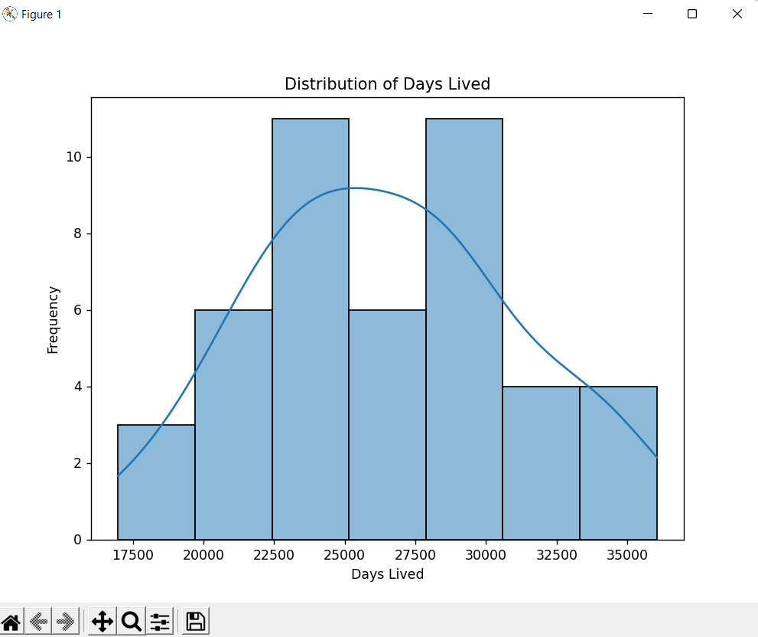

The following is the boxplot of the number of days lived. Boxplot shows the information of all the quartiles. It shows distribution of data based on a five number summary (“minimum”, first quartile [Q1], median, third quartile [Q3], and “maximum”).

**Conclusion:**

There are many aggregations that can be observed from the above graphs. The most amusing observation is that there is so much diversity in a data with approximately 45 entries. The maximum age that the president has achieved is 98 which is of Jimmy Carter. While the minimum age is 46 which is John Kennedy. Using histogram it can be seen that the mean of number of days lived is near the range having maximum frequency.