import numpy as np

import cv2

from google.colab.patches import cv2_imshow

img = cv2.imread('/content/hough.jpg', cv2.IMREAD_COLOR)

cv2_imshow(img)

gray = cv2.cvtColor(img, cv2.COLOR_BGR2GRAY)

edges = cv2.Canny(gray, 50, 200)

lines = cv2.HoughLinesP(edges, 1, np.pi/180, 68, minLineLength=15, maxLineGap=250)

for line in lines:

   x1, y1, x2, y2 = line[0]

   cv2.line(img, (x1, y1), (x2, y2), (255, 0, 0), 3)

print("Line Detection using Hough Transform")

from google.colab.patches import cv2_imshow

cv2_imshow(img)

cv2.waitKey(0)

cv2.destroyAllWindows()

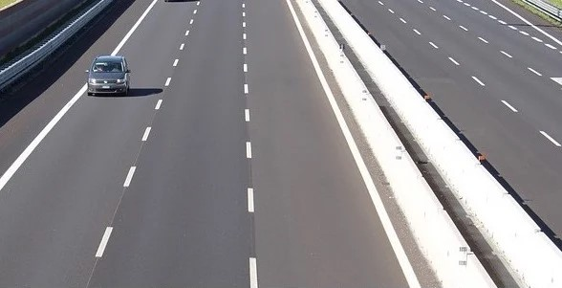

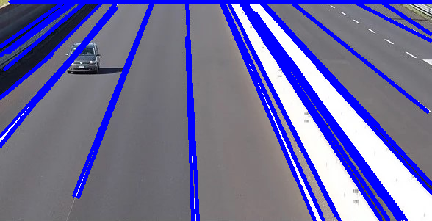**Line Detection using Hough Transform**