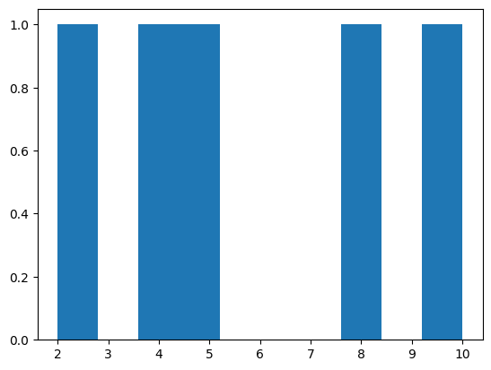

**# HISTOGRAM USING MATPLOTLIB**

# importing matplotlib module

from matplotlib import pyplot as plt

# Y-axis values

y = [10, 5, 8, 4, 2]

# Function to plot histogram

plt.hist(y)

# Function to show the plot

plt.show()

**#PIE CHARTS**

import matplotlib.pyplot as plt

import numpy as np

y = np.array([35, 25, 25, 15])

plt.pie(y)

plt.show()

**#PIE CHART WITH LABEL**

import matplotlib.pyplot as plt

labels = 'apple', 'banana', 'cherry', 'durian', 'elderberries', 'figs', 'grapes'

sizes= [32, 20, 15, 10, 10, 8, 5]

p = plt.pie (sizes, labels=labels, explode=(0.07, 0, 0, 0, 0, 0, 0),

             autopct='%1.1fXX', startangle=130, shadow=True)

plt.axis('equal')

for i, (apple, banana, cherry, durian, elderberries, figs, grapes) in enumerate(p):

  if i > 0:

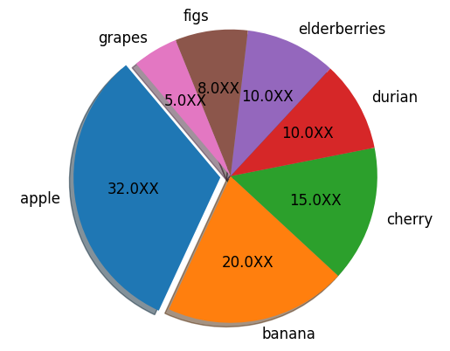    apple.set_fontsize(12)

    banana.set_fontsize(12)

    cherry.set_fontsize(12)

    durian.set_fontsize(12)

    elderberries.set_fontsize(12)

    figs.set_fontsize(12)

    grapes.set_fontsize(12)

plt.show()

**#ADDING GRID LINES TO PLOT**

import numpy as np

import matplotlib.pyplot as plt

x = np.array([80, 85, 90, 95, 100, 105, 110, 115, 120, 125])

y = np.array([240, 250, 260, 270, 280, 290, 300, 310, 320, 330])

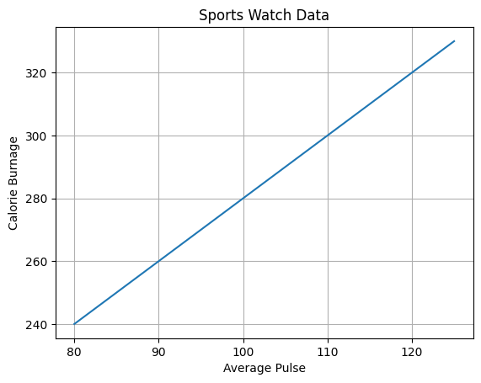plt.title("Sports Watch Data")

plt.xlabel("Average Pulse")

plt.ylabel("Calorie Burnage")

plt.plot(x, y)

plt.grid()

plt.show()

**#STAIRS VALUE**

import matplotlib.pyplot as plt

import numpy as np

plt.style.use('_mpl-gallery')

# make data

y = [4.8, 5.5, 3.5, 4.6, 6.5, 6.6, 2.6, 3.0]

# plot

fig, ax = plt.subplots()

ax. stairs(y, linewidth=2.5)

ax.set(xlim=(0, 8), xticks=np.arange(1, 8),

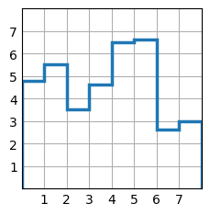       ylim=(0, 8), yticks=np.arange(1, 8))

plt.show()