**SCATTER PLOT**

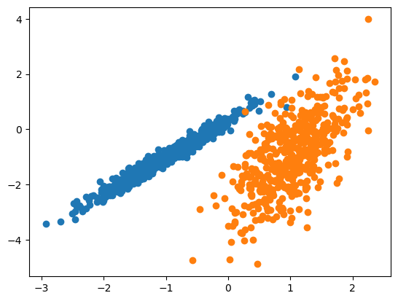from numpy import where

from sklearn.datasets import

make_classification

from matplotlib import pyplot

x,y=make_classification(n_samples=1000,

n_feat ures=2,n_informative=2,n_redundant=0,  
 n_clusters_per_class=1,random_state=4)

for class_value in range(2):

row_ix=where(y==class_value)

pyplot.scatter(x[row_ix,0],x[row_ix,1])

pyplot.show()

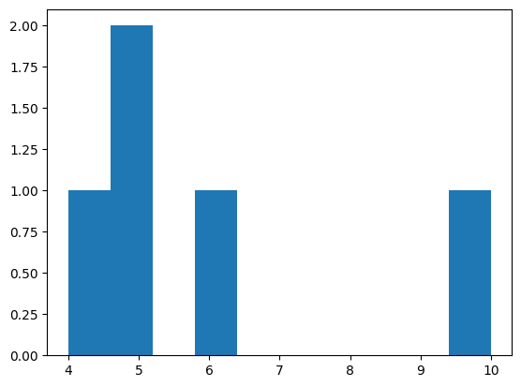

**HISTOGRAM USING MATPLOTLIB**

**# importing matplotlib module**

from matplotlib import pyplot as plt

# Y-axis values

y = [10, 5, 8, 4, 2]

**# Function to plot histogram**

plt.hist(y)

**# Function to show the plot**

plt.show()

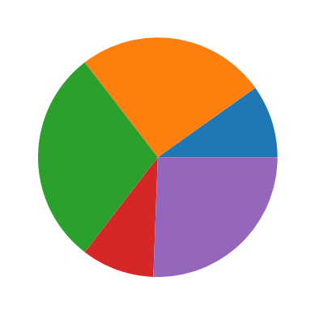

**PIE CHARTS**

import matplotlib.pyplot as plt

import numpy as np

y = np.array([35, 25, 25, 15])

plt.pie(y)

plt.show()

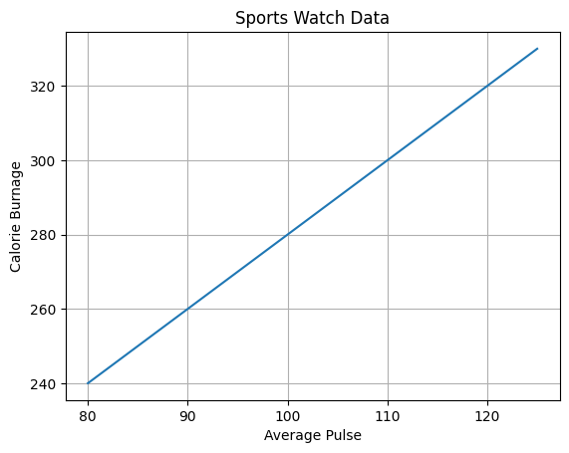**ADDING GRID LINES TO PLOT**

import numpy as np

import matplotlib.pyplot as plt

x = np.array([80, 85, 90, 95, 100, 105, 110, 115, 120, 125])

y = np.array([240, 250, 260, 270, 280, 290, 300, 310, 320, 330])

plt.title("Sports Watch Data")

plt.xlabel("Average Pulse")

plt.ylabel("Calorie Burnage")

plt.plot(x, y)

plt.grid()

plt.show()

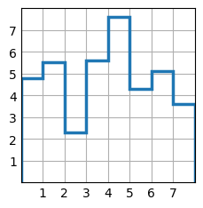

**STAIRS(VALUES)**

import matplotlib.pyplot as plt

import numpy as np

plt.style.use("_mpl-gallery")

**# make data**

y = [4.8,5.5,2.3,5.6,7.6,4.3,5.1,3.6]

**# plot**

fig, ax = plt.subplots()

ax.stairs(y, linewidth=2.5)

ax.set(xlim=(0,8), xticks=np.arange(1,8),

       ylim=(0,8), yticks=np.arange(1,8))

plt.show()