**Visualization Of Data**

**# Step 1**

import pandas as pd

import matplotlib.pyplot as plt

import seaborn as sns

import scipy

import warnings

warnings.filterwarnings('ignore')

boston_df=pd.read_csv('/content/boston.csv')

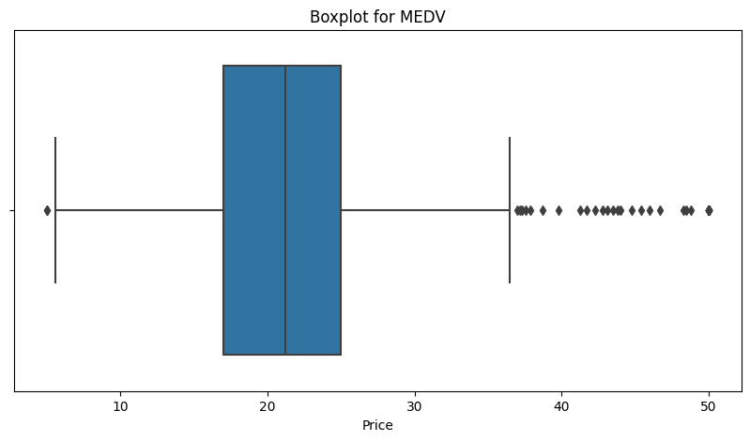print(boston_df)

**Output**

**# Step 2**

plt.figure(figsize=(10,5))

sns.boxplot(x = boston_df.Price)

plt.title('Boxplot for MEDV')

plt.show()

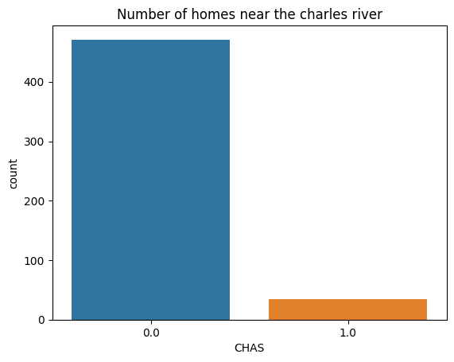

**Output**

**# Step 3**

ax2 = sns.countplot

(x='CHAS', data=boston_df)

ax2.set_title

('No. of homes near charles river')

**# Step 4**

boston_df.loc[(boston_df["AGE"]<35),"AGE_GROUP"] = "35 years and younger"

boston_df.loc[(boston_df["AGE"]<35) & (boston_df["AGE"]<70) ,"AGE_GROUP"]

= "Between 35 years abd 70 Years"

boston_df.loc[(boston_df["AGE"]>=70),"AGE_GROUP"] = "70 years and older"

plt.figure(figsize=(10,5))

sns.boxplot(x=boston_df.Price, y=boston_df.AGE_GROUP, data=boston_df)

plt.title("BOXPLOT FOR THE MEDV VARIABLE VS THE AGE VARIABLE")

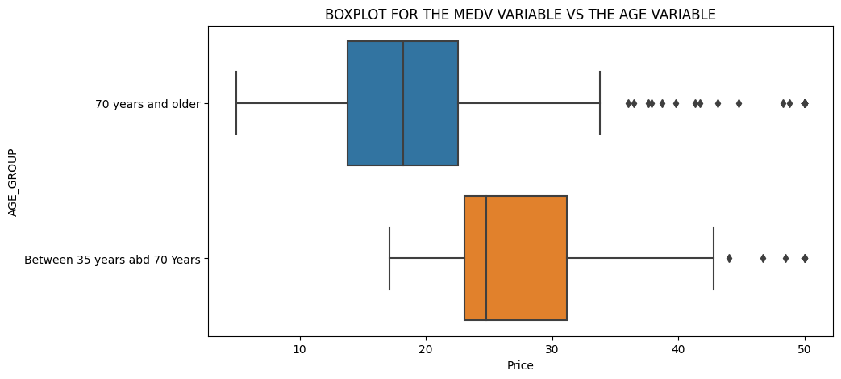plt.show()

**Output**

ax4 = sns.scatterplot(y='NOX', x="INDUS", data=boston_df)

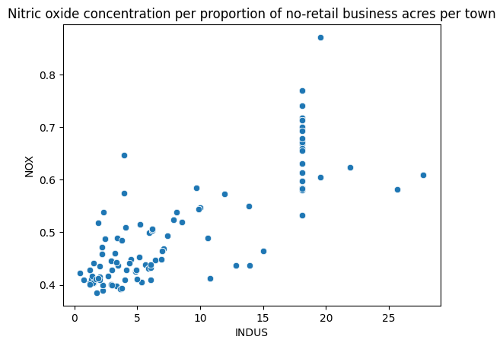ax4.set_title("Nitric oxide concentration per proportion of no-retail business acres per town")

**Output**

plt.figure(figsize=(10,5))

sns.distplot(a=boston_df.PTRATIO, bins=10, kde=False, color="red")

plt.title("HISTOGRAM FOR THE PUPIL TO TEACHER PATIO VARIABLE")

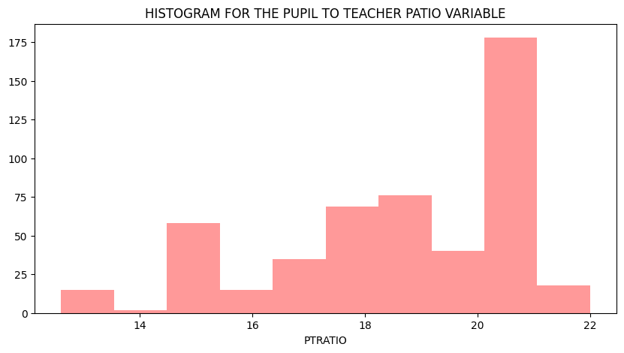plt.show()

**Output**